Topic 8. HIGHER FATTY ACIDS. LIPIDS. PHOSPHOGLYCERIDES.

1. Actuality of the topic:
Knowledge of the structure and chemical properties of lipids and their derivatives is necessary to understand the processes of lipids’ metabolism in a human organism and the structure of biological membranes.

2. General aim:
To interpret the regularity of lipid metabolism in order to predict biochemical reactions which are accompanied and stimulated by lipids.

3. Actual aims and abilities:
3.1. To know the structure and chemical properties of lipids and their structural components.
3.2. To be able to use knowledge for understanding of the biological membrane structure and the regularity of the lipid metabolism as the basis of the metabolic changes in human organism.

4. Literature:
4.1. Lecture.
4.2. Zurabyan S.E. Fundamentals of bioorganic chemistry, Moscow, 2004, pp. 238-249.

5. The main questions of the seminar:
5.1. Lipids, saponification lipids (definition).
5.2. Higher fatty acids: saturated and unsaturated, sPartial structure of unsaturated acids, chemical characteristics.
5.3. Fats as triacylglycerols, their composition, structure, classification, chemical properties (hydrolysis, iodine number, peroxide oxidation).
5.4. Phosphoglycerols: composition, structure of phosphatidylcholine, phosphatidylcolamine, phosphatidylserine and their biological meaning.

6. The questions for individual learning:
6.1. Non Saponification lipids (definition).
6.2. Structure of cholesterine, bile acids.

7. Examples of task:
7.1. Write the configuration of oleic acid.
Answer:
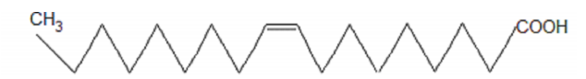
7.2. Write the scheme of alkaline hydrolysis of 1 – palmetoyl – 2 – oleoyl – 3– stearine.
Answer:
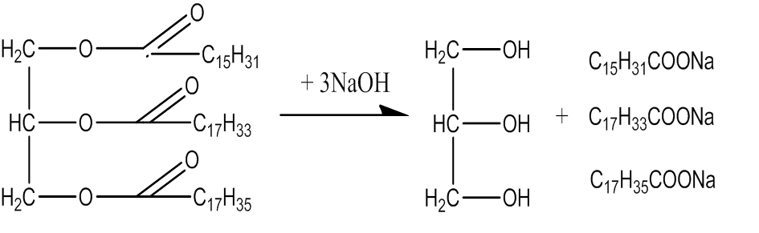
8. Homework (must be performed in the laboratory notebook):
8.1. Write the reaction equation of alkaline hydrolysis of dioleoylstearine.
8.2. Write the structure of phosphatidylcholine.
8.3. Write the spartial structure of unsaturated fatty acids: oleic and linoleic.

9. Example of control test:
9.1. Write structure and scheme of alkaline hydrolysis of tristearin.
Answers:
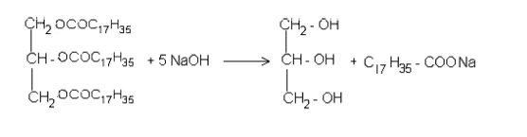
10. The Control Test:
Sample 1
1. Write the formation reaction of 1-O-palmitoyl-2,3-di-O- stearoyl glycerol 2. Write the configuration of linoleic acid.
3. Design the chemical method to distinguish between saturated and unsaturated fatty acids.
Sample 2
1. Write the formation reaction of fat containing one residue of linoleic acid and two molecules of palmitic acid.
2. Write the reaction equation of oxidation of oleic acid by potassium permanganate.
3. Call the products of hydrolysis of oil.
Sample 3
1. Write the reaction equation of interaction between iodine and trioleoylglycerol.
2. Write the differences between fat, oil and waxes.
3. What are the bile acids? Design their general formula.
Sample 4
1. Write the formation reaction of oil.
2. Write the configuration of linolenic acid.
3. What is hydrogenation of fats? Write the scheme of the reaction.

12. Laboratory work.
Experiment 1 Formation of the fatty drop and its extraction.
Detailed description:
On the filter paper put 3 separated drops of oil with sizes of 1 cm. Touch the center of the first drop with the tube that contains diethyl ether, the second with benzene and the third with water. Describe the results of the experiment and make the conclusions.
Experiment 2 Extraction of free fatty acids from soap.
Detailed description:
In the test tube put 5 drops of saturated soap solution and 1 drop of sulphuric acid. Point the effect, write reaction equation and make the conclusion.
Experiment 3 Formation of unsolutable calcium salts (unsolutable soap).
Detailed description:
In the test tube put 5 drops of soap solution and 1 drop of calcium chloride solution. Mix the test-tube. Point the effect, write reaction equation, and make the conclusion.
Experiment 4 Unsaturated fatty acids reaction.
Detailed description:
Put 5 drops of oil and 4 drops of bromine water into a test-tube and mix it. Point the effect, write reaction equation, and make the conclusion.

