Name: …………………………………………
Date Due: ……………………………………
1.
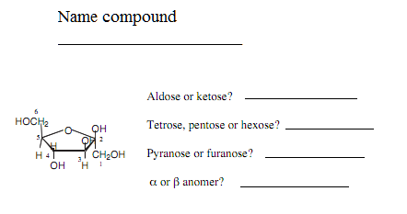
2. Give reagents to carry out the transformations below.
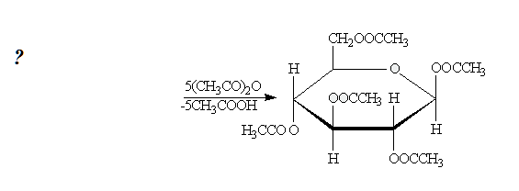
3. Predict the major organic products of the following reactions.
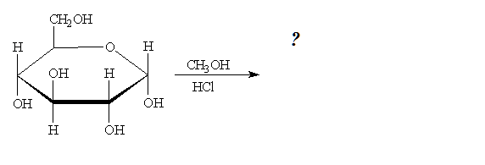
4. Name each compound.
