Topic 5: THE BUFFER SYSTEMS.

1. Actuality of the topic: Buffer systems support the constancy of the reaction environment of biological fluids in living organisms. Buffer systems are widely used for the practical creation of an environment with a certain pH.

2. Key questions of the theme:
2.1. Determination of buffer system.
2.2. The main types of buffer system.
2.3. Basic equations of the buffer systems. Formula Henderson-Hasselbach”s.
2.4. The mechanism of action of buffer system.
2.5. Buffer capacity. Factors on which it depends.
2.6. Buffer systems of the human body.
2.7. The biological significance of buffer systems.

3. Literature:
3.1. Lecture material.
3.2. M.I. Ravitch-Scherbo, Vladimir Novikov. Physical and Colloid Chemistry, 1975, p.90-97.

4. Standard test solution control.
4.1. Calculating pH of buffer system.
Task. Calculate the pH of buffer system which consists of 100 ml of dilute acetic acid, C = 0,1 mol/l and 200 ml of sodium acetate C = 0,2 mol/l, Kd (acid) = 1,75·10-5.
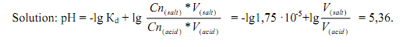
4.2. Quantification of components for the preparation of buffer systems with a certain pH.
Task. Calculate the volume of sodium acetate C = 0,1 mol/l and the amount of acetic acid with C = 0,1 mol/l which must be mixed to prepare 3l of acetate buffer рH = 5,24 (Кd (acid) = =1,75·10-5).

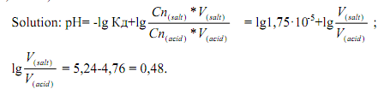
Antilog of 0,48 is equal to 3. [V (salt)] / [V (acid)] = 3/1. So you need 3 parts of salt solution and one part acid solution for the preparation of buffer systems with pH = 5,24. The volume of salt is: 3000 · 3/4 = 2250ml, and acid 3000 1/4 = 750ml.

5. Homework (must be performed in the laboratory notebook):
Task 1. Calculate the pH of buffer solution that contains 3,6 ml of ammonium chloride solution C = 0,2 mol/l and 2,6 ml of ammonium hydroxide solution С = 0,1 mol/l (Кd(NH₄OH)=1,8·10-5).
Task 2. Calculate the volume of acetic acid with C = 0,1 mol/l sodium acetate C = 0,1 mol/l which must be mixed to obtain 150 ml solution рН = 4,94. (Кd (СН₃СООН) = 1,75·10-5).

6. Laboratory work.

Experiment 1. Preparation of buffer systems and the calculation of pH.
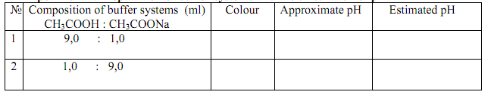
Add one drop of universal indicator in 1 ml solution obtained. Determine the approximate pH of a color table and calculate the pH with the formula:
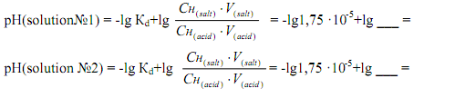

Experiment 2. Effect of acid and alkali on the pH of the buffer solution.
Divide 9 ml of solution № 1 obtained in experiment № 1 equally into 3 tubes: in the first tube 3 drops of hydrochloric acid with C = 0,1 mol/l were added, the second - 3 drops of sodium hydroxide with C =0,1 mol/l. In each tube add 2 drops of methyl red indicator. Compare the color of the solution and draw conclusions.
Conclusion:
Experiment 3. Effect of dilution on the pH of the buffer solution.
In 2 tubes evenly divide the solution number 2 obtained in experiment number 1. In the first tube to 2 ml of water. To each tube add 2 drops of methyl red indicator. Compare the color and draw conclusions.
Conclusion:
Experiment 4.
Prepare 10 ml of acetate buffer with a calculated pH 5,24 and determine its approximate pH (see reference 4.2.).
Conclusion:

