Name: …………………………………………
Date Due: ……………………………………
1.
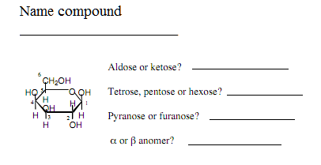
2. Give reagents to show how to synthesize the compounds on the right from the compounds on the left.
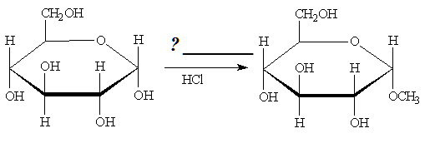
3. Name each compound.
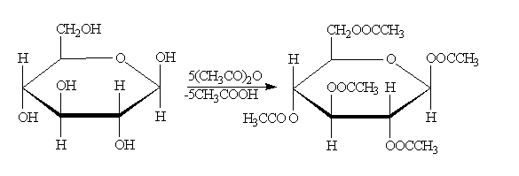
_____________ __________________

4. Give reagents to carry out the transformations below.
