Topic 3: BASIC CLASSES OF INORGANIC COMPOUNDS.

1. The actuality of the topic: Representatives of the basic classes of inorganic compounds are widely used in medicine as medical products and chemicals. The study and knowledge of chemical properties is essential for further possible use of them for therapeutic purposes.

2. Key questions of the theme: Representatives of the basic classes of inorganic compounds are widely used in medicine as drugs and chemicals. Study and knowledge of chemical properties are essential for further possible use of them for therapeutic purposes.

3. General aim: Classify simple and complex matter depending on their composition and the presence of functional groups. Explain the chemical properties of substances with a certain class of chemical reactions.

4. Actual aims and abilities: Demonstrate knowledge of nomenclature of inorganic compounds with specific examples.

5. The main question of the study:
5.1. Simple matter: metals and nonmetals.
5.2. Complex substances: binary, tertiary, complex.
5.3. Oxides of: single, double, polymer. Peroxides and superoxide. Use of Nomenclature.
5.4. Hydroxides: basic, acidic, amphoteric. Nomenclature Application.
5.5. Acid. Ortho-, iso-and polyforms acids. Application.
5.6. Salt. Classification. Nomenclature. Application.
5.7. The dependence of acid-base forms and properties of oxides and hydroxides of the position of the elements that they constitute in the Mendeleev periodic table.

6. Questions for self study:
6.1. The dependence of acid-base forms and properties of oxides and bases from the position of elements which form in the periodic table of Mendeleev.

7. Literature:
7.1. Lecture notes.
7.2. Glinka L.G. General chemistry. L.A.: 1986.
7.3. Grigorieva V.V. and others. General Chemistry, 1991, p. 62-85.

8. Standards of solving tasks:
8.1. Give examples of oxides: a) acid b) basic c) amphoteric d) indifferent.
acid _________________________________________________________
basic ________________________________________________________
amphoteric ___________________________________________________
indifferent ____________________________________________________

8.2. Write IUPAC name of these substances:
a) acids: H₂SO₄ , H₃BO₃, H₂SO₃, H₂S.
b) the grounds of: Fe(OH)₂, Fe(OH)₃, Cr(OH)₃.
c) oxides: N₂O, NO, Mn₂O₇, N₂O₃.
d) salts: Al₂(SO₄)₃, FeOHCl₂, Na₃PO₄, Ca(HCO₃)₂.

8.3. Complete reaction equation:
K₂O+ZnO=________________________________________________________
CaО+Cl₂O₇=________________________________________________________
Ca(H₂PO₄)₂+Al₂(SO₄)₃=_______________________________________________

8.4. Write the equation of dissociation of the following electrolytes: H₂SO₄, Al₂(SO₄)₃, H₃PO₄, Cr(OH)₂Cl.

8.5. Make the reactions necessary for the following transformations:
а) Ba→ BaО→ BaCl₂ → Ba₃(PO₄)₂→ BaSO₄;
б) Zn → K₂ZnО → ZnCl₂ → Zn(OH)₂ → Na₂[Zn(OH)₄] → ZnSO₄
в) C → CO→ CO₂ → Na₂CO₃→ NaHCO₃ → Na₂CO₃→ CaCO₃→ Ca(HCO₃)₂ → CaCO₃.

QUESTIONS FOR SELF STUDY

Calculations of chemical equations.

1. Actuality of the topic: Ability to make calculations based on chemical equations needed to study the following disciplines of organic, analytical, physical, colloid chemistry, etc.

2. Key questions to the theme: Ability to make calculations based on chemical equations is needed to study the following disciplines of organic, analytical, physical, colloid chemistry, etc.

3. General aim: To be able to complete the reactions, pick the stoichiometric coefficients and do stoichiometric calculations of mass and volume of the reactants with the reactions using the law of conservation of mass of substances.

4. Actual aims and abilities: Do it stoichiometric calculations of weight and volume ratios between the reactants, the calculations of chemical formulas and equations.

5. The main question of the study:
5.1. What shows the chemical formula.
5.2. Structure of the chemical equation. Show the stoichiometric coefficients.
5.3. Calculating the number, masses and volumes of reagents for chemical equations.
5.4. The concept of: - the output of products of the reaction - the mass fraction (the main substance, a component in the mixture; dissolve substance in solution; element in the molecule) - volumetric particle - density.
5.5. Equivalent and the equivalent weight of the oxidant and reductant.
5.6. Equivalent and the equivalent weight of simple and complex substances in the chemical reaction. The law of equivalents.

6. Literature:
6.1. Lecture notes.
6.2. Levitin E.Y. and others. General and inorganic chemistry. Textbook. Vineyard: NEW BOOK, 2003, p.4-14.
6.3. Khomchenko G.P. Collection of problems in chemistry, 1993.

7. Examples of test control:
Task 7.1. Solution that contains silver nitrate weighing 25,5 g was added a solution that contains sodium sulphide, the mass of 7,8g. What mass of sediment isformed at the same time?
Solution:
Write the reaction equation:
2AgNO₃ + Na₂S = Ag₂S↓ + 2NaNO₃
Determine the amount of the substance of silver nitrate and sodium sulphide:
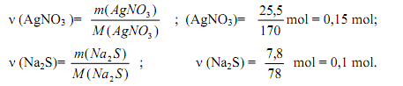
From the reaction equation follows: for the reaction of silver nitrate with the amount of material 2 mols, 1 mol of sodium sulfide. Accordingly:
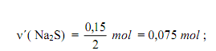
Where: 0,075 mole - the amount of matter of sodium sulphide required for the reaction is taken in excess. Calculation of amount of substance and weight to the starting material to manufacture, using the mass and the amount of substance that is taken in the lack of, that is, silver nitrate. From reaction equation follows: 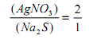
Hence:
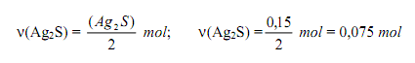
Determine the mass of silver sulphide:

Task 7.2. A mixture of copper and magnesium сhips weighing 1,5 g was treated with excess of hydrochloric acid. The reaction released hydrogen volume of 560 ml (normal conditions). Identify the mass of copper particles in mixture.

Solution. Of the two metals, hydrochloric acid reacts only magnesium:
Mg + 2HCl = MgCl₂ + H₂

Determine the amount of hydrogen which include:
From the reaction equation follows:
We find the weight of magnesium:
The mass of copper in the mixture will be:
We expect the mass fraction of copper in the mixture:
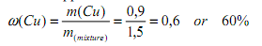
Task 7.3. Determine the mass of salt that is obtained by mixing 40 ml of solution with mass fraction of nitric acid, 0,2 and density 1,12 g/ml with a solution volume of 36 ml of mass fraction of sodium hydroxide and 0,15 density1, 17 g/ml.

Solution. We introduce the notation: m₁ - mass; V₁ - volume; ρ₁ - density of a solution of nitric acid-slots; m₂ - mass; V₂ - volume; ρ₂ - density of sodium hydroxide; m₃ - density of sodium hydroxide; m₃ - density of sodium hydroxide; m₃ - mass of produced solution. We write the reaction equation:
HNO₃ + NaOH = NaNO₃ + H₂O

Determine the mass and the amount of substance in a solution of HNO₃:
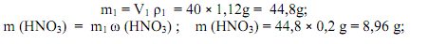
Similarly, we can find the mass and the amount of the substance in a solution of sodium hydroxide:
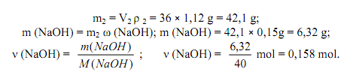
From the reaction equation it follows that the nitric acid of 0,142 mole of a substance will react with sodium hydroxide, the amount of material 0,142 mol, respectively, NaOH taken in excess.
From the reaction equation it follows that:
To determine the mass of salt which was formed:
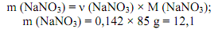
The mass of the obtained solution is:
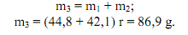
Define mass fraction of salt in the resulting solution:
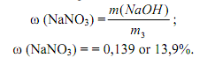

Task 7.4. A reaction of a sample of technical sodium sulphate spent weighing 9 g solution weight of 40 grams of mass part of potassium permanganate (KMnO₄) 7,9%. Determine the mass-equivalent fraction of Na₂SO₃ in the technical sulphite. The reaction between potassium permanganate and sodium sulfite takes place in the presence of sulphuric acid.

Solution. Equation of the reaction:

5Na₂SO₃ + 2KMnО₄ + 3H₂SO₄ = 5Na₂SO₄ + 2MnSO₄ + K₂SO₄ + 3H₂O
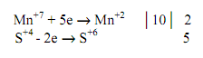
Determine the weight and the amount of matter of potassium permanganate:
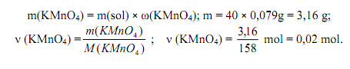
From the reaction of the equation it follows that:
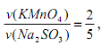
Location:
The mass of Na₂SO₃, which is placed in the sample is:
We expect a mass of Na2SO3 in the technical sulphite:

Task 7.5. To a solution in which the aluminum nitrate weighing 42,6g the solution that contains sodium carbonate was added, the precipitate mass of 37,2g calcined. Determine the mass of residue after calcined.

Solution. Aluminum nitrate - the salt of weak base and strong acid, sodium carbonate - the salt of strong base and weak acid, respectively, two salts in solution are subject to hydrolysis. When mixing the solutions is mutually enhanced hydrolysis, which in this case proceeds in full.

2Al(NO₃)₃ + 3Na₂CO₃ + 3H₂O = 2Al(OH)₃ + 6NaNO₃ + 3CO₂ (а)

When calcined alumina precipitate is obtained:

2Al(OH)₃ = Al₂O₃ + 3H₂O (b)

Quantities of materials:
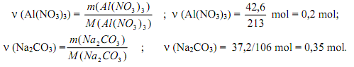
From (a) show that for the reaction with 0,2 mol of aluminum nitrate to 0,3 mole of sodium carbonate, sodium carbonate, respectively, taken in excess.

From equations we have (a)
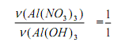

From equations we have (b)
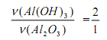
so:
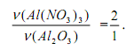
Hence:
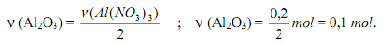
Determine the mass of aluminum oxide obtained after calcination:
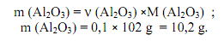

8. Homework (must be performed in the laboratory notebook):
8.1. A mixture of hydrogen and hydrogen chloride volume of 7 liters (standard conditions) was passed through silver nitrate solution, taken in excess, and received sediment mass was 28,7g. Determine the volume fraction of hydrogen in the mixture.
8.2. Calculate the mass of carbon dioxide (IV), which can be extracted from the interaction of calcium carbonate weighing 7 g of hydrochloric acid, weight 30 grams, in which the mass fraction of chlorine-hydrogen is 20%.
8.3. Calculate the mass of base formation interactions 34 silver nitrate and 21 g barium chloride.

