Topic 2: THE STRUCTURE OF COMPOUNDS

Part 1: BASIC THEORETICAL CONCEPTS ON THE STRUCTURE OF ATOM.

1. Actuality of the topic: Electronic theory of atomic structure explains the physical content of the periodic law of Mendeleev. Knowledge of the topic enables students to find any elements valence, oxidation state and to characterize the properties of that element.

2. Key questions of the theme: Electron theory of atomic structure explains the physical meaning of the periodic law of Mendeleev. Knowledge of the topic enables students to find any elements valence, oxidation states and to characterize the properties of this element.

3. General aim: values of quantum numbers and the rules and principles governing the sequence of filling of atomic orbitals for the electronic image and general: learn the basic of modern quantum-mechanical theory of atomic structure. Electrons apply the formula of atoms and ions of elements.

4. Actual aims and abilities: Learn examples of radiopharmaceuticals used for healing and disease diagnosis.

5. The main question of study:
5.1. The planetary model of atom and its contradiction. Experimental studies confirm the complex structure of atom. Bohr's postulates.
5.2. Wave-corpuscle duality of the electron, the equation of de-Broglie, Heisenberg's uncertainty principle. Motion of electrons in atom. Atomic orbitals.
5.3. Quantization of energy in the micro particles. Electronic energy levels. Quantum numbers: characteristics, importance (important, the orbital shape of s, p, d, f - orbitals, magnetic). The orientation of atomic orbitals, the spin quantum number.
5.4. Principles and rules of filling of atomic orbitals by electrons: the principle of lowest energy, the Pauli principle, Hund's rule and Klechkovskogo. Electric and electronic graphic formula of atoms and ions.
5.5. Natural and artificial radioactivity. Toxic effect of radionuclides, radiopharmaceuticals in the treatment and diagnosis of diseases.

6. Questions for self study:
6.1. Natural and artificial radioactivity. Toxic effect of radionuclides, radiopharmaceutical drugs for treatment and diagnosis of diseases.

7. Literature:
7.1. Lecture notes.
7.2. Glinka L.G. General chemistry. L.A.: 1986.
7.4. Olenin S., Fadeev, G.N. Inorganic Chemistry. G.: 1979. p.68-72, 76-80, 83-85, 91-93.

8. Standards of solving tasks:

Task 1. Write an expression of iron (Fe, z = 26).
26 Fe 1s² 2s²2p⁶ 3s²3p⁶3d⁶ 4s²

Task 2. Write electro-graphical formula of chlorine in normal and excited states, to establish equivalency, the degree of oxidation and provide examples of compounds with data degrees of oxidation.
Answer: 17 Cl 1s² 2s²2p⁶ 3s²3p⁵
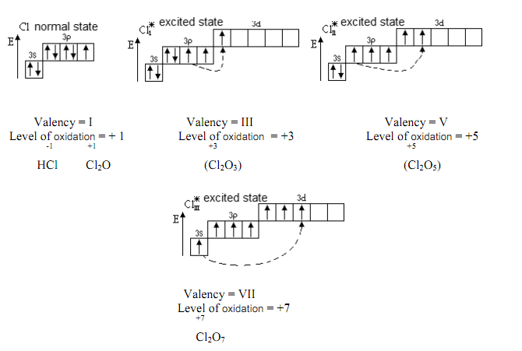9. Homework (must be performed in the laboratory notebook):
9.1. Leave e-formula of elements with atomic numbers 15, 34 and 53, determined to divide the family, emphasize the valence electrons and for the latter represent the electro-graphical formula in the normal and excited states, determine the valency, the degree of oxidation and provide examples of compounds with given degrees of oxidation.
9.2. Why is s-orbital full in the formation of the first electronic layer?
9.3. What determines the spin quantum number?
9.4. How many entries are the magnetic quantum number, if l = 1?
9.5.Complete the following table. The first two rows have been done for you. You may need to look at your periodic table.
Element | Symbol | Protons | Neutrons | Electrons
lithium | Li | 3 | 7-3=4 | 3
carbon | С | 6 | 12-6=6 | 6
 |  | 72
 |  |  |  | 15
 |  |  | 0
tungsten

Part 2: STRUCTURE OF MOLECULE.

1. Actuality of the topic: Knowledge of this topic will allow students to provide the type and the strength of bonds in chemical compounds and their reactivity. This knowledge can help students understand the issue of sPartial structure and reactivity of chemical compounds in the study of inorganic, organic, biological, an analytic chemistry and other disciplines better.

2. Key questions of the theme:
2.1. Modern ideas about the nature of chemical bonds. Bond characteristics: energy, length, bond angle.
2.2. Covalent bond. The method of valence bond (VB). Two-electron chemical bond on Geytleru-London (on the example of education H₂).
2.3. Exchange and donor-acceptor mechanism of covalent bond formation.
2.4. Properties of covalent bond: saturation, direction, polarization ability.
2.5. Education σ and π bonds, of bonds in accordance with the method of OT.
2.6. Formation of the covalent bond in the excited atoms. Hybridization of atomic orbitals and the sPartial structure of molecules.
2.7. Determination of the valence of OT method.

3. General aim: Apply the method of valence bonds to determine the shapes of molecules and their polarity and molecular orbital method for determining the magnetic properties and staining substances. Analyze the advantages and disadvantages of these methods.

4. Actual aims and abilities: Depending on the type of intermolecular interaction explain the properties of substances in liquid, gaseous or liquid state.

5. The main question of the study:
5.1. Fundamentals of molecular orbitals (MOs) methods. Binding the gap-board and nonbonding molecular orbitals. Their energy and shape.
5.2. Energy diagrams of molecules that the formation of atoms of elements I and II periods of the periodic table of elements. Multiplicity of communications for the MO method.
5.3. Ionic bond and its properties: unsaturated, non-directional. Structure and properties of compounds with ionic bonds.
5.4. Metallic bond.
5.5. Intermolecular interaction and its nature. Orientation, induction and dispersion interaction.
5.6. Hydrogen bond and its types. The role of hydrogen bonding in biological systems.

6. Questions for self study:
6.1. Intermolecular interaction and its nature. Orientation, induction and the dispersion interaction.

7. Literature:
7.1. Lecture notes.
7.2. Levitin E.Y. and others. General and inorganic chemistry. Textbook. Vineyard: NEW BOOK, 2003 .- with. 61-98.
7.3. Glinka L.G.General chemistry. L.A.: 1986.
7.4. Olenin S., Fadeev, G.N. Inorganic Chemistry. G.: 1979. p.68-72, 76-80, 83-85, 91-93.
7.5. Grigorieva, V.V. and others General Chemistry, 1991, p. 62-85.

8. Standards of solving tasks:
8.1. Write the energy diagram filling of the MO in the hydrogen molecule.
Solution:
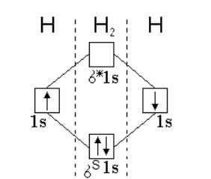
8.2. Show the hydrogen bond between molecules of hydrogen fluoride.
Solution:
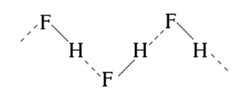

9. The task to consolidate the material:
9.1. Draw energy diagrams of the following molecules: F₂, N₂, NO, CO.
9.2. By the example of water molecules show schematically the formation of hydrogen bonds. What is the biological role of hydrogen bonding?

10. Additional Questions
1. Write electron dot formulas for each of the following:
  - chlorite ion
  - sulfur hexafluoride
  - BCl₄⁺

2. Circle the most correct answer.
  - Which has the higher melting point?
CCl₄, CBr₄
  - Which has the lower melting point?
NaF, NaI
  - Which is harder?
CO₂, SiO₂
  - Which has the strongest intermolecular forces?
PCl₃, BCl₃, BH₃
  - Which has the higher melting point?
MgCl₂, BCl₃, BI₃
3. Make a sketch showing the structure of SiO₂.
4. Give formulas for the following compounds:
aluminum oxide, magnesium hydroxide, silver iodide, cobaltous phosphate, ferric arsenate, chromic perchlorate, lithium dihydrogen phosphate, cuprous hypoiodite, ammonium bromate, auric sulfite, cadmium nitride, ferrous sulfide, nickel nitrite, barium sulfate
5. Name the following compounds:
Rb₂O, K₃PO_{3,} Ni(ClO₂)_{2,} HgF_{2,} PbCO_{3,} Mn(OH)_{2,} BaHPO_{4,} CsNO_{3 ,}Ca(HCO₃)_{2,} Fe(CN)_{3,} H₃PO₂

Part 3: THEORY OF CHEMICAL BOND.

1. Actuality of the topic: Knowledge of the topic will allow students to provide the type and the strength of bonds in chemical compounds and their reactivity. This knowledge can help students understand the issue of sPartial structure and reactivity of chemical compounds in the study of inorganic, organic, biological, and analytic chemistry, and other disciplines better.

2. Key questions of the theme:
2.1. Modern ideas about the nature of chemical bonds. Bond characteristics: energy, length, bond angle.
2.2. Covalent bond. The method of valence bond (VB). Two-electronic chemical bond on Geytleru-London (on the example of education H₂).
2.3. Exchange and donor-acceptor mechanism of formation of a covalent bond.
2.4. Properties of covalent bond: saturation, direction, polarization ability.
2.5. Education σ and π bonds, bonds in accordance with the method of OT (OT-method).
2.6. Formation of the covalent bond in the excited atoms. Hybridization of atomic orbitals and the sPartial structure of molecules.
2.7. Determination of the valence of the OT method.

3. General aim: Learn the basic concepts of modern theory of chemical bonding.

4. Actual aims and abilities: Classify the types of chemical bonds to explain the properties of substances depending on the type of bond in the molecule.

5. The main question of the study:
5.1. Modern ideas about the nature of chemical bonds. Bond characteristics: energy, length, bond angle.
5.2. Covalent bond. The method of valence bond (VB). Two-electron chemical bond on Geytleru-London (on the example of education H₂).
5.3. Exchange and donor-acceptor mechanism of formation of a covalent bond.
5.4. Properties of covalent bond: saturation, direction, polarization ability.
5.5. Education σ and π bonds, of bonds in accordance with the method of OT.
5.6. Formation of the covalent bond in the excited atoms. Hybridization of atomic orbitals and the sPartial structure of molecules.
5.7. Determination of valence on the method of OT.

6. Questions for self study:
6.1. Formation of the covalent bond in the excited atoms. Hybridization of atomic orbitals and the sPartial structure of molecules.

7. Literature:
7.1. Lecture notes.
7.2. Levitin E.Y. and others. General and inorganic chemistry. Textbook. Vineyard: NEW BOOK, 2003 .- with. 61-98.
7.3. Glinka L.G. General chemistry. L.A.: 1986.
7.4. Olenin S., Fadeev, G.N. Inorganic Chemistry. G.: 1979. p.68-72, 76-80, 83-85, 91-93.
7.5. Grigorieva, V.V. and others General Chemistry, 1991, p. 62-85.

8. Standards of solving tasks:
8.1. How many electron pairs are involved in the formation of a bond in a molecule of water?
Show e-formula. Answer: 2 (two).
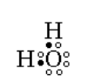

8.2. Leave scheme for the formation of the cation hydroxal.
Answer:
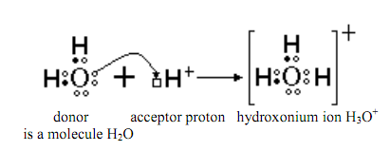

8.3. Determine the type of hybridization of atomic orbitals, the sPartial structure and valence limited angle in the following molecules: H₂O, NH₃, CH₄, BeCl₂, BCl₃.
Answer:
H₂O: atom oxygenation in sp³-hybridization state, the angular shape of the molecule, the angle of 104.5 D;
NH₃: Nitrogen atom in a state of sp³-hybridization, pyramidal shape of the molecule, the angle of 107.3 D;
CH₄: carbon atom in a state of sp³-hybridization, the tetrahedral shape of the molecule, the angle 109°28;
BeCl₂: beryllium atom in a state of sp-hybridization, the shape of the molecule is linear, angle 180°;
BCl₃: boron atom in a state of sp²-hybridization, the shape of the molecule plane, the angle 120°.

9. Homework (must be performed in the laboratory notebook):
9.1. Determine the type of hybridization of atomic orbitals, the sPartial structure and valence limited angle in the following molecules: H₂S, PH₃, SіCl₄, MgCl₂, AlCl₃. 9.2. In what compounds there are only σ-bond (the answer motivate):
a) carbon dioxide;
b) in hydrogen chloride;
c) oxygen;
d) fluorine;
d) hydrogen.
9.3. If there are bond rotations of carbon atoms relative to each other but impossible.

Part 4: CONTEMPORARY INTERPRETATION OF THE PERIODIC LAW OF D.I. MENDELEEV ON THE BASIS OF ELECTRONIC THEORY OF ATOM.

1. Actuality of the topic: Knowledge of the periodic law and the structure of the periodic system is of great importance in the study of general chemistry and chemistry of elements. Ability to use the laws of the periodic system in periods and in groups allows students to characterize the properties of elements and their compounds.

2. Key questions of the theme: Knowledge of the periodic law and the structure of the periodic system is of great importance in the study of general chemistry and chemistry of the elements. Ability to use the laws of the periodic system the periods and in groups will allow students to characterize the properties of elements and their compounds.

3. General aim: Assimilate modern definition of periodic law and the physical meaning of the law of periodicity.

4. Actual aims and abilities: Interpret the frequency change of the atomic radius, ionization energy, electron affinity, electro negativity and chemical properties of simple substances and compounds of elements based on the electronic structure of atoms.

5. The main question of the study:
5.1. Formulation of the periodic law of D.I. Mendeleev and the modern-formula of the periodic law. Law Moseley.
5.2. The structure of the periodic table of elements: time, group, subgroup, s, p, d, f - a family of elements.
5.3.Periodic behavior of the atomic properties of elements in a gaseous state as a function of changes in their electronic structure: the atomic radii, ionization energy, electron affinity, the relative electro negativity.
5.4. Metallic, nonmetallic and redox properties.
5.5. Internal and secondary periodicity.
5.6. Periodicity of chemical properties of elements and their compounds. The physical content of the periodic law.

6. Questions for self study:
6.1. Periodicity of chemical properties of elements and their compounds. The physical meaning of the periodic law.

7. Literature:
7.1. Lecture notes.
7.2. Levitin E.Y. and others. General and inorganic chemistry. Textbook. Vineyard: NEW BOOK, 2003 .- with. 61-98.
7.3. Glinka L.G General chemistry. L.A.: 1986.
7.4. Olenin S., Fadeev, G.N. Inorganic Chemistry. G.: 1979. p.68-72, 76-80, 83-85, 91-93.
7.5. Grigorieva, V.V. and others. General Chemistry, 1991, p. 62-85.

8. Standards of solving tasks:
8.1. For the elements of the III period taking consideration in to ascending serial number form higher oxides and indicate their acid-base character.
Na₂O; CaO; Al₂O₃; SіO₂; P₂O₅; Cl₂O₇
base base amf. acid acid. acid

8.2. What kind of connection with hydrogenated and oxygenic form elements of the main

9. Homework (must be performed in the laboratory notebook):
9.1. Using the periodic law consider the formula of phosphorus compounds with hydrogen and oxygenic and give a general characterization of these compounds.
9.2. Using the periodic law give answers to questions such as:
a) some of the elements have a greater electro negativity of P and Cl? Why?
b) specify the nature of these chromium oxides: CrO, Cr₂O₃, CrO₃, and confirm the corresponding equations of reactions.
c) for the elements of the formula II period what causes higher oxides and specify their nature.

