Federal State Budgetary Educational Institution of
Higher Education
"Orenburg State Medical University" of the
Ministry of Health of the Russian Federation

ASSESSMENT FUND

FOR CURRENT PROGRESS MONITORING AND MIDTERM CERTIFICATION OF STUDENTS STUDYING ON DISCIPLINE

CHEMISTRY
in the field of training (specialty)
31.05.01 Medical business (Faculty of Foreign Students)

It is part of the main professional educational program of higher education in the field of training (specialty)
31.05.01 Medical Business (Faculty of Foreign Students),
approved by the Academic Council of the Russian State Medical University of the Ministry of Health of the Russian Federation
protocol № _________ from "___" ______________20___

ORENBURG

1. Passport of the assessment fund

The fund of evaluation tools for the discipline contains standard control and evaluation materials for the current control of students 'progress, including the control of students' independent work, as well as for the control of the results of training formed in the course of studying the discipline at the intermediate certification in the form of a credit.
Control and evaluation materials of the current control of academic performance are distributed according to the topics of the discipline and are accompanied by an indication of the forms of control used and evaluation criteria. Control and evaluation materials for intermediate certification correspond to the form of intermediate certification for the discipline defined in the curriculum and are aimed at checking the formation of knowledge, skills and abilities for each competence established in the work program of the discipline.
As a result of studying the discipline, the student develops the following competencies:

OK-1 – ability to abstract thinking, analysis, synthesis
OK-5 – readiness for self-development, self-realization, self-education, use of creative potential
OPK-1 – readiness to use basic physico-chemical, mathematical and other natural science concepts and methods in solving professional problems

2. Evaluation materials of the current control of students ' progress.

Evaluation materials for each topic of the discipline

Module 1. General chemistry. Structure of matter. The doctrine of the solutions

Topic 1 The structure of compounds. Basic theoretical concepts about the structure of atom. Theory of chemical bond. Structure of molecule.
Topic 2 Basic concepts and laws of chemistry.
Topic 3 The doctrine of solutions. Preparation of solutions with a given mass fraction. Colligative properties of solutions. Osmoses.

Topic 1. The structure of compounds. Basic theoretical concepts about the structure of atom. Theory of chemical bond. Structure of molecule

Tasks

- A compound contains 40.00% carbon, 6.73% hydrogen and 53.27% oxygen by mass, determine the empirical formula.
- Calculate the M_{r} of glucose.
- The two isotopes of chlorine occur in the ratio of 3:1. That is, naturally occurring сhlorine contains 75% ₁₇³⁵Cl and 25% ₁₇³⁷Cl. Calculate the relative atomic mass of naturally occurring сhlorine.

Tests: The structure of compounds. Basic theoretical concepts about the structure of atom. Theory of chemical bond. Structure of molecule

1. The maximal oxidation state of element as a rule is equal
a) to the number of group in the periodic table
b) to the number of subgroup in the periodic table
c) to the number of period
d) to the number of row
e) to the difference of positive oxidation state and date 8

2. What is the difference between the large periods and small periods of elements
a) presence of d and f- elements.
b) presence of s- elements
c) presence of inert gases.
d) presence of metals.
e) presence of nonmetals

3. All elements of periodic system can be classified on s-, p-, d-, and f-electronic families. Which of the specified elements belong only to p – electronic family
a) Cl, S, N
b) Ag, Mg, O
c) Al, Pt, N
d) Na, Ca, Fe
e) Fe, Cu, Cr

4. Atomic and ionic radii in the row О – S – Se – Te are:
a) increased
b) decreased
c) decreased and after increased
d) increased and after decreased
e) not changed

5. Which alkali metal has the largest ionization energy
a) Li
b) K
c) Na
d) Rb
e) Cs

6. All elements of periodic system can be classified on s-, p-, d-, and f-electronic families. Which of the specified elements belong only to s-electronic family
a) K, Ca, Ba
b) S, P, Cl
c) Be, Mg, S
d) Mn, Br, Mo
e) P, S, Cr

7. All elements of periodic system can be classified on s-, p-, d-, and f-electronic families. Which of the specified elements belong only to p– electronic family
a) Р
b) Сu
c) Fe
d) Mg
e) K

8. All elements of periodic system can be classified on s-, p-, d-, and f-electronic families. Which of the specified elements belong only to s-electronic family
a) K, Ca, Sr
b) S, P, Cl
c) Be, Mg, Al
d) Mn, Br, Mo

9. All elements of periodic system can be classified on s-, p-, d-, and f-electronic families. Which of the specified elements belong only to p– electronic family
a) Br, O, P
b) Cl, Ca, O
c) N, Al, Cd
d) K, Ca, Ni
e) P, S, Cr

10. All elements of periodic system can be classified on s-, p-, d-, and f-electronic families. Which of the specified elements belong only to p-electronic family
a) S, P, Cl
b) K, Ca, Sc
c) Be, Mg, Al
d) Mn, Br, Mo
e) P, S, Cr

11. Specify the oxidation state of sulfur that has the octet of electrons on the outermost level
a) minus 2
b) plus 2
c) plus 4
d) plus 6

12. All elements of periodic system can be classified on s-, p-, d-, and f-electronic families. Which of the specified elements belong only to p – electronic family
a) P, О, S
b) Na, P, Cl
c) Ca, Mg, Fe
d) K, Br, Ba

13. On the base of electronic structure of the atom Cl specify the number of neutrons in it
a) 18
b) 52
c) 10
d) 22

14. The atomic number of chemical element is
a) the number of protons in the nuclear of atom
b) the number of neutrons in the nuclear of atom
c) the number of nucleons in the nuclear of atom
d) the number of protons and neutrons in the nuclear of atom

15. Specify the type of chemical bond in the molecule of hydrogen
a) covalent nonpolar
b) covalent polar
c) hydrogen
d) metallic
e) ionic

16. What is the type of chemical bond between the water molecules
a) hydrogen
b) covalent and ionic
c) ionic
d) metallic

17. What property of covalent bond predetermines the spatial structure of molecules
a) direction
b) saturation
c) polarity
d) polarization
e) energy

18. Which of the choices has covalent polar bond
a) HCl
b) NaBr
c) CaS
d) LiF

19. Identical valence in hydrogen compound and in a higher oxide is exposed by an element
a) carbon
b) phosphorus
c) selenium
d) bromine
e) argon

20. Which of the choices has covalent nonpolar bond
a) molecule of nitrogen
b) CO
c) PbS
d) NaCl

21. Which of the choices has only ionic bond
a) CaS
b) HCl
c) HCOOH
d) NO

22. Which of the choices has only covalent polar bond
a) HCl
b) KClO
c) PbS
d) HCOOK

23. Which of the choices has covalent non-polar bond
a) molecule of hydrogen
b) KCl
c) KI
d) HBr

24. Specify the type of chemical bond in the molecule of sodium chloride
a) ionic
b) covalent non-polar
c) hydrogen
d) covalent polar
e) metallic

25. What is the maximal valence of fluorine
a) 7
b) 2
c) 5
d) 3

26. What is the structure of water molecule
a) angle
b) line
c) square
d) cube
e) octahedral

27. What is the maximal valence of nitrogen taking into account the donor-acceptor mechanism of formation of covalent bond
a) 4
b) 1
c) 2
d) 3
e) 5

28. The molecule of CO has a very high energy of chemical bond. It is caused by
a) the triple bond between carbon and oxygen
b) covalent bond
c) ionic bond
d) the high polarity of the bond
e) hydrogen bond

29 .Taking into account ability of iodine to dissolve in non-polar solvents, specify the type of chemical bond in the iodine molecule
a) covalent non-polar
b) ionic
c) covalent polar
d) metallic
e) intermolecular bonding

30. Specify the type of chemical bond in the chlorine molecule
a) covalent non-polar
b) ionic
c) hydrogen
d) covalent polar
e) coordination

31. Hydrogen compounds of which from the elements can form the hydrogen bonds
a) F
b) С
c) Si
d) P
e) I

32. Specify a valence of carbon atom in the molecule carbon (II) oxide
a) 3
b) 4
c) 2
d) 1
e) 4

33. The ionic bond in the NaCl define
a) the ability of the solution current electricity
b) plasticity
c) heat conductivity
d) opacity
e) conductivity

34. Intermolecular hydrogen bond does not influence on such physical property of matter, as
a) molecular mass
b) boiling temperature
c) solubility in the water
d) density of solution
e) transformation of gas on a liquid

35. What is the name for chemical bond which appears due to electrostatic attraction of the oppositely charged ions
a) ionic
b) polar covalent
c) non-polar covalent
d) donor-acceptor
e) hydrogen

Topic 2. Basic concepts and laws of chemistry

Tasks

1. Write an expression of iron (Fe, z = 26).

2. Write electro-graphical formula of chlorine in normal and excited states, to establish equivalency, the degree of oxidation and provide examples of compounds with data degrees of oxidation.

Tests: Basic concepts and laws of chemistry

1. The best first aid when a chemical gets into the eyes is to
a) rub the eyes.
b) wash the eye with clear water.
c) put on safety glasses.

2. Select the correct statement
a) with appropriate precautions, it is possible to work safely with any chemicals
b) with appropriate precautions, you can only work safely with alkalis
c) with appropriate precautions, it is only safe to work with acids
d) with appropriate precautions, it is impossible to work safely with all chemicals

3. The best way to learn hazardous characteristics of a chemical is
a) read the label on the bottle.
b) ask your classmate.
c) refer to your textbook.
d) none of the above.

4. Safety glasses should be worn in the laboratory
a) only when working with acids.
b) only when working with bases.
c) all of the time.
d) only when heating a substance.

5. Burners should be lighted
a) only when needed
b) all the time.
c) when cooling a chemical.
d) never.

6. One should use the contents of an unlabeled container.
a) always
b) seldom
c) never
d) none of the above.

7. Foods, drinks, and smoking are permitted in a laboratory.
a) never
b) always
c) once in a while

8. Which of the following are NOT required for a fire:
a) oxygen
b) fuel
c) heat
d) carbon dioxide
9. Which of the following is a hazardous nature of chemicals?
a) toxic
b) flammable
c) irritating
d) explosive
e) all of the above.
f) none of the above.

10. Glassware which is chipped or cracked should be
a) used right away.
b) discarded
c) given to your partner.

11. The proper way to dilute acid is to
a) add acid and water at the same time.
b) add acid to water.
c) add water to acid
d) none of the above.

12. When dangerous gases are given off in a reaction, the experiment should be carried out
a) on your laboratory bench.
b) outdoors.
c) in a fume hood
d) in the hallways.

13. It is a good practice to read the experiment and follow the instructions carefully.
a) true
b) false
c) no opinion

14. Excess reagents should be
a) placed in a waste container.
b) should be returned to the reagent bottle.
c) consumed by the student.

15. A chemical may enter the human body through the
a) mouth.
b) skin.
c) lungs.
d) all of the above.

16. Which acid is monoprotic?
a) hypophosphorous
b) orthophosphoric
c) diphosphoric
d) sulfurous
e) sulfuric

17. In the reaction of amphoteric metals with the exes of solution of alkalis the following compounds are formed
a) hydroxo-complexes
b) oxides
c) hydroxides
d) neutral salts
e) basic salts

18. Amphoteric compounds react with
a) acids and bases
b) only with acids
c) only with bases
d) only with acidic oxides
e) only with basic oxides

19. The maximal oxidation state of element as a rule is equal
a) to the number of group in the periodic table
b) to the number of subgroup in the periodic table
c) to the number of period
d) to the number of row
e) to the difference of positive oxidation state and date 8

20. What is the difference between the large periods and small periods of elements
a) presence of d and f- elements.
b) presence of s- elements
c) presence of inert gases.
d) presence of metals.
e) presence of nonmetals

21. The amount of the dissolved substance, that is contained in a 1 liter of solution a) determines:
b) molar concentration
c) mass percent
d) equivalent concentration
e) molar part
f) molal concentration

Topic 3. The doctrine of solutions. Preparation of solutions with a given mass fraction. Colligative properties of solutions. Osmoses

Tasks

- Solution that contains silver nitrate weighing 25,5 g was added a solution that contains sodium sulphide, the mass of 7,8g. What mass of sediment isformed at the same time?

- A mixture of copper and magnesium сhips weighing 1,5 g was treated with excess of hydrochloric acid. The reaction released hydrogen volume of 560 ml (normal conditions). Identify the mass of copper particles in mixture.

- Determine the mass of salt that is obtained by mixing 40 ml of solution with mass fraction of nitric acid, 0,2 and density 1,12 g/ml with a solution volume of 36 ml of mass fraction of sodium hydroxide and 0,15 density1, 17 g/ml.

- A reaction of a sample of technical sodium sulphate spent weighing 9 g solution weight of 40 grams of mass part of potassium permanganate (KMnO₄) 7,9%. Determine the mass-equivalent fraction of Na₂SO₃ in the technical sulphite. The reaction between potassium permanganate and sodium sulfite takes place in the presence of sulphuric acid.

- To a solution in which the aluminum nitrate weighing 42,6g the solution that contains sodium carbonate was added, the precipitate mass of 37,2g calcined. Determine the mass of residue after calcined.

- How many grams of boric acid and water is needed to prepare 250g of solution with mass fraction of 3% boric acid?

- How many grams of sodium chloride is necessary for the preparation of 1L solution with C_{M} = 2 mol/l?

- How many grams of KMnO₄ is required to prepare a 2l solution with C_{H} = 0,5 mol/l if the analysis are performed in acidic environment?

- Calculate the molality concentration of the solution prepared with 2g of KOH and 200g of water.

- Calculate the titer of sulphuric acid, cw = 50% and ρ = 1,4 g/ml.

- Find the molar concentration equivalent of sulfuric acid solution with mass fraction of 10% (density 1,22, f_{ekv}. = 1/2).

Tests: The doctrine of solutions. Preparation of solutions with a given mass fraction. Colligative properties of solutions. Osmoses
1. In the pharmaceutical analysis, as titrante the 0.1 M solution of hydrochloric acid is used. What volume of this acid can be prepared from 100 ml 1 M of solution of HCl
a) 1000 ml
b) 50 ml
c) 200 ml
d) 2000 ml
e) 5000 ml

2. For preparation of 200 g of 10 % solution of the potassium iodide must be taken
a) 20 g KI
b) 2 g KI
c) 0.2 g KI
d) 10 g KI
e) 4 g KI

3. At dissolution of salt in water the temperature of the solution is decreased. What is the process
a) endothermic
b) exothermic
c) isobaric
d) adiabatic
e) isochoric

4. In the pharmaceutical analysis, as titrate the 0.1 M solution of hydrochloric acid is used. What volume of this acid can be prepared from 100 ml 0.5 M of solution of HCl
a) 500 ml
b) 50 ml
c) 200 ml
d) 1000 ml
e) 5000 ml

5. For preparation of 500 g 10% of sodium hydroxide solution must be taken
a) 50 g
b) 0.5 g
c) 5 g
d) 10 g
e) 25 g

6. Solubility of gases in water at the increase of temperature
a) Decrease
b) Does not change
c) Increase
d) At first is increased, and then decreased
e) Decreased at first, and then is increased

7. Specify pH of 0.005 М solution of the sulphuric acid
a) 2
b) 0
c) 1
d) 3
e) 4

8. Which of the following oxyacids is stronger
a) perchloric acid
b) chlorous acid
c) hypochlorous acid
d) chloric acid

9.What constant of dissociation of polyprotic acid always have anymore values
a) First
b) Second
c) Third
d) Fourth
e) Last

10. What is the pH in 0.001 М solution of HCl
a) 3
b) 0
c) 10
d) 7
e) 5

11. What is the pH in 0.001 М solution of KOH
a) 11
b) 13
c) 10
d) 12
e) 9

12. What is the pH in 0.1 М solution of HCl
a) 1
b) 0
c) 2
d) 3
e) 4

13. Specify, which from the resulted aqueous solutions with identical molar concentrations, worse conducts an electric current
a) solution of cyanic acid
b) solution of potassium cyanide
c) solution of sulphuric acid
d) solution of potassium hydroxide
e) solution of potassium sulphate

14.To decrease concentration in water ОН, it is needed to add
a) Acid
b) Sodium nitrate
c) Alkali
d) Ammonia
e) Water

15. As the result of hydrolysis of magnesium silicide the following compound are appeared
a) silane and magnesium hydroxide
b) silane and magnesium oxide
c) coordination compound
d) silicon, magnesium oxide and hydrogen
e) silicon oxide, magnesium oxide and hydrogen

16. Specify the colour of phenolphthalein in the solution of sodium sulfide
a) crimson (dark pink)
b) colourless
c) dark blue
d) yellow
e) green

17. Which from the following salts as a result of hydrolysis gives an acidic solution
a) ammonium chloride
b) ammonium carbonate
c) sodium chloride
d) sodium carbonate
e) sodium sulphate

Laboratory work.
General rules of preparation of solutions.
Weigh the mass of material which is weighed on is hour-glass on the scale. Solvent measure with dimensional glass. Suspended matter is transferred to a volumetric flask. Remains of the substance on the hour glass wash away solvent from the measuring cup.
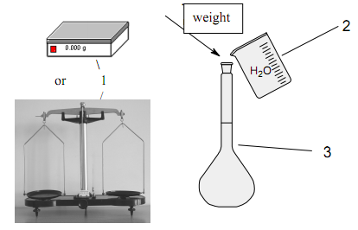

Experiment 1. Preparation of solutions with a given mass fraction.
In 135g of water dissolv 15g of salt. What is the mass fraction of salt (in %) in the solution?
Calculations:
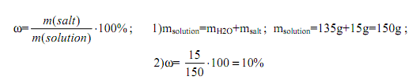
Experiment 2. Preparation of solutions with a given mass fraction for mixing the two solutions.
Calculate the volume of solution with mass fraction of sulfuric acid 56% (ρ = 1,460 g/ml) and water volume which are necessary for the preparation of 100 ml with a mass fraction of sulphuric acid 20% (ρ = 1,143 g/ml)
Solution: When mixing solutions use the "rule of the cross "diagonal scheme". In the center of the cross record the mass fraction of solution (w₃) which must be prepared. From left record the concentration of w₁ and w₂. Right record the difference between w₃ and w₂, w₃ and w₁.
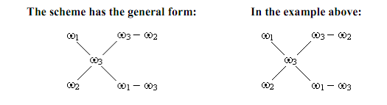
According to the scheme by 20g solution with w = 56%, you must take 36g water and the weight of the solution is:
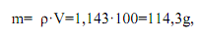
That is 20+36 = 56 according to the scheme
Mass of sulphuric acid which is necessary to prepare the solution can be found in the proportion of:
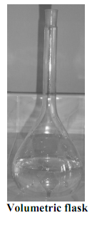
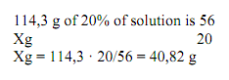
and the volume of the resulting solution: V= 28
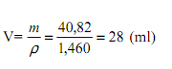
To prepare the solution to water:
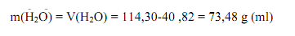
Reliability of calculations and preparation of sulphuric acid test by determining the density of this solution which is set by using a hydrometer. The tabulated data according to on the density determine the concentration.

Experiment 3. Prepare 0,1 M solution of calcium chloride dissolving crystalohydrate.
Calculate the mass CaC1₂ · 6H₂O which is necessary for the preparation of 50 ml of 0,1 M solution.
Calculations:
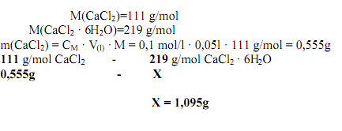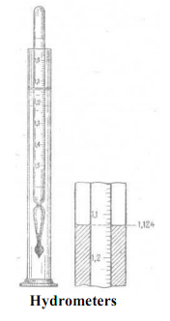
To prepare 50 ml of 0,1 M solution of calcium chloride we must take 1,095 g crystalohydrate.

Experiment 4. Preparation of solution cultivation of a more concentrated solution.
How much salt solution with mass fraction of 18% is to be added to 46g of water to form a 15% solution.
Calculations:
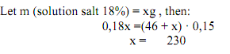
To prepare the 15% solution with W = 18% we should take 230g of 18% solution and 46g water.

Laboratory work.
General rules of preparation of solutions. Weigh the mass of material which is weighed on is hour-glass on the scale. Solvent measure with dimensional glass. Suspended matter is transferred to a volumetric flask. Remains of the substance on the hour glass wash away solvent from the measuring cup.

Experiment 1. Preparation of solutions with a given mass fraction.
In 135g of water dissolve 15g of salt. What is the mass fraction of salt (in %) in the solution? Calculations:
Experiment 2. Getting inorganic semipermeable membrane.
Add are poured 2 ml of copper sulphate; crystals of yellow blood salt in a test tube (not stirred). In 20 min. note the result. Write the reaction equation and explain what connection there is in a semipermeable membrane and why "cell" is growing.

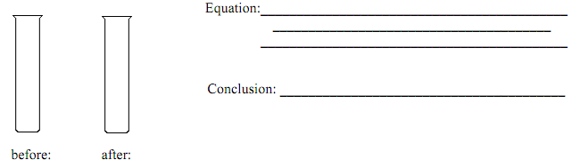

Laboratory work.

Experiment 1. Preparation of buffer systems and the calculation of pH.
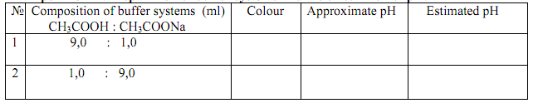
Add one drop of universal indicator in 1 ml solution obtained. Determine the approximate pH of a color table and calculate the pH with the formula:
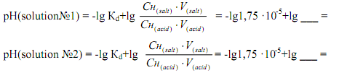
Experiment 2. Effect of acid and alkali on the pH of the buffer solution.
Divide 9 ml of solution № 1 obtained in experiment № 1 equally into 3 tubes: in the first tube 3 drops of hydrochloric acid with C = 0,1 mol/l were added, the second - 3 drops of sodium hydroxide with C =0,1 mol/l. In each tube add 2 drops of methyl red indicator. Compare the color of the solution and draw conclusions.
Conclusion:
Experiment 3. Effect of dilution on the pH of the buffer solution.
In 2 tubes evenly divide the solution number 2 obtained in experiment number 1. In the first tube to 2 ml of water. To each tube add 2 drops of methyl red indicator. Compare the color and draw conclusions.
Conclusion:
Experiment 4.
Prepare 10 ml of acetate buffer with a calculated pH 5,24 and determine its approximate pH (see reference 4.2.).
Conclusion:

Calculate the volume of sodium acetate C = 0,1 mol/l and the amount of acetic acid with C = 0,1 mol/l which must be mixed to prepare 3l of acetate buffer рH = 5,24 (Кd (acid) = =1,75·10-5).
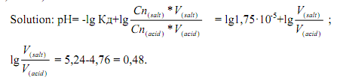
Antilog of 0,48 is equal to 3. [V (salt)] / [V (acid)] = 3/1. So you need 3 parts of salt solution and one part acid solution for the preparation of buffer systems with pH = 5,24. The volume of salt is: 3000 · 3/4 = 2250ml, and acid 3000 1/4 = 750ml.

Characteristics of monitoring forms for MODULE 1
Monitoring form | Characteristics
Control of assignments in the workbook | Control tasks in the workbook are aimed at identifying and comparing at a particular stage of learning the results of students' educational activities with the requirements set by the content of the discipline being studied. It can be used in IS OrSMU if the workbook with methodological instructions is placed in the work program of the discipline and students have the opportunity to complete tasks by filling out the notebook and sending it to the teacher for checking. It allows you to check and evaluate the knowledge of students, to determine the degree of their readiness for further education, as well as the skills level, if the tasks are of a practice-oriented nature.
Test | A test is one of the forms of written verification and assessment of the acquired knowledge, the level of independence and activity of students in educational activities. They can be carried out in the classroom and in the form of homework, current and final, graphic, practical, frontal (for all) and individual. Traditionally, the test involves the identification of knowledge on a specific topic (section), as well as an understanding of the essence of the studied phenomena, objects, their patterns (for example, assignments for comparison, insertion of missing words, etc.). To assess the skills of students primarily graphical and practical tests are used. The graphical test is aimed at identifying the ability of students to draw up a generalized visual model that reflects certain relationships, relationships in an object or in their totality. These can be graphics, pictures, drawings, diagrams, tables. Practical tests are carried out to identify the abilities and skills of students to carry out certain research, laboratory experiments, make measurements, perform appropriate operations and manipulations in educational and industrial conditions. One of the forms of testing practical skills and abilities is a control practical exercise lesson (in physics, chemistry, biology, anatomy, physiology, surgery, etc.), usually held at the end of the study of the topic or section of the discipline.
Written questionnaire | A written questionnaire is a type of written assessment of students' knowledge on certain questions or topics. It can be current and final, individual and frontal. It involves posing a number of questions to students, to which they give a detailed written answer. It allows you to assess the knowledge of students on the passed topic (or module) of the discipline.
Testing | Testing is a written way of testing students' knowledge. It can be current and final (by Module or discipline as a whole). Test items can include questions with one or more correct answers, assignments for matching and sequencing, as well as problem-situation tasks that require the selection of the correct (or several correct) answer options, as well as graphic images that require interpretation or definition. In most cases, testing is aimed at assessing students' knowledge. It allows to assess the students' skills when the test tasks are presented by problem-situational tasks, tasks with graphic (visual) images that require the use of a solution algorithm (action with an object).
Recitation | Recitation is a method of testing the knowledge and skills of students, which consists in the fact that students are invited to reproduce a certain content: empirical facts, theoretical positions, formulations of concepts, examples, classifications, scientific laws. It allows you to assess the level of knowledge of students on a particular issue, topic, section, discipline. Assessment of the students' skills is possible if, in the course of answering the question posed, the student needs to demonstrate the acquired knowledge in order to solve a problem question or problem-situational task.
Practical task completion monitoring | A practical task is a task that contains exercises and tasks that the student must solve (complete) visually (effectively), i.e. practically manipulating real objects or their substitutes. It is widely used in mathematics, computer science, physics, chemistry, economics, and other natural science disciplines. In medicine, it can be represented by the student performing direct practical manipulations with the "patient" both in the course of practical training and directly at the bases of practical training. It allows you to assess the ability of students to apply theoretical knowledge to solve (perform) a practical task in both standard and non-standard situations.
Practical skills testing | Testing of practical skills can be used to control the students' practical actions (medical manipulations) with the "patient". It allows you to assess the skills and abilities of students to apply the theoretical knowledge (about certain actions and manipulations) in standard and non-standard situations.

Assessment criteria used in the current control of academic performance, including the control of independent work of students

Monitoring form | Assessment criteria
Recitation | On "FIVE POINTS" the answer is assessed, which shows solid knowledge of the main questions of the studied material, is distinguished by the depth and completeness of the disclosure of the topic; knowledge of the terminological apparatus; the ability to explain the essence of phenomena, processes, events, draw conclusions and generalizations, give reasoned answers, give examples; fluency in monologue speech, consistency and consistency of the answer.
 | On "FOUR POINTS" the answer is assessed, which reveals a solid knowledge of the basic questions of the studied material, differs in the depth and completeness of the disclosure of the topic; knowledge of the terminological apparatus; the ability to explain the essence of phenomena, processes, events, draw conclusions and generalizations, give reasoned answers, give examples; fluency in monologue speech, consistency and consistency of the answer. However, one or two inaccuracies in the answer are allowed.
 | On "THREE POINTS" the answer is assessed, which testifies mainly to the knowledge of the studied material, which is characterized by insufficient depth and completeness of the disclosure of the topic; knowledge of the basic issues of theory; poorly formed skills in analyzing phenomena, processes, insufficient ability to give reasoned answers and give examples; lack of fluency in monologue speech, logic and consistency of the answer. Several mistakes are allowed in the content of the answer.
 | On "TWO POINTS" the answer is assessed, revealing ignorance of the studied material, characterized by a shallow disclosure of the topic; ignorance of the main issues of theory, unformed skills in the analysis of phenomena, processes; inability to give reasoned answers, weak command of monologue speech, lack of consistency and consistency. Serious errors in the content of the answer are allowed.
 | ZERO POINTS" is given if there is no answer
Testing | "FIVE POINTS" is given on condition of 91-100% correct answers
 | "FOUR POINTS" is given on condition of 81-90% correct answers
 | "THREE POINTS" is given on condition of 71-80% correct answers
 | "TWO POINTS" is given on condition of 70% or less correct answers.
 | "ZERO POINTS" is given if there is no answer
Written questionnaire | "FIVE POINTS" is given to a student if he knows the conceptual apparatus, demonstrates the depth and complete mastery of the content of the educational material, in which he is easily oriented.
 | "FOUR POINTS" are given to the student for the ability to correctly present the material, but the content and form of the answer may have some inaccuracies.
 | "THREE POINTS" is awarded if a student discovers knowledge and understanding of the main provisions of the educational material, but expresses it incompletely, inconsistently, makes inaccuracies in the definition of concepts, does not know how to substantiate his judgments with evidence.
 | "TWO POINTS" is given if a student has scattered, unsystematic knowledge, does not know how to distinguish the main and the secondary, makes mistakes in the definition of concepts, distorts their meaning.
 | "ZERO POINTS" is set if there is no answer.
Practical skills | "FIVE POINTS". The student has shown full knowledge of the program material, the workplace is equipped with all the requirements for preparation for performing manipulations; practical actions are performed sequentially in accordance with the algorithm for performing manipulations; all requirements for the safety of the patient and medical staff are observed; the time limit is observed; the workplace is cleaned in accordance with the requirements of the sanitary and epidemiological supervision; all actions are justified.
 | "FOUR POINTS". The student has shown complete knowledge of the program material, the workplace is not fully independently equipped to perform practical manipulations; practical actions are performed consistently, but not confidently; all requirements for the safety of the patient and medical staff are observed; time regulations are violated; the workplace is cleaned in accordance with the requirements of the sanitary and epidemiological regime; all actions are justified with clarifying questions of the teacher, made small mistakes or inaccuracies.
 | "THREE POINTS". The student showed knowledge of the basic program material in the amount necessary for the upcoming professional activity, but made no more than one fundamental mistake, the workplace is not fully equipped to perform practical manipulations; the sequence of their implementation is broken; unsure actions, leading and additional questions and comments of the teacher are needed to justify actions; all requirements for the safety of the patient and medical staff are observed; the workplace is cleaned in accordance with the requirements of the sanitary and epidemiological regime.
 | "TWO POINTS". The student discovered significant gaps in the knowledge of the practical skill algorithm, made more than one fundamental mistake, difficulties in preparing the workplace, the inability to independently perform practical manipulations; actions are taken that violate the safety of the patient and the medical staff, the requirements of the sanitary and epidemiological regime, safety measures when working with the equipment and materials used are violated.
 | "ZERO POINTS" is given if there is no answer

Answer of Tasks

Module 1. General chemistry. Structure of matter. The doctrine of the solutions
Topic 1. The structure of compounds. Basic theoretical concepts about the structure of atom. Theory of chemical bond. Structure of molecule
1. Answer: CH₂O
2. Answer: 180.18
3. Answer: 35.5

Topic 2. Basic concepts and laws of chemistry
1. Answer: 26 Fe 1s² 2s²2p⁶ 3s²3p⁶3d⁶ 4s²
2. Answer:
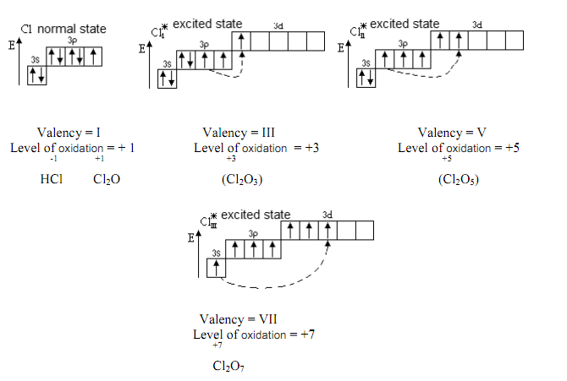
Topic 3. The doctrine of solutions. Preparation of solutions with a given mass fraction. Colligative properties of solutions. Osmoses

1. Answer: 18.6
2. Answer: 60%
3. Answer: 13.9
4. Answer: 70%
5. Answer: 10.2
6. Answer: 242,5
7. Answer: 117
8. Answer: 31.6
9. Answer: 0,18
10. Answer: 0,7
11. Answer: 2,38

Answers of tests

Module 1. General chemistry. Structure of matter. The doctrine of the solutions

Topic 1. The structure of compounds. Basic theoretical concepts about the structure of atom. Theory of chemical bond. Structure of molecule
1. | a
2. | a
3. | a
4. | a
5. | a
6. | a
7. | a
8. | a
9. | a
10. | a
11. | a
12. | a
13. | a
14. | a
15. | a
16. | a
17. | a
18. | a
19. | a
20. | a
21. | a
22. | a
23. | a
24. | a
25. | a
26. | a
27. | a
28. | d
29. | a
30. | a
31. | b
32. | a
33. | a

Topic 2. Basic concepts and laws of chemistry
1. | b
2. | a
3. | a
4. | d
5. | a
6. | c
7. | a
8. | a
9. | a
10. | b
11. | b
12. | c
13. | c
14. | a
15. | d
16. | a
17. | a
18. | a
19. | a
20. | a
21. | a

Topic 3. The doctrine of solutions. Preparation of solutions with a given mass fraction. Colligative properties of solutions. Osmoses
1. | a
2. | a
3. | a
4. | a
5. | a
6. | a
7. | a
8. | a
9. | a
10. | a
11. | a
12. | a
13. | a
14. | a
15. | a
16. | a
17. | a

Module 2. Biopolymers and their structural components

Topic 6 Carbohydrates, structure and chemical properties. Monosaccharides, structure and chemical properties
Topic 7 Olygo-and polysaccharides, structure and chemical properties.
Topic 8 Higher fatty acids. lipids. phosphoglycerides.
Topic 9 The structure and chemical properties of α -amino acids.
Topic 10 Nucleic acids, composition, structure and biological significance.

Topic 6. Carbohydrates, structure and chemical properties. Monosaccharides, structure and chemical properties

Tasks

1. Write the hydrolysis scheme of О–methyl –β–D–glycopyranoside.
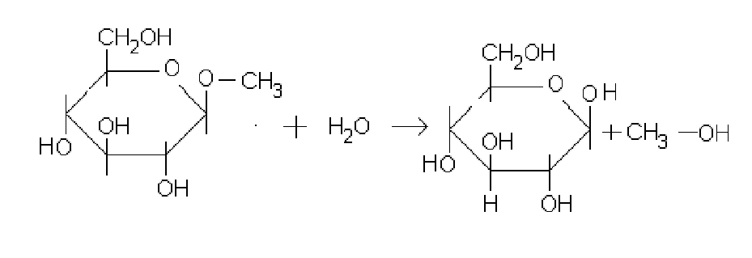
2. Write the formula of glucosamine.
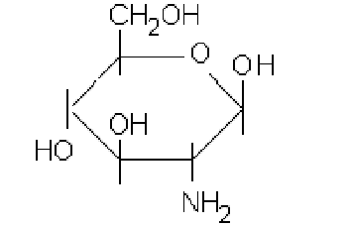
3. Name each compound.
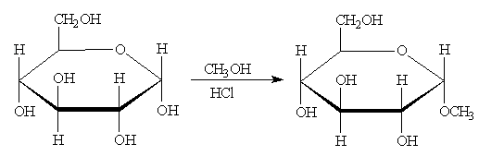
4. Give reagents to show how to synthesize the compounds on the right from the compounds on the left.
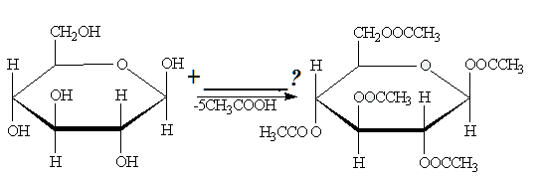
5. Give reagents to carry out the transformations below.
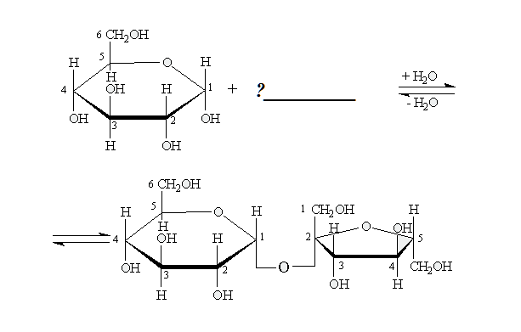

Tests: Carbohydrates. Monosaccharides

1. Monosaccharides are polyatomic:
a) aldehyde – or hydroxyl-ketones;
b) aldehyde– oracid alcohol;
c) aldehyde – or alkaamines.

2. Two monosaccharides belong to:
a) sucrose, lactose;
b) glucose, fructose;
c) mannose and maltose.

3. Glucose is:
a) hydroxyl-ketone;
b) acid alcohol;
c) aldehyde alcohol.

4. Functional groups in the molecule of glucose is:
a) aldehydic and alcoholic oxygroup;
b) carboxyl- and alcoholic oxogroup;
c) keto- and alcoholic oxygroup.

5. The acyclic form of glucose has:
a) D – configuration;
b) L – configuration;
с) N – configuration.

6. The cyclic form of glucose has:
a) λ– and μ – configuration;
b) γ– and δ – configuration;
с) α – and β – configuration.

7. The cyclic form of glucose is named:
a) geptanose;
b) tetra nose;
с) pyranose.

8. Pyranose the cycle of glucose has configuration of:
a) arm-chairs;
b) baths;
с) linear.

9. The isomer of glucose is:
a) sucrose;
b) lactose;
с) lacto glucose.

10. Specify the correct pair of isomers:
a) glucose is mannose;
b) glucose is maltose;
с) glucose is sucrose.

11. A high-quality reaction on the aldehydic group of glucose is a reaction of:
a) Kucherov;
b) Trommer;
с) Friedel–Crafts.

12. A high-quality reaction on polyatomic of glucose is education in:
a) chelates;
b) red sediment;
с) СO2.

13. Glucose gives chelates to:
a) FeСl3;
b) Cu (OH)2;
c) brome water.

14. Glucose forms O creates are glycosides during co-operation with:
a) aldehydes;
b) acids;
c) alcohols.

15. Glucose forms N glycosides during co-operation with:
a) amides;
b) by amines;
c) imines.

16. N is glycosides of ribose and deoxyribose included in composition of:
a) albumens;
b) fats;
c) RNA and DNA.

17. Alkalization of monosaccharide conduct with:
a) halogen alkanes;
b) halogen anhydrides;
c) free radicals’.

18. The product of alkylation glucose has such copulas:
a) O create are glycosides and difficult ether copulas;
b) O create are glycosides and simple ether copulas;
c) O create are glycosides and anhydride copulas.

19. As a result of hydrolysis fully alkyles glucose collapses only:
a) OH – glycoside and simple ether copulas;
b) simple ether copulas;
c) OH – glycoside connection.

20. Acidylatings of monosaccharides conduct for help from:
a) halogen alkanes;
b) halogen acid;
c) halogen anhydres.

21. Acidilate glucose has such copulas:
a) hard ether;
b) OH – glycoside and simple ether;
c) OH – glycoside and difficult ether.

22. As a result of hydrolysis fully acilation glucose collapses only when:
a) OH – glycoside and hard efires copulas;
b) simple ether copulas;
c) all hard efires copulas.

23. Fructose is polyatomic:
a) aldehyde alcohol;
b) hydroxyl-ketone;
c) alcohol.

24. Functional groups are in the molecule of fructose:
a) aldehydic;
b) carboxyl- and oxy groups
c) oxo- and oxi- groups.

25. The cyclic form of fructose is called:
a) furanozic;
b) piranose;
c) tiazolic.

26. The cyclic form of fructose has:
a) λ – and μ– configuration;
b) α– and β – configuration;
c) γ– and δ – configuration.

27. Semiacetic hydroxyl in the molecule of fructose is located near the:
a) second atom of carbon;
b) first atom of carbon;
c) sixth atom of carbon.

28. Fructose is distinguished from glucose by a reaction of:
a) Kucherov;
b) Selivanov;
c) Feling.

29. In the molecule of deoxyribose oxy-group there’s absence of:
a) second atom of carbon;
b) first atom of carbon;
c) fifth atom of carbon.

Laboratory work.

The algorithm of the experiments
(Must be performed in the laboratory notebook):
1. Demonstration of the presence of hydroxyl-groups in D-glucose.
2. Reduction of copper (II) hydroxide with glucose in alkaline medium (Tromer test).
3. Selivanov reaction for determination of fructose.
Detailed description of experiment:
1. Demonstration of the presence of hydroxyl-groups in D-glucose.
Put 1dropof glucose solution, 6drops of NaOH solution, 1dropof CuSO4 solution in to a test-tube. Note the results, write the reaction equation, make the conclusions.
2. Reduction of copper (II) hydroxide with glucose in alkaline medium (Tromer test).
Add several drops of water to the solution that appeared in the first experiment. Heat the test-tube until boiling. Mark the results, write the reaction equation and make conclusions.
3. Selivanov`s reaction for fructose determination.
Put the resorcinol crystal and 2 drops of НСl (conc.) Add 2 drops of fructose solution and heat until boiling. Mark the results, write the reaction equation and make conclusions.

Topic 7. Olygo-and polysaccharides, structure and chemical properties

Tasks

1. Write the structural formula of lactose, show the bond type between two monosaccharide units.

2. Write the structural formula of maltose, show the bond type between two monosaccharide units.

3. Write the structure of cellulose disaccharide fragment and show the bond type between two monosaccharide units.

Tests: Oligosaccharides

1. Oligosaccharides are hard carbohydrates which contain:
a) from 2 to 10 monosaccharide tailings
b) from 5 to 20 monosaccharide tailings
c) from 1 to 5 monosaccharide tailings

2. Disaccharides are hard carbohydrates which contain:
a) to 10 monosaccharide tailings
b) to 2 monosaccharide;
c) to 5 monosaccharide tailings.

3. To disaccharides belong
a) glucose, galactose
b) sucrose, lactose
c) fructose, mannose.

4. A sucrose consists of tailings such:
a) α– mannose and β– glucose;
b) α– galactose and β – fructose;
c) α – glucose and β – fructose.

5. A type of connection between a sucrose and monosaccharide tailings is:
a) α – 1, 2 – glycoside;
b) α – 1, 4– glycoside;
c) α,β – 1, 2 – glycoside.

6. Sucrose is:
a) reducing sugar;
b) non-reducing sugar;
c) insoluble sugar.

7. A sucrose is non-reducing sugar, because of absence:
a) of ionic connection;
b) of piranoic cycle;
c) of semiacetal hydroxyl.

8. Sucrose from Cu (OH)2 gives:
a) esters;
b) chelates;
c) salts.

9. A sucrose and lactose belongs to oxygroup because of:
a) acylation and alkalizations;
b) forms aldehydes;
c) forms amides.

10. During a hydrolysis a sucrose gives:
a) lactose and galactose;
b) glucose and fructose;
c) maltose and fructose.

11. The products of hydrolysis of sucrose are called:
a) leaden sugar;
b) artificial sugar;
c) invert sugar.

12. Lactose is a disaccharide, which consists of tailings:
a) α– mannose and β– glucose;
b) β– galactoseand α– glucose;
c) α– glucose and β – fructose.

13. A type of connection between lactose and monosaccharide tailings:
a) α –1,2 – glycoside;
b) α – 1,4 – glycoside;
c) β – 1,4 – glycoside.

14. Lactose has:
a) linear configuration;
b) located in a plane;
c) a piranoic cycle has conformation of bath.

15. Lactose is:
a) reducing sugar;
b) non-reducing sugar;
c) insoluble sugar.

16. Lactose is a recuperative sugar, because there’s presence of:
a) ionic connection;
b) pyranoic cycle;
c) semiacetal hydroxyl.

17. Lactose can renew:
а) Cu+2and Ag+1;
b) Fe+3and Al+3;
c) Cu+1 and Cl+1.

18. During co-operation of lactose from Cu(OH)2 appears for temperatures:
a) dark blue sediment of Cu (OH)2;
b) brick red sediment of Cu2O;
c) yellow sediment of Cu2O.

19. Lactose gives:
a) O- and N- forms glycosides;
b) forms only N- glycosides;
c) forms only O form glycosides.

20. During a hydrolysis lactose gives:
a) α – mannose and β - glucose;
b) β – galactose and α – glucose;
c) α – glucose and β – fructose.

21. In humans, lactose is contained in free and bound forms:
a) in a woman milk;
b) in a stomach;
c) in a brain.

22. In human beings lactose fissions in stomach – intestinal highway under the action of ferment is:
a) glucose;
b) sucrose;
с) lactase.

23. In the organism of man there is the inherited immunity to:
a) cellobiose;
b) lactose;
c) sucroses.

24. A maltose is disaccharide, which consists of:
a) two tailings β– glucose;
b) two tailings β – galactose;
c) two tailings α – glucose.

25. A type of connection between maltose and monosaccharide tailings:
a) α – 1, 2 – glycoside;
b) α – 1, 4– glycoside;
c) β – 1, 4 – galactoside.

26. α – 1, 4-glycoside connection has in maltose:
a) linear configuration;
b) located in a plane;
c) angular configuration.

27. Maltose is a:
a) recuperative sugar;
b) un-recuperative sugar;
c) insoluble sugar.

28. A maltose it recuperative sugar, because presence of:
a) ionic connection;
b) pyranoic cycle;
c) semiacetal hydroxyl.

29. A maltose can renew:
а) Cu+2and Ag+1;
b) Fe+3and Al+3;
c) Cu+1and Cl+1.

30. During co-operation of maltose from Cu (OH)2 appears:
a) dark blue sediment of Cu(OH);
b) brick red sediment of Cu2O;
c) yellow sediment of Cu2O.

31. Maltose can:
a) O- and N- forms glycosides;
b) forms only N- glycosides;
c) forms only OH are glycosides.

32. During a hydrolysis a maltose gives:
a) 2 molecules α– mannose
b) 2 molecules α – glucose
c) 2 molecules β – fructose

Tests: Polysaccharidess

1. Polysaccharidess are:
a) polyoxycarbonyl connections with general formula Cm(H2O)n;
b) polyoxycarbonyl connections with general formula Cn(H2O)n;
c) polyoxycarbonyl connections with general formula CnH2nOn.

2. Molecular formula of gomo-polysaccharidess is:
a) С6Н10О6
b) С6Н10О5
c) С6Н12О6

3. Starch is a product of:
a) photosynthesis
b) polymerization
c) catabolism

4. Starch is a homo- polysaccharides which consists of tailings:
a) α-mannose;
b) α-glucose;
c) β-fructose.

5. Starch consists of two functions:
a) dextranes and cellulose
b) cellulose and glucose
c) amylase and to the amylopectin

6. A type of connection between monosaccharide tailings in amylase is:
a) α-1, 2- forms only N-glycosides
b) α-1, 4-glycosides
c) β-1, 4- galactose

7. Primary structure of amylase is:
a) polypeptide sequence
b) poly nucleic sequence
c) poly glycosides sequence

8. Second structure of amylase is:
a) spiral
b) ramified chain
c) bunch of polyglycosides chains

9. What structure amylopectin has unlike amylase:
a) linear polyglycosides chain
b) a polyglycosides chain is ramified
c) a polypeptide chain is ramified

10. A type of connection between monosaccharide tailings in amylopectin is:
a) α-1, 2-glycosides connection in points a fork
b) α-1, 4-glycosides connection mainly to the chain
c) α-1, 4-mainly to the chain and α – 1,6 is glycosides connection in points a fork

11. Intermediate connections of hydrolysis of starch are:
a) dextrin and maltose
b) dextranes and lactose
c) cellulose and glucose

12. The last product of hydrolysis of starch is:
a) β-fructose
b) α-glucose
c) β-glucose

13. A high quality reaction of starch is:
a) discoloring of brome water
b) the violet coloring with iron (III) chloride
c) the dark blue coloring with iodine.

14. Starch is used in pharmacy for preparations of:
a) pastes, powders and pills
b) suspensions
c) emulsions

15. Reserve power carbohydrate for animals is:
a) cellulose
b) dextrin
c) glycogen

16. Glycogen is homopolysaccharide which consists of tailings:
a) α-mannose
b) α-glucose
c) β-fructose

17. A type of connection between monosaccharide tailings in a glycogen is:
a) α-1,2-glycoside connection in points a fork
b) α-1,4-glycoside connection mainly to the chain
c) α-1,4-mainly to the chain and α-1,6 is glycoside connection in points a fork

18. Cellulose is homo polysaccharide which consists of tailings:
a) α-mannose
b) α-glucose
c) β-glucose

19. A type of connection between monosaccharide tailings in cellulose is:
a) β-1,4-glycosides
b) α-1,4-glycosides
c) β-1,4-galactose

20. Primary structure of cellulose is:
a) spiral
b) linear polyglycoside chain
c) polyglycoside chain is ramified

21. The food fibers of fruit and green vegetables stimulate working of:
a) brain
b) cages of CNS
c) intestine

22. The food fibers of fruit and green vegetables absorb:
a) toxic matters
b) haemoglobin
c) phosphates

23. Decline of calories content of food use is:
a) acetyl cellulose
b) methyl cellulose
c) nitro cellulose

24. The polysaccharides of bacterial origin is:
a) starch
b) dextrin
c) detrains

25. Dextranes consist of tailings:
a) α-glucose
b) β-galactose
c) α-fructose

26. From dextranes get blood substitutions under the name of:
a) poly glucine
b) polyhybrid
c) polyglucose

27. Dextranes promote in an oral cavity the:
a) fall of teeth
b) development of caries
c) loosening of gums

Laboratory work.

The algorithm of the experiments:
1. Demonstration of the presence of hydroxyle groups in saccharose.
2. Demonstration of absence of reductive abilities in saccharose.
3. Demonstration of saccharose hydrolysis.
4. Presence of reductive abilities in lactose.
5. Acidic hydrolysis of starch.
2. Detailed description of experiment:
1.1. Demonstration of the presence of hydroxyle groups in saccharose.
Put 1 drop of saccharose solution and 6 drops of NaOH solution, 5-6 drops of water and 1 drop of copper sulfate solution in to the test-tube. Mark the results, write the reaction equation and make conclusions.
2.2. Demonstration of absence of reducing properties in saccharose.
The solution that was received in the first experiment must be heated until boiling.
Mark the results, make the conclusions.
2.3. Demonstration of saccharose hydrolysis.
Put 1 drop of saccharose solution and 1 drop of HCl solution, 6 drops of water in to a test-tube and boil for 1min. Hydrolysed solute on put into two test-tubes. Add 6 drops of NaOH solution, 4-5 drops of water and1 drop of CuSO4 solution in to the first one and heat until boiling. Put the resorcinol crystal, 2 drops of HCl concentrated in to the second one and heat untiol boiling. Mark the results, write the scheme and make the conclusions.
2.4. The reducing abilities of lactose.
Put 1 drop of lactose solution, 4 drops of NaOH solution, 1 drop of CuSO4 solution and heat until boiling. Mark the results, write the reaction equations and make conclusions.
2.5. Acidic hydrolysis of starch.
Put 1 drop of starch gleu, 2 drops of sulfuric acid in the test-tube and put the test-tube in to the boiling water. After 20 and 40min. Make the qualitative reaction on the starch with one drop of hydrolysed solution. Mark the results, write the scheme of starch hydrolysis and make conclusions.

Topic 8. Higher Fatty Acids. Lipids. Phosphoglycerides

Tasks

- Write the configuration of oleic acid.

- Write the scheme of alkaline hydrolysis of fat.

- Which structure represents the most unsaturated fatty acid?

- Which structure represents the fatty acid which is able to add one mole of hydrogen in a hydrogenation reaction?

Tests

1. Fats – esterуs:
a) tree atom alcohol of glycerol and higher fat acids;
b) diatomic alcohol a glycol and higher fat acids;
c) tree atom alcohol of glycerol and low of fat acids.

2. Tailings enter in the complement of fats:
a) diatomic alcohol a glycol and higher fat acids;
b) tree atom alcohol glycerol and higher fat acids;
c) tree atom alcohol of glycerol and low of fat acids.

3. A type of connection is in fats:
a) peptide;
b) glycoside;
c) hard efires.

4. The most widespread are saturated higher fat acids in composition of fats:
a) palmitic, stearic;
b) olein; elaidinoic;
c) linolic, palmitic.

5. The most widespread are unsaturated higher fat acids in composition of fats:
a) palmitic, stearin;
b) olein, linolic, linolenic;
c) linolic, palmitic.

6. A high-quality reaction is on the unsaturated higher fat acids in composition of fats:
a) discolouring of copper(II) hydroxide;
b) discolouring of iron(III) chloride;
c) discolouring of bromic water.

7. Higher fat acids are unsaturated in composition of fats differ:
a) by the structure of carbon structure;
b) by the number of double connections;
c) by the type of isomery.

8. Higher fat acids are unsaturated in composition of fats have:
a) trance – configuration;
b) L – configuration;
c) cis – configuration.

9. Hard fats are contained by tailings:
a) unsaturated higher fat acids;
b) saturated higher fat acids;
c) saturated low fat acids.52

10.Liquid fats are contained by tailings:
a) saturated higher fat acids;
b) unsaturated higher fat acids;
c) saturated low fat acids.

11.Fats – it :
a) alkyl gliceride;
b) anhydride gliceride;
c) acyl gliceride.

12.Fats are better added a hydrolysis in:
a) sour and alkaline environments;
b) neutral environment;
c) environment of brome water.

13.The products of acid hydrolysis of fats is:
a) ethylene glycol andhigher fat acids;
b) glycerine and higher fat acids;
c) glycerine and salts of higher fatacids.

14.The products of alkaline hydrolysis of fats is:
a) ethylene glycol andhigher fat acids;
b) glycerine and higher fat acids;
c) glycerine and salts of higher fat acids.

15. Iodine number – it:
a) amount of grammes of ion, that joinsin with 100g fat;
b) amount of ion, that joins in with 100g fat;
c) an amount of grammesis potassium of ion, that joinsin with 100g fat.

16. Iodine a number is characterized by a degree:
a) to the saturation of fat;
b) izomerisation of fat;
c) to the unsaturation of fat.

17.Than anymore ion number, that:
a) less biological value of fat;
b) greater biological value of fat;
c) an ion number does not influence on the biological value of fat.

18.Than greater degree of unsaturation of fat, that:
a) less biological value of fat;
b) an ion number does not influence on the biological value of fat.
c) greater biological value of fat.

19.Heating of fats is a result:
a) peroxyde oxidation fats;
b) proceeding in fats;
c) besieging of fats.

20.Hydrogenation fats – it:
a) converting of hard fat is into liquid;
b) converting of liquid fat is into hard;
c) converting of desi is into butter.

21.Hydrogenating fats is a reaction:
a) hydrogenising;
b) hydratations;
c) dehydrogenization.
22.In the organism of man fats are added a hydrolysis:
a) in a stomach in a sour environment;
b) in an intestine in an alkaline environment;
c) in an oral cavity in an alkaline environment.

23.The products of hydrolysis of fats in the organism of man is:
a) glycol and soap;
b) HFA and alcohol;
c) glycerin and soap.

24.Medicinal preparations of fats:
a) linetol, arakhiden;
b) protargolum, palmitic acid;
c) soap, stearin acid.

25.Phospho glicerides are derivatives:
a) phosphate acid;
b) phosphate acids;
c) pyro phosphate acids.

26.Phosphate acid consists of tailings:
a) saturated HFA, glycerin, phosphate acid;
b) saturated or unsaturated HFA, glycerin, phosphate acid;
c) unsaturated HFA, to the glycol, phosphate acid.

27.A type of connection is between the components of phosphate:
a) glycoside;
b) peptide;
c) hard efires.

28.Phosphate acid has:
a) L – configuration;
b) D –configuration;
c) cis – configuration.

29.Phosphate glycerides in biological membranes form
a) lipids bashar;
b) lipids monolayer;
c) micelles

Laboratory work.

The algorithm of lab work:
1. Formation of the fatty drop and its extraction.
Detailed description:
On the filter paper put 3 separated drops of oil with sizes 1 cm. Touch the center of the first drop with the tube that contains diethyl ether, the second with benzene and the third with water. Describe the results of the experiment and make the conclusions.
2. Extraction of free fatty acids from soap.
Detailed description:
In the test tube put 5 drops of saturated soap solution and 1 drop of sulphuric acid. Point the effect, write reaction equation and make the conclusion.
3. Formation of unsolutable calcium salts (unsolutable soap).
Detailed description:
In the test tube put 5 drops of soap solution and 1 drop of calcium chloride solution. Mix the test-tube. Point the effect, write reaction equation, and make the conclusion.
4. Unsaturated fatty acids reaction.
Detailed description:
Put 5 drops of oil and 4 drops of bromine water into a test-tube and mix it. Point the effect, write reaction equation, and make the conclusion.

Topic 9. The structure and chemical properties of α -amino acids

Tasks

- Write the structural formulas of aromatic amino acids.
- Write the structural formulas of monoamino-monocarboxylic acids.
- Write the structural formulas of oxy amino acids.
- Write the structural formulas of Essential Amino Acids.

Tests

1.In the complement of albumens of living organism enter only:
a) β – amino acid;
b) α – amino acid;
c) γ –amino acid.

2. For amino acid such types of isomers are characteristic:
a) lactim – lactam;
b) cis – tranc;
c) structural, enantiomeric excess.

3. Structural isomers of amino acidis:
a) a leucine – isoleucine;
b) a serine – treonin;
c) a valine – alanine.

4. The example of structural isomers of amino acid is:
a) α – alanine –γ – aminobutyric acid;
b) α – alanine –β – alanine;
c) β – alanine – β – aminobutyric acid.

5. The example of enantiomers of aminoacid is:
a) α – alanine –β– alanine;
b) L – alanine –D – valine;
c) L – methionine – D – methionine.

6. The natural amino acid have only:
a) L – configuration;
b) D – configuration;
c) cis – configuration.

7. Amino acid show:
a) only acid properties;
b) amphoteric properties;
c) only basic properties.

8. It is exists in water of aminoacid in the form of:
a) to cation;
b) to the anion;
c) bipolar an ion.

9. The isoelectric state of amino acid is exists in the form of:
a) to the anion;
b) bipolar an ion;
c) to cation.

10.Aminoacid are in the isoelectric state at a certain size:
a) temperatures;
b) pressure;
c) рН.

11.Isoelectric point – рН, for which the amino acid is in:
a) isoelectric state;
b) kind cation;
c) in a kind an anion.

12.After the size of isoelectric point the amino acid are classified on:
a) soluble, insoluble;
b) neutral, sour, basic;
c) volatile, non-flying.

13.Neutral amino acids are:
a) alanine, valine;
b) serine, tyrosine;
c) aspartic.

14.The example of souramino acid is:
a) phenylalanine, tryptophane;
b) cystein, methionine;
c) aspartic, glutamine amino acid.

15.The example of basicamino acid is:
a) leucine, isoleucine;
b) methionine, valine;
c) lysine, arginine.

16.Aminoacid for a carboxy – it is given a group:
a) esteres;
b) ethers;
c) amines.

17.Formation of esters amino acid is used duringthe synthesis of peptides and albumens for:
a) to defence of aminogroups;
b) defence of carboxy – group;
c) activating of carboxy is groups.

18.Formation of halogen anhydrides amino acid is used during the synthesis of peptides and albumens for:
a) activating of carboxy is groups;
b) defence of carboxy – group;
c) to defence of aminogroups.

19.Formation of N – acyl of derivative amino acid is usedduringthe synthesisof peptids and albumens for:
a) activating amino group;
b) defence of carboxy group;
c) to defence of amino group.

20.Co-operating of amino acid with formaldehyde is used for the quantitative analysis of amino acid in a method:
a) by Zensen;
b) by Boyle Mariotte;
c) by Shrouds – Goffa.

21.The all amino acid give the violet coloring from:
a) brome water;
b) ninhydrin;
c) a ferum(III) chloride.

22.Xanta Protein reaction of amino acid is an origin:
a) violet coloring from H2SO4;
b) red coloring;
c) yellow coloring from HNO3.

23.The aromatic amino acid give with the reagent of Million's:
a) red coloring;
b) violet coloring;

24.Heterocycle amino acid give with the reagent of Adamkevich:
a) red coloring;
b) violet coloring;
c) yellow coloring.

25.In the containing of amino acid give with the reagent of Folya:
a) red coloring;
b) violet coloring;
c) black coloring.

26.In result of decarboxylation serine in the organism of man appears:
a) colamine;
b) kholin;
c) thiaminum.

27.Glutamate of sodium has a taste:
a) meat;
b) milk;
c) lemon.

28.From amino acid a serine as a result of chain of transformations to the organism of man appears:
a) serotonin;
b) acetylkholin;
c) histaminum.

29.A methionine in a human being is a source:
a) sulphure and metyl groups;
b) acetyl group;
c) aminogroup and alkyl.

30.From amino acid of tyrosine as a result of chain of transformations in a human being appears:
a) serotonin;
b) noradrenalin and adrenalin;
c) histamine.

31. Irreplaceable amino acid – it such, that:
a) synthesized in the organism of man;
b) not synthesized in the organism of man;
c) not very much necessary the organism of man.

Laboratory work.

The algorithm of the experiments:
1. Biuretic reaction.
2. Xanthoproteic reaction.
3. Foll`s reaction.
Detailed description of experiment.
1. Biuretic reaction.
Put 5 drops of protein solution, 10 drops of NaOH solution and 1-2 drops CuSO4 solution into the test-tube. Describe the result, make conclusions.
2. Xanthoproteic test.
Put 5 drops of protein, 5 drops of HNO3 (conc.) (carefully!) and heat. Describe the results, write the equation of tyrosine nitrification, make the conclusion.
3. Foll reaction.
Put 5 drops of protein solution, 2 drops of NaOH solution into the test-tube, heat until boiling and add 2 drops of (CH3COO)2Pb solution. Describe the results, write the reaction equation of sulfur-containing amino acid with Plumbum acetate.

Topic 10. Nucleic acids, composition, structure and biological significance

Tasks

Give one word answer
1. What is a nucleoside?
2. What are purine bases?
3. What is phosphodiester linkage?
4. Give the keto enol form of adenine.
5. Explain the structure of purine and pyrimidine bases.
6. Explain the primary structure of DNA.
7. List out the functions of DNa and RNA.

Tests

Nucleic acids, composition, structure and biological significance.
1 Nucleic acids are shown by acid properties due to a presence of
a) carbohydrates
b) nitrous bases
c) phosphatic acid
d) aminoacid

2 Purinoic nitrous bases which enter in the compliment of nucleic acids are
a) uracil, thymine and cytosine
b) adenine and guanine
c) thumidine and uridine
d) cytosine and uridine

3 Nitrous bases in nucleic acids are in
a) laktime form
b) laktame form
c) cis-to the form
d) trans-to the form

4 Such carbohydrates enter in the compliment of nucleic acids are
a) galactoseand mannose
b) ribose and deoxyribose
c) deoxyglucose and fructose
d) ribose and fructose

5 Deoxyribose can be distinguished from ribose by the absence of oxy group near
a) first carbon
b) third carbon
c) second carbon
d) sixth carbon

6 Ribose and deoxyribose is polyatomic
a) aldehydoalcohol
b) hydroxy-ketones
c) acid alcohol
d) aminoacide

7 Nucleoside is
a) OH glycosides which aglykonom of nitrous bases are
b) N glycosides which aglykonom of nitrous bases are
c) N is glycosides which aglykonom of phosphatic acid is
d) O is glycosides which aglykonom of phosphatic acid is

8 In the complement of nucleoside enter
a) nitrous basis and phosphatic acid
b) nitrous basis and glucose
c) nitrous basis and carbohydrate
d) nitrous basis and aminoacid

9 Type nucleoside connection between nitrous basis and carbohydrate is
a) N-glycoside
b) OH-glycoside
c) hard efires
d) simple efires

10 The products of hydrolysis of nucleoside is
a) phosphate acid
b) nitrous basis and carbohydrates
c) nitrous basis and phosphate acid
d) nitrous basis and aminoacid

11 Nucleoside which consist of uracil and ribose are called
a) ureic acid
b) uridine
c) ribose
d) deoxyribose

12 The compliment of citadines enters are called
a) cytosine and phosphoric acid
b) amid and ribose
c) cytosine and ribose
d)ribose and phosphoric acid

13 In the compliment of guanosine enters is called
a) guanosine
b) guanylic acid
c) guanine and ribose
d) phosphoric acid

14 Nucleoside which consist of thymine and deoxyribose enters is called
a) deoxyribose
b) deoxythymidine
c) deoxidized
d) ribose

15 Mononucleotides is
a) phosphates of nucleotides
b) phosphates of carbohydrates
c) phosphates of nucleosides
d) phosphates of aminoacides

16 Mononucleotides are
a) nucleoside-5-phosphates
b) nucleoside- 3-phosphates
c) nucleotide -5 phosphates
d)nucleotide -4 phosphates

17 In the compliment of mononucleotides enters
a) nitrous basis, carbohydrate and phosphate acid
b) amine, glucose and phosphate acid
c) nitrous acid, ribose and phosphate acid
d) amine, ribose and phosphate acid

18 In nucleotides a type of connection between components is
a) hard efires
b) N-glycosides and hard efires
c) OH-glycosides and hard efires
d) simple efires

19 In nucleotides a type of connection between a carbohydrate and phosphatic acid is
a) OH-glycosides
b) N-glycoside
c) hard efires
d) simple efires

20 In nucleotides a type of connection between nitrous basis and carbohydrate
a) N-glycosides
b) hard efires
c) OH-glycosides
d) simple efires

21 Tailings enters in the compliment of timidile acid
a) thumine, ribose, to the phosphate of sodium
b) thumine, ribose, phosphate acid
c) thumine, deoxyribose, phosphatic acid
d) thumidine, deoxyribose, to the phosphate of sodium

22 Tailings enters in the compliment of guanile acid
a) guanozine, ribose and phosphate acid
b) guanine, ribose and phosphate acid
c) guanine, ribose
d) ribose and phosphate acid

Characteristics of monitoring forms for MODULE 1
Monitoring form | Characteristics
Control of assignments in the workbook | Control tasks in the workbook are aimed at identifying and comparing at a particular stage of learning the results of students' educational activities with the requirements set by the content of the discipline being studied. It can be used in IS OrSMU if the workbook with methodological instructions is placed in the work program of the discipline and students have the opportunity to complete tasks by filling out the notebook and sending it to the teacher for checking. It allows you to check and evaluate the knowledge of students, to determine the degree of their readiness for further education, as well as the skills level, if the tasks are of a practice-oriented nature.
Test | A test is one of the forms of written verification and assessment of the acquired knowledge, the level of independence and activity of students in educational activities. They can be carried out in the classroom and in the form of homework, current and final, graphic, practical, frontal (for all) and individual. Traditionally, the test involves the identification of knowledge on a specific topic (section), as well as an understanding of the essence of the studied phenomena, objects, their patterns (for example, assignments for comparison, insertion of missing words, etc.). To assess the skills of students primarily graphical and practical tests are used. The graphical test is aimed at identifying the ability of students to draw up a generalized visual model that reflects certain relationships, relationships in an object or in their totality. These can be graphics, pictures, drawings, diagrams, tables. Practical tests are carried out to identify the abilities and skills of students to carry out certain research, laboratory experiments, make measurements, perform appropriate operations and manipulations in educational and industrial conditions. One of the forms of testing practical skills and abilities is a control practical exercise lesson (in physics, chemistry, biology, anatomy, physiology, surgery, etc.), usually held at the end of the study of the topic or section of the discipline.
Written questionnaire | A written questionnaire is a type of written assessment of students' knowledge on certain questions or topics. It can be current and final, individual and frontal. It involves posing a number of questions to students, to which they give a detailed written answer. It allows you to assess the knowledge of students on the passed topic (or module) of the discipline.
Testing | Testing is a written way of testing students' knowledge. It can be current and final (by Module or discipline as a whole). Test items can include questions with one or more correct answers, assignments for matching and sequencing, as well as problem-situation tasks that require the selection of the correct (or several correct) answer options, as well as graphic images that require interpretation or definition. In most cases, testing is aimed at assessing students' knowledge. It allows to assess the students' skills when the test tasks are presented by problem-situational tasks, tasks with graphic (visual) images that require the use of a solution algorithm (action with an object).
Recitation | Recitation is a method of testing the knowledge and skills of students, which consists in the fact that students are invited to reproduce a certain content: empirical facts, theoretical positions, formulations of concepts, examples, classifications, scientific laws. It allows you to assess the level of knowledge of students on a particular issue, topic, section, discipline. Assessment of the students' skills is possible if, in the course of answering the question posed, the student needs to demonstrate the acquired knowledge in order to solve a problem question or problem-situational task.
Practical task completion monitoring | A practical task is a task that contains exercises and tasks that the student must solve (complete) visually (effectively), i.e. practically manipulating real objects or their substitutes. It is widely used in mathematics, computer science, physics, chemistry, economics, and other natural science disciplines. In medicine, it can be represented by the student performing direct practical manipulations with the "patient" both in the course of practical training and directly at the bases of practical training. It allows you to assess the ability of students to apply theoretical knowledge to solve (perform) a practical task in both standard and non-standard situations.
Practical skills testing | Testing of practical skills can be used to control the students' practical actions (medical manipulations) with the "patient". It allows you to assess the skills and abilities of students to apply the theoretical knowledge (about certain actions and manipulations) in standard and non-standard situations.

Assessment criteria used in the current control of academic performance, including the control of independent work of students

Monitoring form | Assessment criteria
Recitation | On "FIVE POINTS" the answer is assessed, which shows solid knowledge of the main questions of the studied material, is distinguished by the depth and completeness of the disclosure of the topic; knowledge of the terminological apparatus; the ability to explain the essence of phenomena, processes, events, draw conclusions and generalizations, give reasoned answers, give examples; fluency in monologue speech, consistency and consistency of the answer.
 | On "FOUR POINTS" the answer is assessed, which reveals a solid knowledge of the basic questions of the studied material, differs in the depth and completeness of the disclosure of the topic; knowledge of the terminological apparatus; the ability to explain the essence of phenomena, processes, events, draw conclusions and generalizations, give reasoned answers, give examples; fluency in monologue speech, consistency and consistency of the answer. However, one or two inaccuracies in the answer are allowed.
 | On "THREE POINTS" the answer is assessed, which testifies mainly to the knowledge of the studied material, which is characterized by insufficient depth and completeness of the disclosure of the topic; knowledge of the basic issues of theory; poorly formed skills in analyzing phenomena, processes, insufficient ability to give reasoned answers and give examples; lack of fluency in monologue speech, logic and consistency of the answer. Several mistakes are allowed in the content of the answer.
 | On "TWO POINTS" the answer is assessed, revealing ignorance of the studied material, characterized by a shallow disclosure of the topic; ignorance of the main issues of theory, unformed skills in the analysis of phenomena, processes; inability to give reasoned answers, weak command of monologue speech, lack of consistency and consistency. Serious errors in the content of the answer are allowed.
 | ZERO POINTS" is given if there is no answer
Testing | "FIVE POINTS" is given on condition of 91-100% correct answers
 | "FOUR POINTS" is given on condition of 81-90% correct answers
 | "THREE POINTS" is given on condition of 71-80% correct answers
 | "TWO POINTS" is given on condition of 70% or less correct answers.
 | "ZERO POINTS" is given if there is no answer
Written questionnaire | "FIVE POINTS" is given to a student if he knows the conceptual apparatus, demonstrates the depth and complete mastery of the content of the educational material, in which he is easily oriented.
 | "FOUR POINTS" are given to the student for the ability to correctly present the material, but the content and form of the answer may have some inaccuracies.
 | "THREE POINTS" is awarded if a student discovers knowledge and understanding of the main provisions of the educational material, but expresses it incompletely, inconsistently, makes inaccuracies in the definition of concepts, does not know how to substantiate his judgments with evidence.
 | "TWO POINTS" is given if a student has scattered, unsystematic knowledge, does not know how to distinguish the main and the secondary, makes mistakes in the definition of concepts, distorts their meaning.
 | "ZERO POINTS" is set if there is no answer.
Practical skills | "FIVE POINTS". The student has shown full knowledge of the program material, the workplace is equipped with all the requirements for preparation for performing manipulations; practical actions are performed sequentially in accordance with the algorithm for performing manipulations; all requirements for the safety of the patient and medical staff are observed; the time limit is observed; the workplace is cleaned in accordance with the requirements of the sanitary and epidemiological supervision; all actions are justified.
 | "FOUR POINTS". The student has shown complete knowledge of the program material, the workplace is not fully independently equipped to perform practical manipulations; practical actions are performed consistently, but not confidently; all requirements for the safety of the patient and medical staff are observed; time regulations are violated; the workplace is cleaned in accordance with the requirements of the sanitary and epidemiological regime; all actions are justified with clarifying questions of the teacher, made small mistakes or inaccuracies.
 | "THREE POINTS". The student showed knowledge of the basic program material in the amount necessary for the upcoming professional activity, but made no more than one fundamental mistake, the workplace is not fully equipped to perform practical manipulations; the sequence of their implementation is broken; unsure actions, leading and additional questions and comments of the teacher are needed to justify actions; all requirements for the safety of the patient and medical staff are observed; the workplace is cleaned in accordance with the requirements of the sanitary and epidemiological regime.
 | "TWO POINTS". The student discovered significant gaps in the knowledge of the practical skill algorithm, made more than one fundamental mistake, difficulties in preparing the workplace, the inability to independently perform practical manipulations; actions are taken that violate the safety of the patient and the medical staff, the requirements of the sanitary and epidemiological regime, safety measures when working with the equipment and materials used are violated.
 | "ZERO POINTS" is given if there is no answer

Answer of Tasks
Module 2. Biopolymers and their structural components

Topic 6. Carbohydrates, structure and chemical properties. Monosaccharides, structure and chemical properties
4. Answer: (CH₃CO)₂O
5. Answer: fructose

Topic 7. Olygo-and polysaccharides, structure and chemical properties
1.
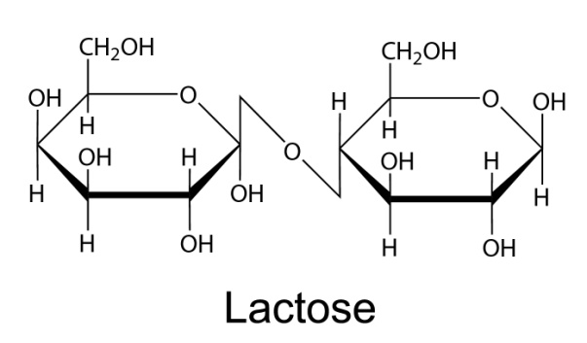
2.
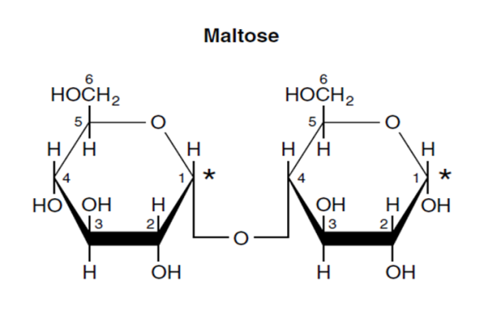
3.
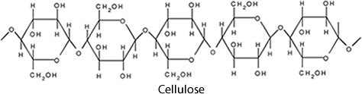

Topic 8. Higher Fatty Acids. Lipids. Phosphoglycerides

1.
2.
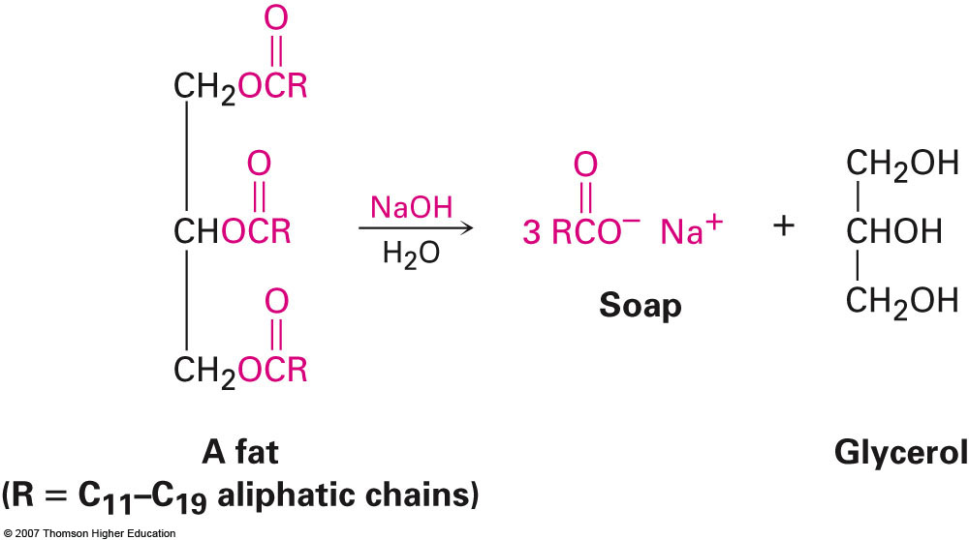
3.
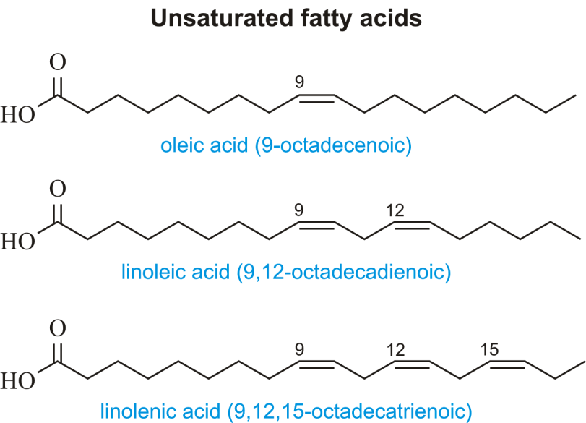
4.
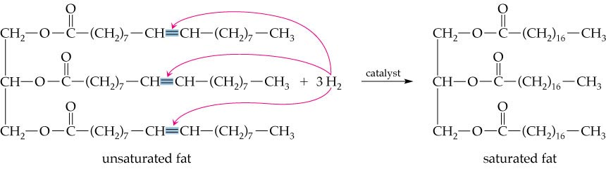

Topic 9. The structure and chemical properties of α -amino acids

1.
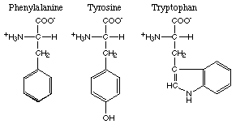
2.
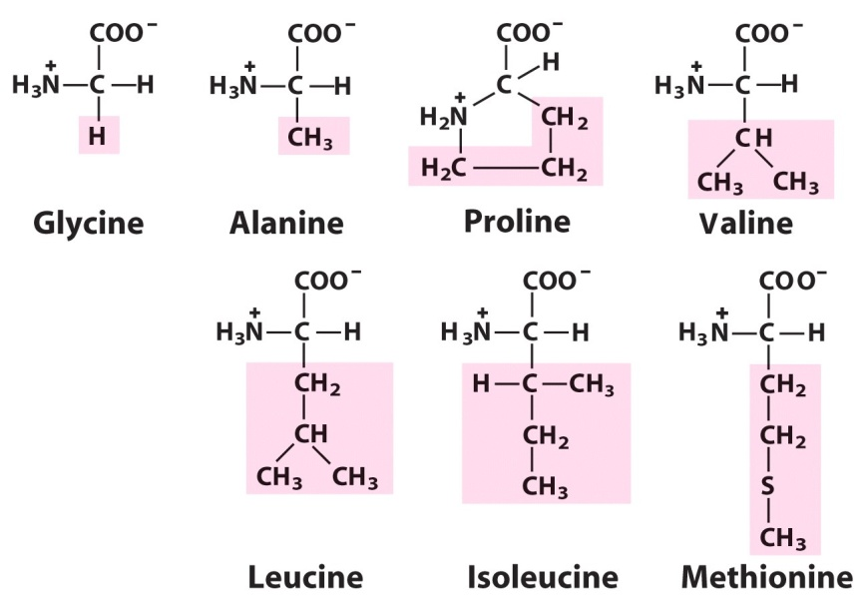
3.
4. Phenylalanine, Valine, Threonine, Tryptophan, Isoleucine, Methionine, Histidine, Arginine, Lysine, Leucine.

Topic 10. Nucleic acids, composition, structure and biological significance

1. Answer: Nucleosides are glycosylamines that can be thought of as nucleotides without a phosphate group

2. Answer: Purine is a heterocyclic aromatic organic compound that consists of a pyrimidine ring fused to an imidazole ring.

3. Answer: The phosphodiester linkage between two ribonucleotides can be broken by alkaline hydrolysis, whereas the linkage between two deoxyribonucleotides is more stable under these conditions.

4.
5. 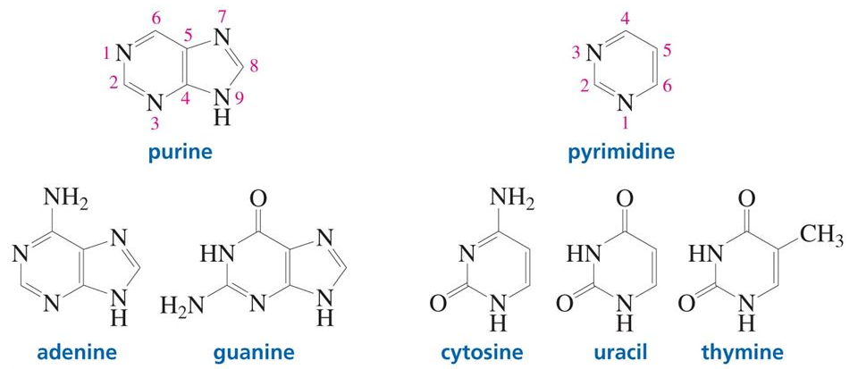

6. Answer: Nucleic acids have a primary, secondary, and tertiary structure analogous to the classification of protein structure. The sequence of bases in the nucleic acid chain gives the primary structure of DNA

7. Answer: DNA- It is a structure composed of double stranded polynucleotide chains. It has specific arrangement of nitrogen bases which codes for amino acids thus determining the types of proteins produced which decides your metabolism.
Concisely, DNA performs the following functions:
Storage of Genetic information
Replication of Genetic data during cell division.
As it provides scope for mutation, so it helps in accumulating variations leading to evolution.
RNA- It is a single stranded polynucleotide chain. There are 3 types of RNA; m-rna,t-rna and r-rna
RNA performs the following functions:
It is catalytic in nature and more reactive than DNA, so it performs the work of certain enzymes like ribozyme and ribonuclease
m-rna forms the transcripting base. The exonic genes are transcribed on m-rna
t-rna helps in translation, i.e converting the transcribed codes into corresponding amino acids. It leads to formation of peptide bonds that gives rise to protein structures.
Due to catalytic nature of RNA, it is weel considered to be the first replicating molecule to have come into existence.

Answers of tests
Module 2. Biopolymers and their structural components

Topic 6. Carbohydrates, structure and chemical properties. Monosaccharides, structure and chemical properties

1. | a
2. | b
3. | c
4. | a
5. | a
6. | c
7. | c
8. | a
9. | c
10. | a
11. | b
12. | a
13. | b
14. | c
15. | b
16. | c
17. | a
18. | b
19. | c
20. | c
21. | c
22. | c
23. | b
24. | c
25. | a
26. | b
27. | a
28. | c
29. | a

Topic 7. Olygo-and polysaccharides, structure and chemical properties

1. | a
2. | b
3. | b
4. | c
5. | c
6. | c
7. | c
8. | b
9. | b
10. | b
11. | c
12. | b
13. | c
14. | b
15. | a
16. | c
17. | a
18. | b
19. | a
20. | b
21. | a
22. | c
23. | b
24. | c
25. | b
26. | b
27. | a
28. | c
29. | a
30. | b
31. | a
32. | b

POLYSACCHARIDESS

1. | a
2. | c
3. | a
4. | b
5. | c
6. | b
7. | c
8. | a
9. | a
10. | c
11. | a
12. | b
13. | c
14. | a
15. | c
16. | b
17. | c
18. | c
19. | a
20. | b
21. | b
22. | a
23. | b
24. | c
25. | a
26. | c
27. | b
Topic 8. HIGHER FATTY ACIDS. LIPIDS. PHOSPHOGLYCERIDES

1. | a
2. | b
3. | c
4. | c
5. | b
6. | c
7. | b
8. | c
9. | b
10. | b
11. | c
12. | a
13. | b
14. | c
15. | a
16. | c
17. | b
18. | c
19. | a
20. | b
21. | a
22. | b
23. | b
24. | a
25. | a
26. | b
27. | c
28. | a
29. | a

Topic 9. The structure and chemical properties of α -amino acids

1. | b
2. | c
3. | a
4. | b
5. | c
6. | a
7. | b
8. | c
9. | b
10. | c
11. | a
12. | b
13. | a
14. | c
15. | c
16. | a
17. | b
18. | a
19. | b
20. | a
21. | b
22. | c
23. | a
24. | b
25. | c
26. | a
27. | a
28. | b
29. | a
30. | b
31. | b

Topic 10. Nucleic acids, composition, structure and biological significance
1. | c
2. | b
3. | b
4. | b
5. | c
6. | a
7. | b
8. | c
9. | a
10. | b
11. | b
12. | c
13. | c
14. | b
15. | c
16. | a
17. | a
18. | b
19. | c
20. | a
21. | c
22. | b

Questions for testing the theoretical knowledge of the discipline
- The planetary model of atom and its contradiction. Experimental studies confirm the complex structure of atom. Bohr's postulates.
- Wave-corpuscle duality of the electron, the equation of de-Broglie, Heisenberg's uncertainty principle. Motion of electrons in atom. Atomic orbitals.
- Quantization of energy in the micro particles. Electronic energy levels. Quantum numbers: characteristics, importance (important, the orbital shape of s, p, d, f - orbitals, magnetic). The orientation of atomic orbitals, the spin quantum number
- Principles and rules of filling of atomic orbitals by electrons: the principle of lowest energy, the Pauli principle, Hund's rule and Klechkovskogo. Electric and electronic graphic formula of atoms and ions.
- Natural and artificial radioactivity. Toxic effect of radionuclides, radiopharmaceuticals in the treatment and diagnosis of diseases.
- Fundamentals of molecular orbitals (MOs) methods. Binding the gap-board and nonbonding molecular orbitals. Their energy and shape.
- Energy diagrams of molecules that the formation of atoms of elements I and II periods of the periodic table of elements. Multiplicity of communications for the MO method.
- Ionic bond and its properties: unsaturated, non-directional. Structure and properties of compounds with ionic bonds.
- Metallic bond.
- Intermolecular interaction and its nature. Orientation, induction and dispersion interaction.
- Hydrogen bond and its types. The role of hydrogen bonding in biological systems.
- Modern ideas about the nature of chemical bonds. Bond characteristics: energy, length, bond angle.
- Covalent bond. The method of valence bond (VB). Two-electron chemical bond on Geytleru-London (on the example of education H2).
- Exchange and donor-acceptor mechanism of formation of a covalent bond.
- Properties of covalent bond: saturation, direction, polarization ability.
- Education σ and π bonds, of bonds in accordance with the method of OT.
- Formation of the covalent bond in the excited atoms.
- Formulation of the periodic law of D.I. Mendeleev and the modern-formula of the periodic law. Law Moseley.
- The structure of the periodic table of elements: time, group, subgroup, s, p, d, f - a family of elements.
- Periodic behavior of the atomic properties of elements in a gaseous state as a function of changes in their electronic structure: the atomic radii, ionization energy, electron affinity, the relative electro negativity.
- Metallic, nonmetallic and redox properties.
- Internal and secondary periodicity.
- Periodicity of chemical properties of elements and their compounds. The physical content of the periodic law.
- Simple matter: metals and nonmetals.
- Complex substances: binary, tertiary, complex.
- Oxides of: single, double, polymer. Peroxides and superoxide. Use of Nomenclature.
- Hydroxides: basic, acidic, amphoteric. Nomenclature Application.
- Acid. Ortho-, iso-and polyforms acids. Application.
- Salt. Classification. Nomenclature. Application.
- The dependence of acid-base forms and properties of oxides and hydroxides of the position of the elements that they constitute in the Mendeleev periodic table.
- Structure of the chemical equation. Show the stoichiometric coefficients.
- Calculating the number, masses and volumes of reagents for chemical equations.
- The concept of: - the output of products of the reaction - the mass fraction (the main substance, a component in the mixture; dissolve substance in solution; element in the molecule) - volumetric particle - density.
- Equivalent and the equivalent weight of simple and complex substances in the chemical reaction. The law of equivalents.
- Mass fraction (in %).
- Molar concentration. Mole fraction.
- Equivalence factor (acids, bases, salts, oxidants).
- Molar mass of equivalent.
- Molar concentration equivalent to (normal).
- Molality concentration.
- Titre solutions.
- The phenomenon of diffusion in solution. Semipermeable membrane. Osmose.
- Osmotic law of Van't Hof equation for nonelectrolytes and electrolytes.
- Isotonic coefficient, its relation with the degree of dissociation. Solutions: isotonic, hypotonic and hypertonic.
- The biological significance of osmosis: isoosmosis, hemolysis, plasmolysis, turgor.
- Determination of buffer system.
- The main types of buffer system.
- Basic equations of the buffer systems. Formula Henderson-Hasselbachs.
- The mechanism of action of buffer system.
- Buffer capacity. Factors on which it depends.
- Buffer systems of the human body.
- The biological significance of buffer systems.
- What carbohydrate is.The classification of carbohydrates.
- Glucose: -non-cyclic form: Fisher projection, D- and L-configuration; -cyclic form (pyranose and furanose): Heuorse`s projection, α- and β-anomers; -conformation: α-D and β-D–configuration. Tautorotation (birotation).
- Chemical properties of glucose: formation of helates, О– and N–glycosides, alkylation, acetylation.
- The formulas to know: glucose, fructose, ribose, desoxyribose and their derivatives (glycone, glycarone, glycurone acids, glucosamine’s, phosphor esters).
- Qualitative reactions on monoatomic alcohols and aldehyde group.
- Qualitative reaction on fructose (Selivanov’s reaction).
- What disaccharides are. Classification of disaccharides according to their ability to oxydative-reductive reactions.
- Saccharose structure, lactose structure: reductive abellies and oxy-groups (helates appearance, alkylation, acetylation).
- Homopolysaccharides: starch, glycogen, cellulose, dextranes: composition, structure, primary and secondary structure, chemical properties, biological meaning.
- Starch hydrolysis, qualitative reaction for starch determination.
- Heteropolysaccharides: hyaluronic acid, heparin, chondroitin sulfate, their composition and the structure of disaccharide fragment, biological meaning.
- Lipids, saponification lipids (definition).
- Higher fatty acids: saturated and unsaturated, sPartial structure of unsaturated acids, chemical characteristics.
- Fats as triacylglycerols, their composition, structure, classification, chemical properties (hydrolysis, iodine number, peroxide oxidation).
- Phosphoglycerols: composition, structure of phosphatidylcholine, phosphatidylcolamine, phosphatidylserine and their biological meaning.
- Structure of cholesterine, bile acids.
- Amino acids: definition, composition, structure.
- Acid-base properties of amino acids.
- Chemical reactions of amino acids by carboxy-group: ester and halogenanhydrydes formation. Biological meaning of these reactions.
- Chemical reactions of amino acids by amino-group: N-acyl derivatives formation, interaction with nitrite acid, formaldehyde, phenylisothyocyanate. Biological significance of these reactions.
- Decarboxylation of amino acids and biological meaning of biogen amines’ formation.
- Write down the Fischer projections for the following compounds: a) L-glutaminic acid; b) L-threonine; c) L-tyrosine; d) D-isoleucine; e) L-isoleucine.
- Show the structure of cysteine and alanine according to the R, S-nomenclature.
- Write down the proteinogenic amino acids which possess charge at pH = 7,4 (ionogenic amino acids).
- Write the hydrophobic amino acids (aliphatic and aromatic).
- Write the structures of amino acids at the pH = 1, pH = 7,4, pH = 10: a) Ala; b) Glu; c) Asn; d) His; e) Arg; f) Tyr.
- Write the oxidation reaction of cysteine.
- Write down the reaction of methionine with: a) acetic anhydride; b) ethanol in the H+ presence; c) PCl5.
- Write down the schemas of biologically important reactions: a) pyruvic acid with Glu; b) α-oxoglutaric acid with Asp; c) decarboxylation of His; d) decarboxylation of 3,4-dihydroxyphenylamine; e) decarboxylation of Glu; f) oxidative deamination of Glu; g) oxidative deamination of 3,4-dihydroxyphenylamine; h) non-oxidative deamination of Asp; i) hydroxylation of Phe; j) hydroxylation of Tyr.
- Structural components of nucleic acids, chemical properties. Qualitative reaction.
- Nucleosides: definition, structure, types of linkages, nomenclature, properties.
- Nucleotides: difinition, structure, types of linkages, nomenclature, properties.
- Nucleoside phosphate, the meaning of ATP. The role of nucleotides in the formation of coenzymes.
- RNA and DNA: structure, types, types of linkages, complementary pairs. Biological significance of nucleic acids.
- DNA duplex (Double spiral of DRA). Complementary pairs.
- Qualitative reaction on carbohydrate component and phosphoric acid.
- Formation of N-glicosidic and ester bonds.
- The action mechanism of coenzyme NAD⁺.

Practical tasks to test the formed skills and abilities

- Leave e-formula of elements with atomic numbers 15, 34 and 53, determined to divide the family, emphasize the valence electrons and for the latter represent the electro-graphical formula in the normal and excited states, determine the valency, the degree of oxidation and provide examples of compounds with given degrees of oxidation.
- Write an expression of iron (Fe, z = 26).
- Write electro-graphical formula of chlorine in normal and excited states, to establish equivalency, the degree of oxidation and provide examples of compounds with data degrees of oxidation.
- Write the energy diagram filling of the MO in the hydrogen molecule.
- Show the hydrogen bond between molecules of hydrogen fluoride.
- Draw energy diagrams of the following molecules: F2, N2, NO, CO.
- Make a sketch showing the structure of SiO2.
- Give formulas for the following compounds: aluminum oxide, magnesium hydroxide, silver iodide, cobaltous phosphate, ferric arsenate, chromic perchlorate, lithium dihydrogen phosphate, cuprous hypoiodite, ammonium bromate, auric sulfite, cadmium nitride, ferrous sulfide, nickel nitrite, barium sulfate.
- For the elements of the III period taking consideration in to ascending serial number form higher oxides and indicate their acid-base character.
- Using the periodic law consider the formula of phosphorus compounds with hydrogen and oxygenic and give a general characterization of these compounds.
- Using the periodic law give answers to questions such as: a) some of the elements have a greater electro negativity of P and Cl? Why? b) specify the nature of these chromium oxides: CrO, Cr2O3, CrO3, and confirm the corresponding equations of reactions. c) for the elements of the formula II period what causes higher oxides and specify their nature.
- Write IUPAC name of these substances: a) acids: H2SO4 , H3BO3, H2SO3, H2S. b) the grounds of: Fe(OH)2, Fe(OH)3, Cr(OH)3. c) oxides: N2O, NO, Mn2O7, N2O3. d) salts: Al2(SO4)3, FeOHCl2, Na3PO4, Ca(HCO3)2.
- Write the equation of dissociation of the following electrolytes: H2SO4, Al2(SO4)3, H3PO4, Cr(OH)2Cl.
- Make the reactions necessary for the following transformations: а) Ba→ BaО→ BaCl2 → Ba3(PO4)2→ BaSO4; б) Zn → K2ZnО → ZnCl2 → Zn(OH)2 → Na2[Zn(OH)4] → ZnSO4 в) C → CO→ CO2 → Na2CO3→ NaHCO3 → Na2CO3→ CaCO3→ Ca(HCO3)2 → CaCO3.
- Solution that contains silver nitrate weighing 25,5 g was added a solution that contains sodium sulphide, the mass of 7,8g. What mass of sediment isformed at the same time?
- A mixture of copper and magnesium сhips weighing 1,5 g was treated with excess of hydrochloric acid. The reaction released hydrogen volume of 560 ml (normal conditions). Identify the mass of copper particles in mixture.
- Determine the mass of salt that is obtained by mixing 40 ml of solution with mass fraction of nitric acid, 0,2 and density 1,12 g/ml with a solution volume of 36 ml of mass fraction of sodium hydroxide and 0,15 density1, 17 g/ml.
- A reaction of a sample of technical sodium sulphate spent weighing 9 g solution weight of 40 grams of mass part of potassium permanganate (KMnO4) 7,9%. Determine the mass-equivalent fraction of Na2SO3 in the technical sulphite.
- To a solution in which the aluminum nitrate weighing 42,6g the solution that contains sodium carbonate was added, the precipitate mass of 37,2g calcined. Determine the mass of residue after calcined.
- A mixture of hydrogen and hydrogen chloride volume of 7 liters (standard conditions) was passed through silver nitrate solution, taken in excess, and received sediment mass was 28,7g. Determine the volume fraction of hydrogen in the mixture.
- Calculate the mass of carbon dioxide (IV), which can be extracted from the interaction of calcium carbonate weighing 7 g of hydrochloric acid, weight 30 grams, in which the mass fraction of chlorine-hydrogen is 20%.
- Calculate the mass of base formation interactions 34 silver nitrate and 21 g barium chloride.
- How many grams of boric acid and water is needed to prepare 250g of solution with mass fraction of 3% boric acid?
- How many grams of sodium chloride is necessary for the preparation of 1L solution with CM = 2 mol/l?
- How many grams of KMnO4 is required to prepare a 2l solution with CH = 0,5 mol/l if the analysis are performed in acidic environment?
- Calculate the molality concentration of the solution prepared with 2g of KOH and 200g of water.
- Calculate the titer of sulphuric acid, cw = 50% and ρ = 1,4 g/ml.
- Find the molar concentration equivalent of sulfuric acid solution with mass fraction of 10% (density 1,22, fekv. = 1/2).
- Calculate the mass of water that is needed to 50g of sodium chloride solution with mass fraction NaCl 2% for solution with mass fraction of NaCl 0,9%.
- Mass fraction of sulfuric acid in solution 3,2%. Calculate the molar concentration equivalent of sulfuric acid in the solution (ρ = 1,02 g / ml).
- For introducting in to the Partient general anesthesia using sodium oxybutyrate that comes in 10 ml vials in a mass fraction of substance 20%, weight 60 kg Partient. The drug must enter at the rate of 70 mg/kg. How many ml must enter into the Partient?
- In 135g of water dissolv 15g of salt. What is the mass fraction of salt (in %) in the solution?
- Calculate the volume of solution with mass fraction of sulfuric acid 56% (ρ = 1,460 g/ml) and water volume which are necessary for the preparation of 100 ml with a mass fraction of sulphuric acid 20% (ρ = 1,143 g/ml).
- Calculate the mass CaC12 • 6H2O which is necessary for the preparation of 50 ml of 0,1 M solution.
- How much salt solution with mass fraction of 18% is to be added to 46g of water to form a 15% solution.
- Calculate Posm. sodium chloride solution with mass fraction 5,85% at 0° C. The degree of dissociation of sodium chloride 0,96, and ρ = 1,04 g / ml.
- How many moles of nonelectrolyte are placed in 1 liter of solution at 0° C if Posm. = 1atm?
- Is there an isotonic solution of urea and acetic acid by mass 0,6%, if the degree of dissociation of acetic acid is equal to 0,01, while the density of solutions - 1 g/ml.
- Determine the molar concentration of sucrose solution which is isotonic relative to blood.
- Calculate the isotonic coefficient of calcium chloride solution if the degree of dissociation of calcium chloride is equal to 68%.
- Calculate the pH of buffer system which consists of 100 ml of dilute acetic acid, C = 0,1 mol/l and 200 ml of sodium acetate C = 0,2 mol/l, Kd (acid) = 0,0000175.
- Calculate the volume of sodium acetate C = 0,1 mol/l and the amount of acetic acid with C = 0,1 mol/l which must be mixed to prepare 3l of acetate buffer рH = 5,24 (Кd (acid) = =0,0000175).
- Calculate the pH of buffer solution that contains 3,6 ml of ammonium chloride solution C = 0,2 mol/l and 2,6 ml of ammonium hydroxide solution С = 0,1 mol/l (Кd(NH4OH)=0,000018).
- Calculate the volume of acetic acid with C = 0,1 mol/l sodium acetate C = 0,1 mol/l which must be mixed to obtain 150 ml solution рН = 4,94. (Кd (СН3СООН) = 0,0000175).
- 2 Биологически важные классы органических соединений. Биополимеры и их структурные компоненты. Write the hydrolysis scheme of О–methyl –β–D–glycopyranoside.
- Write the formula of glucosamine.
- Write the equation of interaction between glucose and ethanol. Show the bond type and determine the product.
- Write the equation of fructose alkylation with chloromethane. Show the bond type and determine the product.
- Write the α-D-glucopyranose formula.
- Write the equation of interaction between α, D-fructofuranose and ethylamine. Determine the product and show the bond type.
- What is Trommer’s reagent and what is it used for?
- What are homopolysaccharides (examples)?
- Write the structural formula of lactose, show the bond type between two monosaccharide units.
- Write the structure of cellulose disaccharide fragment and show the bond type between two monosaccharide units.
- Write the structure of galactose and the scheme of its hydrolysis. What compounds are the reductors in this reaction?
- . Write the structure of disaccharide fragment of glucose and show the bond type.
- Write the structure of completely acetylated disaccharide fragment of amylose, lactose, glucose and galactose are the reductors.
- Write the configuration of oleic acid.
- Write the scheme of alkaline hydrolysis of 1 – palmetoyl – 2 – oleoyl – 3– stearine.
- Write the reaction equation of alkaline hydrolysis of dioleoylstearine.
- Write the structure of phosphatidylcholine.
- Write the spartial structure of unsaturated fatty acids: oleic and linoleic.
- Write structure and scheme of alkaline hydrolysis of tristearin.
- Write the formation reaction of 1-O-palmitoyl-2,3-di-O- stearoyl glycerol 2. Write the configuration of linoleic acid.
- Design the chemical method to distinguish between saturated and unsaturated fatty acids.
- Write the formation reaction of fat containing one residue of linoleic acid and two molecules of palmitic acid.
- Write the reaction equation of oxidation of oleic acid by potassium permanganate.
- Call the products of hydrolysis of oil.
- Write the reaction equation of interaction between iodine and trioleoylglycerol.
- Write the differences between fat, oil and waxes.
- What are the bile acids? Design their general formula.
- Write the formation reaction of oil.
- Write the configuration of linolenic acid.
- What is hydrogenation of fats? Write the scheme of the reaction.
- What types of isomery are typical for α -amino acids.
- Explain the amino acids’ amphotericity.
- Write and learn 20 formules of aminoacids that form proteins; mark irreplaceable aminoacids.
- Write the reaction of interaction between serine and ethanol equation.
- Write the reaction of interaction between asparagine and phenylisothyocyanate equation.
- Write down the Fischer projections for the following compounds: a) L-glutaminic acid; b) L-threonine; c) L-tyrosine; d) D-isoleucine; e) L-isoleucine.
- Show the structure of cysteine and alanine according to the R, S-nomenclature.
- Write down the proteinogenic amino acids which possess charge at pH = 7,4 (ionogenic amino acids).
- Write the hydrophobic amino acids (aliphatic and aromatic).
- Write the structures of amino acids at the pH = 1, pH = 7,4, pH = 10: a) Ala; b) Glu; c) Asn; d) His; e) Arg; f) Tyr.
- Write the oxidation reaction of cysteine.
- Write down the reaction of methionine with: a) acetic anhydride; b) ethanol in the H+ presence; c) PCl5.
- Write down the schemas of biologically important reactions: a) pyruvic acid with Glu; b) α-oxoglutaric acid with Asp; c) decarboxylation of His; d) decarboxylation of 3,4-dihydroxyphenylamine; e) decarboxylation of Glu; f) oxidative deamination of Glu; g) oxidative deamination of 3,4-dihydroxyphenylamine; h) non-oxidative deamination of Asp; i) hydroxylation of Phe; j) hydroxylation of Tyr.
- Write the scheme of appearance of aminoacid – valine - bipolar ion. What pH does its isoelectrical point located in.
- Write the formulas of three possible alanine salts.
- Write the structural formulas of aromatic amino acids.
- Write the reaction equation between cysteine and methanol.
- Write the scheme of decarboxylation of valine.
- Write the structural formulas of heterocyclic amino acids.
- Write the reaction equation between arginine and ethanol.
- Write the reaction equation between alanine and phenylisothiocyanate.
- Write the structural formulas of monoamino-monocarboxylic acids.
- Write the reaction equation between lysine and formaldehyde.
- Write the reaction equation between valine and nitrous acids.
- Write the structural formulas of oxy amino acids.
- Write the reaction equation between glycine and ethanol.
- Write the scheme of decarboxylation of leucine.
- Write the structural formula of adenine and point out the pyrrol and pyridine nitrogen atoms.
- Write the structure of DNA-GT fragment.
- Write the structure of cytidine, deoxyguanosine. Point out the lactim-lactam tautomerization.
- Write the structure of adenilic and thymidylic acid, point out the types of linkages.
- Write the structure of the dinucleotides DNA: T-G.
- Write the structure of lactim-lactam tautomerization of uracyl.
- Write the hydrolysis of cytidine.
- Write the structure of the dinucleotides RNA: guanine – cytosine.

The form of the current control of academic performance: credit testing
TEST TASKS
for testing knowledge in the discipline "Chemistry»
# Pentose phosphate pathway produces
+NADPH
ATP
Acetyl CoA
ADP
# Aldolase is an enzyme whose substrate is
glucose -6-phosphate
fructose-6-phosphate
fructose
+fructose-1, biphosphate
# What is not given in fructose intolerance patient
glucose + fructose
fructose +galactose
+fructose + sucrose
fructose +maltose
# Source of ATP in RBC cells
fatty acid oxidation
oxidative phosphorylation
NADPH paroxidase
+EMP pathway
# In which cells or tissue, Lactate will convert to pyruvate
muscles
+liver
erythrocytes
brain
# Glucose-6-phosphatase enzyme is absent in
liver
kidney
brain
+muscles
# Which functionla group is found in triglycerides
amide
carboxylic acid
+ester
phosphate
amino alcohol
# Which unsaturated fatty acid contains 3 double bonds
oleic acid
linoleic acid+linolenic acid
arachidonic acid
myristic acid
# Having both hydrophobic and hydrophilic portions is called a bivalent
+amphipathic
soluble
nonpolar
polar
# Fats – esterуs
+tree atom alcohol of glycerol and higher fat acids
diatomic alcohol a glycol and higher fat acids
diatomic alcohol a glycol and low fat acids
tree atom alcohol of glycerol and low of fat acids
# Tailings enter in the complement of fats
diatomic alcohol a glycol and higher fat acids
diatomic alcohol a glycol and low fat acids
+tree atom alcohol glycerol and higher fat acids
tree atom alcohol of glycerol and low of fat acids
# A type of connection is in fats
peptide
glycoside
+hard efires
ionic bond
# The most widespread are saturated higher fat acids in composition of fats
+palmitic, stearic
olein; elaidinoic
linolic, palmitic
linolic, olein
# The most widespread are unsaturated higher fat acids in composition of fats
palmitic, stearin
+olein, linolic, linolenic
linolic, palmitic
palmitic, stearic, linolic
# A high-quality reaction is on the unsaturated higher fat acids in composition of fats
discolouring of copper(II) hydroxide
discolouring of iron(III) chloride
+discolouring of bromic water
discolouring of iron(II) hydroxide
# Higher fat acids are unsaturated in composition of fats differ
by the structure of carbon structure
+by the number of double connections
by the type of isomery
by the type of isomery and the structure of carbon structure
# Higher fat acids are unsaturated in composition of fats have
trance – configuration
L – configuration
+cis – configuration
D – configuration
# Hard fats are contained by tailings
unsaturated higher fat acids
+saturated higher fat acids
saturated low fat acids
unsaturated low fat acids
# Liquid fats are contained by tailings
saturated higher fat acids
+unsaturated higher fat acids
saturated low fat acids
unsaturated low fat acids
# Fats – it
alkyl gliceride
anhydride gliceride
+ acyl glyceride
amide gliceride
# Fats are better added a hydrolysis in
+sour and alkaline environments
neutral environment
environment of brome water
neutral and sour environment
# The products of acid hydrolysis of fats is
ethylene glycol and higher low acids
ethylene glycol and higher fat acids
+glycerine and higher fat acids
glycerine and salts of higher fatacids
# The products of alkaline hydrolysis of fats is
ethylene glycol and higher fat acids
ethylene glycol and low fat acids
glycerine and higher fat acids
+glycerine and salts of higher fat acids
# Iodine number – it
+amount of grammes of iodine, that joinsin with 100g fat
amount of iodine, that joins in with 100g fat
an amount of grammesis potassium of iodine, that joinsin with 100g fat
amount of iodine, that joins in with 1g fat
# Iodine a number is characterized by a degree
to the saturation of fat
to the saturation of fat and izomerisation of fat
izomerisation of fat
+to the unsaturation of fat
# Than anymore iodine number, that
less biological value of fat
+greater biological value of fat
an ion number does not influence on the biological value of fat
less biological value of fat low fat acids
# Than greater degree of unsaturation of fat, that
less biological value of fat
an ion number does not influence on the biological value of fat
+greater biological value of fat
less biological value of fat low fat acids
# Heating of fats is a result
+peroxyde oxidation fats
proceeding in fats
besieging of fats
izomerisation of fats
# Hydrogenation fats – it
converting of hard fat is into liquid
+converting of liquid fat is into hard
converting of desi is into butter
without converting of hard fat
# Hydrogenating fats is a reaction
+hydrogenising
hydratations
dehydrogenization
izomerisation
# In the organism of man fats are added a hydrolysis
in a stomach in a sour environment
+in an intestine in environment
in an oral cavity in an alkaline environment
in an oral cavity in a sour environment
# The products of hydrolysis of fats in the organism of man is
glycol and soap
+HFA and alcohol
glycerin and soap
glycol and alcohol
# Medicinal preparations of fats
linetol, arakhiden
+protargolum, palmitic acid
soap, stearin acid
soap, arakhiden
# Phospho glicerides are derivatives
phosphate acid
+phosphatidic acid
pyro phosphate acids
ethanoic acid
# Phosphatidic acid consists of tailings
+saturated and unsaturated HFA, glycerin, phosphate acid
unsaturated HFA, glycerin, phosphate acid
saturated and unsaturated HFA, to the glycerin, phosphate acid
saturated and unsaturated HFA, to the glycol, pyro phosphate acid
# A type of connection is between the components of phosphate
glycoside
peptide
+hard efires
amide bond
# Phosphate acid has
L – configuration
D –configuration
+cis – configuration
trans – configuration
# The remain of kholine, which is connected with a remain, enters in the complement of phosphate dilkholine
phosphate acid
+phosphatidic acid
to glycerin
glycol
# Phosphate glycerides in biological membranes form
+lipids bashar
lipids monolayer
micelles
lipids trilayer
# Which of the following is an Omega-3 fatty acid
linoleic acid
+a-linolenic acid
oleic acid
arachidonic acid
# Which one of the following is an example of omega-3 fatty acids
gamma linolenic acid
oleic acid
+docosahexaenoic acid
palmitoleic acid
# Which of the following nitrogen base is not seen in RNA
adenine
+thymine
guanine
cytosine
# Which of the following amino acid is common in Purine and pyridimines
alanine
+glutamine
guanine
uracil
# The Watson’s Crick double helix model of DNA is
+right handed anti parallel
left handed anti parallel
right handed parallel
left handed parallel
# Equal number of nucleotide bases are seen between which pair of nucleotides
A equal G
G equal T
+G equal C
A equal C
# The technique used for separation and detection of RNA is which one of the following
+northern blot
southern blot
eastern blot
western blot
# The structural polysaccharide chitin is a polymer of which of the following
galactosamine
glucosamine
N- acetyl galactosamine
+N-acetyl glucosamine
# The initiation of hemoglobin synthesis requires
+histidine
glycine
folate
iron
# In Hartnup’s disease which of the following is excreted in the urine
ornithine
glycine
+tryptophan
cystine
# Intestinal flora (bacteria) digests all except
cellulose
+lignin
pectin
starch
# Amino acid which contributes to biosynthesis of purine ribonucleotide are all except
aspartate
+histidine
glutamate
glycine
# Vitamin C is necessary in the formation of collagen. It is required for the conversion of
+proline to hydroxyproline
beta-carotene to vitamin a
glutamate to gamma-carboxyglutamate
pyridoxine to pyridoxal phosphate
# What changes the conformation of alpha helix in collagen
methionine
+proline
alanine
tyrosine
# Used in Transamination
+TP
NADPH
NADP
FAD
# Radiation affects
RNA
+DNA
mitochondria
cytoskeleton protein
# Protein synthesis occurs in
golgi bodies
+endoplasmic reticulum
mitochondria
peroxisomes
# Protein synthesized in rough Endoplasmic reticulum will first go to
mitochondria
cytosol
+golgi body
lysosome
# The main catabolic product /products of purine nucleotides in humans is which one of the following
ammonia + CО
ammonia
+uric acid
CО and water
# Most common RNA is
t-RNA
m-RNA
+r-RNA
sn-RNA
# RNA silencing is seen with
t-RNA
m-RNA
sn-RNA
+mi-RNA
# Which is a niacin sparing amino acid
+tryptophan
methionine
cysteine
tyrosine
# Which vitamin can be synthesized from tryptophan
+niacin
riboflavin
cobalamin
folic acid
# Disease entity due to deficiency of alpha keto- decarboxylase enzyme
hartnup’s disease
+maple syrup disease
alkaptonuria
alport syndrome
# Limiting amino acid in maize
niacin
tyrosine
+tryptophan
methionine
# In Alkaptonuria deficiency is
phosphofructokinase
HMG COA reductase
+homogentisate oxidase
xanthine oxidase
# First product of tryptophan catabolism is
+kynerunine
bradykinin
PAF
xantheurenate
# Urea is formed from which substrate
arginine
orginine
citrulline
+aspartate
# Polyamine like putrescine is derived from
arginine
+ornithine
yohimibine
arginosuccine
# Cystinuria presents with excess of
+cysteine
tyrosine
glutamine
valine
# Nitric oxide is synthesized from
+L- arginine
L- citrulline
lysine
tryptophan
# The initiation of hemoglobin synthesis requires
histidine
+glycine
folate d
iron
# True about Riboflavin is
deficiency causes beri beri
+consist of flavin group which is required in oxidation- reduction reaction
pyridoxal phosphate act as a cofactor
green leafy vegetables are major sources
# Which vitamin is associated with carboxylation reactions
thiamine
riboflavin v
+ biotin
folic acid
# Pellagra is due to
utilization of tryptophan
+deficiency of tryptophan
deficiency of thiamine
utilization of niacin
# All of the following vitamins are anti-oxidants except
beta- carotene
ascorbic acid
vitamin E
+vitamin К
# Among the following, which is the most effective antioxidant
vitamin A
vitamin C
+vitamin E
vitamin К
# The normal pH of the human blood is which one of the following
7.0-7.2
7.25-7.35
+7.36-7.44
7.50-7.55
# Which enzyme is used to convert phenylalanine to tyrosine
tyrosine synthase
tyrosine hydroxylase
+phenylalanine hydroxylase
phenylethanolamine methyltransferase
# Monosaccharides are polyatomic
+hydroxyl-aldehyde – or hydroxyl-ketones
aldehyde– or acid alcohol
aldehyde – or alkaamines
aldehyde – or amides
# Two monosaccharides belong to
saccharose, lactose
+glucose, fructose
mannose and maltose
saccharose, fructose
# Glucose is
hydroxyl-ketone
acid alcohol
+aldehyde alcohol
hydroxyl-aldehyde
# Functional groups in the molecule of glucose is
+aldehydic and alcoholic oxygroup
carboxyl- and alcoholic oxogroup
keto- and alcoholic oxygroup
aldehydic and amino group
# The acyclic form of glucose has
+D – configuration
L – configuration
N – configuration
trans – configuration
# The cyclic form of glucose has
λ– and μ – configuration
γ– and δ – configuration
+α – and β – configuration
γ– and α – configuration
# The cyclic form of glucose is named
geptanose
tetranose
+pyranose
trinose
# Pyranose the cycle of glucose has configuration of
+arm-chairs
baths
linear
baths and linear
# The isomer of glucose is
saccharose
+galactose
lactose
maltose
# Specify the correct pair of isomers
+glucose is mannose
glucose is maltose
glucose is saccharose
fructose is saccharose
# A high-quality reaction on the aldehydic group of glucose is a reaction of
Kucherov
+Trommer
Friedel–Crafts
Folls
# A high-quality reaction on polyatomic of glucose is education in
+chelates
red sediment
gas
black sediment
# Glucose forms O creates are glycosides during co-operation with
aldehydes
acids
ketones
+alcohols
# Glucose forms N glycosides during co-operation with
amides
+by amines
imines
alcohols
# N is glycosides of ribose and deoxyribose included in composition of
albumens
fats
globulines
+RNA and DNA
# Alkalization of monosaccharide conduct with
+halogen alkanes
halogen anhydrides
halogen radicals
free radicals
# The product of alkylation glucose has such copulas
O create are glycosides and difficult ether copulas
+O create are glycosides and simple ether copulas
O create are glycosides and anhydride copulas
N create are glycosides and anhydride copulas
# As a result of hydrolysis fully alkyles glucose collapses only
+OH – glycoside and simple ether copulas
simple ether copulas
hard ether copulas
OH – glycoside connection
# Acidylatings of monosaccharides conduct for help from
halogen alkanes
halogen acid
aminoacid
+halogen anhydres
# Acidilate glucose has such copulas
simple ether
hard ether
OH – glycoside and simple ether
+OH – glycoside and difficult ether
# Fructose is polyatomic
aldehyde alcohol
+hydroxyl-ketone
alcohol
amino-ketone
# Functional groups are in the molecule of fructose
aldehydic
carboxyl- and oxy groups
+oxo- and oxi- groups
aldehydic and carboxyl groups
# The cyclic form of fructose has
λ – and μ– configuration
+α– and β – configuration
γ– and δ – configuration
λ – and β – configuration
# Semiacetic hydroxyl in the molecule of fructose is located near the
+second atom of carbon
first atom of carbon
seventh atom of carbon
sixth atom of carbon
# Fructose is distinguished from glucose by a reaction of
Kucherov
+Selivanov
Feling
Foll
# In the molecule of deoxyribose oxy-group there is absence of
+second atom of carbon
first atom of carbon
fifth atom of carbon
sixth atom of carbon
# Oligosaccharides are hard carbohydrates which contain
+from 2 to 10 monosaccharide tailings
from 5 to 20 monosaccharide tailings
from 1 to 5 monosaccharide tailings
from 2 to 100 monosaccharide tailings
# Disaccharides are hard carbohydrates which contain
to 10 monosaccharide tailings
+to 2 monosaccharide
to 5 monosaccharide tailings
to 20 monosaccharide tailings
# To disaccharides belong
glucose, lactoglucose
+saccharose, lactose
fructose, mannose
glucose, fructose
# A saccharose consists of tailings such
α– mannose and β– glucose
α– lactose and β – fructose
+α – glucose and β – fructose
β – mannose and β – fructose
# A type of connection between a saccharose and monosaccharide tailings is
+α – 1, 2 – glycoside
α – 1, 4– glycoside
β – 1, 4– glycoside
α, β – 1, 2 – glycoside
# Saccharose is
recuperative sugar
+unrecuperative sugar
insoluble sugar
polysaccharide
# A saccharose is unrecuperative sugar, because of absence
of ionic connection
of furanoic cycle
of piranoic cycle
+of semiacetal hydroxyl
# During a hydrolysis a saccharose gives
lactose and lacto glucose
+glucose and fructose
maltose and fructose
maltose and glucose
# The products of hydrolysis of saccharose are called
leaden sugar
artificial sugar
+invert sugar
polysaccharide
# Lactose is a disaccharide, which consists of tailings
α– mannose and β– glucose
+β– galactose and α– glucose
α– glucose and β – fructose
β – glucose and β – fructose
# A type of connection between lactose and monosaccharide tailings
α –1,2 – glycoside
α – 1,4 – glycoside
β – 1,2 – glycoside
+β – 1,4 – glycoside
# Lactose is
+recuperative sugar
un-recuperative sugar
polysaccharide
insoluble sugar
# Lactose is a recuperative sugar, because there is presence of
ionic connection
pyranoic cycle
furanoic cycle
+semiacetal hydroxyl
# In human beings lactose is contained in the free state
+in a woman milk
in a stomach
an a liver
in a brain
# In human being lactose fissions in stomach – intestinal highway under the action of ferment is
glucose
saccharose
maltase
+lactase
# In the organism of man there is the inherited immunity to
maltose
cellobiose
+lactose
saccharoses
# A maltose is disaccharide, which consists of
two tailings β– glucose
three tailings β – lactoglucose
two tailings β – lactoglucose
+two tailings α – glucose
# A type of connection between maltose and monosaccharide tailings
α – 1, 2 – glycoside
+α – 1, 4– glycoside
β – 1, 2 – galactoside
β – 1, 4 – galactoside
# α – 1, 4-glycoside connection has in maltose
+linear configuration
located in a plane
angular configuration
located in a plane and angular configuration
# Maltose is a
+recuperative sugar
polysaccharide
un-recuperative sugar
insoluble sugar
# A maltose it recuperative sugar, because presence of
ionic connection
furanoic cycle
pyranoic cycle
+semiacetal hydroxyl
# Maltose can
+O- and N- forms glycosides
forms only N- glycosides
forms only OH are glycosides
forms only S- glycosides
# During a hydrolysis a maltose gives
2 molecules α– mannose
+2 molecules α – glucose
3 molecules α – fructose
2 molecules β – fructose
# Molecular formula of gomo-polysaccharidess is
С6Н10О6
+(С6Н10О5)n
С6Н12О6
С3Н6О3
# Starch is a product of
photosynthesis
+polymerization
catabolism
hydrolisis
# Starch is a homo-polysaccharidess which consists of tailings
α-mannose
+α-glucose
β -mannose
β-fructose
# Starch consists of two functions
dextranes and glucose
dextranes and cellulose
cellulose and glucose
+amylose and to the amylopectin
# A type of connection between monosaccharide tailings in amylose is
α-1, 2- forms only O-glycosides
α-1, 2- forms only N-glycosides
+α-1, 4-glycosides
β-1, 4- galactose
# What structure amylopectin has unlike amylose
linear polynucleic chain
linear polyglycosides chain
+a polyglycosides chain is ramified
a polypeptide chain is ramified
# A type of connection between monosaccharide tailings in amylopectin is
α-1, 2-glycosides connection in points a fork
α-1, 4-glycosides connection mainly to the chain
β -1, 3-glycosides connection mainly to the chain
+α-1, 4-mainly to the chain and α – 1,6 is glycosides connection in points a fork
# Intermediate connections of hydrolysis of starch are
+dextrin and maltose
dextranes and lactose
dextranes and glucose
cellulose and glucose
# The last product of hydrolysis of starch is
α -fructose
β-fructose
+α-glucose
β-glucose
# A high quality reaction of starch is
discoloring of brome water
the red coloring with iodine
the violet coloring with iron (III) chloride
+the dark blue coloring with iodine
# Starch is used in pharmacy for preparations of
pastes
powders and pills
+suspensions
emulsions
# Reserve power carbohydrate for animals is
cellulose
starch
dextrin
+glycogen
# Glycogen is homopolysaccharide which consists of tailings
α-mannose
+α-glucose
α -fructose
β-fructose
# A type of connection between monosaccharide tailings in a glycogen is
α-1,2-glycoside connection in points a fork
β -1,3-glycoside connection in points a fork
α-1,4-glycoside connection mainly to the chain
+α-1,4-mainly to the chain and α-1,6 is glycoside connection in points a fork
# Cellulose is homo polysaccharide which consists of tailings
α-mannose
β -mannose
α-glucose
+β-glucose
# A type of connection between monosaccharide tailings in cellulose is
+β-1,4-glycosides
α-1,2-glycosides
α-1,4-glycosides
β-1,4-galactose
# The food fibers of fruit and green vegetables stimulate working of
brain
cages of CNS
liver
+intestine
# The food fibers of fruit and green vegetables absorb
+toxic matters
haemoglobin
phosphates
enzimes
# The polysaccharides of bacterial origin is
cellulose
starch
dextrin
+dextranes
# Dextranes consist of tailings
+α-glucose
β-lactoglucose
β -fructose
α-fructose
# From dextranes get blood substitutions under the name of
poly glucine
polypeptide
polyhybrid
+polyglucose
# Structural isomers of amino acidis
+a leucine – isoleucine
a methionine – treonin
a serine – treonin
a valine – alanine
# The example of enantiomers of aminoacid is
a methionine – treonin
α – alanine –β– alanine
L – alanine –D – valine
+L – methionine – D – methionine
# The natural amino acid have only
+L – configuration
D – configuration
cis – configuration
trans – configuration
# It is existing in water of aminoacid in the form of
to cation
to the anion
+bipolar an ion
neutral
# The isoelectric state of amino acid is existing in the form of
to the anion
+bipolar an ion
to cation
neutral
# Aminoacid are in the isoelectric state at a certain size
temperatures
pressure
+рН
temperatures and pressure
# Isoelectric point – рН, for which the amino acid is in
+isoelectric state
kind cation
kind an anion
kind an ion
# After the size of isoelectric point the amino acid are classified on
soluble, insoluble
+neutral, sour, basic
volatile, non-flying
sour, basic
# Neutral amino acids are
+alanine, valine
serine, tyrosine
aspartic
tyrosine
# The example of sour amino acid is
phenylalanine, tryptophane
cystein, methionine
+aspartic, glutamine amino acid
tyrosine
# The example of basic amino acid is
leucine, isoleucine
methionine, valine
+lysine, arginine
tyrosine
# Aminoacid for a carboxy – it is given a group
+esteres
ethers
amines
glycosides
# The all amino acid give the violet coloring from
brome water
+ninhydrin
a ferum(III) chloride
iodine
# In the containing of amino acid give with the reagent of Folya
red coloring
violet coloring
+black coloring
have not coloring
# In result of decarboxylation serine in the organism of man appears
+colamine
kholin
thiaminum
tyrosine
#Glutamate of sodium has a taste
+meat
milk
lemon
apple
# Nucleic acids are called biopolymers morphons of which are
+mononucleotides connected between itself and phosphorus copulas
mononucleotides connected between itself and glycoside copulas
mononucleotides connected between itself anhydride copulas
polynucleotides connected between itself and peptide copulas
# Composition of nucleic acids is
glucose and amino acid
+nitrous bases, carbohydrate and phosphate acid
sulfate acid, phosphate acid and bases
sulfate acid and bases
# Nucleic acids are shown by acid properties due to a presence of
carbohydrates
nitrous bases
+phosphatic acid
aminoacid
# Purinoic nitrous bases which enter in the compliment of nucleic acids are
uracil, thymine and cytosine
+adenine and guanine
thumidine and uridine
cytosine and uridine
# Nitrous bases in nucleic acids are in
laktime form
+laktame form
cis-to the form
trans-to the form
# Such carbohydrates enter in the compliment of nucleic acids are
lacto glucose and mannose
+ ribose and deoxyribose
deoxyglucose and fructose
ribose and fructose
# Deoxyribose can be distinguished from ribose by the absence of oxy group near
first carbon
third carbon
+second carbon
sixth carbon
# Ribose and deoxyribose is polyatomic
+aldehydoalcohol
hydroxy-ketones
acid alcohol
aminoacide
# Nucleoside is
OH glycosides which aglykonom of nitrous bases are
+N glycosides which aglykonom of nitrous bases are
N is glycosides which aglykonom of phosphatic acid is
O is glycosides which aglykonom of phosphatic acid is
# In the complement of nucleoside enter
nitrous basis and phosphatic acid
nitrous basis and glucose
+ nitrous basis and carbohydrate
nitrous basis and aminoacid
# Type nucleoside connection between nitrous basis and carbohydrate is
+ N-glycoside
OH-glycoside
hard efires
simple efires
# The products of hydrolysis of nucleoside is
phosphate acid
+ nitrous basis and carbohydrates
nitrous basis and phosphate acid
nitrous basis and aminoacid
# Nucleoside which consist of uracil and ribose are called
ureic acid
+ uridine
ribose
deoxyribose
# The compliment of citadines enters are called
cytosine and phosphoric acid
amid and ribose
+cytosine and ribose
ribose and phosphoric acid
# In the compliment of guanosine enters is called
guanosine
guanylic acid
+guanine and ribose
phosphoric acid
# Nucleoside which consist of thymine and deoxyribose enters is called
deoxyribose
+ deoxythymidine
deoxidized
ribose
# Mononucleotides is
phosphates of nucleotides
phosphates of carbohydrates
+phosphates of nucleosides
phosphates of aminoacides
# Mononucleotides are
+nucleoside-5-phosphates
nucleoside- 3-phosphates
nucleotide -5 phosphates
nucleotide -4 phosphates
# In the compliment of mononucleotides enters
+nitrous basis, carbohydrate and phosphate acid
amine, glucose and phosphate acid
nitrous acid, ribose and phosphate acid
amine, ribose and phosphate acid
# In nucleotides a type of connection between components is
hard efires
+N-glycosides and hard efires
OH-glycosides and hard efires
simple efires
# In nucleotides a type of connection between a carbohydrate and phosphatic acid is
OH-glycosides
N-glycoside
+hard efires
simple efires
# In nucleotides a type of connection between nitrous basis and carbohydrate
+N-glycosides
hard efires
OH-glycosides
simple efires
# Tailings enters in the compliment of timidile acid
thumine, ribose, to the phosphate of sodium
thumine, ribose, phosphate acid
+thumine, deoxyribose, phosphatic acid
thumidine, deoxyribose, to the phosphate of sodium
# Tailings enters in the compliment of guanile acid
guanozine, ribose and phosphate acid
+guanine, ribose and phosphate acid
guanine, ribose
ribose and phosphate acid

The list of the used literature

1 Ershov Y. A., General chemistry. Biophysical chemistry. Chemistry of biogenic elements [Text]: textbook for universities / Y. A. Ershov, V. A. Popkov, A. S. berliand; under the editorship of Yu. a. Ershov. - 10th ed., pererab. and additional-M.: yurayt Publishing house, 2015. – 560 p. – Series: the Bachelor. Academic course. (modules 1, 2)
2 Tyukavkina N. A., Bioorganic chemistry [Electronic resource] : textbook / Tyukavkina N. A., Baukov Yu. I., Zurabyan S. E.-M.: GEOTAR-Media, 2012. - 416 p. - ISBN 978-5-9704-2102-4-access
Mode: http://www.studmedlib.ru/book/ISBN9785970421024.html

The list of recommended literature

1 Popkov V. A., General chemistry [Electronic resource] : textbook / Zholnin A.V. ed. - Moscow: GEOTAR-Media, 2012. - 400 s. - ISBN 978-5-9704-2108-6-access Mode: http://www.studmedlib.ru/book/ISBN9785970421086.html
2 Tyukavkina N. A., Bioorganic chemistry: a guide to practical classes [Electronic resource]: textbook / ed. N. A. Tyukavkina-M.: GEOTAR-Media, 2013. - 168 p. - ISBN 978-5-9704-2625-8-access
Mode: http://www.studmedlib.ru/book/ISBN9785970426258.html
3 Popkov, V. A. General chemistry [Electronic resource] / Popkov V. A., Puzakov S. A.-M.: GEOTAR-Media, 2010
http://www.studmedlib.ru/book/ISBN9785970415702.html (modules 1, 2)
4 Luchinskaya M. G., General chemistry [Electronic resource] / Luchinskaya M. G., Firsova A. Ya., Zhidkova a.m., Drozdova T. D.-M.: GEOTAR-Media, 2010. - 248 p. - ISBN 978-5-9704-1384-5-access
Mode: http://www.studmedlib.ru/book/ISBN9785970413845.html
5 Systematic course practical lessons in chemistry for foreign students [Electronic resource] / S. I. Krasikov [et al.], 2015. - 49 p.
on-line http://lib.orgma.ru/jirbis2/elektronnyj-katalog

