Topic 4: SOLUTIONS.

Part 1: PREPARATION OF SOLUTIONS WITH A GIVEN MASS FRACTION.

1. Actuality of the topic: Examples of solutions. Here are some biological systems: blood plasma, lymph, intracellular fluid, gastric juice and so on. The forms of solutions are used in a lot of medicinal products.
2. Key questions of the theme:
2.1. Mass fraction (in %).
2.2. Molar concentration. Mole fraction.
2.3. Equivalence factor (acids, bases, salts, oxidants).
2.4. Molar mass of equivalent.
2.5. Molar concentration equivalent to (normal).
2.6. Molality concentration;
2.7. Titre solutions;
2.8. Recalculations of different ways of expressing solution concentration.
3. Standards of solving problems:
3.1. The calculation of the mass fraction of substances in solution.
Task. How many grams of boric acid and water is needed to prepare 250g of solution with mass fraction of 3% boric acid?
Solution: The formula for calculating the mass fraction:
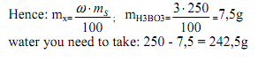
3.2. Calculation of the molar concentration of a solution.
Task. How many grams of sodium chloride is necessary for the preparation of 1L solution with C_{M} = 2 mol/l?
Solution: The formula for calculating the molar concentration:
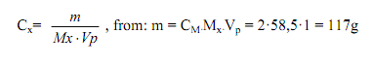
3.3. Calculation of the molar concentration equivalent.
Task. How many grams of KMnO₄ is required to prepare a 2l solution with C_{H} = 0,5 mol/l if the analysis are performed in acidic environment?
Solution:
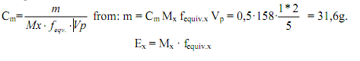
3.4. Calculation of molality concentration.
Task. Calculate the molality concentration of the solution prepared with 2g of KOH and 200g of water.
Solution: The formula for calculating molality concentration:
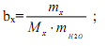
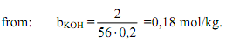
3.5. Calculation of titer.
Task. Calculate the titer of sulphuric acid, cw = 50% and ρ = 1,4 g/ml.
Solution: The formula for calculating the titer of the solution
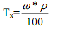
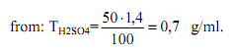
3.6. Relationship of different ways of expressing concentration.
Task. Find the molar concentration equivalent of sulfuric acid solution with mass fraction of 10% (density 1,22, f_{ekv}. = 1/2).
Solution: The formula for the transition from the mass of the particle to a molar
concentration equivalent to:
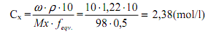
4. Task for the material:
4.1. Calculate the mass of water that is needed to 50g of sodium chloride solution with mass fraction NaCl 2% for solution with mass fraction of NaCl 0,9%.
4.2. Calculate the mass of water that is needed to 100g of sodium chloride solution with mass fraction NaCl 10% for solution with mass fraction of NaCl 0,9%.
4.3. Calculate the mass of water that is needed to 50g of sulfuric acid solution with mass fraction sulfuric acid 10% for solution with mass fraction of sulfuric acid 20%.
4.4. Mass fraction of sulfuric acid in solution 3,2%. Calculate the molar concentration equivalent of sulfuric acid in the solution (ρ = 1,02 g / ml).
Part 2: COLLIGATIVE PROPERTIES OF SOLUTIONS. OSMOSE.
1. Key questions of the theme:
1.1. The phenomenon of diffusion in solution. Semipermeable membrane. Osmose.
1.2. Osmotic law of Van't Hof equation for nonelectrolytes and electrolytes.
1.3. Isotonic coefficient, its relation with the degree of dissociation. Solutions: isotonic, hypotonic and hypertonic.
1.4. The biological significance of osmosis: isoosmosis, hemolysis, plasmolysis, turgor.
3. Standard test solution control.
Task: Calculate P_{osm}. sodium chloride solution with mass fraction 5,85% at 0° C. The degree of dissociation of sodium chloride 0,96, and ρ = 1,04 g / ml.
Solution: We translate the mass fraction in the molar concentration.
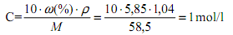
Let’s calculate the isotonic coefficient:
Osmotic pressure is calculated using the formula for the electrolytes:
2. Task for the material:
2.1. How many moles of nonelectrolyte are placed in 1 liter of solution at 0° C if Posm. = 1atm?
2.2. Is there an isotonic solution of urea and acetic acid by mass 0,6%, if the degree of dissociation of acetic acid is equal to 0,01, while the density of solutions - 1 g/ml.
2.3. Determine the molar concentration of sucrose solution which is isotonic relative to blood.
2.4. Calculate the isotonic coefficient of calcium chloride solution if the degree of dissociation of calcium chloride is equal to 68%.

