Federal state budgetary educational institute of the higher education
«Orenburg state medical university» of Ministry of Health of the Russian Federation»

ASSESSMENT FUND

FOR CURRENT PROGRESS MONITORING AND MIDTERM CERTIFICATION OF STUDENTS STUDYING ON DISCIPLINE

Nursing in therapy

majoring in (specialty)

31.05.01 General medicine, Faculty of Foreign Students

It is part of the main professional educational program of higher education majoring in (specialty) 31.05.01 General medicine, approved by the Academic Council of the FSBEI HE ORGMU of the Ministry of Health of Russia

protocol № 8 from «_25__» _March 2016

Orenburg

- Explanatory note

The Fund of estimated means on discipline contains the standard control and estimated materials for the current control, including control of independent work, and also for control of the results of training formed in the course of studying of discipline on intermediate certification in the form of examination.
Control and assessment materials of the current control of progress are distributed on themes of discipline and are accompanied by the indication of the used forms of control and criteria of assessment. Control and assessment materials for intermediate certification correspond to the form of intermediate certification of the discipline defined in the curriculum and aimed at checking the formation of knowledge and skills for each competence established in the work program of the discipline.
As a result of the study of the discipline in the student formed the following competencies:
ОПК-10 readiness to ensure the patient care and the provision of primary pre-medical health care
ОПК-11 readiness to use medical devices provided for in the procedures for providing medical care
ПК-11 readiness to provide emergency medical care for conditions requiring urgent medical intervention

- Assessment materials of the current control of academic performance

Assessment materials within the discipline (СIW)

The form of the current control of academic performance – аbstract defense.
Assessment materials within the discipline (СIW)

The form of the current control of academic performance – аbstract defense.

АBSTRACT DEFENSE TOPICS:
1. History of nursing.
2. Nurse and patient.
3.
4. Optimization of nursing care for patients with neuropsychiatric pathology in a specialized sanatorium.
5. Organization of nursing care in the intensive care unit.
6. Organization of nursing care for patients with gravesbody'sdisease.
7. Basic manipulations on the Nursing.
8. Features of the nursing process in emergency medicine.
9. The concept of body's biomechanics. Professional protection during transportation of patients
10. Professional stress. General patient care as an integral part of the treatment process.
11. Communication and psychological influence as an effective means of helping sick people.
12. Medical ethics and deontology in the work of medical personnel.
13. The doctor as the organizer of qualified patient care.
14. Moral and legal responsibility of medical workers.
15. The iatrogeny. Causes of occurrence, prevention.
16. Features of the work of nurses in the departments of palliative care.
17. Features of the work of nurses in hospices.
18. Simulation training and nursing skills.
19. Psychological problems of a sick person.
20. Professional burnout syndrome.

Assessment materials for each topic of the discipline:

Module 1. Participation of a nurse in the medical and diagnostic process

Topic 1. Nursing in nephrology

Forms of current monitoring of academic performance: сontrol of assignments in the workbook, solving problem-situational tasks, рractical task completion monitoring.

Assessment materials of the current control of academic performance:

ASSIGNMENTS IN THE WORKBOOK

Question № 1. List the patient's symptoms related to kidney disease
________________________________________________________________________________________________________________________________________________________________________________________________________________________

Question № 2: Fill the table
Urination Disorders
NAME OF DISORDER | CHARACTERISTIC OF DISORDER
Dysuria

Stranguria

Pollakiuria

Enuresis

Ischuria

Anuria

Oliguria

Nocturia

Polyuria

Question № 3: Fill the table
Differential diagnosis of edema
PARAMETERS | KIDNEY EDEMA | HEART EDEMA
Localization
Time of occurrence
Density (consistency)
The slew rate of edema

Question № 4: List the features of arterial hypertension of renal origin
________________________________________________________________________________________________________________________________________________________________________________________________________________________

Question № 5: Fill the table «Diets for kidney diseases»

 | Diet №__ | Diet №__ | Diet №__
Indications for use

Characteristic

Products that should be restricted or excluded

Question № 6: Explain to a 32-year-old female patient the rules for collecting urine for Zimnitsky test. ________________________________________________________________________________________________________________________________________________________________________________________________________________________________________________________________________________________________
Tell her what to do if the seventh container is empty at 3.00 a.m.
____________________________________________________________________________________________________________________________________
________________________________________________________________________
Tell her what to do if the fifth container is already full at 8 p.m.
________________________________________________________________________________________________________________________________________________

Question № 7: Fill the table (looking at the photos determine type of catheterization)

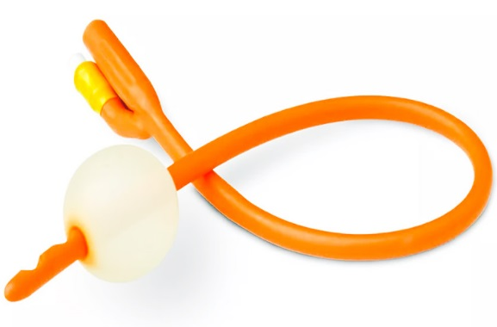
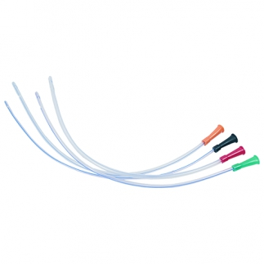
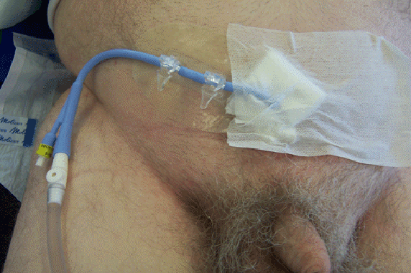

PROBLEM-SITUATIONAL TASKS

Task № 1. A 38-year-old patient with glomerulonephritis was admitted to the Nephrology Department
Questions
Give recommendations for the care of this patient (Assign the necessary regimen (ward, bed rest, strict bed rest or there’s no restriction of the routine activity) to this patient and explain why it is important to follow it.
Explain the rules of the regime to the patient in detail.
Tell him about Dietary restriction
________________________________________________________________________________________________________________________________________________________________________________________________________________________________________________________________________________________________

Task № 2. 42-year male patient woke up at night because of sudden sharp pain in the lumber region spread to the groin and painful urge for urination
Patient told previous night he had eaten a large portion of grilled meat. He describes this pain as the most intense painful experience in his life.
Objective data: Consciousness is clear, the patient cannot find a comfortable position. Body temperature is normal, pulse 100 BPM, BP 120/80 mm Hg Urination is frequent and painful, with blood.
Questions
Determine an emergency
Provide first aid at the pre-medical stage
________________________________________________________________________________________________________________________________________________________________________________________________________________________

Task 3. The patient complains of pain in the lower abdomen and a painful urge to urinate. According to the patient, the last urination was difficult about 9 hours ago. Objective data: patient's condition is satisfactory. Body temperature is normal, pulse 60 BPM, BP 120/80 mm Hg. In the lungs: vesicular breathing, no wheezes. The tongue is clean and moist. Palpation of the abdomen is difficult due to soreness, palpated full bladder
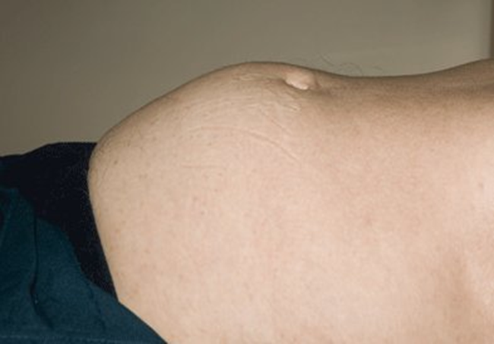
1. What diagnosis do you suggest?
__________________________________________________________________
2. What is first aid for this condition?
________________________________________________________________________________________________________________________________________________
3. What are the possible causes of this condition? ________________________________
________________________________________________________________________________________________________________________________________________

Task 4: The patient has an indwelling catheter installed. The patient's wife insists on being allowed to take care of the patient herself. The doctor agrees, but asks you to instruct her.
Question
Explain to her how to care for catheterized patient.
________________________________________________________________________________________________________________________________________________________________________________________________________________________
Task 5: The daily diuresis of the patient is 1000 ml of urine. The patient drank and administered 1000 ml of liquid parenterally per day.
Question
Evaluate the water balance
___________________________________________________________________________________________________________________________________________________________________________________________________________________

PRACTICAL TASKS TO DEMONSTRATE PRACTICAL SKILLS:

1. The algorithm of catheterization of the bladder to a woman
2. The algorithm of catheterization of the bladder to a man
3. An algorithm for catheterization of the bladder with a "permanent" urinary catheter
4. Algorithm for the care of a permanent urinary catheter

Topic 2. Nursing in Intensive Care

Forms of current monitoring of academic performance: сontrol of assignments in the workbook, solving problem-situational tasks, рractical task completion monitoring.

Assessment materials of the current control of academic performance:

ASSIGNMENTS IN THE WORKBOOK

Question № 1 Fill in the table
Differences between clinical and biological death
 | CLINICAL DEATH | BIOLOGICAL DEATH
Definition

Main symptoms

Question № 2. Define the CARDIO PULMONARY RESUSCITATION
________________________________________________________________________________________________________________________________________________________________________________________________________________________

Question № 3. Look at the picture and answer the questions
Describe the symptom shown in the picture, what does it mean?

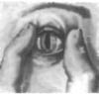
________________________________________________________________________________________________________________________________________________

Question № 4. What is the name and purpose of this procedure?
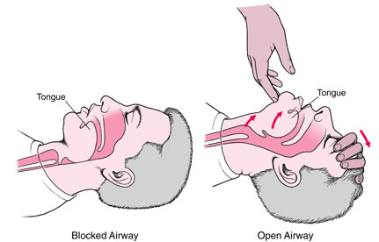
________________________________________________________________________________________________________________________________________________

Question № 5. What is the name and purpose of the device shown in the picture. Tell us about the rules for using this device.
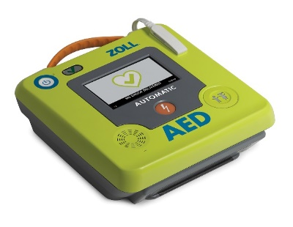
________________________________________________________________________________________________________________________________________________

Question № 6. Look at the pictures, identify errors in the actions of rescuers and fill in the table
Actions | Mistakes
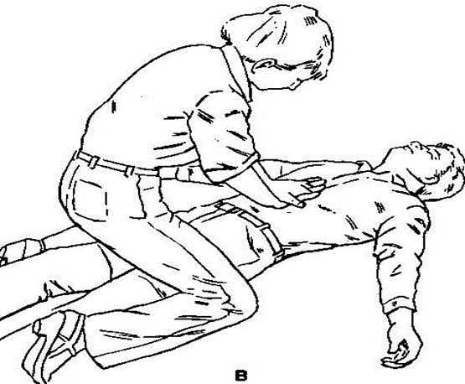
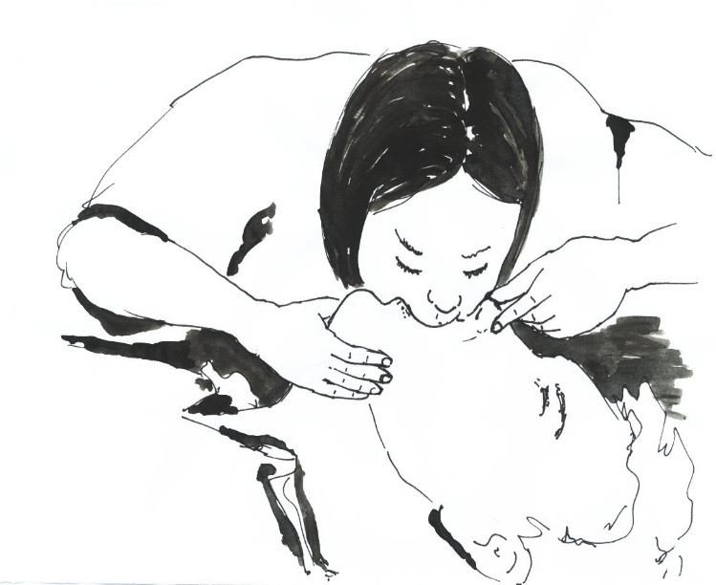

PROBLEM-SITUATIONAL TASKS

Task № 1. A 36-year-old patient died as a result of acute drug poisoning.
Questions
Determine the type of death (depending on the cause of death), explain your answer
________________________________________________________________________________________________________________________________________________________________________________________________________________________
Task № 2. A 56-year-old patient diagnosed with a myocardial infarction died in an ambulance. During the inspection the following data were obtained: there is no consciousness, breathing absent, pulse on carotid arteries is not defined, skin pale, pupils dilated.
Question
Determine the type of death (depending on the stages of dying), explain your answer
________________________________________________________________________________________________________________________________________________________________________________________________________________________

Task № 3. The ambulance arrived to the patient. During the examination, the following data were obtained; consciousness is absent, breath is absent, the pulse on the carotid arteries is not detected, when the pupil is examined, it takes the form of a cat's pupil, blue-red coloring of some parts of the body.
Question
Determine the type of death (depending on the stages of dying), explain your answer
_______________________________________________________________________________________________________________________________________________________________________________________________________________________

Task № 4. In the airport building, the man suddenly lost consciousness. During the examination, the following data were obtained: consciousness is absent, respiration is absent.
Questions
Determine the emergency condition
Describe the algorithm of your actions
________________________________________________________________________________________________________________________________________________________________________________________________________________________

Task№ 5. In the building, a man suddenly lost consciousness. The rescuer performed the following actions: 1. Checked consciousness 2. Restored patency of breath 3. Checked breath 4. Went to the administrator for a defibrillator 5. Used a defibrillator 6. Performed the CAB algorithm (30 compressions and 2 breaths) for 30 minutes.
Questions
Evaluate the actions of the rescuer, explain his mistakes
________________________________________________________________________________________________________________________________________________________________________________________________________________________

Task № 6. When carrying out artificial lung ventilation by technique mouth-to-mouth rescuer noticed that there is no movement of the chest (during ventilation the chest must rise and fall).
Questions
List possible causes of that
________________________________________________________________________________________________________________________________________________

PRACTICAL TASKS TO DEMONSTRATE PRACTICAL SKILLS:

1. Assessment of the patient's consciousness
2. Algorithm for determining the central and peripheral pulse
3. Algorithm for determining respiration
4. Algorithm for conducting cardiopulmonary resuscitation

Topic 3. Emergency conditions in therapeutic practice

Forms of current monitoring of academic performance: сontrol of assignments in the workbook, solving problem-situational tasks, рractical task completion monitoring.

Assessment materials of the current control of academic performance:

ASSIGNMENTS IN THE WORKBOOK

Question № 1. Give a description of the heart pain
* Localization of pain _______________
* Reasons and conditions of pain occurrence ________________
* Nature of pain ________________________
* Pain commonly irradiates ______________________
* The pain is usually removed by ____________

Question № 2. Сompare the clinical picture of Heart and Bronchial asthma and emergency care, fill in the table

INDICATES | CARDIAC ASTHMA | BRONCIAL ASTHMA
AGE OF PATIENTS

PAST HYSTORY

TYPE OF DYSPNEA

CHARACTER OF SPUTUM
SKIN COLOR

BREATHING SOUNDS
FORCED POSITION
FIRST AID

Question № 3. Сompare clinical picture of Collapse and Syncopy, fill in the table

INDICATES | SYNCOPE | COLLAPSE
CAUSES
CONSIOSNESS
BLOOD PRESSURE
DURATION
FIRST AID

Question № 4. Select symptoms related to the upper and lower gastrointestinal tract. Fill in the table
COFFEE GROUND VOMIT
HEMOPTYSIS
MELENA
IMPURITY OF BLOOD IN VOMIT OF PIMK COLOR
FRESH BLOOD IN STOOL
NOSE BLEEDING

Upper GIT bleeding | Lower GIT bleeding

Question № 5. What position should be given to the patient in different emergency conditions. Fill the table

Emergency condition | Position which should be given
Gastrointestinal bleeding
Hypertensive crisis
Collapse
Pulmonary hemorrhage
Syncope
Cardiac asthma
Bronchial asthma

PROBLEM-SITUATIONAL TASKS

TASK № 1. The patient complains of severe pain behind the sternum. The pain started about an hour ago. The patient had taken 2 nitroglycerin tablets without effect. Anamnesis data: the patient has been suffering from coronary heart disease for about 10 years.
Question
Your presumed diagnosis and emergency care
________________________________________________________________________________________________________________________________________________________________________________________________________________________

TASK № 2. A 67-year-old patient woke up at night with a sudden feeling of suffocation. Objective data; the condition is severe, the patient is sitting on the bed with his legs down, breathing is difficult breathing rate is 35 per minute, shortness of breath with difficulty inhaling, at a distance you can hear wet wheezes, pink frothy sputum. life history: suffered a myocardial infarction 3 years ago
Question
Your presumed diagnosis and emergency care
________________________________________________________________________________________________________________________________________________________________________________________________________________________

TASK № 3. A 43-year- old patient suffering from stomach ulcers complains of weakness, dizziness and black stools.
Question
What are the presumptive diagnosis?
________________________________________________________________________________________________________________________________________________________________________________________________________________________
/
TASK № 4. The patient of the infectious Department complains of severe weakness. Objective data: the patient is inhibited, answers questions late, the skin is pale, BP is 80 /50 mm Hg, the temperature dropped within an hour from 39 C to 36.2 C.
Question
Identify an emergency and provide first aid
________________________________________________________________________________________________________________________________________________

TASK № 5. A patient in the cardiology Department complained of pain behind the sternum. Objective data: blood PRESSURE 90/70 mm Hg, pulse rate 110 in a min. The nurse gave the patient nitroglycerin under the tongue.
Question
Whether you agree with the actions of the nurse
Explain your answer
________________________________________________________________________________________________________________________________________________________________________________________________________________________

TASK № 6. A nurse came to a patient diagnosed with lung cancer to administer pain medication. The patient started coughing with the release of red foamy blood.
Question
Identify an emergency and provide first aid
________________________________________________________________________________________________________________________________________________________________________________________________________________________

TASK № 7. A 52 year old patient suffering from arterial hypertension has come to you with the following complaints: a sharp headache in the occipital region that appeared about 15 minutes ago after emotional stress. Objective data: facial hyperemia, BP 195/90 mm Hg pulse 74 BPM
Question
Identify an emergency and provide first aid
________________________________________________________________________________________________________________________________________________________________________________________________________________________

PRACTICAL TASKS TO DEMONSTRATE PRACTICAL SKILLS:

1. Algorithm for measuring blood pressure
2. Algorithm for determining the pulse in the central and peripheral arteries
3. Algorithm for evaluating the patient's breathing
4. Algorithm for oxygen administration

Topic 4. Nursing in allergology, neurology, and infectious diseases

Forms of current monitoring of academic performance: сontrol of assignments in the workbook, solving problem-situational tasks, рractical task completion monitoring.

Assessment materials of the current control of academic performance:

ASSIGNMENTS IN THE WORKBOOK
Question № 1. Fill the table

Classification based on how the allergen enters the body
Way of entering | Examples of allergens

Question № 2. Give the definition of Anaphylactic shock
________________________________________________________________________________________________________________________________________________________________________________________________________________________________________________________________________________________________

Question № 3. In your opinion, the symptom of what disease is depicted in the pictures (characterized as itchy blistering rashes)
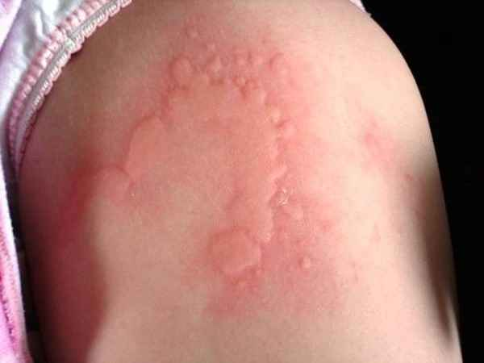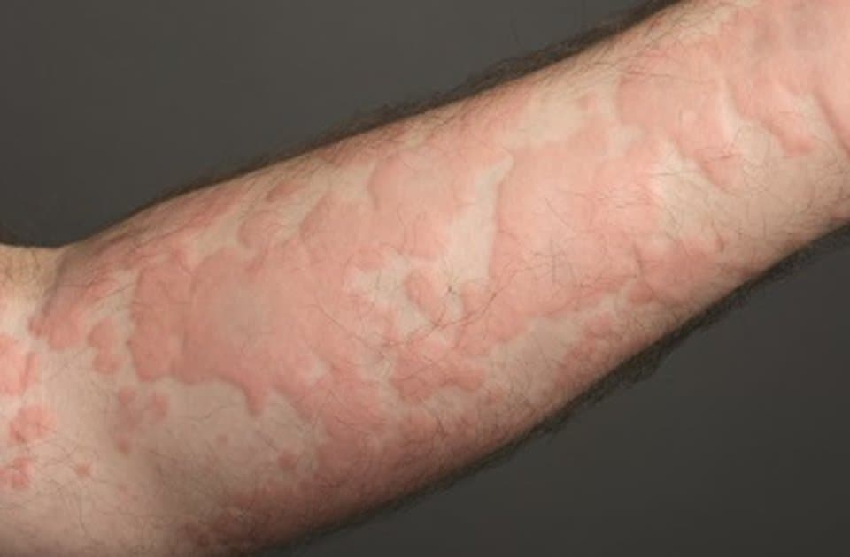

________________________________________________________________________________________________________________________________________________

Question № 4. Describe the plan of nursing interventions for allergic diseases
________________________________________________________________________________________________________________________________________________________________________________________________________________________________________________________________________________________________
Question № 5. Describe the symptoms of the Fever, depending on its stage, and the care plan. Fill in the table

Stages of Fever | Symptoms | Nursing care

Question № 6. Make a graphic record of the curve and determine the type of fever by the nature of the fluctuations.
Days Morning ( ° C) Evening (° C)
1day 37,2 40,7
2day 37,0 40,3
3day 37,4 40,5
4day 36,8 40,0
5day 37,1 40,2
6day 36,6 39,9
7day 36,7 39,8
________________________________________________________________________________________________________________________________________________________________________________________________________________________

Question № 7. Make a graphic record of the curve and determine the type of fever by the nature of the fluctuations.
Days Morning (° C) Evening (° C)
1day 36,7 37,3
2day 37,1 37,8
3day 36,9 37,7
4day 36,6 37,3
5day 37,1 37,9
6day 37,0 37,8
7day 36,8 37,5
____________________________________________________________________________________________________________________________________________________________________________________________________________________________________________________________________________________________________________________________________________________

PROBLEM-SITUATIONAL TASKS

Task № 1. When examining a feverish patient, the following data were obtained: the Patient complains of chills (cannot warm up), headache, muscle pain, weakness. On examination, the condition is satisfactory, the position in bed is active, the skin is pale and cold, the heart rate is 115 BPM, BP 130/70mm Hg, breathing is free 20 per minute, temperature 38.5 ° C
Questions:
1. Determine the stage of fever
2. Write the rules for the care of the patient
________________________________________________________________________________________________________________________________________________________________________________________________________________________

Task № 2. When examining a feverish patient, the following data were obtained: the patient's condition is severe, consciousness is confused (the patient is delirious) the position in bed is passive due to pronounced weakness, the skin is hyperemic, there is dryness of the skin and mucous membranes (cracks on the lips) the tongue is covered with a gray coating, the heart rate is 130 BPM, BP 140/80 mm Hg, breathing 32 per minute, temperature 41 ° C
Questions:
1. Determine the stage of fever
2. Write the rules for the care of the patient
3. Tell about the principles of nutrition of this patient (specify the number of the diet)
________________________________________________________________________________________________________________________________________________

Task № 3. During the intravenous administration of the drug, the patient complained of severe heat in the body and difficulty breathing. After a few seconds, he lost consciousness. Objective data: pronounced facial hyperemia and blistering rashes, blood pressure is not determined, breathing is stridorous.
Questions
Identify an emergency and provide first aid
________________________________________________________________________________________________________________________________________________________________________________________________________________________

Task № 4. Patient suddenly started blankly for a few seconds then repeatedly twitched his arms and legs and Lost of consciousness. During the attack, white foam was released from the mouth
Questions
Determine the emergency condition
Provide first aid
________________________________________________________________________________________________________________________________________________________________________________________________________________________________________________________________________________________________

PRACTICAL TASKS TO DEMONSTRATE PRACTICAL SKILLS:

1. Algorithm for providing emergency care for Anaphylactic shock
2. Algorithm for providing emergency care for Convulsions
3. Algorithm for applying a cold compress for fever
4. Algorithm for intramuscular administration of Epinephrine

Topic 5. Manipulation techniques in nursing practice

Forms of current monitoring of academic performance: сontrol of assignments in the workbook, solving problem-situational tasks, рractical task completion monitoring.

Assessment materials of the current control of academic performance:

ASSIGNMENTS IN THE WORKBOOK

Question № 1. Requirements for the treatment of the hands of medical personnel. After studying the appropriate manipulation algorithm, fill in the following diagrams:

Hand treatment
in a hygienic way.

Levels
The algorithm:

The algorithm:

Question № 2. The requirements for personal hygiene and clothes for medical personnel. After studying the appropriate manipulation algorithm, fill in the following diagrams:

?
?
?

Protective clothing
?
?

?

Question № 3. ANTI-AIDS KIT
After studying the algorithm of the manipulation "ANTI-AIDS KIT", mark on the diagram your actions when blood gets on the mucous membrane of the eye, nose, mouth, and skin.
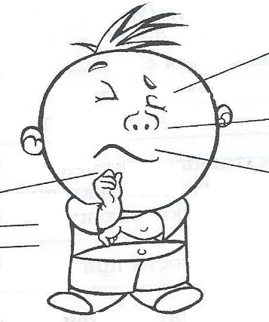

Question № 4. Fill in the table.
Parenteral method of drug administration
Injection | Syringe volume | Needle length | Injection site
Subcutaneous
injection

Intramuscular injection

Intravenous injection

Question № 5. Fill in the table
The simplest methods of physical therapy
Method of physical therapy | Indications | Contraindications
Cold applications

Heat applications

Question № 6. A medical college student is undergoing an internship at the therapeutic department. While working in the treatment room, she pricked her finger with an infected needle. She has not been vaccinated against hepatitis B.
List the contents of the first aid kit ANTI-AIDS:
________________________________________________________________________________________________________________________________________________________________________________________________________________________

PROBLEM-SITUATIONAL TASKS

TASK № 1. In the neurological department there is a patient receiving treatment for acute cerebral circulatory disorders. The patient has serious motor activity disorders in the right arm and leg, a violation of the swallowing process. The patient is on artificial nutrition through a nasogastric tube.
Questions
Determine what vital needs are violated in the patient.
__________________________________________________________________________________________________________________________________________________
What kind of a diet prescribed by a doctor?
__________________________________________________________________________________________________________________________________________________

TASK № 2. A patient with severe chronic heart failure is in the cardiology department for treatment. Due to the deterioration of the patient's condition, the doctor prescribed bed rest.
Question
Name the potential problems of the patient. Your actions in the event of these problems.
___________________________________________________________________________________________________________________________________________________________________________________________________________________________

TASK № 3. The patient has chronic catarrhal rhinitis. The attending physician prescribed instillation of nose drops to restore nasal breathing 3 times a day. The patient performed the procedure independently. After the next instillation, the patient complained to the nurse about unpleasant sensations after instilling in the throat, the appearance of a taste of the drug in the mouth, the lack of effect.
Question
What mistake does the patient make when performing the manipulation?
___________________________________________________________________________________________________________________________________________________________________________________________________________________________

TASK № 4. The patient is on an intravenous infusion in the treatment room. 5 minutes after the start of the infusion, he complained of shortness of breath and chills.
Question
What the emergency condition can you suspect? Your actions.
___________________________________________________________________________________________________________________________________________________________________________________________________________________________

TASK № 5. The patient is on inpatient treatment in the pulmonology department. She was prescribed a course of treatment with antibiotics. In the evening, the patient turned to the nurse on duty with complaints of pain in the area of the right buttock. During the examination, the nurse determined a swelling, a seal at the injection site.
Questions
What possible complication of injections did the patient develop?
Specify the possible cause of this condition, make a care plan.
________________________________________________________________________________________________________________________________________________

PRACTICAL TASKS TO DEMONSTRATE PRACTICAL SKILLS:

1. Blood collection from the peripheral vein with a syringe
2. Intradermal administration of drugs
3. Intravenous-jet injection of drugs
4. Subcutaneous administration of drugs
5. Subcutaneous administration of drugs
6. Intravenous-drip administration of medicines
7. Setting up a medical hot water bottle
8. Setting up an ice bubble
9. Setting up a wet warming compress
10. Instillation in the ears
11. Instilling drops in the eyes
12. Instilling drops in the nose
13. Carrying out catheterization of the bladder in men
14. Carrying out catheterization of the bladder in women

Topic 6. Instrumental methods of examination of the patient. Types of instrumental methods, general presentation. Preparation of the patient for instrumental methods. Laboratory research methods. The method of collecting tests of urine, sputum, blood, feces.

Forms of current monitoring of academic performance: сontrol of assignments in the workbook, solving problem-situational tasks, рractical task completion monitoring.

Assessment materials of the current control of academic performance:

ASSIGNMENTS IN THE WORKBOOK

Question № 1. List the Most common laboratory tests:
1. _________________________
2._________________________
3._________________________

Question № 2. Fill the table

Key red blood cells indices
Name | Abbreviation | What does it mean
 | RBC
 | Hb
 | MCV
 | Hct

Question № 3. Fill the table
Laboratory and instrumental methods of research
Types of Laboratory and instrumental methods | Research methods related to this type
Radiological methods

Endoscopic methods

Functional methods

Question № 4. Describe the stages of preparation of the patient for Irrigoscopy

3 days before examination

In the evening before examination

In the morning of day examination

Question № 5. What are the main endoscopic methods for examining various organs? Fill the table

Organs to be examined | Name of the method
examination of the trachea and bronchi
examination of the esophagus
examination of the esophagus, stomach and duodenum
examination of the colon
examination of the rectum and sigmoid colon
examination of the bladder
examination of the abdominal cavity ( is an invasive operation)

PROBLEM-SITUATIONAL TASKS
TASK 1. At 22 o'clock, a patient who will have a cholecystography in the morning asked you if he could eat a little now, as a strong feeling of hunger prevents him from falling asleep.
Questions
Your tactics?

TASK 2. The patient is in the hospital for chronic cholecystitis and in a day he will have a cholecystography. The patient's relatives brought him a transfer; milk, apples, cookies, boiled chicken.
Questions
What should you do?
Explain your actions
________________________________________________________________________________________________________________________________________________________________________________________________________________________

TASK 3. The patient, who was scheduled for FGDS, took medication in the morning, when it turned out, he said that the nurse warned him that he should not start eating before the examination. The patient did not have breakfast.
Questions
What is the mistake of the ward nurse?
Is it possible to perform FGDS for this patient?
______________________________________________________________________________________________________________________________________________________________________________________________________________________________

TASK 4. The patient is prescribed intravenous urography. The patient suffers from constipation, complains of poor gas discharge.
Questions
Your tactics?
______________________________________________________________________________________________________________________________________________________________________________________________________________

TASK 5. The patient is scheduled for a colonoscopy. The nurse recommended that he exclude black bread, vegetables, fruits, milk, and sweets from his diet. The patient was given two cleansing enemas with a capacity of 1 liter - one the day before at 10 pm. The other is 30 minutes before the study.
Questions
What is the nurse mistake?
__________________________________________________________________________________________________________________________________________________________________________________________________________________________

Assessment materials of the current control of academic performance:

QUESTIONS TO THE RECITATION
1. The main complaints of patients with kidney diseases.
2. Preparation of the patient for urine tests (urine according to Zimnitsky, Nechiporenko, general urine analysis)
3. Indications for catheterization of the bladder.
4. Emergency conditions in nephrology (emergency care for an attack of renal colic)
5. Symptoms of clinical death.
6. Symptoms of biological death.
7. Algorithm of cardiopulmonary resuscitation.
8. An attack of bronchial asthma, the causes, the main pathogenetic mechanisms, the clinic, help at the pre-medical stage.
9. Laryngeal stenosis, causes, main pathogenetic mechanisms, clinic, primary pre-medical medical care.
10. Acute left ventricular failure syndrome: an attack of cardiac asthma and pulmonary edema. The causes, the main pathogenetic mechanisms, the clinic, the help at the pre-medical stage.
11. Hypertensive crisis, causes, main pathogenetic mechanisms, clinic, help at the pre-medical stage.
12. Angina, causes, main pathogenetic mechanisms, clinic, pre-medical care.
13. Myocardial infarction, causes, main pathogenetic mechanisms, clinic, pre-medical care.
14. Symptoms of anaphylactic shock, main pathogenetic mechanisms
15. Emergency care for anaphylactic shock.
16. Fever, definition, stages of fever. Care for a feverish patient
.
PRACTICAL TASKS TO DEMONSTRATE PRACTICAL SKILLS:

1. Algorithm of urinary bladder catheterization in women.
2. The algorithm of urinary bladder catheterization in men
3. Algorithm of cardiopulmonary resuscitation.
4. The algorithm for evaluating respiration.
5. Algorithm for determining the pulse in the central and peripheral arteries.

Assessment criteria used in the current control of progress, including the monitoring of students' independent work.
Monitoring form | Assessment criteria
Recitation | On "FIVE POINTS" the answer is assessed, which shows solid knowledge of the main questions of the studied material, is distinguished by the depth and completeness of the disclosure of the topic; knowledge of the terminological apparatus; the ability to explain the essence of phenomena, processes, events, draw conclusions and generalizations, give reasoned answers, give examples; fluency in monologue speech, consistency and consistency of the answer.
 | On "FOUR POINTS" the answer is assessed, which reveals a solid knowledge of the basic questions of the studied material, differs in the depth and completeness of the disclosure of the topic; knowledge of the terminological apparatus; the ability to explain the essence of phenomena, processes, events, draw conclusions and generalizations, give reasoned answers, give examples; fluency in monologue speech, consistency and consistency of the answer. However, one or two inaccuracies in the answer are allowed.
 | On "THREE POINTS" the answer is assessed, which testifies mainly to the knowledge of the studied material, which is characterized by insufficient depth and completeness of the disclosure of the topic; knowledge of the basic issues of theory; poorly formed skills in analyzing phenomena, processes, insufficient ability to give reasoned answers and give examples; lack of fluency in monologue speech, logic and consistency of the answer. Several mistakes are allowed in the content of the answer.
 | On "TWO POINTS" the answer is assessed, revealing ignorance of the studied material, characterized by a shallow disclosure of the topic; ignorance of the main issues of theory, unformed skills in the analysis of phenomena, processes; inability to give reasoned answers, weak command of monologue speech, lack of consistency and consistency. Serious errors in the content of the answer are allowed.
 | ZERO POINTS" is given if there is no answer
Problem-situational tasks | "FIVE POINTS" - the student correctly and fully conducts the initial assessment of the condition, independently identifies the satisfaction of which needs are violated, determines the patient's problems, sets goals and plans nursing interventions with their justification, conducts current and final assessment.
 | "FOUR POINTS" - the student correctly conducts the initial assessment of the condition, identifies the satisfaction of what needs are violated, determines the patient's problems, sets goals and plans nursing interventions with their justification, conducts the current and final assessment. Some minor difficulties in answering are allowed; justification and final assessment is carried out with additional comments from the teacher.
 | "THREE POINTS" - the student correctly but incompletely conducts the initial assessment of the patient's condition. Identifying the satisfaction of what needs are violated, determining the patient's problem is possible with leading questions from the teacher. Sets goals and plans for nursing interventions without justification, conducts ongoing and final assessment with leading questions from the teacher; Difficulties with a comprehensive assessment of the proposed situation.
 | "TWO POINTS" - wrong assessment of the situation; incorrectly chosen tactics of action.
 | "ZERO POINTS" is set if there is no answer.
Practical skills | "FIVE POINTS". The student has shown full knowledge of the program material, the workplace is equipped with all the requirements for preparation for performing manipulations; practical actions are performed sequentially in accordance with the algorithm for performing manipulations; all requirements for the safety of the patient and medical staff are observed; the time limit is observed; the workplace is cleaned in accordance with the requirements of the sanitary and epidemiological supervision; all actions are justified.
 | "FOUR POINTS". The student has shown complete knowledge of the program material, the workplace is not fully independently equipped to perform practical manipulations; practical actions are performed consistently, but not confidently; all requirements for the safety of the patient and medical staff are observed; time regulations are violated; the workplace is cleaned in accordance with the requirements of the sanitary and epidemiological regime; all actions are justified with clarifying questions of the teacher, made small mistakes or inaccuracies.
 | "THREE POINTS". The student showed knowledge of the basic program material in the amount necessary for the upcoming professional activity, but made no more than one fundamental mistake, the workplace is not fully equipped to perform practical manipulations; the sequence of their implementation is broken; unsure actions, leading and additional questions and comments of the teacher are needed to justify actions; all requirements for the safety of the patient and medical staff are observed; the workplace is cleaned in accordance with the requirements of the sanitary and epidemiological regime.
 | "TWO POINTS". The student discovered significant gaps in the knowledge of the practical skill algorithm, made more than one fundamental mistake, difficulties in preparing the workplace, the inability to independently perform practical manipulations; actions are taken that violate the safety of the patient and the medical staff, the requirements of the sanitary and epidemiological regime, safety measures when working with the equipment and materials used are violated.
 | "ZERO POINTS" is given if there is no answer
Abstract defense | "FIVE POINTS" is awarded if the student fulfills all the requirements for writing and defending the abstract: the problem is identified and its relevance is justified, a brief analysis of various points of view on the problem under consideration is made and their own position is logically stated, conclusions are formulated, the topic is fully disclosed, the volume is maintained, requirements for the external design, the correct answers to additional questions are given.
 | "FOUR POINTS" is given if the students meet the basic requirements for the abstract and its defense, but at the same time there are some mistakes. In particular, there are inaccuracies in the presentation of the material; there is no logical consistency in judgments; the volume of the abstract is not kept; there are omissions in the design; incomplete answers were given to additional questions during the defense.
 | "THREE POINTS" is given if the student allows significant deviations from the requirements for abstracting. In particular, the topic is covered only partially; factual errors were made in the content of the abstract or when answering additional questions; there is no output during protection.
 | "TWO POINTS" is given if the topic of the abstract is not disclosed to the students, a significant misunderstanding of the problem is revealed.
 | "ZERO POINTS" is given if there is no answer
Control of assignments in the workbook | "FIVE POINTS" is given to a student if he knows the conceptual apparatus, demonstrates the depth and complete mastery of the content of the educational material, in which he is easily oriented.
 | "FOUR POINTS" are given to the student for the ability to correctly present the material, but the content and form of the answer may have some inaccuracies.
 | "THREE POINTS" is awarded if a student discovers knowledge and understanding of the main provisions of the educational material, but expresses it incompletely, inconsistently, makes inaccuracies in the definition of concepts, does not know how to substantiate his judgments with evidence.
 | "TWO POINTS" is given if a student has scattered, unsystematic knowledge, does not know how to distinguish the main and the secondary, makes mistakes in the definition of concepts, distorts their meaning.
 | "ZERO POINTS" is set if there is no answer.

3. Assessment materials for the midterm certification of students
The discipline has Intermediate certification. Ticket contain two theoretical questions (in oral form), one practical question (in the form of a demonstration of practical skills).

Evaluating criteria students on the intermediate certification

Table 3.1
Criteria for evaluating the Recitation (5-point system)
Assessment | Assessment criteria
5 | On "FIVE POINTS" the answer is assessed, which shows solid knowledge of the main questions of the studied material, is distinguished by the depth and completeness of the disclosure of the topic; knowledge of the terminological apparatus; the ability to explain the essence of phenomena, processes, events, draw conclusions and generalizations, give reasoned answers, give examples; fluency in monologue speech, consistency and consistency of the answer.
4 | On "FOUR POINTS" the answer is assessed, which reveals a solid knowledge of the basic questions of the studied material, differs in the depth and completeness of the disclosure of the topic; knowledge of the terminological apparatus; the ability to explain the essence of phenomena, processes, events, draw conclusions and generalizations, give reasoned answers, give examples; fluency in monologue speech, consistency and consistency of the answer. However, one or two inaccuracies in the answer are allowed.
3 | On "THREE POINTS" the answer is assessed, which testifies mainly to the knowledge of the studied material, which is characterized by insufficient depth and completeness of the disclosure of the topic; knowledge of the basic issues of theory; poorly formed skills in analyzing phenomena, processes, insufficient ability to give reasoned answers and give examples; lack of fluency in monologue speech, logic and consistency of the answer. Several mistakes are allowed in the content of the answer.
2 | On "TWO POINTS" the answer is assessed, revealing ignorance of the studied material, characterized by a shallow disclosure of the topic; ignorance of the main issues of theory, unformed skills in the analysis of phenomena, processes; inability to give reasoned answers, weak command of monologue speech, lack of consistency and consistency. Serious errors in the content of the answer are allowed.
0 | ZERO POINTS" is given if there is no answer

Table 3.1
Criteria for evaluating the Practical skill (5-point system)
Assessment | Assessment criteria
5 | "FIVE POINTS". The student has shown full knowledge of the program material, the workplace is equipped with all the requirements for preparation for performing manipulations; practical actions are performed sequentially in accordance with the algorithm for performing manipulations; all requirements for the safety of the patient and medical staff are observed; the time limit is observed; the workplace is cleaned in accordance with the requirements of the sanitary and epidemiological supervision; all actions are justified.
4 | "FOUR POINTS". The student has shown complete knowledge of the program material, the workplace is not fully independently equipped to perform practical manipulations; practical actions are performed consistently, but not confidently; all requirements for the safety of the patient and medical staff are observed; time regulations are violated; the workplace is cleaned in accordance with the requirements of the sanitary and epidemiological regime; all actions are justified with clarifying questions of the teacher, made small mistakes or inaccuracies.
3 | "THREE POINTS". The student showed knowledge of the basic program material in the amount necessary for the upcoming professional activity, but made no more than one fundamental mistake, the workplace is not fully equipped to perform practical manipulations; the sequence of their implementation is broken; unsure actions, leading and additional questions and comments of the teacher are needed to justify actions; all requirements for the safety of the patient and medical staff are observed; the workplace is cleaned in accordance with the requirements of the sanitary and epidemiological regime.
2 | "TWO POINTS". The student discovered significant gaps in the knowledge of the practical skill algorithm, made more than one fundamental mistake, difficulties in preparing the workplace, the inability to independently perform practical manipulations; actions are taken that violate the safety of the patient and the medical staff, the requirements of the sanitary and epidemiological regime, safety measures when working with the equipment and materials used are violated.
0 | "ZERO POINTS" is given if there is no answer
Table 3.3
Formation of the final assessment of the midterm certification
Stage | Content | Assessment
1 | Recitation | 0 - 5
2 | Recitation | 0 - 5
3 | Practical skill | 0 - 5
RESULT | FINAL ASSESSMENT | 0 - 15

The translation system Final Assessment of the midterm certification from 5-point to 30-point for the purpose of standardization

Calculated by the formula:
FA = (Aa * 30)/мак (Aa)
Where:
FA – final assessment for the midterm certification;
Aa – actual assessment for the midterm certification;
Мах (Aa) мак assessment for the midterm certification (15);
Midterm certification in the discipline is passed if the student received:
- final assessment for the midterm certification at least 15 points
- current standardized rating of at least 35 points

The disciplinary rating for the discipline (Dr) is calculated according to the formula:
Dr = current standardized rating + final assessment for the midterm certification
Questions for testing the theoretical knowledge of the discipline

1. Symptoms of clinical death
2. Symptoms of biological death
3. Stages of cardiopulmonary resuscitation
4. Termination conditions CPR
5. Physical methods of research
6. Sources of information
7. Types of information
8. Methods of examination of patients
9. The main parts of the questioning of patients
10. The methods of physical of examination of patients
11. Plan of general inspection
12. Types of general condition
13. Quantitative violations consciousness
14. Qualitative impairment of consciousness (mental disorders)
15. The position of the patient
16. Body types
17. Skin and visible mucous membranes examination
18. Assessment of subcutaneous fat
19. Methods of peripheral edema determination
20. Main vital functions evaluation
21. Stages of the fever
22. Nursing care in fevers
23. Properties of normal urine
24. Main symptoms of urinary system pathology (change of urine properties,
25. Urinary disorder, swellings, pain in the lumbar region, increased blood pressure.
26. Urinary disorder
27. Laboratory methods of urine examination. Type, general principles of urine collection for analysis. clinical urine analysis, nechiporenko test, zimnitsky test.
28. General recommendations on the care for patients with kidney diseases
29. Renal colic, symptoms, first aid.
30. Acute urinary retention, symptoms, first aid.
31. Pulmonary bleeding, symptoms, first aid.
32. Bronchial asthma attack, symptoms, first aid.
33. Gastrointestinal bleeding, symptoms, first aid.
34. Acute abdominal pain, symptoms, first aid.
35. Heart pain (stenocardia, myocardial infarction) , symptoms, first aid.
36. Cardiac asthma, symptoms, first aid.
37. Hypertensive crisis, symptoms, first aid.
38. Fainting/syncope, symptoms, first aid.
39. Collapse, symptoms, first aid.
40. Stroke, Risk factors, symptoms, first aid.
41. Anaphylactic shock, symptoms, first aid.
42. Bronchial asthma attack, clinic, premedical aid.
43. Stenocardia. Clinic. First Aid (predoctor care).
44. Hypertensive crisis. Clinic. First Aid (predoctor care).
45. Syncope. Clinic. First Aid (predoctor care).
46. Collapse. Clinic. First Aid (predoctor care).
47. Define Diabetes. Differences between type 1 and type 2 diabetes
48. Complications of diabetes mellitus
49. Symptoms of hyperglycemia
50. Symptoms and signs of ketoacidosis
51. Symptoms of hypoglycemia.
52. Diabetes. Chronic complications.
1. Symptoms of clinical death
2. Symptoms of biological death
3. Stages of cardiopulmonary resuscitation
4. Termination conditions CPR
5. Physical methods of research
6. Sources of information
7. Types of information
8. Methods of examination of patients
9. The main parts of the questioning of patients
10. The methods of physical of examination of patients
11. Plan of general inspection
12. Types of general condition
13. Quantitative violations consciousness
14. Qualitative impairment of consciousness (mental disorders)
15. The position of the patient
16. Body types
17. Skin and visible mucous membranes examination
18. Assessment of subcutaneous fat
19. Methods of peripheral edema determination
20. Main vital functions evaluation
21. Stages of the fever
22. Nursing care in fevers
23. Properties of normal urine
24. Main symptoms of urinary system pathology (change of urine properties,
25. Urinary disorder, swellings, pain in the lumbar region, increased blood pressure.
26. Urinary disorder
27. Laboratory methods of urine examination. Type, general principles of urine collection for analysis. clinical urine analysis, nechiporenko test, zimnitsky test.
28. General recommendations on the care for patients with kidney diseases
29. Renal colic, symptoms, first aid.
30. Acute urinary retention, symptoms, first aid.
31. Pulmonary bleeding, symptoms, first aid.
32. Bronchial asthma attack, symptoms, first aid.
33. Gastrointestinal bleeding, symptoms, first aid.
34. Acute abdominal pain, symptoms, first aid.
35. Heart pain (stenocardia, myocardial infarction) , symptoms, first aid.
36. Cardiac asthma, symptoms, first aid.
37. Hypertensive crisis, symptoms, first aid.
38. Fainting/syncope, symptoms, first aid.
39. Collapse, symptoms, first aid.
40. Stroke, Risk factors, symptoms, first aid.
41. Anaphylactic shock, symptoms, first aid.
42. Bronchial asthma attack, clinic, premedical aid.
43. Stenocardia. Clinic. First Aid (predoctor care).
44. Hypertensive crisis. Clinic. First Aid (predoctor care).
45. Syncope. Clinic. First Aid (predoctor care).
46. Collapse. Clinic. First Aid (predoctor care).
47. Define Diabetes. Differences between type 1 and type 2 diabetes
48. Complications of diabetes mellitus
49. Symptoms of hyperglycemia
50. Symptoms and signs of ketoacidosis
51. Symptoms of hypoglycemia.
52. Diabetes. Chronic complications.
1. Symptoms of clinical death
2. Symptoms of biological death
3. Stages of cardiopulmonary resuscitation
4. Termination conditions CPR
5. Physical methods of research
6. Sources of information
7. Types of information
8. Methods of examination of patients
9. The main parts of the questioning of patients
10. The methods of physical of examination of patients
11. Plan of general inspection
12. Types of general condition
13. Quantitative violations consciousness
14. Qualitative impairment of consciousness (mental disorders)
15. The position of the patient
16. Body types
17. Skin and visible mucous membranes examination
18. Assessment of subcutaneous fat
19. Methods of peripheral edema determination
20. Main vital functions evaluation
21. Stages of the fever
22. Nursing care in fevers
23. Properties of normal urine
24. Main symptoms of urinary system pathology (change of urine properties,
25. Urinary disorder, swellings, pain in the lumbar region, increased blood pressure.
26. Urinary disorder
27. Laboratory methods of urine examination. Type, general principles of urine collection for analysis. clinical urine analysis, nechiporenko test, zimnitsky test.
28. General recommendations on the care for patients with kidney diseases
29. Renal colic, symptoms, first aid.
30. Acute urinary retention, symptoms, first aid.
31. Pulmonary bleeding, symptoms, first aid.
32. Bronchial asthma attack, symptoms, first aid.
33. Gastrointestinal bleeding, symptoms, first aid.
34. Acute abdominal pain, symptoms, first aid.
35. Heart pain (stenocardia, myocardial infarction) , symptoms, first aid.
36. Cardiac asthma, symptoms, first aid.
37. Hypertensive crisis, symptoms, first aid.
38. Fainting/syncope, symptoms, first aid.
39. Collapse, symptoms, first aid.
40. Stroke, Risk factors, symptoms, first aid.
41. Anaphylactic shock, symptoms, first aid.
42. Bronchial asthma attack, clinic, premedical aid.
43. Stenocardia. Clinic. First Aid (predoctor care).
44. Hypertensive crisis. Clinic. First Aid (predoctor care).
45. Syncope. Clinic. First Aid (predoctor care).
46. Collapse. Clinic. First Aid (predoctor care).
47. Define Diabetes. Differences between type 1 and type 2 diabetes
48. Complications of diabetes mellitus. Prevention
49. Symptoms of hyperglycemia. Prevention
50. Symptoms and signs of ketoacidosis. Prevention
51. Symptoms of hypoglycemia. Prevention.
52. Diabetes. Chronic complications. Prevention

PRACTICAL TASKS TO DEMONSTRATE PRACTICAL SKILLS

- Catheterization of the urinary bladder of men
- Catheterization of the urinary bladder of women
- Cardiopulmonary resuscitation
- Removal of a foreign body in adults
- Blood pressure Measurement.
- Counting the pulse and assessment of its main characteristics.
- Subcutaneous injection
- Intramuscular injection
- Intravenous injection
- Water balance
- Decision of clinical tasks. Emergency (urgent) situation, first aid. Pulmonary bleeding, Gastrointestinal bleeding, bronchial asthma attack, heart pain (stenocardia, myocardial infarction), cardiac asthma, hypertensive crisis, fainting/syncope, collapse, Acute abdominal pain.
- Preparation medicines (take out from an ampule)
- Intradermal Injection
- Subcutaneous Injection
- Intramuscular inject
- Intravenous injection

A sample ticket

FEDERAL STATE BUDGETARY EDUCATIONAL INSTITUTE OF THE HIGHER EDUCATION
«ORENBURG STATE MEDICAL UNIVERSITY» OF MINISTRY OF HEALTH OF THE RUSSIAN FEDERATION»

department " Training Simulation Center»
majoring in (specialty) 31.05.01 General medicine, Faculty of Foreign Students
discipline «Nursing in therapy»

TICKET № 1.

I. General rules for Collection of Stool Specimen.
II. Hypertensive crisis. Clinic. First Aid (predoctor care).
III. Technique of determination of the pulse on the carotid artery.

Head of the Department __________________________ (Yudaeva Yu. A.)

Dean of the General medicine _____________ (Mironchev A.O.)

« 01» september 2021г.

List of equipment used for carrying out the midterm assessment

Simulation equipment:
    - Mannequin of the Nursing care (female)
    - Mannequin of the Nursing care (male)
    - The phantom of the female perineum
    - The phantom of the male perineum
    - Phantom for the formation of skills for performing various types of enemas
    - Манекен для отработки навыков зондирования
    - Манекен для отработки навыков СЛР без обратной связи
    - Манекен для отработки навыков с электронным контролем
    - Dummy for practicing the Heimlich technique
    - Dummy for ECG

Medical equipment:
1. Bed
2. Bed linen
3. Tweezers
4. Forceps
5. Trays
6. Waste containers of Class A and B
7. Syringes
8. Additional needles
9. Harnesses
10. The slut
11. Dressing material
12. Spatulas
13. Ampoules with imitation of a medicinal product
14. Medical tripod
15. Systems for intravenous drip administration of drugs
16. Probes (thick, thin, nasogastric)
17. Urinary catheters (Nelaton, Foley)
18. Urination device
19. Esmarch mug, rectal tips
20. Bottles with imitation lube, skin antiseptics

Table of compliance of the training results in the discipline and evaluation materials
№ | Verifiable competence | Descriptor | Evaluation materials (Question / practical skill)
1 | ОПК-10 readiness to ensure the patient care and the provision of primary pre-medical health care | To know:  Know the meaning, types, and basics of the organization of patient care in a medical organization;  General principles of the organization of general and special care for the patient of the therapeutic profile;  Basic principles of the organization of general and special care in a surgical hospital;  The main clinical signs of urgent and emergency conditions that threaten the patient's life;  The volume and methods of primary pre-medical health care, actions algorithms of nurse in the provision of primary pre-medical health care. | Question № 1-28, 47-52
 |  | Be able to:  Observe hospital regimes, organize a safe hospital environment, nutrition the patient in the hospital, care for the elderly and seriously ill patient;  Perform pharmacotherapy in a hospital setting;  Organize special care for cardiological, pulmonological, gastroenterological patients;  Provide care for the patient in the perioperative period, organize the work of the dressing room;  Conduct a patient examination, provide primary pre-medical medical care using standard medical devices and medical devices. | practical skills № 1-12
 |  | Possess:  Methods of performing simple medical manipulations, administering medications in various ways, collecting biological fluids for laboratory testing, and organizing special care depending on the disease;  The skills to assess the patient's condition to make a decision about the need to provide him with primary pre-medical care. | practical skills № 1-12
2 | ОПК-11 readiness to use medical devices provided for in the procedures for providing medical care | To know:  Types of medical devices provided for in the procedures for providing medical care;  The significance and basic principles of the sanitary and epidemiological regime;  Types of medical waste, methods of disposal;  Definition of disinfection and sterilization, types, methods. | Question № 3,10,19-20, 27,52
 |  | Be able to:  It is correct to use standard medical devices when performing the manipulation, taking into account single-use and reusable using. | practical skills № 1-12
 |  | Possess:  The skills to work with disposable and reusable medical instruments;  Master the skills of using standard medical devices in nursing care and primary pre-hospital health care. | practical skills № 1-12
3 | ПК-11 readiness to provide emergency medical care for conditions requiring urgent medical intervention | To know:  Methods of parenteral administration of drugs, possible post-injection complications. | Question № 1-5, 8, 11-17, 21-22, 29-46, 50-51
 |  | Be able to:  Apply the rules of asepsis and antiseptics in the parenteral administration of drugs;  Provide first aid for post-injection complications. | practical skills № 1-3, 5-9, 11-12
 |  | Possess:  The technique of performing subcutaneous, intramuscular, intravenous injections;  The technique of assembling the system for intravenous drip administration of the drug. | practical skills № 1-3, 5-9, 11-12

4. Methodological recommendations for the use of a rating system for evaluating students ' academic achievements

  - Rules for forming the current actual rating of the student.
The current actual rating for the discipline (maximum 5 points) is calculated as the arithmetic mean of the results (points) of all control points:
- current control at each practical lesson;
- control of extracurricular independent work of students in the discipline and practical classes.
For each practical lesson, there are two control points (theory and practice). For these control points, the student receives from 0 to 5 points inclusive. The control forms are presented in Section 2.
If a student skipped a practical lesson, he gets a " 0 " for each control point. The student can increase the current rating in the discipline during consultations.

4.2. Rules for the formation of the bonus actual rating.
Bonus points are determined in the range from 0 to 5 points. The criteria for receiving bonus points are:
- visit of all practical classes and lectures – 2 points;
- results of the student's participation in the Olympiad in the studied discipline: 1st place – 3 points, 2nd place, 3rd place-2 points, participation – 1 point.

