federal state budgetary educational institution
higher education
"Orenburg State Medical University"
Ministry of Health of the Russian Federation

GUIDELINES
FOR THE TEACHER
ORGANIZING THE STUDY OF THE DISCIPLINE

ADAPTIVE PHYSICAL CULTURE AND SPORTS FOR THE DISABLED

in the direction of training (specialty)

31.05.01 General medicine

It is part of the main professional educational program of higher education in the field of study (specialty)31.05.01 General medicine, approved by the Academic Council of the Orgmu HE Orgmu of the Ministry of Health of Russia (protocol No. 9 dated April 30, 2021) and approved by the rector of Orgmu Orgmu of the Ministry of Health of Russia on April 30, 2021

Orenburg

Methodological recommendations for conducting practical classes
Module 1General physical training - adaptive forms and types.
Topic 1 Safety briefing. Teaching the technique of Nordic walking.
Type of training session: practical lesson
Target:To instruct people with disabilities (including the disabled) about safety precautions in physical education classes, to create an idea about the technique of Nordic walking.
Lesson plan

No.  p/n | Stages and content of the lesson
1  1.1  1.2  1.3  1.4  1.5 | Organizing time.  Announcement of the topic, purpose of the lesson.  Motivational moment (formation of a complex of motor skills and physical qualities necessary in professional activity).  Safety briefing:  I. General safety requirements.  The student must:  - undergo a medical examination and engage in the medical group to which he belongs for health reasons;  - to have a neat sports uniform (panties, T-shirt, T-shirt, tracksuit, tights, clean shoes - sneakers, sneakers), corresponding to the weather conditions and the topic of the lesson;  - leave the locker room at the first request of the teacher;  - after an illness, provide the teacher with a certificate from a doctor;  - to be present at the lesson in case of release by the doctor from classes after illness;  - treat sports equipment and equipment with care and use it for its intended purpose;  - have short-cut nails;  - Know and follow the safety instructions.  Students cannot:  - sharply open the doors and hang on them, turn off the light, touch the ceiling lights in the locker room, gym;  - insert foreign objects into sockets;  - drink cold water before and after class;  - exercise on wet ground, slippery and uneven ground.  II. Safety requirements before the start of classes.  The student must:  - change clothes in the locker room, put on a sports uniform and shoes;  - take off objects that are dangerous for other trainees (earrings, watches, bracelets, etc.);  - remove prickly and other foreign objects from the pockets of the sports uniform;  - under the guidance of a teacher, prepare the inventory and equipment necessary for the lesson;  - with the permission of the teacher to go to the place of the lesson;  - at the command of the teacher, stand in line for a common formation.  III. Safety requirements during classes.  The student must:  - listen carefully and clearly follow the instructions of the teacher;  - take sports equipment and perform exercises with the permission of the teacher;  - while moving, look ahead, keep sufficient interval and distance, avoid collisions;  - perform exercises with serviceable inventory and engage in serviceable equipment.  Students cannot:  - leave the place of the lesson without the permission of the teacher;  - push, put steps in the ranks and movement;  - climb onto basketball uniforms, hang on the rings;  - chew chewing gum;  - interfere and distract when explaining tasks and performing exercises;  - perform exercises with wet palms;  - sharply change the direction of its movement.  IV. Safety requirements in case of accidents and extreme situations.  student must:  - in case of injury or deterioration of health, stop classes and notify the teacher;  - with the help of a teacher, provide first aid to the injured, if necessary, take him to the hospital or call an ambulance;  - in the event of a fire in the gym, immediately stop the lesson, in an organized manner, under the guidance of a teacher, leave the place of the lesson through emergency exits according to the evacuation plan;  - by order of the teacher, notify the administration of the educational institution and report the fire to the fire department.  V. Safety requirements at the end of classes.  The student must:  - under the guidance of a teacher, remove sports equipment to its storage places;  - leave the place of the lesson in an organized manner;  - change clothes in the locker room, take off your tracksuit and sports shoes;  - Wash your hands with soap.  Walking and its varieties:  1 - on socks, arms up;  2 - on the heels, arms to the sides;  3 - on the outside of the foot, hands behind the head;  4 - on the inside of the foot, hands behind the back;  5 - "high" step, hands forward;  6 - in a half-crouch, hands on the belt  Running and its varieties:  1 - running at a slow pace;  2 - running with straightened legs forward;  3 - running with straightened legs back;  4 - running with straightened legs to the sides  “Step march!”, “Stay where you are!”, “To the left!”, “On the first, second, pay!”  switchgear in place  1) I. p. - O. s., hands on the belt. Head tilts to the right, forward, left, back  2) I. p. - O. s., hands on the belt. Head rotation left and right  3) I. n. - O. s., feet shoulder-width apart, arms straight to the sides. Circular rotation of the arms in the elbow joint inward and outward  4) I. p. - O. s., feet shoulder-width apart, arms straight to the sides. Circular rotation of the arms in the shoulder joint forward and backward  5) I. p. - O. s., feet shoulder-width apart, arms bent at the elbows in front of you. Rotation of the upper body to the right and left  6) I. p. - O. s., feet shoulder-width apart, hands on the belt. Circular rotation of the body to the right and left  7) I. n. - O. s., feet shoulder-width apart, hands on the belt. Torso forward alternately to the left leg, between the feet, to the right leg
2  2.1  2.2  2.3 | The main part of the lesson.  Development of practical skills and abilities, testing of practical skills.  To create in students an idea of ​​Nordic walking:  The movements of the lower body (legs) are an alternation of 2 phases: transfer and support. The stance phase implies support on the heel, the entire foot and the balls of the fingers. In the swing phase, the foot loses contact with the ground and moves to the next point of support. In the stance phase, the heel first touches the ground, and the foot is in a slight supination position. Then the support is transferred to the entire foot, the body moves forward, and the leg moves back. At the last stage of the stance phase, supination of the foot occurs again, after which it leaves the ground and begins the transfer phase. Then the whole cycle is repeated.  When the leg is taken back in the stance phase, the body moves forward due to this and the transfer of the second leg is facilitated. When the leg moves forward, the concentric phase begins for the quadriceps (contraction under load), and when the leg moves back, it begins for the muscles of the back of the thigh and lower leg. Also in the movement of flexion / extension of the leg in the hip and knee joints (and small movements of the knee and hip), the adductors (adductors of the thigh) and the popliteal muscle are involved.  Nordic walking training:  - the process of walking with sticks is a natural process of walking;  - steps are made by rolling from heel to toe;  - keep your back straight, slightly tilting your body forward;  - keep your shoulders relaxed and down;  - arms and legs should move alternately (right leg in front / left arm in front);  - use longer steps than usual;  - during the movement, the arms should move like a pendulum, and the elbows should be free and slightly bent;  - exhale - through the mouth, inhale - through the nose, observing the rhythm of walking. Inhale for the first two steps, exhale for 3-5 steps (as an example of one of the breathing options);  - when the hand with the stick is pulled back, the palm is unclenched (opened) and only the glove of the lanyard fixes it;  - the arm should not go forward / backward more than 45 degrees.  Main mistakes:  - bending the arms at the elbow. All movements of the top in the “Scandinavian” come from the shoulder and with a straight arm (including repulsion);  - Amplitude reduction. The hand should move like a pendulum and make a full swing;  - carrying sticks. The stick is not carried in the fist and stuck into the surface, but follows the hand;  - strong compression of the stick in the fist. You need to hold the stick between the thumb and forefinger, slightly squeezing it in a fist;  - carrying/throwing sticks. The sticks should go straight and be parallel to each other;  - imitation of repulsion. Transfer your body weight to your hands and actively push off with them, as when skiing;  - "ski" gait. Movements in the Scandinavian, as in normal walking without any slip.  Passing a distance of 500m. in full coordination (error correction)
3 | Final part of the lesson:  - attention exercises;  - oral survey (questions for conducting an oral survey are presented in the FOS);  - summarizing the lesson;  - presenting current grades in the educational journal.
Means of education:
- material and technical: chronometers, track and field equipment and inventory, Nordic walking poles, places for walking and running.

Module 1General physical training - adaptive forms and types.
Theme 2Improving the technique of sports walking. Development of endurance.
Type of training session:practical lesson.
Target:Consolidation of the technique of movements of the legs and pelvis, hands in combination with the movements of the legs in Nordic walking.
Lesson plan
No.  p/n | Stages and content of the lesson
1  1.1  1.2  1.3 | Organizing time.  Announcement of the topic, purpose of the lesson.  Motivational moment (formation of a complex of motor skills and physical qualities necessary in professional activity).  Walking and its varieties:  1 - on socks, arms up;  2 - on the heels, arms to the sides;  3 - on the outside of the foot, hands behind the head;  4 - on the inside of the foot, hands behind the back;  5 - "high" step, hands forward;  6 - in a half-crouch, hands on the belt  Running and its varieties:  1 - running at a slow pace;  2 - running with straightened legs forward;  3 - running with straightened legs back;  4 - running with straightened legs to the sides  “Step march!”, “Stay where you are!”, “To the left!”, “On the first, second, pay!”  switchgear in place  1) I. p. - O. s., hands on the belt. Head tilts to the right, forward, left, back  2) I. p. - O. s., hands on the belt. Head rotation left and right  3) I. n. - O. s., feet shoulder-width apart, arms straight to the sides. Circular rotation of the arms in the elbow joint inward and outward  4) I. p. - O. s., feet shoulder-width apart, arms straight to the sides. Circular rotation of the arms in the shoulder joint forward and backward  5) I. p. - O. s., feet shoulder-width apart, arms bent at the elbows in front of you. Rotation of the upper body to the right and left  6) I. p. - O. s., feet shoulder-width apart, hands on the belt. Circular rotation of the body to the right and left  7) I. n. - O. s., feet shoulder-width apart, hands on the belt. Torso forward alternately to the left leg, between the feet, to the right leg
2  2.1  2.2 | The main part of the lesson.  Development of practical skills and abilities, testing of practical skills.  Improving the technique of Nordic walking  - we walk with a calm, even step, the arms are down along the body, the hands are relaxed, the sticks are held on the hands with the help of lanyards (fasteners for the hands). We drag the sticks behind us, along the torso.  - we also walk with a calm step, dragging the sticks behind us, but only now we begin to swing our arms back and forth a little, alternately with our legs, just as we do during normal walking.  – direct transition to Nordic walking. Now we begin to pick up the stick when moving forward, lean on it and push off, the sticks no longer “drag” along the ground, but leave behind only “holes”.  Nordic walking at an average pace with active work of the arms and shoulder girdle.  Passing a distance of 1000-2000m. in full coordination
3 | Final part of the lesson:  Development of endurance through outdoor play.  Construction. Error analysis. Summarizing. Grading.
Means of education:
- material and technical: chronometers, track and field equipment and inventory, Nordic walking poles, places for walking and running.

Module 1General physical training - adaptive forms and types.
Theme 3Training in running technique. Development of agility, speed and endurance.
Type of training session:practical lesson.
Target:create an idea ofrunning technique.
Lesson plan
No.  p/n | Stages and content of the lesson
1  1.1  1.2  1.3  1.4  1.5 | Organizing time.  Construction, greeting, assessment of student readiness,  Announcement of the topic, purpose, tasks of the lesson  Brief description of the stages and content of the work of students in the classroom  Attention exercise:  1) I.p.: - o.s.  1 - step forward;  2 - turn "to the right";  3 - arms to the sides;  4 - hands up;  5 - cotton;  6 - arms to the sides;  7 - arms along the body;  8 - turn "left"  Walking and its varieties:  1 - on socks, arms up;  2 - on the heels, arms to the sides;  3 - on the outside of the foot, hands behind the head;  4 - on the inside of the foot, hands behind the back;  5 - "high" step, hands forward;  6 - in a half-crouch, hands on the belt  Running and its varieties:  1 - running at a slow pace;  2 - running with straightened legs forward;  3 - running with straightened legs back;  4 - running with straightened legs to the sides  “Step march!”, “Stay where you are!”, “To the left!”, “On the first, second, pay!”  switchgear in place  1) I. p. - O. s., hands on the belt. Head tilts to the right, forward, left, back  2) I. p. - O. s., hands on the belt. Head rotation left and right  3) I. n. - O. s., feet shoulder-width apart, arms straight to the sides. Circular rotation of the arms in the elbow joint inward and outward  4) I. p. - O. s., feet shoulder-width apart, arms straight to the sides. Circular rotation of the arms in the shoulder joint forward and backward  5) I. p. - O. s., feet shoulder-width apart, arms bent at the elbows in front of you. Rotation of the upper body to the right and left  6) I. p. - O. s., feet shoulder-width apart, hands on the belt. Circular rotation of the body to the right and left  7) I. n. - O. s., feet shoulder-width apart, hands on the belt. Torso forward alternately to the left leg, between the feet, to the right leg
2  2.1  2.2 | Development of practical skills and abilities, testing of practical skills.  Running technique training  1. Imitation of the positions of the legs, arms, torso, head, standing at the gymnastic wall.  2. Imitation of the movement of the hands, standing still on the toes (one leg in front, the other behind), the torso is vertical.  3. Slow running on the forefoot.  4. Running with a high lift of the hip with the transition to a regular run.  5. Minching run with the transition to normal running.  6. Accelerations on segments of 30-50 m.  7. Acceleration with speed retention on segments of 50-100 m.  8. Running 100-200 meters at a uniform speed on the instructions of the teacher.  9. Run for 100-200 meters at a variable speed on the instructions of the teacher.  10. Free run  from 400 to 1200 m  Development of dexterity, speed and endurance through outdoor play.
3 | Final part of the lesson:  Stretching exercises for all muscle groups  Construction. Error analysis. Summarizing. Grading.
Means of education:
- material and technical: chronometers, athletics equipment and inventory, places for jumping, walking, running.
Module 1General physical training - adaptive forms and types.
Theme 4Improving running technique. Development of endurance and speed qualities.
Type of training session:practical lesson.
Target:to fixrunning technique.
Lesson plan
No.  p/n | Stages and content of the lesson
1  1.1  1.2  1.3  1.4  1.5 | Organizing time.  Construction, greeting, assessment of student readiness,  Announcement of the topic, purpose, tasks of the lesson  Brief description of the stages and content of the work of students in the classroom  Attention exercise:  1) I.p.: - o.s.  1 - step forward;  2 - turn "to the right";  3 - arms to the sides;  4 - hands up;  5 - cotton;  6 - arms to the sides;  7 - arms along the body;  8 - turn "left"  Walking and its varieties:  1 - on socks, arms up;  2 - on the heels, arms to the sides;  3 - on the outside of the foot, hands behind the head;  4 - on the inside of the foot, hands behind the back;  5 - "high" step, hands forward;  6 - in a half-crouch, hands on the belt  Running and its varieties:  1 - running at a slow pace;  2 - running with straightened legs forward;  3 - running with straightened legs back;  4 - running with straightened legs to the sides  “Step march!”, “Stay where you are!”, “To the left!”, “On the first, second, pay!”  switchgear in place  1) I. p. - O. s., hands on the belt. Head tilts to the right, forward, left, back  2) I. p. - O. s., hands on the belt. Head rotation left and right  3) I. n. - O. s., feet shoulder-width apart, arms straight to the sides. Circular rotation of the arms in the elbow joint inward and outward  4) I. p. - O. s., feet shoulder-width apart, arms straight to the sides. Circular rotation of the arms in the shoulder joint forward and backward  5) I. p. - O. s., feet shoulder-width apart, arms bent at the elbows in front of you. Rotation of the upper body to the right and left  6) I. p. - O. s., feet shoulder-width apart, hands on the belt. Circular rotation of the body to the right and left  7) I. n. - O. s., feet shoulder-width apart, hands on the belt. Torso forward alternately to the left leg, between the feet, to the right leg
2  2.1  2.2 | Development of practical skills and abilities, testing of practical skills.  Improving running technique  1. Imitation of the positions of the legs, arms, torso, head, standing at the gymnastic wall.  2. Imitation of the movement of the hands, standing still on the toes (one leg in front, the other behind), the torso is vertical.  3. Slow running on the forefoot.  4. Running with a high lift of the hip with the transition to a regular run.  5. Minching run with the transition to normal running.  6. Accelerations on segments of 30-50 m.  7. Acceleration with speed retention on segments of 50-100 m.  8. Running 100-200 meters at a uniform speed on the instructions of the teacher.  9. Run for 100-200 meters at a variable speed on the instructions of the teacher.  10. Free run  from 400 to 1200 m  Development of endurance and speed qualities.  through circuit training
3 | Final part of the lesson:  Stretching exercises for all muscle groups  Construction. Error analysis. Summarizing. Grading.
Means of education:
- material and technical: chronometers, athletics equipment and inventory, places for jumping, walking, running.
Module 1General physical training - adaptive forms and types.
Theme 5Learning a set of static stretching exercises.
Type of training session:practical lesson.
Target:Create an exercise viewstaticstretching.
Lesson plan
No. p / p | Stages and content of the lesson
1 | Organizing time.  Organizational moment: construction, greeting, assessment of students' readiness.  Announcement of the topic, purpose and objectives of the lesson.  Posture exercises:  - exercises for the head and neck;  - exercises for arms and shoulder girdle;  - exercises for the legs;  outdoor switchgear  1) I.p. - hands in front of the chest in the castle  1 - 4 - circular movements in the beam - carpal joint "to the right";  1 - 4 - the same - "to the left"  2) I.p. - hands to the side  1 - 4 - circular movements in the elbow joint "inside";  1 - 4 - the same - "to the outside"  3) I.p. - hands to shoulders  1 - 4 - circular movements in the shoulder joint "forward";  1 - 4 - the same - "back"  4) I.p. - right hand at the top, left - along the body  1 - 2 - abduction of straightened arms back;  3 - 4 - the same, change of hands  5) I.p. - hands in front of the chest, bent at the elbow joint  1 - 2 - abduction of bent arms in the elbow joint, back;  3 - 4 - abduction of straightened arms in the elbow joint, back with a turn of the body to the right;  1 - 4 the same - to the left  6) I.p. - right hand at the top, left - on the belt  1 - step left, torso tilt to the left;  2 - change of hands, right step, torso tilt to the right;  3 - 4 - the same  7) I.p. - hands on the belt  1 - step left, slope;  2 - i.p.;  3 - step right, tilt;  4 - i.p.  8) I.p. - hands in front of the chest, bent at the elbow joint  1 - lunge left, turn the body to the left;  2- i.p.;  3 - 4 - the same - to the right  9) I.p. - the same as exercise No. 8  1 - lunge left, turn the body to the left;  2 - right lunge, body turn to the right;  3 - 4 - the same.
2 | The main part of the lesson.  Development of practical skills and abilities, testing of practical skills.  - stretching the neck;  - back stretching;  - stretching exercises for arms and legs;  - stretching of the pectoral muscles;  - stretching the press.  neck stretch:  - smooth turns of the head to the right and left;  - circular movements of the head;  - holding the head in a tilt to the sides and up and down with pressing it with a hand.  Stretching exercises for the back:  - We sit on the floor, spreading our legs wide. Slowly we begin to stretch our chest to the floor, so as to feel the movement of each vertebra.  - The cat is a cow. We get on all fours and begin to alternate backbends and arches in the back. We try to use the entire spine: from the cervical to the lower back.  - Back twists. Sit on a chair and put your feet together. Rotate the upper body so that the shoulders also rotate.  - Lie down on your back and raise your legs bent at the knees up. Place your hands on the floor, palms down. We begin slow turns of the knees in different directions. At the same time, the shoulders should not come off the floor, and the knees from each other.  - Stretching against the wall. We stand with our backs against the wall and firmly press the entire spine against it. We raise our hands up and begin to stretch them. The body should not come off the wall. Another variation of the exercise is squats, sliding your hands along the wall.  Stretching the pectoral muscles:  - We stand facing the doorway.  - We take both hands on the edges of the walls at head level.  - We lean forward, stretching the pectoral muscles as much as possible.  - At the limit point, we fix for a few seconds.  - We return to the starting position.  The same can be done, but with an emphasis on one hand. You can also stretch your chest like this: stand up straight, take your hands back and put your palms on your lower back. We reduce the elbow joints to each other.
3 | Final part of the lesson:  - an exercise in attention;  - summing up the results of the lesson;  - presenting current grades in the educational journal.
Means of education:
-material and technical: gymnastic mats, music center.
Module 1General physical training - adaptive forms and types.
Theme 6Improving the complex of static stretching exercises.
Type of lessonpractical lesson.
TargetConsolidation of a set of exercises of static stretching.
Lesson plan
No. p / p | Stages and content of the lesson
1 | Organizing time.  Organizational moment: construction, greeting, assessment of students' readiness.  Announcement of the topic, purpose and objectives of the lesson.  Posture exercises:  - exercises for the head and neck;  - exercises for arms and shoulder girdle;  - exercises for the legs;  outdoor switchgear  1) I.p. - hands in front of the chest in the castle  1 - 4 - circular movements in the beam - carpal joint "to the right";  1 - 4 - the same - "to the left"  2) I.p. - hands to the side  1 - 4 - circular movements in the elbow joint "inside";  1 - 4 - the same - "to the outside"  3) I.p. - hands to shoulders  1 - 4 - circular movements in the shoulder joint "forward";  1 - 4 - the same - "back"  4) I.p. - right hand at the top, left - along the body  1 - 2 - abduction of straightened arms back;  3 - 4 - the same, change of hands  5) I.p. - hands in front of the chest, bent at the elbow joint  1 - 2 - abduction of bent arms in the elbow joint, back;  3 - 4 - abduction of straightened arms in the elbow joint, back with a turn of the body to the right;  1 - 4 the same - to the left  6) I.p. - right hand at the top, left - on the belt  1 - step left, torso tilt to the left;  2 - change of hands, right step, torso tilt to the right;  3 - 4 - the same  7) I.p. - hands on the belt  1 - step left, slope;  2 - i.p.;  3 - step right, tilt;  4 - i.p.  8) I.p. - hands in front of the chest, bent at the elbow joint  1 - lunge left, turn the body to the left;  2- i.p.;  3 - 4 - the same - to the right  9) I.p. - the same as exercise No. 8  1 - lunge left, turn the body to the left;  2 - right lunge, body turn to the right;  3 - 4 - the same.
2 | The main part of the lesson.  Development of practical skills, testing of practical skills.  Improving the complex of static stretching exercises.  Neck stretch:  - smooth turns of the head to the right and left;  - circular movements of the head;  - holding the head in a tilt to the sides and up and down with pressing it with a hand.  Stretching exercises for the back:  - We sit on the floor, spreading our legs wide. Slowly we begin to stretch our chest to the floor, so as to feel the movement of each vertebra.  - The cat is a cow. We get on all fours and begin to alternate backbends and arches in the back. We try to use the entire spine: from the cervical to the lower back.  - Back twists. Sit on a chair and put your feet together. Rotate the upper body so that the shoulders also rotate.  - Lie down on your back and raise your legs bent at the knees up. Place your hands on the floor, palms down. We begin slow turns of the knees in different directions. At the same time, the shoulders should not come off the floor, and the knees from each other.  - Stretching against the wall. We stand with our backs against the wall and firmly press the entire spine against it. We raise our hands up and begin to stretch them. The body should not come off the wall. Another variation of the exercise is squats, sliding your hands along the wall.  Stretching the pectoral muscles:  - We stand facing the doorway.  - We take both hands on the edges of the walls at head level.  - We lean forward, stretching the pectoral muscles as much as possible.  - At the limit point, we fix for a few seconds.  - We return to the starting position.  The same can be done, but with an emphasis on one hand. You can also stretch your chest like this: stand up straight, take your hands back and put your palms on your lower back. We reduce the elbow joints to each other.
3 | Final part of the lesson:  - an exercise in attention;  - summing up the results of the lesson;  - presenting current grades in the educational journal.
Means of education:
-material and technical: gymnastic mats, music center.
Module 1 General physical training - adaptive forms and types.
Theme 7Learning a set of dynamic stretching exercises.
Type of lessonpractical lesson.
TargetCreate a representation of a set of dynamic stretching exercises.
Lesson plan
No. p / p | Stages and content of the lesson
1 | Organizing time.  Organizational moment: construction, greeting, assessment of students' readiness.  Announcement of the topic, purpose and objectives of the lesson.  Posture exercises:  - exercises for the head and neck;  - exercises for arms and shoulder girdle;  - exercises for the legs;  outdoor switchgear  1) I.p. - hands in front of the chest in the castle  1 - 4 - circular movements in the beam - carpal joint "to the right";  1 - 4 - the same - "to the left"  2) I.p. - hands to the side  1 - 4 - circular movements in the elbow joint "inside";  1 - 4 - the same - "to the outside"  3) I.p. - hands to shoulders  1 - 4 - circular movements in the shoulder joint "forward";  1 - 4 - the same - "back"  4) I.p. - right hand at the top, left - along the body  1 - 2 - abduction of straightened arms back;  3 - 4 - the same, change of hands  5) I.p. - hands in front of the chest, bent at the elbow joint  1 - 2 - abduction of bent arms in the elbow joint, back;  3 - 4 - abduction of straightened arms in the elbow joint, back with a turn of the body to the right;  1 - 4 the same - to the left  6) I.p. - right hand at the top, left - on the belt  1 - step left, torso tilt to the left;  2 - change of hands, right step, torso tilt to the right;  3 - 4 - the same  7) I.p. - hands on the belt  1 - step left, slope;  2 - i.p.;  3 - step right, tilt;  4 - i.p.  8) I.p. - hands in front of the chest, bent at the elbow joint  1 - lunge left, turn the body to the left;  2- i.p.;  3 - 4 - the same - to the right  9) I.p. - the same as exercise No. 8  1 - lunge left, turn the body to the left;  2 - right lunge, body turn to the right;  3 - 4 - the same.
2 | The main part of the lesson.  Development of practical skills, testing of practical skills.  Learning a set of dynamic stretching exercises:  1. Plie with floor touches  The muscles of the arms, back, shoulders, inner thighs work.  Stand straight, feet wider than shoulders, toes out, arms raised up. Lower yourself into a plie, hands down, elbows touching your knees. Raise your right hand, then lower and raise your left hand. Return to starting position. Do 8 reps.  2. Deep lunge  The muscles of the buttocks and back work.  Perform a lunge with your left foot forward. The left thigh should be parallel to the floor. Place your hands on the floor on either side of your left foot. Pull back your left shoulder and raise your left arm. Return to the starting position and proceed to the next exercise.  3. Dove  The hip flexors, buttocks and abs muscles work.  Lower your left knee to the floor next to your right arm, the sole of your left foot on the floor under your right thigh. Lower your right hip as low as possible to the floor (try to put it on the floor), lower your shoulders and pull your head and chest up, back straight. Fix this position and then proceed to the next exercise.  4. Downward facing dog  The muscles of the back, legs and shoulders work.  Raise your hips so that your body forms an inverted V. Raise your left leg until it forms a straight line with your arms. Next, bring your left knee to your chest and lower into a lunge. Perform 8 repetitions of the entire movement sequence (exercise 2 to 4).  5. Stretch turns  The muscles of the neck and shoulders work.  Stand straight, feet shoulder width apart. Bring your right hand behind your back and lower it with your palm away from you. Join your palms behind your back. Squeeze your shoulder blades together and bend your left elbow to stretch your right shoulder. While holding the stretch, tilt your head towards your left shoulder to complete the rep. Do 8 reps.  6. Tilts with arm raises  The muscles of the shoulders, legs, chest and back work.  Stand up straight, legs wide apart, the toe of the left foot turned to the side. Rotate your body to the left. Join your hands behind your back in a lock. Lean forward and raise your arms at the same time. Return to starting position. Do 8 reps.
3 | Final part of the lesson:  - an exercise in attention;  - summing up the results of the lesson;  - presenting current grades in the educational journal.
Means of education:
-material and technical: gymnastic mats, music center.
Module 1 General physical training - adaptive forms and types.
Theme 8Improving the complex of dynamic stretching exercises.
Type of lessonpractical lesson.
TargetConsolidation of a set of dynamic stretching exercises.
Lesson plan
No. p / p | Stages and content of the lesson
1 | Organizing time.  Organizational moment: construction, greeting, assessment of students' readiness.  Announcement of the topic, purpose and objectives of the lesson.  Posture exercises:  - exercises for the head and neck;  - exercises for arms and shoulder girdle;  - exercises for the legs;  outdoor switchgear  1) I.p. - hands in front of the chest in the castle  1 - 4 - circular movements in the beam - carpal joint "to the right";  1 - 4 - the same - "to the left"  2) I.p. - hands to the side  1 - 4 - circular movements in the elbow joint "inside";  1 - 4 - the same - "to the outside"  3) I.p. - hands to shoulders  1 - 4 - circular movements in the shoulder joint "forward";  1 - 4 - the same - "back"  4) I.p. - right hand at the top, left - along the body  1 - 2 - abduction of straightened arms back;  3 - 4 - the same, change of hands  5) I.p. - hands in front of the chest, bent at the elbow joint  1 - 2 - abduction of bent arms in the elbow joint, back;  3 - 4 - abduction of straightened arms in the elbow joint, back with a turn of the body to the right;  1 - 4 the same - to the left  6) I.p. - right hand at the top, left - on the belt  1 - step left, torso tilt to the left;  2 - change of hands, right step, torso tilt to the right;  3 - 4 - the same  7) I.p. - hands on the belt  1 - step left, slope;  2 - i.p.;  3 - step right, tilt;  4 - i.p.  8) I.p. - hands in front of the chest, bent at the elbow joint  1 - lunge left, turn the body to the left;  2- i.p.;  3 - 4 - the same - to the right  9) I.p. - the same as exercise No. 8  1 - lunge left, turn the body to the left;  2 - right lunge, body turn to the right;  3 - 4 - the same.
2 | The main part of the lesson.  Development of practical skills, testing of practical skills.  Improving the complex of dynamic stretching exercises.  1. Plie with floor touches  The muscles of the arms, back, shoulders, inner thighs work.  Stand straight, feet wider than shoulders, toes out, arms raised up. Lower yourself into a plie, hands down, elbows touching your knees. Raise your right hand, then lower and raise your left hand. Return to starting position. Do 8 reps.  2. Deep lunge  The muscles of the buttocks and back work.  Perform a lunge with your left foot forward. The left thigh should be parallel to the floor. Place your hands on the floor on either side of your left foot. Pull back your left shoulder and raise your left arm. Return to the starting position and proceed to the next exercise.  3. Dove  The hip flexors, buttocks and abs muscles work.  Lower your left knee to the floor next to your right arm, the sole of your left foot on the floor under your right thigh. Lower your right hip as low as possible to the floor (try to put it on the floor), lower your shoulders and pull your head and chest up, back straight. Fix this position and then proceed to the next exercise.  4. Downward facing dog  The muscles of the back, legs and shoulders work.  Raise your hips so that your body forms an inverted V. Raise your left leg until it forms a straight line with your arms. Next, bring your left knee to your chest and lower into a lunge. Perform 8 repetitions of the entire movement sequence (exercise 2 to 4).  5. Stretch turns  The muscles of the neck and shoulders work.  Stand straight, feet shoulder width apart. Bring your right hand behind your back and lower it with your palm away from you. Join your palms behind your back. Squeeze your shoulder blades together and bend your left elbow to stretch your right shoulder. While holding the stretch, tilt your head towards your left shoulder to complete the rep. Do 8 reps.  6. Tilts with arm raises  The muscles of the shoulders, legs, chest and back work.  Stand up straight, legs wide apart, the toe of the left foot turned to the side. Rotate your body to the left. Join your hands behind your back in a lock. Lean forward and raise your arms at the same time. Return to starting position. Do 8 reps.
3 | Final part of the lesson:  - an exercise in attention;  - summing up the results of the lesson;  - presenting current grades in the educational journal.
Means of education:
-material and technical: gymnastic mats, music center.
Module 1 General physical training - adaptive forms and types.
Theme 9Learning a set of ballistic stretching exercises.
Type of lessonpractical lesson.
TargetCreate a presentation of a set of ballistic stretching exercises.
Lesson plan
No. p / p | Stages and content of the lesson
1 | Organizing time.  Organizational moment: construction, greeting, assessment of students' readiness.  Announcement of the topic, purpose and objectives of the lesson.  Posture exercises:  - exercises for the head and neck;  - exercises for arms and shoulder girdle;  - exercises for the legs;  outdoor switchgear  1) I.p. - hands in front of the chest in the castle  1 - 4 - circular movements in the beam - carpal joint "to the right";  1 - 4 - the same - "to the left"  2) I.p. - hands to the side  1 - 4 - circular movements in the elbow joint "inside";  1 - 4 - the same - "to the outside"  3) I.p. - hands to shoulders  1 - 4 - circular movements in the shoulder joint "forward";  1 - 4 - the same - "back"  4) I.p. - right hand at the top, left - along the body  1 - 2 - abduction of straightened arms back;  3 - 4 - the same, change of hands  5) I.p. - hands in front of the chest, bent at the elbow joint  1 - 2 - abduction of bent arms in the elbow joint, back;  3 - 4 - abduction of straightened arms in the elbow joint, back with a turn of the body to the right;  1 - 4 the same - to the left  6) I.p. - right hand at the top, left - on the belt  1 - step left, torso tilt to the left;  2 - change of hands, right step, torso tilt to the right;  3 - 4 - the same  7) I.p. - hands on the belt  1 - step left, slope;  2 - i.p.;  3 - step right, tilt;  4 - i.p.  8) I.p. - hands in front of the chest, bent at the elbow joint  1 - lunge left, turn the body to the left;  2- i.p.;  3 - 4 - the same - to the right  9) I.p. - the same as exercise No. 8  1 - lunge left, turn the body to the left;  2 - right lunge, body turn to the right;  3 - 4 - the same.
2 | The main part of the lesson.  Development of practical skills, testing of practical skills.  Learning a set of ballistic stretching exercises.  Quadriceps stretch  Exercise 1. Get up in a right-sided lunge. We take the left leg as far back as possible and rest the knee on the floor. Raise the left shin, grab it with your hand and pull it to the buttocks. We stand in this position and periodically shake the pelvis to increase the stretch. We repeat the exercise for the other leg.  Exercise 2. Get on your knees. At the same time, we do not lower the buttocks to the heels, we hold them on weight. We put our feet on the floor with our toes and grab our heels with our palms. We bend the lower back as far as possible and tilt the head back. We stretch the quadriceps in this position.  Stretching the hamstrings  Exercise 1. We sit on the buttocks and straighten our legs. Bend the left knee and pull the foot as close to the groin as possible. We fix it in one position. Then gently bend your chest to your right knee and grab your toes. We stay in this position. After that, change legs and repeat. When doing this, try to keep your back straight.  Exercise 2. Sitting on the buttocks, bring the legs together and straighten the knee joints. Exhale and slowly lean forward. We try to press the chest to the kneecaps. In the lower phase, we linger and grab the ankles from the back. We pull the body to the legs. It is important that the knees do not bend.  Stretching the calf and soleus muscles  Exercise 1. We stand with our toes on the lower crossbar of the Swedish wall. We lower the heels as much as possible. At the same time, we do not bend our legs. We fix this position. With the help of hands, we hold on to the wall, but we direct the weight of the body to the heels. During the approach, we rise on our toes, and then we lower ourselves again. We repeat this 2-3 times per approach. This is necessary for a better stretching of the legs.  Exercise 2. We get up a meter from any stable object (simulator, wall). We perform a lunge on the right leg and press the palms to the support. Straighten the left leg back so that the foot remains completely pressed to the floor. We fix this position. Periodically swing the body down for better stretching of the left shin. Then we repeat the exercise with a left-sided lunge.  Ankle and Achilles Tendon Stretch  Exercise 1. We sit on our knees. We lower the hips and buttocks to the shins. We straighten the feet back and press the upper part to the floor surface. Lean back and place your palms behind your buttocks. We hold this position and periodically shake our backs back.  Exercise 2. We remain on our knees. Raise your right leg and place your foot on the floor. We stretch our arms forward and bend over, thereby stretching the Achilles tendon on the right foot. Periodically rock the body forward to increase the stretch. After that, repeat with the other leg.  Stretching the adductor thigh muscles.  Exercise 1. We lower ourselves into the “frog” position: we get on all fours, spread our knees to the sides as much as possible and bring our feet together. After that, we lower the forearms to the floor and linger in this position. Periodically shake the body to spread the knees further. The exercise is best performed on a smooth surface so that the knees slide easily to the sides.  Exercise 2. We sit on the buttocks and take the “butterfly” position: we pull the feet towards us and bring them together. Then we put our hands on the knee joints and press down, trying to lower the hips to the floor. The leg muscles will tense up and counteract our movements. Therefore, we try to relax as much as possible. Periodically increase the pressure for better stretching.  Stretching the back muscles  Exercise 1. We stand up straight, legs apart at shoulder level. Gently bend over and lower your palms to the floor. At the same time, we do not bend our knees and elbows. We do not tear off the heels from the floor. The body is like a triangle. We fix the pose. During the approach, we shake the body, trying to bring the chest closer to the hips;  Exercise 2. We get up in the “birch” position: from the “lying” position we raise the legs and pelvis vertically, we take emphasis on the shoulder blades. Then put your hands under your back for balance. From this position, gently lower your legs behind your head and put your feet on the floor with your toes. We spread our arms to the sides. We maintain this position. When performing, do not bend your knees.  Stretching the abdominal muscles  Exercise 1. For oblique muscles. We stand up straight. Raise your right hand vertically. Then we bend it and lower the forearm behind the head. With the left hand, grab the right elbow and pull it in the opposite direction. At the same time, we do not tilt the body behind the elbow, but hold it evenly. Periodically strengthen the traction with the left hand. After that, repeat the exercise on the other side;  Exercise 2. For the rectus muscle. We lay down on our stomach. The feet are slightly parted to the sides. We press the palms to the floor next to the shoulder joints. We straighten our arms and bend the body back. We tilt our heads. In this case, the pelvis and legs remain on the floor. We fix this position. For complication, you can move your palms down a little, closer to the belt.  Shoulder stretch  Exercise 1. We sit on our knees and press the buttocks to the heels. Lean forward and lower your chest to your hips. We take our hands back and interlace our fingers in the lock. Raise your arms as high as possible, ideally to a vertical position. We hold this posture. Periodically shake your hands to the side of your head. When performing, keep your elbows straight;  Exercise 2. We get up about a meter from the wall or any other stable object. We bend over and put our palms on the support. At the same time, we do not bend our legs. Keeping your hands in one position, pull the upper body down. We linger at the extreme point of stretching. Periodically shake the shoulder girdle to enhance the stretch. While doing this, keep your back straight.  Chest stretch  Exercise 1. Stand next to a doorway or power rack post. We raise the right hand, bend it at a stubborn angle and press the forearm against the support. Gently turn and pull the body to the left. Having reached the extreme position, we stop. We fix the position. Periodically shake the body to the side for greater stretching. After that, change hands and repeat.  Exercise 2. Get on your knees. Keep the hips vertical. We put our palms on the region of the sacral spine, bend the back as much as possible back and “open” the chest up. We tilt our heads. We hold this position of the body.  Neck stretch  Exercise 1. We stand up straight. Tilt your head forward and press your chin to your collarbones. We clasp the back of the head with our palms and gently pull the head down. The body is kept strictly vertical. We try to relax the muscles of the neck as much as possible; Exercise 2. We straighten up and tilt our head to the right. We put our right palm on top and gently pull the ear to the shoulder. We try not to strain the muscles of the neck. After that, repeat the stretch in the opposite direction.
3 | Final part of the lesson:  - an exercise in attention;  - summing up the results of the lesson;  - presenting current grades in the educational journal.
Means of education:
-material and technical: gymnastic mats, music center.

Module 1 General physical training - adaptive forms and types.
Theme 10Improving the complex of ballistic stretching exercises.
Type of lessonpractical lesson.
TargetConsolidation of a set of ballistic stretching exercises.
Lesson plan
No. p / p | Stages and content of the lesson
1 | Organizing time.  Organizational moment: construction, greeting, assessment of students' readiness.  Announcement of the topic, purpose and objectives of the lesson.  Posture exercises:  - exercises for the head and neck;  - exercises for arms and shoulder girdle;  - exercises for the legs;  outdoor switchgear  1) I.p. - hands in front of the chest in the castle  1 - 4 - circular movements in the beam - carpal joint "to the right";  1 - 4 - the same - "to the left"  2) I.p. - hands to the side  1 - 4 - circular movements in the elbow joint "inside";  1 - 4 - the same - "to the outside"  3) I.p. - hands to shoulders  1 - 4 - circular movements in the shoulder joint "forward";  1 - 4 - the same - "back"  4) I.p. - right hand at the top, left - along the body  1 - 2 - abduction of straightened arms back;  3 - 4 - the same, change of hands  5) I.p. - hands in front of the chest, bent at the elbow joint  1 - 2 - abduction of bent arms in the elbow joint, back;  3 - 4 - abduction of straightened arms in the elbow joint, back with a turn of the body to the right;  1 - 4 the same - to the left  6) I.p. - right hand at the top, left - on the belt  1 - step left, torso tilt to the left;  2 - change of hands, right step, torso tilt to the right;  3 - 4 - the same  7) I.p. - hands on the belt  1 - step left, slope;  2 - i.p.;  3 - step right, tilt;  4 - i.p.  8) I.p. - hands in front of the chest, bent at the elbow joint  1 - lunge left, turn the body to the left;  2- i.p.;  3 - 4 - the same - to the right  9) I.p. - the same as exercise No. 8  1 - lunge left, turn the body to the left;  2 - right lunge, body turn to the right;  3 - 4 - the same.
2 | The main part of the lesson.  Development of practical skills, testing of practical skills.  Improving the complex of ballistic stretching exercises.  Quadriceps stretch  Exercise 1. Get up in a right-sided lunge. We take the left leg as far back as possible and rest the knee on the floor. Raise the left shin, grab it with your hand and pull it to the buttocks. We stand in this position and periodically shake the pelvis to increase the stretch. We repeat the exercise for the other leg.  Exercise 2. Get on your knees. At the same time, we do not lower the buttocks to the heels, we hold them on weight. We put our feet on the floor with our toes and grab our heels with our palms. We bend the lower back as far as possible and tilt the head back. We stretch the quadriceps in this position.  Stretching the hamstrings  Exercise 1. We sit on the buttocks and straighten our legs. Bend the left knee and pull the foot as close to the groin as possible. We fix it in one position. Then gently bend your chest to your right knee and grab your toes. We stay in this position. After that, change legs and repeat. When doing this, try to keep your back straight.  Exercise 2. Sitting on the buttocks, bring the legs together and straighten the knee joints. Exhale and slowly lean forward. We try to press the chest to the kneecaps. In the lower phase, we linger and grab the ankles from the back. We pull the body to the legs. It is important that the knees do not bend.  Stretching the calf and soleus muscles  Exercise 1. We stand with our toes on the lower crossbar of the Swedish wall. We lower the heels as much as possible. At the same time, we do not bend our legs. We fix this position. With the help of hands, we hold on to the wall, but we direct the weight of the body to the heels. During the approach, we rise on our toes, and then we lower ourselves again. We repeat this 2-3 times per approach. This is necessary for a better stretching of the legs.  Exercise 2. We get up a meter from any stable object (simulator, wall). We perform a lunge on the right leg and press the palms to the support. Straighten the left leg back so that the foot remains completely pressed to the floor. We fix this position. Periodically swing the body down for better stretching of the left shin. Then we repeat the exercise with a left-sided lunge.  Ankle and Achilles Tendon Stretch  Exercise 1. We sit on our knees. We lower the hips and buttocks to the shins. We straighten the feet back and press the upper part to the floor surface. Lean back and place your palms behind your buttocks. We hold this position and periodically shake our backs back.  Exercise 2. We remain on our knees. Raise your right leg and place your foot on the floor. We stretch our arms forward and bend over, thereby stretching the Achilles tendon on the right foot. Periodically rock the body forward to increase the stretch. After that, repeat with the other leg.  Stretching the adductor thigh muscles.  Exercise 1. We lower ourselves into the “frog” position: we get on all fours, spread our knees to the sides as much as possible and bring our feet together. After that, we lower the forearms to the floor and linger in this position. Periodically shake the body to spread the knees further. The exercise is best performed on a smooth surface so that the knees slide easily to the sides.  Exercise 2. We sit on the buttocks and take the “butterfly” position: we pull the feet towards us and bring them together. Then we put our hands on the knee joints and press down, trying to lower the hips to the floor. The leg muscles will tense up and counteract our movements. Therefore, we try to relax as much as possible. Periodically increase the pressure for better stretching.  Stretching the back muscles  Exercise 1. We stand up straight, legs apart at shoulder level. Gently bend over and lower your palms to the floor. At the same time, we do not bend our knees and elbows. We do not tear off the heels from the floor. The body is like a triangle. We fix the pose. During the approach, we shake the body, trying to bring the chest closer to the hips;  Exercise 2. We get up in the “birch” position: from the “lying” position we raise the legs and pelvis vertically, we take emphasis on the shoulder blades. Then put your hands under your back for balance. From this position, gently lower your legs behind your head and put your feet on the floor with your toes. We spread our arms to the sides. We maintain this position. When performing, do not bend your knees.  Stretching the abdominal muscles  Exercise 1. For oblique muscles. We stand up straight. Raise your right hand vertically. Then we bend it and lower the forearm behind the head. With the left hand, grab the right elbow and pull it in the opposite direction. At the same time, we do not tilt the body behind the elbow, but hold it evenly. Periodically strengthen the traction with the left hand. After that, repeat the exercise on the other side;  Exercise 2. For the rectus muscle. We lay down on our stomach. The feet are slightly parted to the sides. We press the palms to the floor next to the shoulder joints. We straighten our arms and bend the body back. We tilt our heads. In this case, the pelvis and legs remain on the floor. We fix this position. For complication, you can move your palms down a little, closer to the belt.  Shoulder stretch  Exercise 1. We sit on our knees and press the buttocks to the heels. Lean forward and lower your chest to your hips. We take our hands back and interlace our fingers in the lock. Raise your arms as high as possible, ideally to a vertical position. We hold this posture. Periodically shake your hands to the side of your head. When performing, keep your elbows straight;  Exercise 2. We get up about a meter from the wall or any other stable object. We bend over and put our palms on the support. At the same time, we do not bend our legs. Keeping your hands in one position, pull the upper body down. We linger at the extreme point of stretching. Periodically shake the shoulder girdle to enhance the stretch. While doing this, keep your back straight.  Chest stretch  Exercise 1. Stand next to a doorway or power rack post. We raise the right hand, bend it at a stubborn angle and press the forearm against the support. Gently turn and pull the body to the left. Having reached the extreme position, we stop. We fix the position. Periodically shake the body to the side for greater stretching. After that, change hands and repeat.  Exercise 2. Get on your knees. Keep the hips vertical. We put our palms on the region of the sacral spine, bend the back as much as possible back and “open” the chest up. We tilt our heads. We hold this position of the body.  Neck stretch  Exercise 1. We stand up straight. Tilt your head forward and press your chin to your collarbones. We clasp the back of the head with our palms and gently pull the head down. The body is kept strictly vertical. We try to relax the muscles of the neck as much as possible; Exercise 2. We straighten up and tilt our head to the right. We put our right palm on top and gently pull the ear to the shoulder. We try not to strain the muscles of the neck. After that, repeat the stretch in the opposite direction.
3 | Final part of the lesson:  - an exercise in attention;  - summing up the results of the lesson;  - presenting current grades in the educational journal.
Means of education:
-material and technical: gymnastic mats, music center.
Module 1 General physical training - adaptive forms and types.
Topic 11Learning a set of slow stretching exercises.
Type of lessonpractical lesson.
TargetCreate a presentation of a set of slow stretching exercises.
Lesson plan
No. p / p | Stages and content of the lesson
1 | Organizing time.  Organizational moment: construction, greeting, assessment of students' readiness.  Announcement of the topic, purpose and objectives of the lesson.  Posture exercises:  - exercises for the head and neck;  - exercises for arms and shoulder girdle;  - exercises for the legs;  outdoor switchgear  1) I.p. - hands in front of the chest in the castle  1 - 4 - circular movements in the beam - carpal joint "to the right";  1 - 4 - the same - "to the left"  2) I.p. - hands to the side  1 - 4 - circular movements in the elbow joint "inside";  1 - 4 - the same - "to the outside"  3) I.p. - hands to shoulders  1 - 4 - circular movements in the shoulder joint "forward";  1 - 4 - the same - "back"  4) I.p. - right hand at the top, left - along the body  1 - 2 - abduction of straightened arms back;  3 - 4 - the same, change of hands  5) I.p. - hands in front of the chest, bent at the elbow joint  1 - 2 - abduction of bent arms in the elbow joint, back;  3 - 4 - abduction of straightened arms in the elbow joint, back with a turn of the body to the right;  1 - 4 the same - to the left  6) I.p. - right hand at the top, left - on the belt  1 - step left, torso tilt to the left;  2 - change of hands, right step, torso tilt to the right;  3 - 4 - the same  7) I.p. - hands on the belt  1 - step left, slope;  2 - i.p.;  3 - step right, tilt;  4 - i.p.  8) I.p. - hands in front of the chest, bent at the elbow joint  1 - lunge left, turn the body to the left;  2- i.p.;  3 - 4 - the same - to the right  9) I.p. - the same as exercise No. 8  1 - lunge left, turn the body to the left;  2 - right lunge, body turn to the right;  3 - 4 - the same.
2 | The main part of the lesson.  Development of practical skills, testing of practical skills.  Learning a set of slow stretching exercises:  exercise 1  Raise your arms up and stretch, lifting your shoulders and chest up. Hold 5 bills.  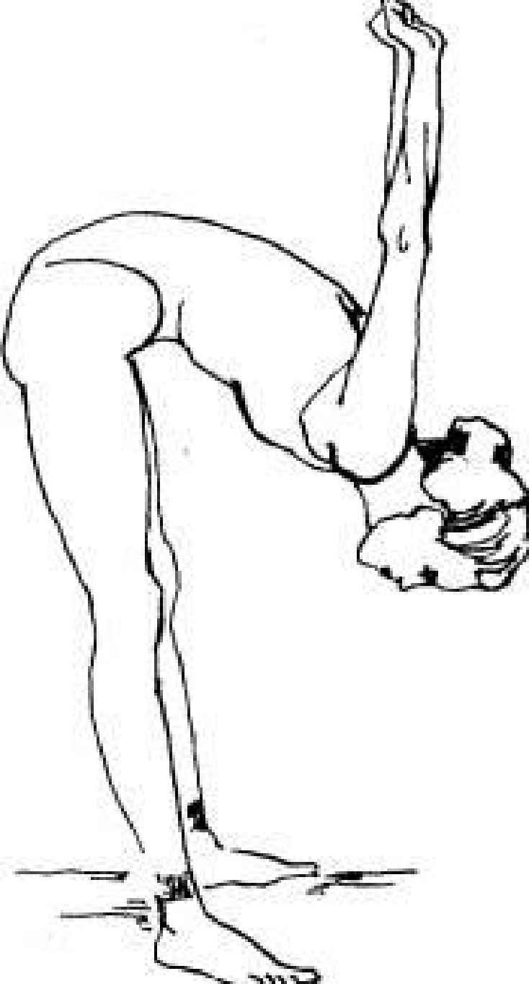  exercise 2  Now put your hands back, clasp your palms, pull your stomach in and lean forward as low as  you can. Hold 15 slow bills.  exercise 3  —Bending your knees, lean forward, touching the floor with your hands.  - Straighten your knees as far as you can. Hold 15 bills. Slowly arch your back  bending the legs and returning to the starting position.  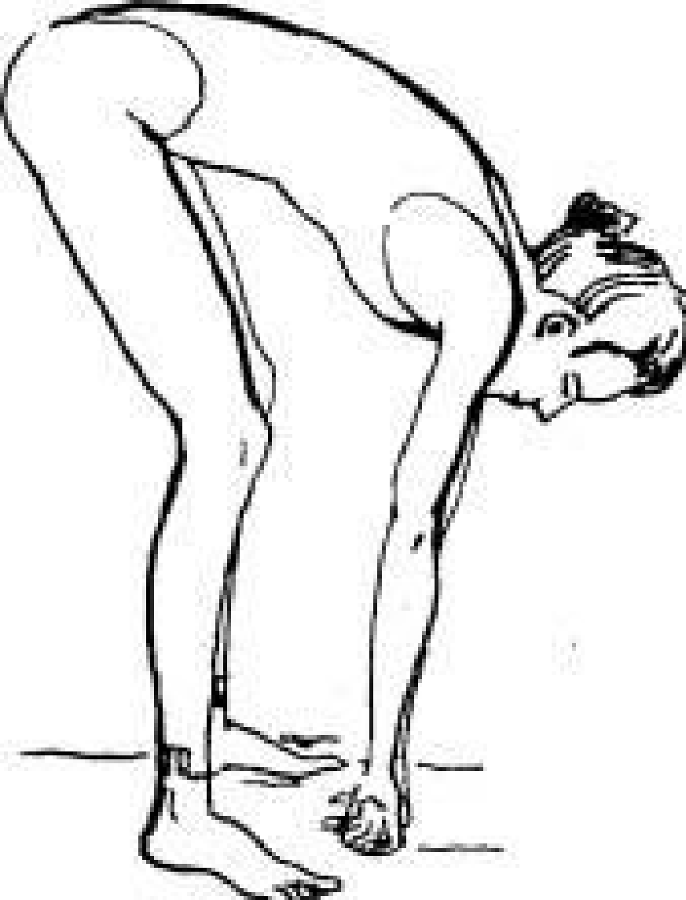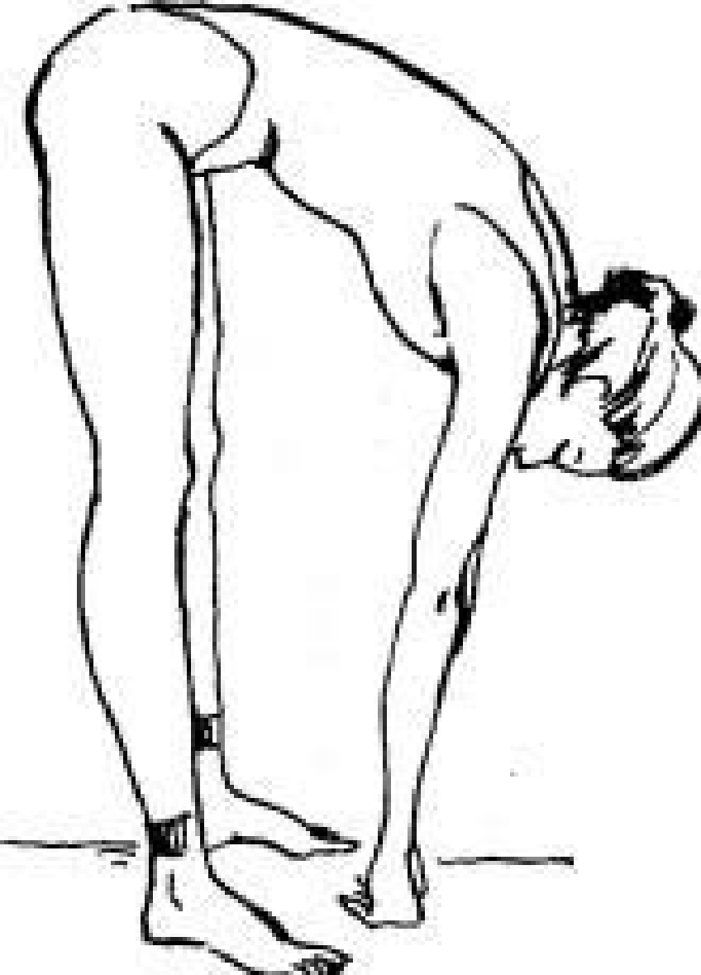  exercise 4  Straighten up, put your legs apart, pull in your stomach, chest is raised. Put the right  hand on the top of the right thigh, and the left - up above the head. Stretch your left hand to the right  as if you want to push the wall with your hand. Hold 15 bills. Slowly return to original  position and do the exercise on the other side.  exercise 5  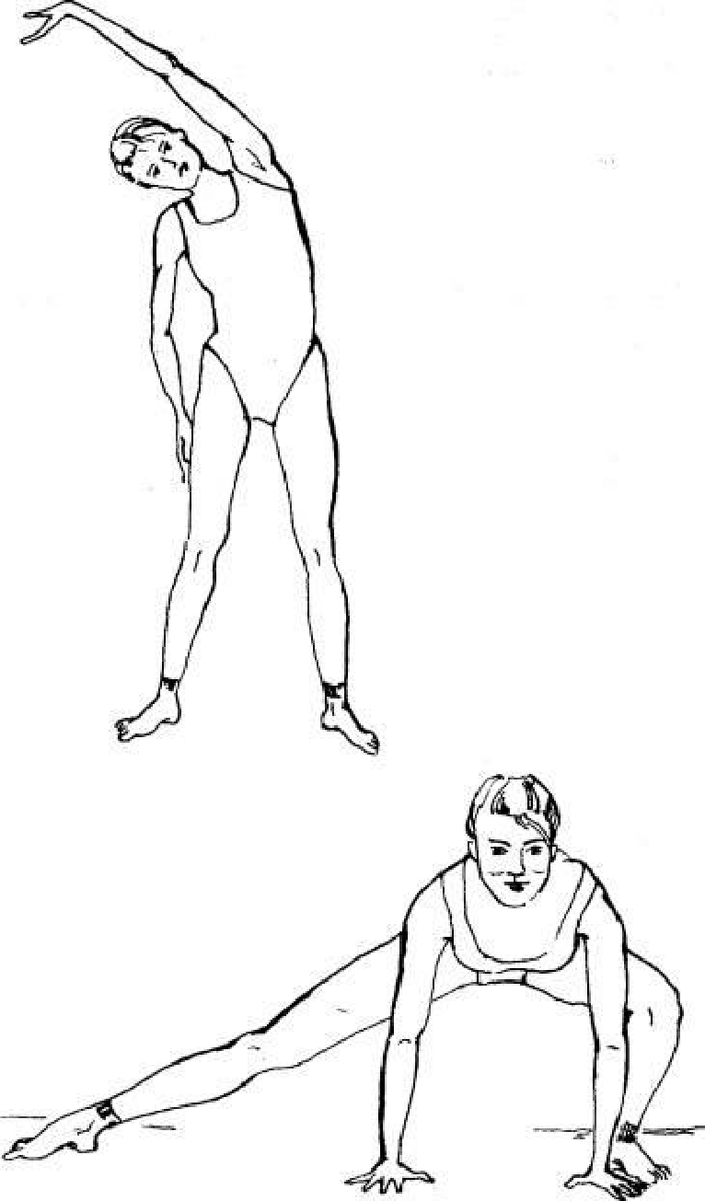  Spread your legs wider, lean forward and place your palms on the floor. Sliding your right foot to the side and bending your left leg, take the position shown in the figure. Feel the stretch throughout your inner right thigh. Hold 15 bills. Change legs and do the exercise on the other side. Control the position of the feet: they should touch the floor with the entire sole throughout the exercise.  exercise 6  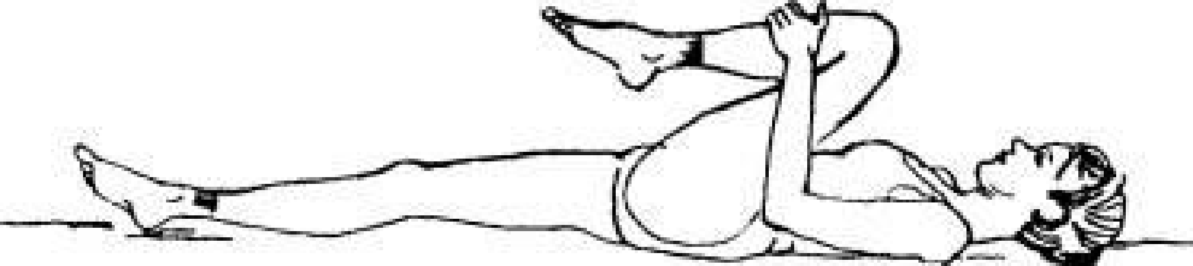  Lie on your back, pull your right knee to your chest. Hold 5 bills.  6-A. Now straighten your right leg as far as you can without causing pain, and try to pull it towards your chest. Hold 10 or 15 bills. Lower your leg slowly. Perform the exercise with the other leg.  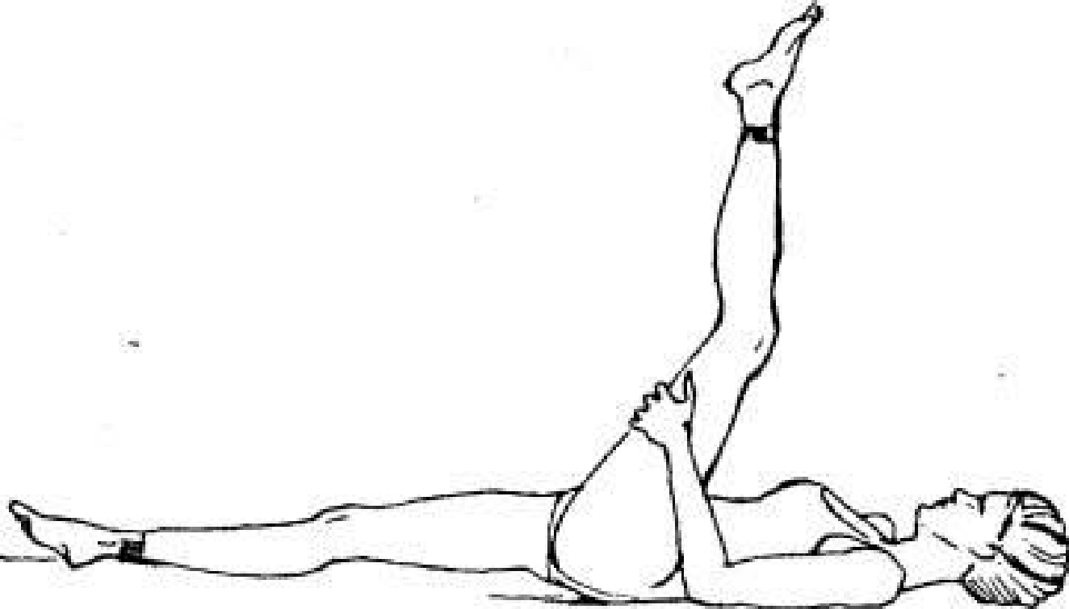  exercise 7  Lie on your back and pull both knees towards your chest. Tilt your head forward to your knees and hold this position for 10-15 counts.  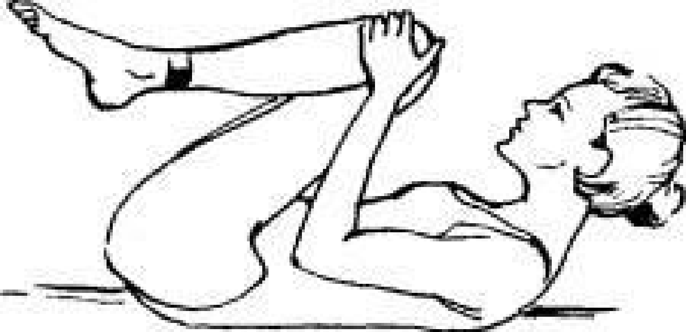  Gexercise 8  —Lying on your back, pull both knees to your chest and grab your feet with your hands.  - Gently and slowly straighten your legs to the position possible for you. Hold 10-15 bills.  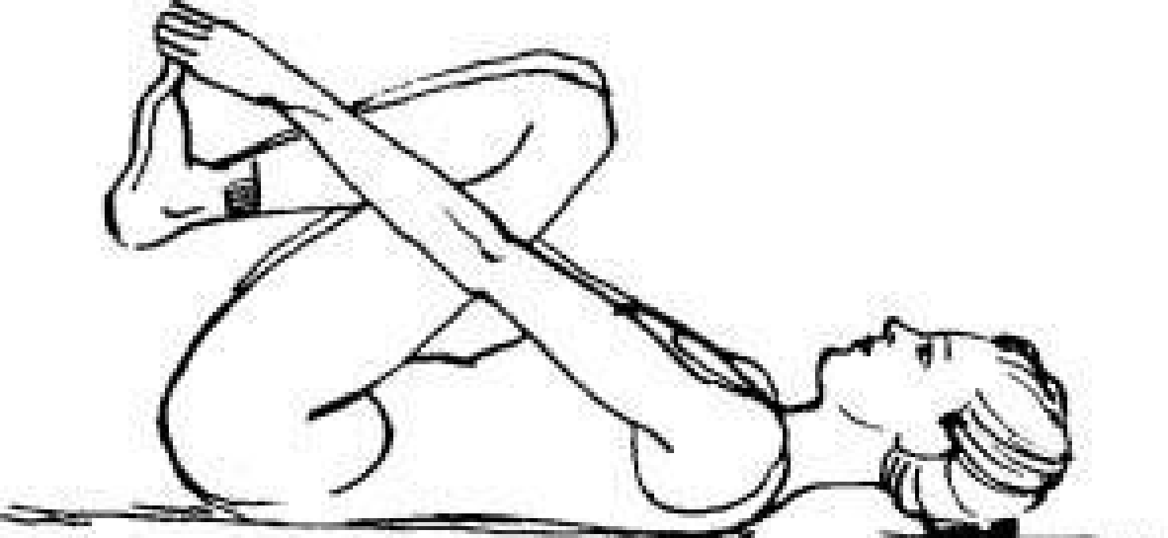  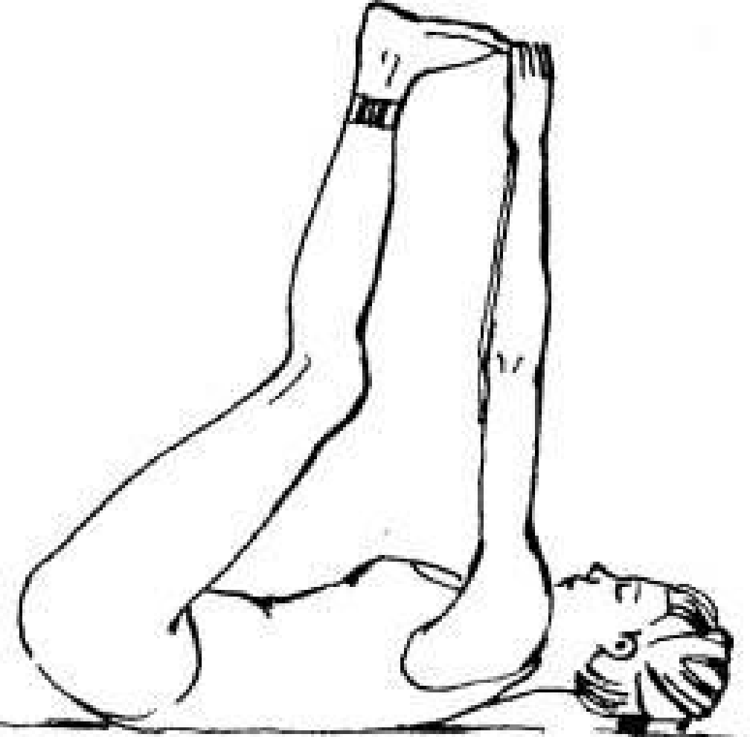  exercise 9  Sitting cross-legged on the floor or standing, tilt your head exactly to the side, as if resting it on your shoulder. Hold 5 bills. Return to the starting position and do the exercise on the other side. Repeat twice.  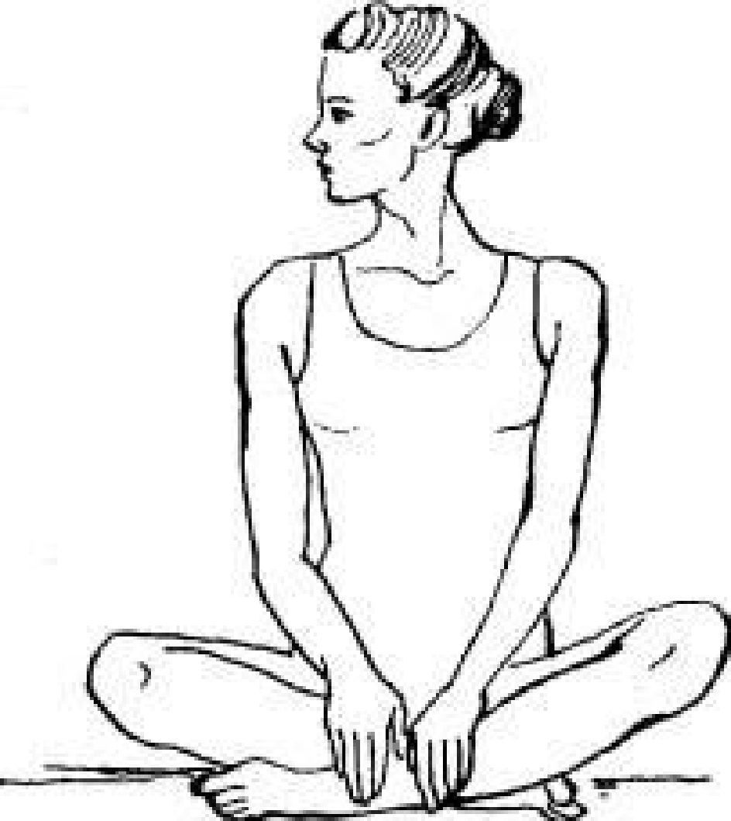  exercise 10  Sitting cross-legged on the floor or standing, turn your head to one side so that you can look over your shoulder. Hold 5 bills. Return to the starting position, then turn your head to the other side and hold again. Repeat twice. At the end of a set of stretching exercises, take a few deep breaths.
3 | Final part of the lesson:  - mobile game;  - summing up the results of the lesson;  - presenting current grades in the educational journal.
Means of education:
-material and technical: gymnastic mats, music center.

Module 1 General physical training - adaptive forms and types.
Topic 12Improving the complex of slow stretching exercises.
Type of lessonpractical lesson.
TargetConsolidation of a set of slow stretching exercises.
Lesson plan
No. p / p | Stages and content of the lesson
1 | Organizing time.  Organizational moment: construction, greeting, assessment of students' readiness.  Announcement of the topic, purpose and objectives of the lesson.  - Posture exercises:  - exercises for the head and neck;  - exercises for arms and shoulder girdle;  - exercises for the legs;  outdoor switchgear  1) I.p. - hands in front of the chest in the castle  1 - 4 - circular movements in the beam - carpal joint "to the right";  1 - 4 - the same - "to the left"  2) I.p. - hands to the side  1 - 4 - circular movements in the elbow joint "inside";  1 - 4 - the same - "to the outside"  3) I.p. - hands to shoulders  1 - 4 - circular movements in the shoulder joint "forward";  1 - 4 - the same - "back"  4) I.p. - right hand at the top, left - along the body  1 - 2 - abduction of straightened arms back;  3 - 4 - the same, change of hands  5) I.p. - hands in front of the chest, bent at the elbow joint  1 - 2 - abduction of bent arms in the elbow joint, back;  3 - 4 - abduction of straightened arms in the elbow joint, back with a turn of the body to the right;  1 - 4 the same - to the left  6) I.p. - right hand at the top, left - on the belt  1 - step left, torso tilt to the left;  2 - change of hands, right step, torso tilt to the right;  3 - 4 - the same  7) I.p. - hands on the belt  1 - step left, slope;  2 - i.p.;  3 - step right, tilt;  4 - i.p.  8) I.p. - hands in front of the chest, bent at the elbow joint  1 - lunge left, turn the body to the left;  2- i.p.;  3 - 4 - the same - to the right  9) I.p. - the same as exercise No. 8  1 - lunge left, turn the body to the left;  2 - right lunge, body turn to the right;  3 - 4 - the same.
2 | The main part of the lesson.  Development of practical skills, testing of practical skills.  Improving the complex of slow stretching exercises:  exercise 1  Raise your arms up and stretch, lifting your shoulders and chest up. Hold 5 bills.  exercise 2  Now put your hands back, clasp your palms, pull your stomach in and lean forward as low as  you can. Hold 15 slow bills.  exercise 3  —Bending your knees, lean forward, touching the floor with your hands.  - Straighten your knees as far as you can. Hold 15 bills. Slowly arch your back  bending the legs and returning to the starting position.  exercise 4  Straighten up, put your legs apart, pull in your stomach, chest is raised. Put the right  hand on the top of the right thigh, and the left - up above the head. Stretch your left hand to the right  as if you want to push the wall with your hand. Hold 15 bills. Slowly return to original  position and do the exercise on the other side.  exercise 5  Spread your legs wider, lean forward and place your palms on the floor. Sliding your right foot to the side and bending your left leg, take the position shown in the figure. Feel the stretch throughout your inner right thigh. Hold 15 bills. Change legs and do the exercise on the other side. Control the position of the feet: they should touch the floor with the entire sole throughout the exercise.  exercise 6  Lie on your back, pull your right knee to your chest. Hold 5 bills.  6-A. Now straighten your right leg as far as you can without causing pain, and try to pull it towards your chest. Hold 10 or 15 bills. Lower your leg slowly. Perform the exercise with the other leg.  exercise 7  Lie on your back and pull both knees towards your chest. Tilt your head forward to your knees and hold this position for 10-15 counts.  Gexercise 8  —Lying on your back, pull both knees to your chest and grab your feet with your hands.  - Gently and slowly straighten your legs to the position possible for you. Hold 10-15 bills.  exercise 9  Sitting cross-legged on the floor or standing, tilt your head exactly to the side, as if resting it on your shoulder. Hold 5 bills. Return to the starting position and do the exercise on the other side. Repeat twice.  exercise 10  Sitting cross-legged on the floor or standing, turn your head to one side so that you can look over your shoulder. Hold 5 bills. Return to the starting position, then turn your head to the other side and hold again. Repeat twice. At the end of a set of stretching exercises, take a few deep breaths.
3 | Final part of the lesson:  - stretching exercise;  - summing up the results of the lesson;  - presenting current grades in the educational journal.
Means of education:
-material and technical: gymnastic mats, music center.

Module 1General physical training - adaptive forms and types.
Topic 13Learning a set of exercises for paired stretching.
Type of lessonpractical lesson.
TargetCreate a representation of a set of paired stretching exercises.
Lesson plan
No. p / p | Stages and content of the lesson
1 | Organizing time.  Organizational moment: construction, greeting, assessment of students' readiness.  Announcement of the topic, purpose and objectives of the lesson.  Posture exercises:  - exercises for the head and neck;  - exercises for arms and shoulder girdle;  - exercises for the legs;  outdoor switchgear  1) I.p. - hands in front of the chest in the castle  1 - 4 - circular movements in the beam - carpal joint "to the right";  1 - 4 - the same - "to the left"  2) I.p. - hands to the side  1 - 4 - circular movements in the elbow joint "inside";  1 - 4 - the same - "to the outside"  3) I.p. - hands to shoulders  1 - 4 - circular movements in the shoulder joint "forward";  1 - 4 - the same - "back"  4) I.p. - right hand at the top, left - along the body  1 - 2 - abduction of straightened arms back;  3 - 4 - the same, change of hands  5) I.p. - hands in front of the chest, bent at the elbow joint  1 - 2 - abduction of bent arms in the elbow joint, back;  3 - 4 - abduction of straightened arms in the elbow joint, back with a turn of the body to the right;  1 - 4 the same - to the left  6) I.p. - right hand at the top, left - on the belt  1 - step left, torso tilt to the left;  2 - change of hands, right step, torso tilt to the right;  3 - 4 - the same  7) I.p. - hands on the belt  1 - step left, slope;  2 - i.p.;  3 - step right, tilt;  4 - i.p.  8) I.p. - hands in front of the chest, bent at the elbow joint  1 - lunge left, turn the body to the left;  2- i.p.;  3 - 4 - the same - to the right  9) I.p. - the same as exercise No. 8  1 - lunge left, turn the body to the left;  2 - right lunge, body turn to the right;  3 - 4 - the same.
2 | The main part of the lesson.  Development of practical skills, testing of practical skills.  Learning a set of paired stretching exercises:  1. "Worker and Collective Farm Girl"  Stretch the chest muscles.  How:Stand facing your partner. Right hand on hip, left hand on top. We take a step with the right foot and freeze in a lunge (for a more stable position). On exhalation, we rest on the partner’s hand for 30-90 seconds. After a short break, repeat the exercise on the other leg.  Maintain balance and upright posture.  2. "Push and Reach"  We stretch the muscles of the back.  How:Sitting facing each other, the legs are bent at the knees, with the feet resting on the feet of the partner. Holding hands, we round our backs and try to stretch our lower backs back, imagining that someone is pulling us by the belt. Hold this position for 30-90 seconds, feeling the stretch in your back muscles.  Try to round your back as much as possible. Don't lift your shoulders. Breathing is even.  3. "Hold on and reach"  Stretch the muscles of the back of the thigh.  How:Without changing the starting position and holding hands, we straighten our knees. As you exhale, try to stretch your tailbone back and up, and press your stomach against your thigh. Hold this position for 30-90 seconds, trying to relax your muscles as much as possible.  Do not strain your knee joints (knees can be slightly bent). Do not hold your breath.  4. "Boat"  Stretch the inner thigh.  How:Sitting facing each other, spread your legs as wide as possible, hands on your partner's shoulders. On exhalation, for 30-90 seconds we press our feet on the partner's feet, trying to spread our legs even wider.  Try to bend your back as much as possible, stretch your tailbone back and up, and your stomach down (to the floor).  5. "On the mound"  We stretch the muscles of the buttocks.  How:Sitting with your back to each other (partner serves as a support), lower the foot of your right foot on the thigh of the opposite leg. Bring your right knee out to the side. As you exhale, pull the right leg to the chest. Hold on in this position for a minute and a half, feeling how the gluteal muscles are stretched, and change your leg.  Try to keep your back as straight as possible. Watch your breath.  6. "Herons"  Stretch the front of the thigh.  How:Standing on the right leg, bend the left so that the heel is pressed against the left buttock. Bend the knee of the supporting leg slightly. Lean your hand on your partner's shoulder - it's easier to maintain balance. Tighten the muscles of the buttocks and slowly move the pelvis forward to feel how the muscles of the front of the thigh are stretched. Try to hold this position for 30-90 seconds, and then repeat the stretch for the right leg.  Keep your knees together. Do not hold your breath.  So, let's begin. First of all, straighten your back and fix it in this position for the entire duration of the workout (by the way, if you monitor your posture during classes, in the future you will not have to remind yourself to straighten your shoulders - the habit is a very powerful thing).  Perform a set of static stretching exercises  Neck stretch:  - smooth head turns left and right;  - circular movements of the head;  - holding the head in a tilt to the sides and up and down with pressing it with a hand.  Stretching the pectoral muscles:  - stand facing the doorway.  - We take both hands on the edges of the walls at head level.  - We lean forward, stretching the pectoral muscles as much as possible.  - At the limit point, we fix for a few seconds.  - We return to the starting position.
3 | Final part of the lesson:  -mobile game;  - summing up the results of the lesson;  - presenting current grades in the educational journal.
Means of education:
-material and technical: gymnastic mats, music center.

Module 1 General physical training - adaptive forms and types.
Topic 14Improving the complex of exercises for paired stretching.
Type of lessonpractical lesson.
TargetConsolidation of a set of exercises for paired stretching.
Lesson plan
No. p / p | Stages and content of the lesson
1 | Organizing time.  Organizational moment: construction, greeting, assessment of students' readiness.  Announcement of the topic, purpose and objectives of the lesson.  Posture exercises:  - exercises for the head and neck;  - exercises for arms and shoulder girdle;  - exercises for the legs;  outdoor switchgear  1) I.p. - hands in front of the chest in the castle  1 - 4 - circular movements in the beam - carpal joint "to the right";  1 - 4 - the same - "to the left"  2) I.p. - hands to the side  1 - 4 - circular movements in the elbow joint "inside";  1 - 4 - the same - "to the outside"  3) I.p. - hands to shoulders  1 - 4 - circular movements in the shoulder joint "forward";  1 - 4 - the same - "back"  4) I.p. - right hand at the top, left - along the body  1 - 2 - abduction of straightened arms back;  3 - 4 - the same, change of hands  5) I.p. - hands in front of the chest, bent at the elbow joint  1 - 2 - abduction of bent arms in the elbow joint, back;  3 - 4 - abduction of straightened arms in the elbow joint, back with a turn of the body to the right;  1 - 4 the same - to the left  6) I.p. - right hand at the top, left - on the belt  1 - step left, torso tilt to the left;  2 - change of hands, right step, torso tilt to the right;  3 - 4 - the same  7) I.p. - hands on the belt  1 - step left, slope;  2 - i.p.;  3 - step right, tilt;  4 - i.p.  8) I.p. - hands in front of the chest, bent at the elbow joint  1 - lunge left, turn the body to the left;  2- i.p.;  3 - 4 - the same - to the right  9) I.p. - the same as exercise No. 8  1 - lunge left, turn the body to the left;  2 - right lunge, body turn to the right;  3 - 4 - the same.
2 | The main part of the lesson.  development of practical skills, testing of practical skills.  Improving the set of exercises for paired stretching:  1. "Worker and Collective Farm Girl"  Stretch the chest muscles.  How:Stand facing your partner. Right hand on hip, left hand on top. We take a step with the right foot and freeze in a lunge (for a more stable position). On exhalation, we rest on the partner’s hand for 30-90 seconds. After a short break, repeat the exercise on the other leg.  Maintain balance and upright posture.  2. "Push and Reach"  We stretch the muscles of the back.  How:Sitting facing each other, the legs are bent at the knees, with the feet resting on the feet of the partner. Holding hands, we round our backs and try to stretch our lower backs back, imagining that someone is pulling us by the belt. Hold this position for 30-90 seconds, feeling the stretch in your back muscles.  Try to round your back as much as possible. Don't lift your shoulders. Breathing is even.  3. "Hold on and reach"  Stretch the muscles of the back of the thigh.  How:Without changing the starting position and holding hands, we straighten our knees. As you exhale, try to stretch your tailbone back and up, and press your stomach against your thigh. Hold this position for 30-90 seconds, trying to relax your muscles as much as possible.  Do not strain your knee joints (knees can be slightly bent). Do not hold your breath.  4. "Boat"  Stretch the inner thigh.  How:Sitting facing each other, spread your legs as wide as possible, hands on your partner's shoulders. On exhalation, for 30-90 seconds we press our feet on the partner's feet, trying to spread our legs even wider.  Try to bend your back as much as possible, stretch your tailbone back and up, and your stomach down (to the floor).  5. "On the mound"  We stretch the muscles of the buttocks.  How:Sitting with your back to each other (partner serves as a support), lower the foot of your right foot on the thigh of the opposite leg. Bring your right knee out to the side. As you exhale, pull the right leg to the chest. Hold on in this position for a minute and a half, feeling how the gluteal muscles are stretched, and change your leg.  Try to keep your back as straight as possible. Watch your breath.  6. "Herons"  Stretch the front of the thigh.  How:Standing on the right leg, bend the left so that the heel is pressed against the left buttock. Bend the knee of the supporting leg slightly. Lean your hand on your partner's shoulder - it's easier to maintain balance. Tighten the muscles of the buttocks and slowly move the pelvis forward to feel how the muscles of the front of the thigh are stretched. Try to hold this position for 30-90 seconds, and then repeat the stretch for the right leg.  Keep your knees together. Do not hold your breath.  So, let's begin. First of all, straighten your back and fix it in this position for the entire duration of the workout (by the way, if you monitor your posture during classes, in the future you will not have to remind yourself to straighten your shoulders - the habit is a very powerful thing).
3 | Final part of the lesson:  - mobile game for attention;  - summing up the results of the lesson;  - presenting current grades in the educational journal.
Means of education:
-material and technical: gymnastic mats, music center.
Module 1 General physical training - adaptive forms and types.
Topic 15 Performing a control exercise.
Type of lessonpractical lesson.
TargetComprehensive physical development and health promotion of students.
Lesson plan
No. p / p | Stages and content of the lesson
1 | Organizing time.  Organizational moment: construction, greeting, assessment of students' readiness.  Announcement of the topic, purpose and objectives of the lesson.  Posture exercises:  - exercises for the head and neck;  - exercises for arms and shoulder girdle;  - exercises for the legs;  outdoor switchgear  1) I.p. - hands in front of the chest in the castle  1 - 4 - circular movements in the beam - carpal joint "to the right";  1 - 4 - the same - "to the left"  2) I.p. - hands to the side  1 - 4 - circular movements in the elbow joint "inside";  1 - 4 - the same - "to the outside"  3) I.p. - hands to shoulders  1 - 4 - circular movements in the shoulder joint "forward";  1 - 4 - the same - "back"  4) I.p. - right hand at the top, left - along the body  1 - 2 - abduction of straightened arms back;  3 - 4 - the same, change of hands  5) I.p. - hands in front of the chest, bent at the elbow joint  1 - 2 - abduction of bent arms in the elbow joint, back;  3 - 4 - abduction of straightened arms in the elbow joint, back with a turn of the body to the right;  1 - 4 the same - to the left  6) I.p. - right hand at the top, left - on the belt  1 - step left, torso tilt to the left;  2 - change of hands, right step, torso tilt to the right;  3 - 4 - the same  7) I.p. - hands on the belt  1 - step left, slope;  2 - i.p.;  3 - step right, tilt;  4 - i.p.  8) I.p. - hands in front of the chest, bent at the elbow joint  1 - lunge left, turn the body to the left;  2- i.p.;  3 - 4 - the same - to the right  9) I.p. - the same as exercise No. 8  1 - lunge left, turn the body to the left;  2 - right lunge, body turn to the right;  3 - 4 - the same.  SBU  1) running with a high hip lift;  2) running with shin overwhelm;  3) right side with a side step, hands on the belt;  4) the same - left side  5) jumps on the right / left leg  6) shuttle run
2 | The main part of the lesson.  Development of practical skills, testing of practical skills.  - taking control exercises:  Control exercise: 1.1. Performing a set of static stretching exercises.  Control exercise: 1.2. Performing a set of dynamic stretching exercises (presented in the FOS).
3 | Final part of the lesson:  - an exercise in attention;  - summing up the results of the lesson;  - presenting current grades in the educational journal.
Means of education:
-logistics: stopwatch, mats, gymnastic mats.
Module 1 General physical training - adaptive forms and types.
Topic 16 Performing a control exercise.
Type of lessonpractical lesson.
TargetComprehensive physical development and health promotion of students.
Lesson plan
No. p / p | Stages and content of the lesson
1 | Organizing time.  Organizational moment: construction, greeting, assessment of students' readiness.  Announcement of the topic, purpose and objectives of the lesson.  Posture exercises:  - exercises for the head and neck;  - exercises for arms and shoulder girdle;  - exercises for the legs;  outdoor switchgear  1) I.p. - hands in front of the chest in the castle  1 - 4 - circular movements in the beam - carpal joint "to the right";  1 - 4 - the same - "to the left"  2) I.p. - hands to the side  1 - 4 - circular movements in the elbow joint "inside";  1 - 4 - the same - "to the outside"  3) I.p. - hands to shoulders  1 - 4 - circular movements in the shoulder joint "forward";  1 - 4 - the same - "back"  4) I.p. - right hand at the top, left - along the body  1 - 2 - abduction of straightened arms back;  3 - 4 - the same, change of hands  5) I.p. - hands in front of the chest, bent at the elbow joint  1 - 2 - abduction of bent arms in the elbow joint, back;  3 - 4 - abduction of straightened arms in the elbow joint, back with a turn of the body to the right;  1 - 4 the same - to the left  6) I.p. - right hand at the top, left - on the belt  1 - step left, torso tilt to the left;  2 - change of hands, right step, torso tilt to the right;  3 - 4 - the same  7) I.p. - hands on the belt  1 - step left, slope;  2 - i.p.;  3 - step right, tilt;  4 - i.p.  8) I.p. - hands in front of the chest, bent at the elbow joint  1 - lunge left, turn the body to the left;  2- i.p.;  3 - 4 - the same - to the right  9) I.p. - the same as exercise No. 8  1 - lunge left, turn the body to the left;  2 - right lunge, body turn to the right;  3 - 4 - the same.  SBU  1) running with a high hip lift;  2) running with shin overwhelm;  3) right side with a side step, hands on the belt;  4) the same - left side  5) jumps on the right / left leg  6) shuttle run
2 | The main part of the lesson.  Development of practical skills, testing of practical skills.  - taking control exercises:  Control exercise: 1.3. Performing a set of ballistic stretching exercises (presented in the FOS).
3 | Final part of the lesson:  - stretching exercise;  - summing up the results of the lesson;  - presenting current grades in the educational journal.
Means of education:
-logistics: stopwatch, mats, gymnastic mats.

Module 1 General physical training - adaptive forms and types.
Topic 17Acceptance of control standards.
Type of lessonpractical lesson.
TargetComprehensive physical development and health promotion of students.
Lesson plan
No. p / p | Stages and content of the lesson
1 | Organizing time.  Organizational moment: construction, greeting, assessment of students' readiness.  Announcement of the topic, purpose and objectives of the lesson.  Posture exercises:  - exercises for the head and neck;  - exercises for arms and shoulder girdle;  - exercises for the legs;  outdoor switchgear  1) I.p. - hands in front of the chest in the castle  1 - 4 - circular movements in the beam - carpal joint "to the right";  1 - 4 - the same - "to the left"  2) I.p. - hands to the side  1 - 4 - circular movements in the elbow joint "inside";  1 - 4 - the same - "to the outside"  3) I.p. - hands to shoulders  1 - 4 - circular movements in the shoulder joint "forward";  1 - 4 - the same - "back"  4) I.p. - right hand at the top, left - along the body  1 - 2 - abduction of straightened arms back;  3 - 4 - the same, change of hands  5) I.p. - hands in front of the chest, bent at the elbow joint  1 - 2 - abduction of bent arms in the elbow joint, back;  3 - 4 - abduction of straightened arms in the elbow joint, back with a turn of the body to the right;  1 - 4 the same - to the left  6) I.p. - right hand at the top, left - on the belt  1 - step left, torso tilt to the left;  2 - change of hands, right step, torso tilt to the right;  3 - 4 - the same  7) I.p. - hands on the belt  1 - step left, slope;  2 - i.p.;  3 - step right, tilt;  4 - i.p.  8) I.p. - hands in front of the chest, bent at the elbow joint  1 - lunge left, turn the body to the left;  2- i.p.;  3 - 4 - the same - to the right  9) I.p. - the same as exercise No. 8  1 - lunge left, turn the body to the left;  2 - right lunge, body turn to the right;  3 - 4 - the same.  SBU  1) running with a high hip lift;  2) running with shin overwhelm;  3) right side with a side step, hands on the belt;  4) the same - left side  5) jumps on the right / left leg  6) shuttle run
2 | The main part of the lesson.  Development of practical skills, testing of practical skills.  - acceptance of control standards, "Table of control standards" is presented in the FOS.
3 | Final part of the lesson:  - stretching exercise;  - summing up the results of the lesson;  - presenting current grades in the educational journal.
Means of education:
-logistics: stopwatch, starting blocks, whistle.
Module 1 General physical training - adaptive forms and types.
Topic 18Acceptance of control standards.
Type of lessonpractical lesson.
TargetComprehensive physical development and health promotion of students.
Lesson plan
No. p / p | Stages and content of the lesson
1 | Organizing time.  Organizational moment: construction, greeting, assessment of students' readiness.  Announcement of the topic, purpose and objectives of the lesson.  Posture exercises:  - exercises for the head and neck;  - exercises for arms and shoulder girdle;  - exercises for the legs;  outdoor switchgear  1) I.p. - hands in front of the chest in the castle  1 - 4 - circular movements in the beam - carpal joint "to the right";  1 - 4 - the same - "to the left"  2) I.p. - hands to the side  1 - 4 - circular movements in the elbow joint "inside";  1 - 4 - the same - "to the outside"  3) I.p. - hands to shoulders  1 - 4 - circular movements in the shoulder joint "forward";  1 - 4 - the same - "back"  4) I.p. - right hand at the top, left - along the body  1 - 2 - abduction of straightened arms back;  3 - 4 - the same, change of hands  5) I.p. - hands in front of the chest, bent at the elbow joint  1 - 2 - abduction of bent arms in the elbow joint, back;  3 - 4 - abduction of straightened arms in the elbow joint, back with a turn of the body to the right;  1 - 4 the same - to the left  6) I.p. - right hand at the top, left - on the belt  1 - step left, torso tilt to the left;  2 - change of hands, right step, torso tilt to the right;  3 - 4 - the same  7) I.p. - hands on the belt  1 - step left, slope;  2 - i.p.;  3 - step right, tilt;  4 - i.p.  8) I.p. - hands in front of the chest, bent at the elbow joint  1 - lunge left, turn the body to the left;  2- i.p.;  3 - 4 - the same - to the right  9) I.p. - the same as exercise No. 8  1 - lunge left, turn the body to the left;  2 - right lunge, body turn to the right;  3 - 4 - the same.  SBU  1) running with a high hip lift;  2) running with shin overwhelm;  3) right side with a side step, hands on the belt;  4) the same - left side  5) jumps on the right / left leg  6) shuttle run
2 | The main part of the lesson.  Development of practical skills, testing of practical skills.  - acceptance of control standards, the table "Control standards" is presented in the FOS.
3 | Final part of the lesson:  - stretching exercise;  - summing up the results of the lesson;  - presenting current grades in the educational journal.
Means of education:-logistics: stopwatch, starting blocks, whistle.

Module 1 General physical training - adaptive forms and types.
SubjectNordic walking.
Targetcontrol of independent work.
No.  p/n | Stages and content of the lesson
1 | Organizing time.  Announcement of the topic, purpose of the lesson.
2 | The main part of the lesson.  Checking the control work on the studied topic
3 | Final part of the lesson:  - summarizing the lesson;  - announcement of points for the performance of control work.

Module 1 General physical training - adaptive forms and types.
Topic 19Safety briefing. Teaching the technique of general developmental exercises at the gymnastic wall.
Type of lessonpractical lesson.
Target Instruct people with disabilities (including the disabled) about safety precautions in physical education classes, create an idea aboutgeneral developmental exercises at the gymnastic wall.
Lesson plan
No.  p/n | Stages and content of the lesson
1  1.1  1.2  1.3  1.4  1.5 | Organizing time.  Announcement of the topic, purpose of the lesson.  Motivational moment (formation of a complex of motor skills and physical qualities necessary in professional activity).  Safety briefing:  I. General safety requirements.  The student must:  - undergo a medical examination and engage in the medical group to which he belongs for health reasons;  - to have a neat sports uniform (panties, T-shirt, T-shirt, tracksuit, tights, clean shoes - sneakers, sneakers), corresponding to the weather conditions and the topic of the lesson;  - leave the locker room at the first request of the teacher;  - after an illness, provide the teacher with a certificate from a doctor;  - to be present at the lesson in case of release by the doctor from classes after illness;  - treat sports equipment and equipment with care and use it for its intended purpose;  - have short-cut nails;  - Know and follow the safety instructions.  Students cannot:  - sharply open the doors and hang on them, turn off the light, touch the ceiling lights in the locker room, gym;  - insert foreign objects into sockets;  - drink cold water before and after class;  - exercise on wet ground, slippery and uneven ground.  II. Safety requirements before the start of classes.  The student must:  - change clothes in the locker room, put on a sports uniform and shoes;  - take off objects that are dangerous for other trainees (earrings, watches, bracelets, etc.);  - remove prickly and other foreign objects from the pockets of the sports uniform;  - under the guidance of a teacher, prepare the inventory and equipment necessary for the lesson;  - with the permission of the teacher to go to the place of the lesson;  - at the command of the teacher, stand in line for a common formation.  III. Safety requirements during classes.  The student must:  - listen carefully and clearly follow the instructions of the teacher;  - take sports equipment and perform exercises with the permission of the teacher;  - while moving, look ahead, keep sufficient interval and distance, avoid collisions;  - perform exercises with serviceable inventory and engage in serviceable equipment.  Students cannot:  - leave the place of the lesson without the permission of the teacher;  - push, put steps in the ranks and movement;  - climb onto basketball uniforms, hang on the rings;  - chew chewing gum;  - interfere and distract when explaining tasks and performing exercises;  - perform exercises with wet palms;  - sharply change the direction of its movement.  IV. Safety requirements in case of accidents and extreme situations.  student must:  - in case of injury or deterioration of health, stop classes and notify the teacher;  - with the help of a teacher, provide first aid to the injured, if necessary, take him to the hospital or call an ambulance;  - in the event of a fire in the gym, immediately stop the lesson, in an organized manner, under the guidance of a teacher, leave the place of the lesson through emergency exits according to the evacuation plan;  - by order of the teacher, notify the administration of the educational institution and report the fire to the fire department.  V. Safety requirements at the end of classes.  The student must:  - under the guidance of a teacher, remove sports equipment to its storage places;  - leave the place of the lesson in an organized manner;  - change clothes in the locker room, take off your tracksuit and sports shoes;  - Wash your hands with soap.  Walking and its varieties:  1 - on socks, arms up;  2 - on the heels, arms to the sides;  3 - on the outside of the foot, hands behind the head;  4 - on the inside of the foot, hands behind the back;  5 - "high" step, hands forward;  6 - in a half-crouch, hands on the belt  Running and its varieties:  1 - running at a slow pace;  2 - running with straightened legs forward;  3 - running with straightened legs back;  4 - running with straightened legs to the sides  “Step march!”, “Stay where you are!”, “To the left!”, “On the first, second, pay!”  switchgear in place  1) I. p. - O. s., hands on the belt. Head tilts to the right, forward, left, back  2) I. p. - O. s., hands on the belt. Head rotation left and right  3) I. n. - O. s., feet shoulder-width apart, arms straight to the sides. Circular rotation of the arms in the elbow joint inward and outward  4) I. p. - O. s., feet shoulder-width apart, arms straight to the sides. Circular rotation of the arms in the shoulder joint forward and backward  5) I. p. - O. s., feet shoulder-width apart, arms bent at the elbows in front of you. Rotation of the upper body to the right and left  6) I. p. - O. s., feet shoulder-width apart, hands on the belt. Circular rotation of the body to the right and left  7) I. n. - O. s., feet shoulder-width apart, hands on the belt. Torso forward alternately to the left leg, between the feet, to the right leg
2  2.1 | The main part of the lesson.  Development of practical skills, testing of practical skills: to create an idea for students about general developmental exercises at the gymnastic wall.  Due to the wide variety, availability and effectiveness of exercises on the gymnastic wall, they are willingly performed by people of all ages, with various nosologies.  Exercise on the gymnastic wall  1. I. p. - standing facing the wall, grab the rail at shoulder level with your hands. Bend your arms, touch the rail with your chest, turn your face to the side - exhale, and. p. - inhale.  2. I. p. - standing on the lower rail facing the wall, grab the rail higher with your hands. Hanging on your hands, bending over, taking your legs back, return to and. n. Breathing is uniform.  3. I. p. - standing with your back to the wall. Hanging on your hands, pulling your socks, arching your back and raising your head, return to and. n. Breathing is uniform.  4. I. p. - standing close to the wall, legs apart. Tilt to the right, grab the rail higher with your left hand, and lower with your right hand, return to and. n. The same in the other direction. Breathing is even.  5. I. p. - standing close to the wall, legs together, grab the rail at shoulder level. Squat deeply, straighten your legs, take your pelvis back, return to and. n. Breathing is uniform.  6. i. p. - standing with your back to the wall at a distance of 0.25-0.5 m. take the rail higher. Bending over, stand on your toes - inhale, return to and. p. - exhale.  7. I. p. - standing on the first rail facing the wall, holding hands on the rail higher. Take the right leg back, bend - inhale, return to and. p. - exhale. The same, moving the left leg.  8. I. p. - hanging with his back to the wall, legs on; level of the first rail. Alternate flexion and extension of the right and left legs in the knee and hip joints. Don't hold your breath.  9. I. p. - the same. Simultaneous bending of the legs in the knee and hip joints - exhale, return to and. p. - inhale.  10. I. p. - standing on the first rail facing the wall and holding the rail at the level of the chin. Turn to the right, take the right leg and arm to the side, straighten the left arm - inhale, return to and. p. - exhale.  11. I. p. - standing with the right side to the wall, legs apart, hands on the belt. deviate to the right, grab the rail with your left hand, return to and. n. The same, standing to the wall with your left side. Breathing is even.  12. I. p. - standing on the floor, facing the wall, holding the rail at face level. Stand up, bending your arms and straightening your legs, return to and. n. Do not hold your breath.  13. I. p. - standing on the first rail, hands behind the rail at hip height. Sit deep; return to i. n. Do not hold your breath.  14. I. p. - lying on your back, hands on your belt, socks fixed under the rail. Raise the torso, sit down, grab the rail at the height of the head, pulling up with your hands and straightening your legs, stand up, return to the SP. Breathing is even.  15. I. p. - hanging with his back to the wall, legs at the level of the first rail. Bend the legs at the knee and hip joints, straighten the knee joints to a right angle, bend the legs at the knee joints again and return to and. n. Breathing is uniform.  16. I. p. - standing with the left side to the wall, left hand on the rail at shoulder level, take the right hand to the side. Squat on the left leg, lifting the right forward, return to and. n. The same, standing with the right side to the wall. Breathing is even.  17. I. p. - hanging facing the wall, legs at the level of the first rail. Flexion and extension of the legs at the knee joints. Breathing is free.  18. I. p. - standing with his back to the wall, holding the rail higher with his hands. Bending over, bend the right leg at the knee and hip joints, stand on the toe with the left foot - inhale, return to and. p. - exhale. The same, bending the left leg. Do not bend the supporting leg at the knee joint.
3 | Final part of the lesson:  - attention exercises;  - oral survey (questions for conducting an oral survey are presented in the FOS);  - summarizing the lesson;  - presenting current grades in the educational journal.
Means of education:
-material and technical: chronometers, places for gymnastics.

Module 1 General physical training - adaptive forms and types.
Topic 20Improving the technique of general developmental exercises at the gymnastic wall.
Type of lessonpractical lesson.
TargetZfasteninggeneral developmental exercises at the gymnastic wall.
Lesson plan
No.  p/n | Stages and content of the lesson
1  1.1  1.2  1.3 | Organizing time.  Announcement of the topic, purpose of the lesson.  Motivational moment (formation of a complex of motor skills and physical qualities necessary in professional activity).  Walking and its varieties:  1 - on socks, arms up;  2 - on the heels, arms to the sides;  3 - on the outside of the foot, hands behind the head;  4 - on the inside of the foot, hands behind the back;  5 - "high" step, hands forward;  6 - in a half-crouch, hands on the belt  Running and its varieties:  1 - running at a slow pace;  2 - running with straightened legs forward;  3 - running with straightened legs back;  4 - running with straightened legs to the sides  “Step march!”, “Stay where you are!”, “To the left!”, “On the first, second, pay!”  switchgear in place  1) I. p. - O. s., hands on the belt. Head tilts to the right, forward, left, back  2) I. p. - O. s., hands on the belt. Head rotation left and right  3) I. n. - O. s., feet shoulder-width apart, arms straight to the sides. Circular rotation of the arms in the elbow joint inward and outward  4) I. p. - O. s., feet shoulder-width apart, arms straight to the sides. Circular rotation of the arms in the shoulder joint forward and backward  5) I. p. - O. s., feet shoulder-width apart, arms bent at the elbows in front of you. Rotation of the upper body to the right and left  6) I. p. - O. s., feet shoulder-width apart, hands on the belt. Circular rotation of the body to the right and left  7) I. n. - O. s., feet shoulder-width apart, hands on the belt. Torso forward alternately to the left leg, between the feet, to the right leg
2  2.1 | The main part of the lesson.  Development of practical skills, testing of practical skills: to consolidate students' understanding of general developmental exercises at the gymnastic wall  Exercise on the gymnastic wall  1. I. p. - standing facing the wall, grab the rail at shoulder level with your hands. Bend your arms, touch the rail with your chest, turn your face to the side - exhale, and. p. - inhale.  2. I. p. - standing on the lower rail facing the wall, grab the rail higher with your hands. Hanging on your hands, bending over, taking your legs back, return to and. n. Breathing is uniform.  3. I. p. - standing with your back to the wall. Hanging on your hands, pulling your socks, arching your back and raising your head, return to and. n. Breathing is uniform.  4. I. p. - standing close to the wall, legs apart. Tilt to the right, grab the rail higher with your left hand, and lower with your right hand, return to and. n. The same in the other direction. Breathing is even.  5. I. p. - standing close to the wall, legs together, grab the rail at shoulder level. Squat deeply, straighten your legs, take your pelvis back, return to and. n. Breathing is uniform.  6. i. p. - standing with your back to the wall at a distance of 0.25-0.5 m. take the rail higher. Bending over, stand on your toes - inhale, return to and. p. - exhale.  7. I. p. - standing on the first rail facing the wall, holding hands on the rail higher. Take the right leg back, bend - inhale, return to and. p. - exhale. The same, moving the left leg.  8. I. p. - hanging with his back to the wall, legs on; level of the first rail. Alternate flexion and extension of the right and left legs in the knee and hip joints. Don't hold your breath.  9. I. p. - the same. Simultaneous bending of the legs in the knee and hip joints - exhale, return to and. p. - inhale.  10. I. p. - standing on the first rail facing the wall and holding the rail at the level of the chin. Turn to the right, take the right leg and arm to the side, straighten the left arm - inhale, return to and. p. - exhale.  11. I. p. - standing with the right side to the wall, legs apart, hands on the belt. deviate to the right, grab the rail with your left hand, return to and. n. The same, standing to the wall with your left side. Breathing is even.  12. I. p. - standing on the floor, facing the wall, holding the rail at face level. Stand up, bending your arms and straightening your legs, return to and. n. Do not hold your breath.  13. I. p. - standing on the first rail, hands behind the rail at hip height. Sit deep; return to i. n. Do not hold your breath.  14. I. p. - lying on your back, hands on your belt, socks fixed under the rail. Raise the torso, sit down, grab the rail at the height of the head, pulling up with your hands and straightening your legs, stand up, return to the SP. Breathing is even.  15. I. p. - hanging with his back to the wall, legs at the level of the first rail. Bend the legs at the knee and hip joints, straighten the knee joints to a right angle, bend the legs at the knee joints again and return to and. n. Breathing is uniform.  16. I. p. - standing with the left side to the wall, left hand on the rail at shoulder level, take the right hand to the side. Squat on the left leg, lifting the right forward, return to and. n. The same, standing with the right side to the wall. Breathing is even.  17. I. p. - hanging facing the wall, legs at the level of the first rail. Flexion and extension of the legs at the knee joints. Breathing is free.  18. I. p. - standing with his back to the wall, holding the rail higher with his hands. Bending over, bend the right leg at the knee and hip joints, stand on the toe with the left foot - inhale, return to and. p. - exhale. The same, bending the left leg. Do not bend the supporting leg at the knee joint.
3 | Final part of the lesson:  - attention exercises;  - summarizing the lesson;  - presenting current grades in the educational journal.
Means of education:
-material and technical: chronometers, places for gymnastics.

Module 1 General physical training - adaptive forms and types.
Topic 21Teaching ORU technique on the gymnastic bench.
Type of lessonpractical lesson.
Targetcreate an idea ofORU technique on the gymnastic bench.
Lesson plan
No.  p/n | Stages and content of the lesson
1  1.1  1.2  1.3 | Organizing time.  Announcement of the topic, purpose of the lesson.  Motivational moment (formation of a complex of motor skills and physical qualities necessary in professional activity).  Walking and its varieties:  1 - on socks, arms up;  2 - on the heels, arms to the sides;  3 - on the outside of the foot, hands behind the head;  4 - on the inside of the foot, hands behind the back;  5 - "high" step, hands forward;  6 - in a half-crouch, hands on the belt  Running and its varieties:  1 - running at a slow pace;  2 - running with straightened legs forward;  3 - running with straightened legs back;  4 - running with straightened legs to the sides  “Step march!”, “Stay where you are!”, “To the left!”, “On the first, second, pay!”  switchgear in place  1) I. p. - O. s., hands on the belt. Head tilts to the right, forward, left, back  2) I. p. - O. s., hands on the belt. Head rotation left and right  3) I. n. - O. s., feet shoulder-width apart, arms straight to the sides. Circular rotation of the arms in the elbow joint inward and outward  4) I. p. - O. s., feet shoulder-width apart, arms straight to the sides. Circular rotation of the arms in the shoulder joint forward and backward  5) I. p. - O. s., feet shoulder-width apart, arms bent at the elbows in front of you. Rotation of the upper body to the right and left  6) I. p. - O. s., feet shoulder-width apart, hands on the belt. Circular rotation of the body to the right and left  7) I. n. - O. s., feet shoulder-width apart, hands on the belt. Torso forward alternately to the left leg, between the feet, to the right leg
2  2.1 | The main part of the lesson.  Development of practical skills, testing of practical skills:outdoor switchgear technique training on a gymnastic bench  A set of general developmental exerciseson the gymnastic bench:  I. (initial) p. (position) - o. (main) with. (stand), standing, etc. sideways to the bench  1 - step pr. foot on the bench, p. (hands) on the belt:  2 - step lion. foot on the bench, r. on the belt:  3 - step with the right foot from the bench, p. to the sides:  4 - step lion. foot from the bench, r. to the sides.  5-8 - also in the other direction (Repeat 4 p.)  I. p. - about. s., standing sideways to the bench  1 - step pr. foot on the bench, p. on the belt:  2 - step lion. foot on the bench, r. on the belt:  3 - step right foot from the bench on the right, p. up;  4 - step lion. foot from the bench on the left, r. up (bench between legs).  (Repeat 3 p.)  On the fourth repetition of exercise No. 2, paragraphs 1 and 2 are the same;  3 - 4 - turning the body by 45,  get off the bench with your foot, lion. leg remains  on the bench, on the belt.  I.p. - standing at an angle of 450 to the right of the bench, lion. leg on the bench, etc. on the floor, r. on the belt.  1 - support lion. foot on the bench, pushing off, etc. bend it forward;  2 - return to sp. (Repeat 3 times)  On the fourth iteration  7 - put the right foot on the bench, p. on the belt;  8 - get off the lion. foot from the bench to the left, other leg remains on the bench.  The next 8 accounts repeat the same exercise. a lion. foot, but at the expense of 8 - return to I.p.  I.p. - the same as in exercise No. 3.  Repeat everything, as in exercise No. 3, but bend the leg back.  On the last repeat, on the score  7 - 8 - stand to the left of the bench, facing it, p. on the belt.  I.p. - standing to the left of the bench, facing it, p. on the belt.  1 - step right foot on the bench;  2 - step lion. foot on the bench;  3 - step with the right foot from the bench;  4 - step lion. foot from the bench;  5 - deep lunge pr.n. on the bench, Per head.  6 - return to sp, but p. Per head;  7 - deep lunge lion. foot on the bench, r. Per head;  8 - return to sp.  (Repeat exercise 4 times). On the last repeat  7 - 8 - turn pr. sideways to the bench, pr.n. put on a bench straight, r. to the sides.  I.p. - standing on the left, pr. sideways to the bench, pr. n. straight on the bench, r. to the sides.  1 - 3 - three springy tilts to the right to the right leg, left. R. up;  4 - I.p.  5 - 7 - three springy slopes down to the left. leg, r. down;  8 - I.p.  Repeat this exercise a second time, but the score  5 - 6 - two springy slopes down to the left. leg, r. down, touch the floor;  7 - 8 - turning to face the bench, jump over the bench and take the SP, the same from the other side of the bench.  Repeat all ex. on the other leg, on the second repetition to the count  7 - 8 - turn around and stand facing the bench to the right of it, p. on the belt.  I.p. - standing to the right of the bench facing her, p. on the belt.  1 - step e.g. on the bench;  2 - step lion. n. on the bench;  3 - step pr. n. to the right on the bench (to the side);  4 - step lion. n. to the left on the bench;  5 - step pr. n. left on the bench (back);  6 - step lion. n. right on the bench;  7 - step pr. n. from the bench;  8 - step lion. n. from the bench.  Repeat ex. 4 times, on the last repetition, the score:  7 - step pr. n. from the bench;  8 - pause, leave the lion. n. on the bench, on the belt.  I.p. - standing facing the bench to the right on the right leg, lion. leg bent on a bench, p. on the belt;  Jumps with alternating pr. and lev. feet on the bench  1 - 2 - jump from the lion. n. to the right;  3 - 4 - jump from pr. n. to the left;  5 - 8 - too;  Repeat four eights, on the last repetition to the count  7 - 8 - stand up, legs apart, bench between legs, p. on the belt.  I.p. - stand legs apart, bench between legs, p. on the belt.  a) 1 - stand on the right knee on the bench, lion. foot on the floor;  2 - stand on the lion. kneeling on a bench in a kneeling position on a bench;  3 - 7 - five springy grays on the heels on the bench;  8 - kneeling on a bench, p. on the belt.  b) Repeat this exercise, but at the expense  c) 1 - get off the right foot from the bench to the right;  d) 2 - get off the lion. n. from the bench (take i. p. exercise No. 9) on the left;  3 - 4 - the same as in the first repetition, counting 1 and 2;  5 - 7 - the same as the score 3 - 7 in the first repetition;  8 - the same as the score of 8 in the first repetition.  Repeat 2 more times in this variation.  e) In the last fourth repetition, the score:  1 - 4 - as in option (b, c, d);  5 - get off the lion. n. to the left from the bench;  6 - get off ave. to the left from the bench;  7 - sit on a bench, support r. behind;  8 - straighten your legs.  I.p. - sitting on a bench, legs straight, support r. behind;  1 - 3 - three springy tilts forward, p. forward.  4 - i.p.  5 - 7 - raise the body, bend, hold;  8 - i. P.  Repeat exercise 2 times  In the second repetition on the account:  5 - 6 - raise the body, bend over, keep two counts;  7 - i. P.  8 - raise the right leg up.  I.p. - sitting on a bench, support r. behind, right leg up;  1 - bend the right leg crosswise in front of the left;  2 - straighten the right leg in and. P.  3 - 6 - repeat twice the score 1-2;  7 - lower the right leg down, taking a seat on the bench with straight legs, support behind with hands;  8 - lift up the lion. leg.  Repeat the next seven counts with the left leg.  8 - raise bent at the knee pr. n., toe towards yourself.  I. p. - sitting on the bench, lion. the leg is extended, raise the right leg bent, the toe towards you;  1 - change position: raise the bent lion. straighten the right leg forward without touching the floor with the feet;  2 - change position in and. P.  3 - 8 - repeat the score 1 - 2;  Repeat the next six accounts in the same way;  7 - 8 - straightening the right leg, take a seat on the bench with straight legs with an inclination forward, arms forward;  Straighten up, bend your knees, stand in the OS, the bench is behind.  (The complex is performed to the music, together).
3 | Final part of the lesson:  - attention exercises;  - summarizing the lesson;  - presenting current grades in the educational journal.
Means of education:
- material and technical: chronometers, places for gymnastics, gymnastic benches, music center.

Module 1 General physical training - adaptive forms and types.
Topic 22Improving the outdoor switchgear technique on the gymnastic bench.
Type of lessonpractical lesson.
Targetto fixoutdoor switchgear technique on the gymnastic bench.
Lesson plan
No.  p/n | Stages and content of the lesson
1  1.1  1.2  1.3 | Organizing time.  Announcement of the topic, purpose of the lesson.  Motivational moment (formation of a complex of motor skills and physical qualities necessary in professional activity).  Walking and its varieties:  1 - on socks, arms up;  2 - on the heels, arms to the sides;  3 - on the outside of the foot, hands behind the head;  4 - on the inside of the foot, hands behind the back;  5 - "high" step, hands forward;  6 - in a half-crouch, hands on the belt  Running and its varieties:  1 - running at a slow pace;  2 - running with straightened legs forward;  3 - running with straightened legs back;  4 - running with straightened legs to the sides  “Step march!”, “Stay where you are!”, “To the left!”, “On the first, second, pay!”  switchgear in place  1) I. p. - O. s., hands on the belt. Head tilts to the right, forward, left, back  2) I. p. - O. s., hands on the belt. Head rotation left and right  3) I. n. - O. s., feet shoulder-width apart, arms straight to the sides. Circular rotation of the arms in the elbow joint inward and outward  4) I. p. - O. s., feet shoulder-width apart, arms straight to the sides. Circular rotation of the arms in the shoulder joint forward and backward  5) I. p. - O. s., feet shoulder-width apart, arms bent at the elbows in front of you. Rotation of the upper body to the right and left  6) I. p. - O. s., feet shoulder-width apart, hands on the belt. Circular rotation of the body to the right and left  7) I. n. - O. s., feet shoulder-width apart, hands on the belt. Torso forward alternately to the left leg, between the feet, to the right leg
2  2.1 | The main part of the lesson.  Development of practical skills and abilities, testing of practical skills:improvement of outdoor switchgear technique on the gymnastic bench  A set of general developmental exerciseson the gymnastic bench:  I. (initial) p. (position) - o. (main) with. (stand), standing, etc. sideways to the bench  1 - step pr. foot on the bench, p. (hands) on the belt:  2 - step lion. foot on the bench, r. on the belt:  3 - step with the right foot from the bench, p. to the sides:  4 - step lion. foot from the bench, r. to the sides.  5-8 - also in the other direction (Repeat 4 p.)  I. p. - about. s., standing sideways to the bench  1 - step pr. foot on the bench, p. on the belt:  2 - step lion. foot on the bench, r. on the belt:  3 - step right foot from the bench on the right, p. up;  4 - step lion. foot from the bench on the left, r. up (bench between legs).  (Repeat 3 p.)  On the fourth repetition of exercise No. 2, paragraphs 1 and 2 are the same;  3 - 4 - turning the body by 45,  get off the bench with your foot, lion. leg remains  on the bench, on the belt.  I.p. - standing at an angle of 450 to the right of the bench, lion. leg on the bench, etc. on the floor, r. on the belt.  1 - support lion. foot on the bench, pushing off, etc. bend it forward;  2 - return to sp. (Repeat 3 times)  On the fourth iteration  7 - put the right foot on the bench, p. on the belt;  8 - get off the lion. foot from the bench to the left, other leg remains on the bench.  The next 8 accounts repeat the same exercise. a lion. foot, but at the expense of 8 - return to I.p.  I.p. - the same as in exercise No. 3.  Repeat everything, as in exercise No. 3, but bend the leg back.  On the last repeat, on the score  7 - 8 - stand to the left of the bench, facing it, p. on the belt.  I.p. - standing to the left of the bench, facing it, p. on the belt.  1 - step right foot on the bench;  2 - step lion. foot on the bench;  3 - step with the right foot from the bench;  4 - step lion. foot from the bench;  5 - deep lunge pr.n. on the bench, Per head.  6 - return to sp, but p. Per head;  7 - deep lunge lion. foot on the bench, r. Per head;  8 - return to sp.  (Repeat exercise 4 times). On the last repeat  7 - 8 - turn pr. sideways to the bench, pr.n. put on a bench straight, r. to the sides.  I.p. - standing on the left, pr. sideways to the bench, pr. n. straight on the bench, r. to the sides.  1 - 3 - three springy tilts to the right to the right leg, left. R. up;  4 - I.p.  5 - 7 - three springy slopes down to the left. leg, r. down;  8 - I.p.  Repeat this exercise a second time, but the score  5 - 6 - two springy slopes down to the left. leg, r. down, touch the floor;  7 - 8 - turning to face the bench, jump over the bench and take the SP, the same from the other side of the bench.  Repeat all ex. on the other leg, on the second repetition to the count  7 - 8 - turn around and stand facing the bench to the right of it, p. on the belt.  I.p. - standing to the right of the bench facing her, p. on the belt.  1 - step e.g. on the bench;  2 - step lion. n. on the bench;  3 - step pr. n. to the right on the bench (to the side);  4 - step lion. n. to the left on the bench;  5 - step pr. n. left on the bench (back);  6 - step lion. n. right on the bench;  7 - step pr. n. from the bench;  8 - step lion. n. from the bench.  Repeat ex. 4 times, on the last repetition, the score:  7 - step pr. n. from the bench;  8 - pause, leave the lion. n. on the bench, on the belt.  I.p. - standing facing the bench to the right on the right leg, lion. leg bent on a bench, p. on the belt;  Jumps with alternating pr. and lev. feet on the bench  1 - 2 - jump from the lion. n. to the right;  3 - 4 - jump from pr. n. to the left;  5 - 8 - too;  Repeat four eights, on the last repetition to the count  7 - 8 - stand up, legs apart, bench between legs, p. on the belt.  I.p. - stand legs apart, bench between legs, p. on the belt.  a) 1 - stand on the right knee on the bench, lion. foot on the floor;  2 - stand on the lion. kneeling on a bench in a kneeling position on a bench;  3 - 7 - five springy grays on the heels on the bench;  8 - kneeling on a bench, p. on the belt.  b) Repeat this exercise, but at the expense  c) 1 - get off the right foot from the bench to the right;  d) 2 - get off the lion. n. from the bench (take i. p. exercise No. 9) on the left;  3 - 4 - the same as in the first repetition, counting 1 and 2;  5 - 7 - the same as the score 3 - 7 in the first repetition;  8 - the same as the score of 8 in the first repetition.  Repeat 2 more times in this variation.  e) In the last fourth repetition, the score:  1 - 4 - as in option (b, c, d);  5 - get off the lion. n. to the left from the bench;  6 - get off ave. to the left from the bench;  7 - sit on a bench, support r. behind;  8 - straighten your legs.  I.p. - sitting on a bench, legs straight, support r. behind;  1 - 3 - three springy tilts forward, p. forward.  4 - i.p.  5 - 7 - raise the body, bend, hold;  8 - i. P.  Repeat exercise 2 times  In the second repetition on the account:  5 - 6 - raise the body, bend over, keep two counts;  7 - i. P.  8 - raise the right leg up.  I.p. - sitting on a bench, support r. behind, right leg up;  1 - bend the right leg crosswise in front of the left;  2 - straighten the right leg in and. P.  3 - 6 - repeat twice the score 1-2;  7 - lower the right leg down, taking a seat on the bench with straight legs, support behind with hands;  8 - lift up the lion. leg.  Repeat the next seven counts with the left leg.  8 - raise bent at the knee pr. n., toe towards yourself.  I. p. - sitting on the bench, lion. the leg is extended, raise the right leg bent, the toe towards you;  1 - change position: raise the bent lion. straighten the right leg forward without touching the floor with the feet;  2 - change position in and. P.  3 - 8 - repeat the score 1 - 2;  Repeat the next six accounts in the same way;  7 - 8 - straightening the right leg, take a seat on the bench with straight legs with an inclination forward, arms forward;  Straighten up, bend your knees, stand in the OS, the bench is behind.  (The complex is performed to the music, together).
3 | Final part of the lesson:  - attention exercises;  - summarizing the lesson;  - presenting current grades in the educational journal.
Means of education:
- material and technical: chronometers, places for gymnastics, gymnastic benches, music center.

Module 1 General physical training - adaptive forms and types.
Topic 23Learning the simplest techniques of self-massage.
Type of lessonpractical lesson.
Targetcreate an idea of ​​​​the simplest methods of self-massage.
Lesson plan
No.  p/n | Stages and content of the lesson
1  1.1  1.2  1.3 | Organizing time.  Announcement of the topic, purpose of the lesson.  Motivational moment (formation of a complex of motor skills and physical qualities necessary in professional activity).  Walking and its varieties:  1 - on socks, arms up;  2 - on the heels, arms to the sides;  3 - on the outside of the foot, hands behind the head;  4 - on the inside of the foot, hands behind the back;  5 - "high" step, hands forward;  6 - in a half-crouch, hands on the belt  Running and its varieties:  1 - running at a slow pace;  2 - running with straightened legs forward;  3 - running with straightened legs back;  4 - running with straightened legs to the sides  “Step march!”, “Stay where you are!”, “To the left!”, “On the first, second, pay!”  switchgear in place  1) I. p. - O. s., hands on the belt. Head tilts to the right, forward, left, back  2) I. p. - O. s., hands on the belt. Head rotation left and right  3) I. n. - O. s., feet shoulder-width apart, arms straight to the sides. Circular rotation of the arms in the elbow joint inward and outward  4) I. p. - O. s., feet shoulder-width apart, arms straight to the sides. Circular rotation of the arms in the shoulder joint forward and backward  5) I. p. - O. s., feet shoulder-width apart, arms bent at the elbows in front of you. Rotation of the upper body to the right and left  6) I. p. - O. s., feet shoulder-width apart, hands on the belt. Circular rotation of the body to the right and left  7) I. n. - O. s., feet shoulder-width apart, hands on the belt. Torso forward alternately to the left leg, between the feet, to the right leg
2  2.1 | The main part of the lesson.  Development of practical skills and abilities, testing of practical skills:training in the simplest techniques of self-massage.  Self-massage is a useful and effective means of reducing fatigue and increasing efficiency. It enhances the outflow of venous blood and lymph, helps to restore all body systems after intense physical exertion.  Only healthy, clean skin can be massaged with clean and dry hands. For better glide, the body can be lubricated with vaseline oil. Self-massage is performed with maximum muscle relaxation.  Basic massage techniquesare applied in the following order:  stroking (performed with one or two hands, they begin and end the massage):  squeezing (performed in the same directions as stroking);  kneading (the muscle pulled away from the bone and pressed against it is vigorously kneaded with fingers);  rubbing (performed in all directions, especially widely in the joint area);  percussion techniques: tapping (light blows with fingers slightly clenched into a fist), patting (light blows with straight, relaxed fingers from the side of the little finger),  chopping (performed with the edge of the hand with widely spread and relaxed fingers);  shaking (performed with the thumb and little finger, has a calming effect).  Each massage is performed 3-5 times. The total massage time should not exceed 7-10 minutes. At first, the massage is done lightly, gently, then gradually increase the strength of the impact.  Self-massage is performed while sitting on a chair at the table. Massage the left, then the right hand. Place your left hand on the table. Grasping it with a brush, right hand, stroke, easily sliding from your fingers to the shoulder joint. Perform 3-5 strokes on the outside of the hand, then on the inside.  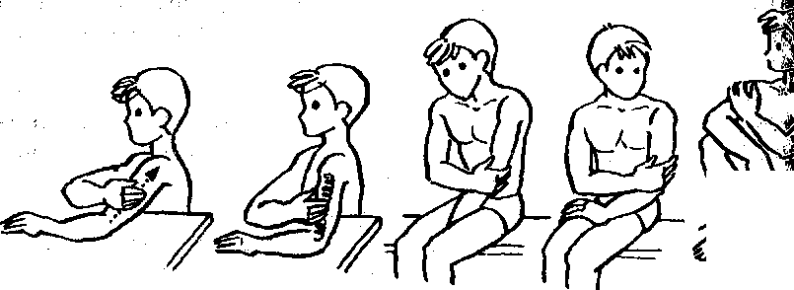  Shoulder self-massage  1. With the palm of the right hand, pressing on the biceps (biceps muscle) of the left, perform sliding movements from the elbow to the shoulder.  2. Grabbing the shoulder muscle on the left hand between the thumb and the other four fingers of the right hand, do kneading. Move the muscle to the side. Move from elbow to shoulder. Do not forget to stroke after each reception.  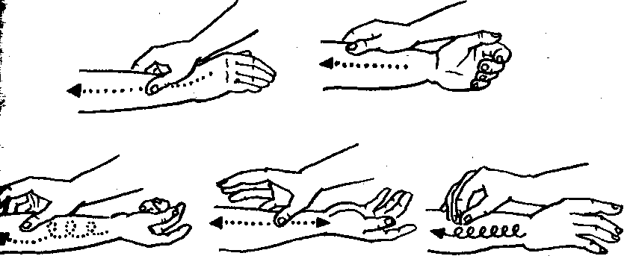  Self-massage of the forearm  1. With the right hand, stroke the left forearm from the hand to the elbow joint with sliding movements.  2. With four fingers of the right hand, knead the outer side of the forearm.  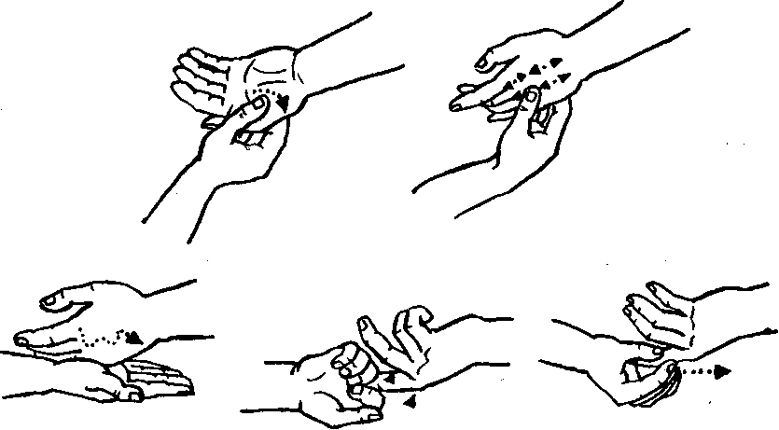  Self-massage of fingers. 1. Left arm bent at the elbow on the table. Stroke each finger with your right hand. To do this, grab it so that four fingers are on the inside, and the thumb is on the back. With your thumb, stroke from the tip of the massaged finger to its base. 2. With your right hand, alternately grasp and rub all the fingers with your left. To do this, use your thumb in circular motions, moving from the tip of the massaged finger to its base. The massage ends with stroking the whole hand.  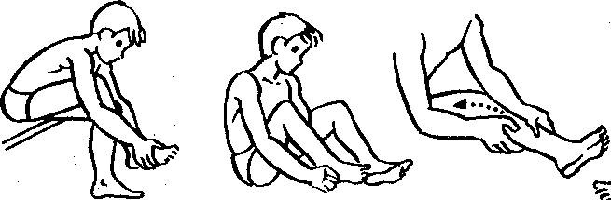  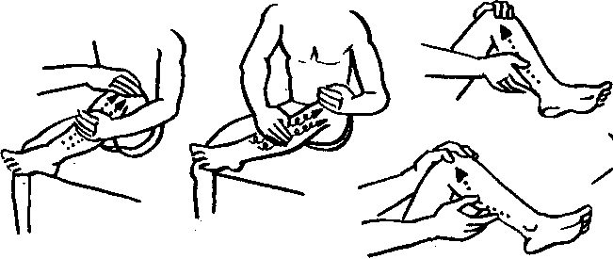  Lower leg self-massagedo it sitting. Place the massaged bent leg on a nearby chair  Self-massage of the thigh  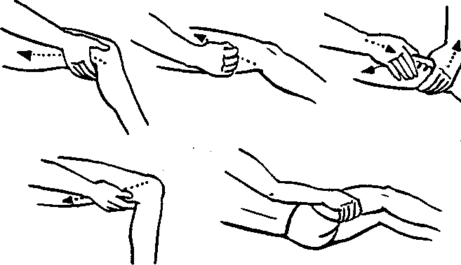  Self-massage of the muscles of the anterior thighperform by stretching forward and slightly bending the leg (the lower leg lies on the pad).  When massaging the back surface, place the bent leg on a chair.  Self-massage of chest musclesdo it sitting. The hand on the massaged side of the chest should be relaxed.  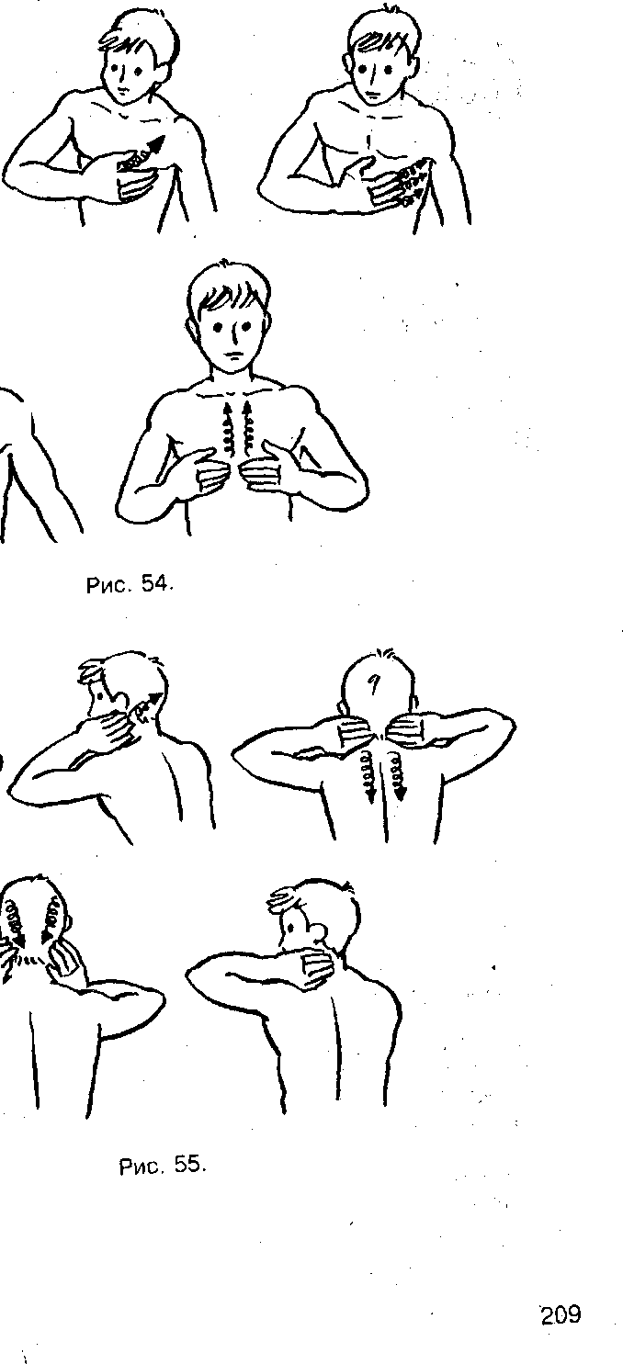  Self-massage of the neck. Usually performed while sitting at a table. Put your elbows on the table, tilt your head slightly back or tilt forward slightly so that your neck does not strain.)  Self-massage of the back and lower back.It is performed in the position of the legs shoulder width apart. Rub your fists on the back on both sides of the spine from the bottom up, and the lower back from the middle to the sides of the mouth. After that, stroke the back from the bottom up with both sides of the palms. The movements of the massaging hand should be directed along the flow of blood and lymph - from the periphery to the heart and the nearest lymph nodes. However, the armpit, elbow, groin and popliteal fossa, where the lymph nodes are located, cannot be massaged. So, the legs should be massaged from the fingers to the knees, and then to the groin, the hands - from the fingers to the shoulders; chest - from the sternum along the ribs to the armpits; back - from the large gluteal muscles to the shoulders, as well as from the spinal column to the sides; stomach - in a circular motion clockwise; neck - from the scalp to the shoulder blades. Massage should not be applied continuously.  In what cases is self-massage not indicated? With bleeding, fever, acute inflammatory processes, with skin and infectious diseases with high fever, with diseases of the heart, lungs, kidneys. It is not advisable to perform a massage on an empty stomach.  Self-massage for physical and mental fatigue.  When tired, you can do general and private self-massage. In the first case, the whole body is massaged for 10 minutes, arms - 6 minutes, torso - 6 minutes, back - 3 minutes. In the second case, the muscles most loaded with work are massaged. Maintaining muscle tone (in shape) is one of the main functions of self-massage. This is facilitated by self-massage of the muscles of the arms, neck, chest, abdomen, back, and lumbar region. If you have a minimum of time, you can limit yourself to local self-massage of the most tired part of the body. Depending on the purpose of the application, two types of self-massage are distinguished: preliminary and restorative.  So, for example, during mental work, preliminary self-massage is useful, which increases the mobility of the chest. To do this, it is necessary to rub the intercostal space, hypochondrium and lower back. With mental fatigue, great importance is attached to the massage of reflex zones that affect the blood circulation of the brain, in particular the occipital, neck and collar, pectoral muscles and shoulder girdle. With them, and you need to start the massage. When jogging, preliminary self-massage includes techniques for the muscles of the thigh and lower leg (2-3 strokes, 3-4 push-ups, 4-6 various kneadings). Self-massage ends with shaking and stroking.  If you experience pain in the muscles and ligaments after running, shake your leg muscles. To do this, stand on one leg and shake the other and vice versa. Do the same while lying on your back. This improves blood circulation in tired muscles and relieves tension in them. It is useful to stroke the leg from the foot to the groin while shaking. In the future, despite the disappearance of pain, it is worth doing self-massage after a daily run - you can always be in shape.  Restorative self-massage is used to restore the performance of tired muscles, quickly relieve fatigue. 4-5 minutes of massage is enough to get back in shape.
3 | Final part of the lesson:  - attention exercises;  - summarizing the lesson;  - presenting current grades in the educational journal.
Means of education:
-material and technical: chronometers, places for gymnastics, mats.

Module 1 General physical training - adaptive forms and types.
Topic 24Improving the simplest techniques of self-massage.
Type of lessonpractical lesson.
Targetfixing the simplest self-massage techniques
Lesson plan
No.  p/n | Stages and content of the lesson
1  1.1  1.2  1.3 | Organizing time.  Announcement of the topic, purpose of the lesson.  Motivational moment (formation of a complex of motor skills and physical qualities necessary in professional activity).  Walking and its varieties:  1 - on socks, arms up;  2 - on the heels, arms to the sides;  3 - on the outside of the foot, hands behind the head;  4 - on the inside of the foot, hands behind the back;  5 - "high" step, hands forward;  6 - in a half-crouch, hands on the belt  Running and its varieties:  1 - running at a slow pace;  2 - running with straightened legs forward;  3 - running with straightened legs back;  4 - running with straightened legs to the sides  “Step march!”, “Stay where you are!”, “To the left!”, “On the first, second, pay!”  switchgear in place  1) I. p. - O. s., hands on the belt. Head tilts to the right, forward, left, back  2) I. p. - O. s., hands on the belt. Head rotation left and right  3) I. n. - O. s., feet shoulder-width apart, arms straight to the sides. Circular rotation of the arms in the elbow joint inward and outward  4) I. p. - O. s., feet shoulder-width apart, arms straight to the sides. Circular rotation of the arms in the shoulder joint forward and backward  5) I. p. - O. s., feet shoulder-width apart, arms bent at the elbows in front of you. Rotation of the upper body to the right and left  6) I. p. - O. s., feet shoulder-width apart, hands on the belt. Circular rotation of the body to the right and left  7) I. n. - O. s., feet shoulder-width apart, hands on the belt. Torso forward alternately to the left leg, between the feet, to the right leg
2  2.1 | The main part of the lesson.  Development of practical skills and abilities, testing of practical skills:improvement of the simplest methods of self-massage.  Self-massage is a useful and effective means of reducing fatigue and increasing efficiency. It enhances the outflow of venous blood and lymph, helps to restore all body systems after intense physical exertion.  Only healthy, clean skin can be massaged with clean and dry hands. For better glide, the body can be lubricated with vaseline oil. Self-massage is performed with maximum muscle relaxation.  Basic massage techniquesare applied in the following order:  stroking (performed with one or two hands, they begin and end the massage):  squeezing (performed in the same directions as stroking);  kneading (the muscle pulled away from the bone and pressed against it is vigorously kneaded with fingers);  rubbing (performed in all directions, especially widely in the joint area);  percussion techniques: tapping (light blows with fingers slightly clenched into a fist), patting (light blows with straight, relaxed fingers from the side of the little finger),  chopping (performed with the edge of the hand with widely spread and relaxed fingers);  shaking (performed with the thumb and little finger, has a calming effect).  Each massage is performed 3-5 times. The total massage time should not exceed 7-10 minutes. At first, the massage is done lightly, gently, then gradually increase the strength of the impact.  Self-massage is performed while sitting on a chair at the table. Massage the left, then the right hand. Place your left hand on the table. Grasping it with a brush, right hand, stroke, easily sliding from your fingers to the shoulder joint. Perform 3-5 strokes on the outside of the hand, then on the inside.  Shoulder self-massage  1. With the palm of the right hand, pressing on the biceps (biceps muscle) of the left, perform sliding movements from the elbow to the shoulder.  2. Grabbing the shoulder muscle on the left hand between the thumb and the other four fingers of the right hand, do kneading. Move the muscle to the side. Move from elbow to shoulder. Do not forget to stroke after each reception.  Self-massage of the forearm  1. With the right hand, stroke the left forearm from the hand to the elbow joint with sliding movements.  2. With four fingers of the right hand, knead the outer side of the forearm.  Self-massage of fingers. 1. Left arm bent at the elbow on the table. Stroke each finger with your right hand. To do this, grab it so that four fingers are on the inside, and the thumb is on the back. With your thumb, stroke from the tip of the massaged finger to its base. 2. With your right hand, alternately grasp and rub all the fingers with your left. To do this, use your thumb in circular motions, moving from the tip of the massaged finger to its base. The massage ends with stroking the whole hand.  Lower leg self-massagedo it sitting. Place the massaged bent leg on a nearby chair  Self-massage of the thigh  Self-massage of the muscles of the anterior thighperform by stretching forward and slightly bending the leg (the lower leg lies on the pad).  When massaging the back surface, place the bent leg on a chair.  Self-massage of chest musclesdo it sitting. The hand on the massaged side of the chest should be relaxed.  Self-massage of the neck. Usually performed while sitting at a table. Put your elbows on the table, tilt your head slightly back or tilt forward slightly so that your neck does not strain.)  Self-massage of the back and lower back.It is performed in the position of the legs shoulder width apart. Rub your fists on the back on both sides of the spine from the bottom up, and the lower back from the middle to the sides of the mouth. After that, stroke the back from the bottom up with both sides of the palms. The movements of the massaging hand should be directed along the flow of blood and lymph - from the periphery to the heart and the nearest lymph nodes. However, the armpit, elbow, groin and popliteal fossa, where the lymph nodes are located, cannot be massaged. So, the legs should be massaged from the fingers to the knees, and then to the groin, the hands - from the fingers to the shoulders; chest - from the sternum along the ribs to the armpits; back - from the large gluteal muscles to the shoulders, as well as from the spinal column to the sides; stomach - in a circular motion clockwise; neck - from the scalp to the shoulder blades. Massage should not be applied continuously.  In what cases is self-massage not indicated? With bleeding, fever, acute inflammatory processes, with skin and infectious diseases with high fever, with diseases of the heart, lungs, kidneys. It is not advisable to perform a massage on an empty stomach.  Self-massage for physical and mental fatigue.  When tired, you can do general and private self-massage. In the first case, the whole body is massaged for 10 minutes, arms - 6 minutes, torso - 6 minutes, back - 3 minutes. In the second case, the muscles most loaded with work are massaged. Maintaining muscle tone (in shape) is one of the main functions of self-massage. This is facilitated by self-massage of the muscles of the arms, neck, chest, abdomen, back, and lumbar region. If you have a minimum of time, you can limit yourself to local self-massage of the most tired part of the body. Depending on the purpose of the application, two types of self-massage are distinguished: preliminary and restorative.  So, for example, during mental work, preliminary self-massage is useful, which increases the mobility of the chest. To do this, it is necessary to rub the intercostal space, hypochondrium and lower back. With mental fatigue, great importance is attached to the massage of reflex zones that affect the blood circulation of the brain, in particular the occipital, neck and collar, pectoral muscles and shoulder girdle. With them, and you need to start the massage. When jogging, preliminary self-massage includes techniques for the muscles of the thigh and lower leg (2-3 strokes, 3-4 push-ups, 4-6 various kneadings). Self-massage ends with shaking and stroking.  If you experience pain in the muscles and ligaments after running, shake your leg muscles. To do this, stand on one leg and shake the other and vice versa. Do the same while lying on your back. This improves blood circulation in tired muscles and relieves tension in them. It is useful to stroke the leg from the foot to the groin while shaking. In the future, despite the disappearance of pain, it is worth doing self-massage after a daily run - you can always be in shape.  Restorative self-massage is used to restore the performance of tired muscles, quickly relieve fatigue. 4-5 minutes of massage is enough to get back in shape.
3 | Final part of the lesson:  - attention exercises;  - summarizing the lesson;  - presenting current grades in the educational journal.
Means of education:
-material and technical: chronometers, places for gymnastics, mats.

Module 1 General physical training - adaptive forms and types.
Topic 25Fixing the simplest techniques of self-massage.
Type of lessonpractical lesson.
Targetfixing the simplest self-massage techniques
Lesson plan
No.  p/n | Stages and content of the lesson
1  1.1  1.2  1.3 | Organizing time.  Announcement of the topic, purpose of the lesson.  Motivational moment (formation of a complex of motor skills and physical qualities necessary in professional activity).  Walking and its varieties:  1 - on socks, arms up;  2 - on the heels, arms to the sides;  3 - on the outside of the foot, hands behind the head;  4 - on the inside of the foot, hands behind the back;  5 - "high" step, hands forward;  6 - in a half-crouch, hands on the belt  Running and its varieties:  1 - running at a slow pace;  2 - running with straightened legs forward;  3 - running with straightened legs back;  4 - running with straightened legs to the sides  “Step march!”, “Stay where you are!”, “To the left!”, “On the first, second, pay!”  switchgear in place  1) I. p. - O. s., hands on the belt. Head tilts to the right, forward, left, back  2) I. p. - O. s., hands on the belt. Head rotation left and right  3) I. n. - O. s., feet shoulder-width apart, arms straight to the sides. Circular rotation of the arms in the elbow joint inward and outward  4) I. p. - O. s., feet shoulder-width apart, arms straight to the sides. Circular rotation of the arms in the shoulder joint forward and backward  5) I. p. - O. s., feet shoulder-width apart, arms bent at the elbows in front of you. Rotation of the upper body to the right and left  6) I. p. - O. s., feet shoulder-width apart, hands on the belt. Circular rotation of the body to the right and left  7) I. n. - O. s., feet shoulder-width apart, hands on the belt. Torso forward alternately to the left leg, between the feet, to the right leg
2  2.1  2.6  2.7 | The main part of the lesson.  Development of practical skills, testing of practical skills: fixing the simplest techniques of self-massage.  Self-massage is a useful and effective means of reducing fatigue and increasing efficiency. It enhances the outflow of venous blood and lymph, helps to restore all body systems after intense physical exertion.  Only healthy, clean skin can be massaged with clean and dry hands. For better glide, the body can be lubricated with vaseline oil. Self-massage is performed with maximum muscle relaxation.  Basic massage techniquesare applied in the following order:  stroking (performed with one or two hands, they begin and end the massage):  squeezing (performed in the same directions as stroking);  kneading (the muscle pulled away from the bone and pressed against it is vigorously kneaded with fingers);  rubbing (performed in all directions, especially widely in the joint area);  percussion techniques: tapping (light blows with fingers slightly clenched into a fist), patting (light blows with straight, relaxed fingers from the side of the little finger),  chopping (performed with the edge of the hand with widely spread and relaxed fingers);  shaking (performed with the thumb and little finger, has a calming effect).  Each massage is performed 3-5 times. The total massage time should not exceed 7-10 minutes. At first, the massage is done lightly, gently, then gradually increase the strength of the impact.  Self-massage is performed while sitting on a chair at the table. Massage the left, then the right hand. Place your left hand on the table. Grasping it with a brush, right hand, stroke, easily sliding from your fingers to the shoulder joint. Perform 3-5 strokes on the outside of the hand, then on the inside.  Shoulder self-massage  1. With the palm of the right hand, pressing on the biceps (biceps muscle) of the left, perform sliding movements from the elbow to the shoulder.  2. Grabbing the shoulder muscle on the left hand between the thumb and the other four fingers of the right hand, do kneading. Move the muscle to the side. Move from elbow to shoulder. Do not forget to stroke after each reception.  Self-massage of the forearm  1. With the right hand, stroke the left forearm from the hand to the elbow joint with sliding movements.  2. With four fingers of the right hand, knead the outer side of the forearm.  Self-massage of fingers. 1. Left arm bent at the elbow on the table. Stroke each finger with your right hand. To do this, grab it so that four fingers are on the inside, and the thumb is on the back. With your thumb, stroke from the tip of the massaged finger to its base. 2. With your right hand, alternately grasp and rub all the fingers with your left. To do this, use your thumb in circular motions, moving from the tip of the massaged finger to its base. The massage ends with stroking the whole hand.  Lower leg self-massagedo it sitting. Place the massaged bent leg on a nearby chair  Self-massage of the thigh  Self-massage of the muscles of the anterior thighperform by stretching forward and slightly bending the leg (the lower leg lies on the pad).  When massaging the back surface, place the bent leg on a chair.  Self-massage of chest musclesdo it sitting. The hand on the massaged side of the chest should be relaxed.  Self-massage of the neck. Usually performed while sitting at a table. Put your elbows on the table, tilt your head slightly back or tilt forward slightly so that your neck does not strain.)  Self-massage of the back and lower back.It is performed in the position of the legs shoulder width apart. Rub your fists on the back on both sides of the spine from the bottom up, and the lower back from the middle to the sides of the mouth. After that, stroke the back from the bottom up with both sides of the palms. The movements of the massaging hand should be directed along the flow of blood and lymph - from the periphery to the heart and the nearest lymph nodes. However, the armpit, elbow, groin and popliteal fossa, where the lymph nodes are located, cannot be massaged. So, the legs should be massaged from the fingers to the knees, and then to the groin, the hands - from the fingers to the shoulders; chest - from the sternum along the ribs to the armpits; back - from the large gluteal muscles to the shoulders, as well as from the spinal column to the sides; stomach - in a circular motion clockwise; neck - from the scalp to the shoulder blades. Massage should not be applied continuously.  In what cases is self-massage not indicated? With bleeding, fever, acute inflammatory processes, with skin and infectious diseases with high fever, with diseases of the heart, lungs, kidneys. It is not advisable to perform a massage on an empty stomach.  Self-massage for physical and mental fatigue.  When tired, you can do general and private self-massage. In the first case, the whole body is massaged for 10 minutes, arms - 6 minutes, torso - 6 minutes, back - 3 minutes. In the second case, the muscles most loaded with work are massaged. Maintaining muscle tone (in shape) is one of the main functions of self-massage. This is facilitated by self-massage of the muscles of the arms, neck, chest, abdomen, back, and lumbar region. If you have a minimum of time, you can limit yourself to local self-massage of the most tired part of the body. Depending on the purpose of the application, two types of self-massage are distinguished: preliminary and restorative.  So, for example, during mental work, preliminary self-massage is useful, which increases the mobility of the chest. To do this, it is necessary to rub the intercostal space, hypochondrium and lower back. With mental fatigue, great importance is attached to the massage of reflex zones that affect the blood circulation of the brain, in particular the occipital, neck and collar, pectoral muscles and shoulder girdle. With them, and you need to start the massage. When jogging, preliminary self-massage includes techniques for the muscles of the thigh and lower leg (2-3 strokes, 3-4 push-ups, 4-6 various kneadings). Self-massage ends with shaking and stroking.  If you experience pain in the muscles and ligaments after running, shake your leg muscles. To do this, stand on one leg and shake the other and vice versa. Do the same while lying on your back. This improves blood circulation in tired muscles and relieves tension in them. It is useful to stroke the leg from the foot to the groin while shaking. In the future, despite the disappearance of pain, it is worth doing self-massage after a daily run - you can always be in shape.  Restorative self-massage is used to restore the performance of tired muscles, quickly relieve fatigue. 4-5 minutes of massage is enough to get back in shape.
3 | Final part of the lesson:  - attention exercises;  - summarizing the lesson;  - presenting current grades in the educational journal.
Means of education:
-material and technical: chronometers, places for gymnastics, mats.

Module 1 General physical training - adaptive forms and types.
Topic 26Learning the elements of relaxation, improving coordination.
Type of lessonpractical lesson.
Targetcreate an idea of ​​the elements of relaxation and improvement of coordination.
Lesson plan
No.  p/n | Stages and content of the lesson
1  1.1  1.2  1.3 | Organizing time.  Announcement of the topic, purpose of the lesson.  Motivational moment (formation of a complex of motor skills and physical qualities necessary in professional activity).  Walking and its varieties:  1 - on socks, arms up;  2 - on the heels, arms to the sides;  3 - on the outside of the foot, hands behind the head;  4 - on the inside of the foot, hands behind the back;  5 - "high" step, hands forward;  6 - in a half-crouch, hands on the belt  Running and its varieties:  1 - running at a slow pace;  2 - running with straightened legs forward;  3 - running with straightened legs back;  4 - running with straightened legs to the sides  “Step march!”, “Stay where you are!”, “To the left!”, “On the first, second, pay!”  switchgear in place  1) I. p. - O. s., hands on the belt. Head tilts to the right, forward, left, back  2) I. p. - O. s., hands on the belt. Head rotation left and right  3) I. n. - O. s., feet shoulder-width apart, arms straight to the sides. Circular rotation of the arms in the elbow joint inward and outward  4) I. p. - O. s., feet shoulder-width apart, arms straight to the sides. Circular rotation of the arms in the shoulder joint forward and backward  5) I. p. - O. s., feet shoulder-width apart, arms bent at the elbows in front of you. Rotation of the upper body to the right and left  6) I. p. - O. s., feet shoulder-width apart, hands on the belt. Circular rotation of the body to the right and left  7) I. n. - O. s., feet shoulder-width apart, hands on the belt. Torso forward alternately to the left leg, between the feet, to the right leg
2  2.1  2.2  2.3 | The main part of the lesson.  Development of practical skills, testing of practical skills: teaching the elements of relaxation, improving coordination:  A set of breathing exercises  - Make a full exhalation, take in air slowly through the nose, making sure that the anterior abdominal wall protrudes more and more forward (take in air freely, without straining). In this case, the diaphragm flattens, increasing the volume of the lungs, the chest expands. Inhale and exhale smoothly, avoiding shocks.  - Exhale and, when the desire to inhale appears, with your mouth closed, take a deep, stress-free breath in through your nose. Then pause (hold the chest in an expanded state). Make a full exhalation, slowly and smoothly releasing the air  through the nose. Pause.  - After exhalation, start breathing through the nose, making sure that the diaphragm, lower ribs and abdominal muscles work correctly, and that the shoulders are calm. After a pause, start a gradual, smooth exhalation through a narrow hole formed by the lips. In this case, there should be a feeling that the air stream is a continuation of the air stream coming from the diaphragm. Care must be taken to ensure that there is no tension in  upper chest and neck. When you feel tension, relax, slowly shake your head to the right and left, back and forth, in a circle.  - Starting position (hereinafter - I. p.) - lying on your back. According to the instructions, the child slowly raises one arm (right, left), leg (left, right), then two limbs simultaneously while inhaling and holds it in a raised position during a pause; slowly lowers on exhalation; relaxes during the break. After this exercise is performed lying on the stomach.  5) I. p. - sitting, back straight. Raise your arms up above your head with an inhalation and lower them down in front of you with an exhalation, bending slightly at the same time.  Coordination exercises  1) Space  I.P. - standing on the leg, arms freely lowered down. Inhale: raise the unhealthy leg, at the same time the arms bend at the elbows and the hands rise to chest level.  Exhale: arms spread apart.  2) Balance  I.P. - the same. Inhale: take the first position of the previous exercise. Exhale: body leans forward, arms stretch forward. Inhale: move to the previous position (put your hands on the floor). Exhale: return to starting position. Then the exercise is repeated on the opposite side.  3) A breath of wind  I.P. - the same. Exhale: the hands make a circular rotational movement to the right-up-left-down, and then, together with the right leg, are retracted to the right, while the leg is fully extended at the knee joint. Inhale: return to the previous position. Exhale: return to starting position. Then the exercise is performed on the opposite side.  4) Half the World  A feature of this exercise is the combination of the previous three  exercises as a whole. From the starting position, the exercises are performed  in series with a common intermediate position. Exercise can be done  repeatedly.  5) Stick insect  1. I.P. - lie on the floor, raise your leg and body up, resting your hands on the lower back, and putting your elbows on the floor. Hold this position, slowly counting to ten, then lower the body to the floor.  2. Having done what is described in option 1, keeping the body in a vertical position, release the hands from the waist and, placing them on the floor, maintain balance in the position.  After counting to ten, lower the body to the floor.  3. Having done what is written in option 2, holding the body in a vertical position, raise your hands and place them along the body and legs - in the "hands at the seams" position,  Keeping balance by relying on the neck and shoulders. Stand in this position, counting to ten, then lower the body.  6) Corner  Sitting on a chair (back straight, neck straight, look forward), grasp the side edge of the seat (with both hands), raise your legs parallel to the floor and, holding them in this position, do a breathing exercise.  7) Crane  I.P. - standing on a leg, arms spread apart. Inhale: lower breath. As you exhale, we slowly lean forward, trying to lean as low as possible. The downward movement ends simultaneously with the exhalation. On an inhale, straighten up and return to the starting position.  8) Tumbler  I.P. - sitting. Take the outer edge of the foot with your hand, and, while maintaining balance, sitting on the buttocks, take the leg to the sides, trying to fully straighten the leg at the knee joint.  In this case, you must try not to fall back.  The exercise is performed from 3-4 to 10-12 times, keeping the balance from 2-3 seconds to 10-15 seconds. Type of breathing - lower.  9) Crab  I.P. - sitting and leaning with his foot and hand on the floor. We tear off the buttocks from the floor, remaining on three points of support, and maintain balance.
3 | Final part of the lesson:  - attention exercises;  - summarizing the lesson;  - presenting current grades in the educational journal.
Means of education:
-material and technical: chronometers, places for gymnastics, mats.

Module 1 General physical training - adaptive forms and types.
Topic 27Improving the elements of relaxation, improving coordination.
Type of lessonpractical lesson.
Targetto consolidate the idea of ​​the elements of relaxation and improvement of coordination.
Lesson plan
No.  p/n | Stages and content of the lesson
1  1.1  1.2  1.3 | Organizing time.  Announcement of the topic, purpose of the lesson.  Motivational moment (formation of a complex of motor skills and physical qualities necessary in professional activity).  Walking and its varieties:  1 - on socks, arms up;  2 - on the heels, arms to the sides;  3 - on the outside of the foot, hands behind the head;  4 - on the inside of the foot, hands behind the back;  5 - "high" step, hands forward;  6 - in a half-crouch, hands on the belt  Running and its varieties:  1 - running at a slow pace;  2 - running with straightened legs forward;  3 - running with straightened legs back;  4 - running with straightened legs to the sides  “Step march!”, “Stay where you are!”, “To the left!”, “On the first, second, pay!”  switchgear in place  1) I. p. - O. s., hands on the belt. Head tilts to the right, forward, left, back  2) I. p. - O. s., hands on the belt. Head rotation left and right  3) I. n. - O. s., feet shoulder-width apart, arms straight to the sides. Circular rotation of the arms in the elbow joint inward and outward  4) I. p. - O. s., feet shoulder-width apart, arms straight to the sides. Circular rotation of the arms in the shoulder joint forward and backward  5) I. p. - O. s., feet shoulder-width apart, arms bent at the elbows in front of you. Rotation of the upper body to the right and left  6) I. p. - O. s., feet shoulder-width apart, hands on the belt. Circular rotation of the body to the right and left  7) I. n. - O. s., feet shoulder-width apart, hands on the belt. Torso forward alternately to the left leg, between the feet, to the right leg
2  2.1  2.2  2.3 | The main part of the lesson.  Development of practical skills, testing of practical skills: improving the elements of relaxation, improving coordination.  A set of breathing exercises  1. Make a full exhalation, take in air slowly through the nose, making sure that the anterior abdominal wall protrudes more and more forward (take in air freely, without straining). In this case, the diaphragm flattens, increasing the volume of the lungs, the chest expands. Inhale and exhale smoothly, avoiding shocks.  2. Exhale and, when there is a desire to inhale, with your mouth closed, take a deep, stress-free inhale through your nose. Then pause (hold the chest in an expanded state). Make a full exhalation, slowly and smoothly releasing the air  through the nose. Pause.  3. After exhalation, start breathing through the nose, making sure that the diaphragm, lower ribs and abdominal muscles work correctly, and that the shoulders are calm. After a pause, start a gradual, smooth exhalation through a narrow hole formed by the lips. In this case, there should be a feeling that the air stream is a continuation of the air stream coming from the diaphragm. Care must be taken to ensure that there is no tension in  upper chest and neck. When you feel tension, relax, slowly shake your head to the right and left, back and forth, in a circle.  4. Starting position (hereinafter referred to as i.p.) - lying on your back. According to the instructions, the child slowly raises one arm (right, left), leg (left, right), then two limbs simultaneously while inhaling and holds it in a raised position during a pause; slowly lowers on exhalation; relaxes during the break. After this exercise is performed lying on the stomach.  5.I. n. - sitting, back straight. Raise your arms up above your head with an inhalation and lower them down in front of you with an exhalation, bending slightly at the same time.  Coordination exercises  1) Space  I.P. - standing on the leg, arms freely lowered down. Inhale: raise the unhealthy leg, at the same time the arms are bent at the elbows and the hands are raised to chest level.  Exhale: arms spread apart.  2) Balance  I.P. - the same. Inhale: take the first position of the previous exercise. Exhale: body leans forward, arms stretch forward. Inhale: move to the previous position (put your hands on the floor). Exhale: return to starting position. Then the exercise is repeated on the opposite side.  3) A breath of wind  I.P. - the same. Exhale: the hands make a circular rotational movement to the right-up-left-down, and then, together with the right leg, are retracted to the right, while the leg is fully extended at the knee joint. Inhale: return to the previous position. Exhale: return to starting position. Then the exercise is performed on the opposite side.  4) Half the World  A feature of this exercise is the combination of the previous three  exercises as a whole. From the starting position, the exercises are performed  in series with a common intermediate position. Exercise can be done  repeatedly.  5) Stick insect  1. I.P. - lie on the floor, raise your leg and body up, resting your hands on the lower back, and putting your elbows on the floor. Hold this position, slowly counting to ten, then lower the body to the floor.  2. Having done what is described in option 1, keeping the body in a vertical position, release the hands from the waist and, placing them on the floor, maintain balance in the position.  After counting to ten, lower the body to the floor.  3. Having done what is written in option 2, holding the body in a vertical position, raise your hands and place them along the body and legs - in the "hands at the seams" position,  Keeping balance by relying on the neck and shoulders. Stand in this position, counting to ten, then lower the body.  6) Corner  Sitting on a chair (back straight, neck straight, look forward), grasp the side edge of the seat (with both hands), raise your legs parallel to the floor and, holding them in this position, do a breathing exercise.  7) Crane  I.P. - standing on a leg, arms spread apart. Inhale: lower breath. As you exhale, we slowly lean forward, trying to lean as low as possible. The downward movement ends simultaneously with the exhalation. On an inhale, straighten up and return to the starting position.  8) Tumbler  I.P. - sitting. Take the outer edge of the foot with your hand, and, while maintaining balance, sitting on the buttocks, take the leg to the sides, trying to fully straighten the leg at the knee joint.  In this case, you must try not to fall back.  The exercise is performed from 3-4 to 10-12 times, keeping the balance from 2-3 seconds to 10-15 seconds. Type of breathing - lower.  9) Crab  I.P. - sitting and leaning with his foot and hand on the floor. We tear off the buttocks from the floor, remaining on three points of support, and maintain balance.
3 | Final part of the lesson:  - attention exercises;  - summarizing the lesson;  - presenting current grades in the educational journal.
Means of education:
-material and technical: chronometers, places for gymnastics, mats.

Module 1 General physical training - adaptive forms and types.
Topic 28Teaching a set of exercises for overweight.
Type of lessonpractical lesson.
Targetcreate an idea of ​​​​a set of exercises for overweight.
Lesson plan
No.  p/n | Stages and content of the lesson
1  1.1  1.2  1.3 | Organizing time.  Announcement of the topic, purpose of the lesson.  Motivational moment (formation of a complex of motor skills and physical qualities necessary in professional activity).  Walking and its varieties:  1 - on socks, arms up;  2 - on the heels, arms to the sides;  3 - on the outside of the foot, hands behind the head;  4 - on the inside of the foot, hands behind the back;  5 - "high" step, hands forward;  6 - in a half-crouch, hands on the belt  Running and its varieties:  1 - running at a slow pace;  2 - running with straightened legs forward;  3 - running with straightened legs back;  4 - running with straightened legs to the sides  “Step march!”, “Stay where you are!”, “To the left!”, “On the first, second, pay!”  switchgear in place  1) I. p. - O. s., hands on the belt. Head tilts to the right, forward, left, back  2) I. p. - O. s., hands on the belt. Head rotation left and right  3) I. n. - O. s., feet shoulder-width apart, arms straight to the sides. Circular rotation of the arms in the elbow joint inward and outward  4) I. p. - O. s., feet shoulder-width apart, arms straight to the sides. Circular rotation of the arms in the shoulder joint forward and backward  5) I. p. - O. s., feet shoulder-width apart, arms bent at the elbows in front of you. Rotation of the upper body to the right and left  6) I. p. - O. s., feet shoulder-width apart, hands on the belt. Circular rotation of the body to the right and left  7) I. n. - O. s., feet shoulder-width apart, hands on the belt. Torso forward alternately to the left leg, between the feet, to the right leg
2  2.1 | The main part of the lesson.  Development of practical skills, testing of practical skills: training in a set of exercises for overweight.  1. Standing, legs apart, stick at the top in outstretched arms. The grip is wide. Turns the stick left and right in a horizontal plane until the arms are completely crossed.  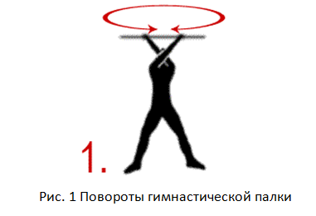  2. Standing, left arm extended forward. Grab the middle of the stick. Rotation of the gymnastic stick left and right - like a propeller. Repeat the exercise, moving your hand not forward, but to the side. Change hands and do the same for the right hand.  3. Standing on a slope, leaning on a stick with straight arms. Two - three springy swings up and down.  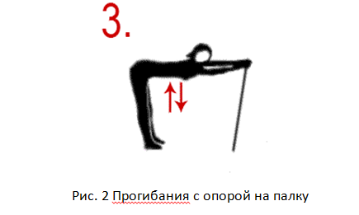  4. Standing on one leg, put a stick on the toe of the second leg, which is on weight. Hold the balance of the stick for a few seconds without touching it with your hand. Change your leg.  5. Standing, the stick is vertically in front of you, the end rests on the floor. Holding it with your hand, swing your straight leg over the stick. Alternate left and right foot.  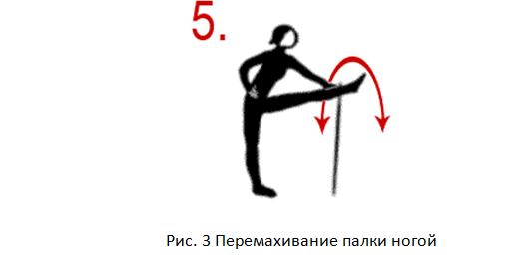  6. An exercise similar to the previous one with the only difference that the stick is on the side and, swinging it with your foot, you need to swing to the sides, and this is more difficult.  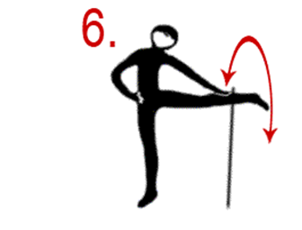  7. Standing, gymnastic stick in the lowered hand parallel to the floor. Grab the end. Describing circles with a stick alternately to the left and right side, jump over the stick.  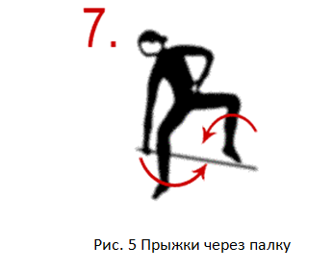  8. In a stand on the shoulder blades, support on a stick. Torso forward. Try not to lift the stick off the floor.  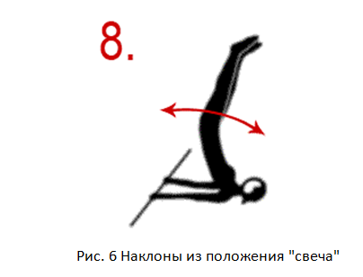  9. Standing, hands up, in them a stick taken with a wide grip. We make lunges alternately with the right and left legs wide forward. Simultaneously with the lunge, we try to take the stick back and bend as much as possible.  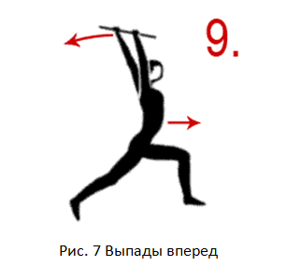  10. Kneeling. Holding the stick with both hands at the end, raise it up like a sword. It is necessary to draw a circle in the air with the “edge of the sword”. In this case, the hands should remain motionless, and all movement is performed due to the circular movement of the body. Run right and left.  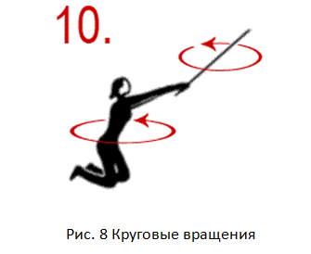  11. Standing, take the stick with an average grip and raise it above your head. Make three springy forward bends. Do not slouch your back, bend in the lower back, take the gymnastic stick back - up.  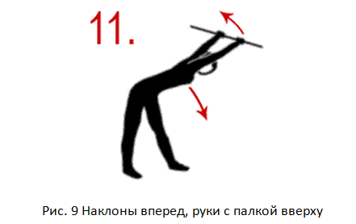  12. Standing, the stick is taken with a wide grip and is behind the back in lowered hands. Make three springy forward bends. Do not stoop your back, bend at the waist, lift the gymnastic stick up.  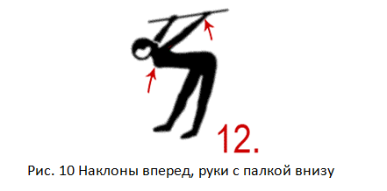  13. Standing, legs wider than shoulders, socks apart. Take a stick with a medium grip and raise it above your head. Bend the right leg, at the same time tilt in the direction of the straight left leg. At the same time, lower the stick behind the head and put it on the shoulder blades. Return to starting position. Repeat the exercise, bending the left leg and leaning in the direction of the straight right.  14. In a stand on the shoulder blades, as well as in exercise No. 8. Stick on the back. Only instead of tilting, perform oncoming swings with your legs - “scissors”. Try to touch the floor behind your head with your toes.  15. Lying on your back, take a stick with an average grip and stretch it in front of you. Bending legs alternately, carry them under the stick forward and backward. Repeat the exercise, passing both legs under the stick at the same time.  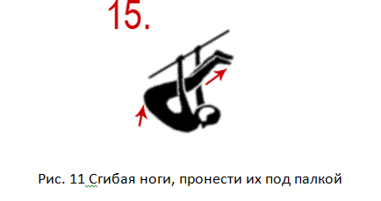  16. Sitting on the floor, stick in hands extended forward. Leaning your heels on a stick, straighten your legs.  17. Standing, legs wider than shoulders, socks apart, take a gymnastic stick with a wide grip, put it behind your back and lower it onto your shoulder blades. Perform tilts and at the same time turn the body to the sides - “windmill”.  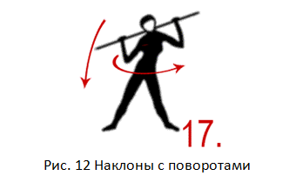
3 | Final part of the lesson:  - mobile game;  - summarizing the lesson;  - presenting current grades in the educational journal.
Means of education:
- material and technical: chronometers, places for gymnastics, gymnastic sticks, mats.

Module 1 General physical training - adaptive forms and types.
Topic 29Improving a set of exercises for overweight.
Type of lessonpractical lesson.
Targetconsolidate a set of exercises with excess weight.
Lesson plan
No.  p/n | Stages and content of the lesson
1  1.1  1.2  1.3 | Organizing time.  Announcement of the topic, purpose of the lesson.  Motivational moment (formation of a complex of motor skills and physical qualities necessary in professional activity).  Walking and its varieties:  1 - on socks, arms up;  2 - on the heels, arms to the sides;  3 - on the outside of the foot, hands behind the head;  4 - on the inside of the foot, hands behind the back;  5 - "high" step, hands forward;  6 - in a half-crouch, hands on the belt  Running and its varieties:  1 - running at a slow pace;  2 - running with straightened legs forward;  3 - running with straightened legs back;  4 - running with straightened legs to the sides  “Step march!”, “Stay where you are!”, “To the left!”, “On the first, second, pay!”  switchgear in place  1) I. p. - O. s., hands on the belt. Head tilts to the right, forward, left, back  2) I. p. - O. s., hands on the belt. Head rotation left and right  3) I. n. - O. s., feet shoulder-width apart, arms straight to the sides. Circular rotation of the arms in the elbow joint inward and outward  4) I. p. - O. s., feet shoulder-width apart, arms straight to the sides. Circular rotation of the arms in the shoulder joint forward and backward  5) I. p. - O. s., feet shoulder-width apart, arms bent at the elbows in front of you. Rotation of the upper body to the right and left  6) I. p. - O. s., feet shoulder-width apart, hands on the belt. Circular rotation of the body to the right and left  7) I. n. - O. s., feet shoulder-width apart, hands on the belt. Torso forward alternately to the left leg, between the feet, to the right leg
2  2.1 | The main part of the lesson.  Development of practical skills, testing of practical skills: to consolidate a set of exercises with excess weight.  1. Standing, legs apart, stick at the top in outstretched arms. The grip is wide. Turns the stick left and right in a horizontal plane until the arms are completely crossed.  2. Standing, left arm extended forward. Grab the middle of the stick. Rotation of the gymnastic stick left and right - like a propeller. Repeat the exercise, moving your hand not forward, but to the side. Change hands and do the same for the right hand.  3. Standing on a slope, leaning on a stick with straight arms. Two - three springy swings up and down.  4. Standing on one leg, put a stick on the toe of the second leg, which is on weight. Hold the balance of the stick for a few seconds without touching it with your hand. Change your leg.  5. Standing, the stick is vertically in front of you, the end rests on the floor. Holding it with your hand, swing your straight leg over the stick. Alternate left and right foot.  6. An exercise similar to the previous one with the only difference that the stick is on the side and, swinging it with your foot, you need to swing to the sides, and this is more difficult.  7. Standing, gymnastic stick in the lowered hand parallel to the floor. Grab the end. Describing circles with a stick alternately to the left and right side, jump over the stick.  8. In a stand on the shoulder blades, support on a stick. Torso forward. Try not to lift the stick off the floor.  9. Standing, hands up, in them a stick taken with a wide grip. We make lunges alternately with the right and left legs wide forward. Simultaneously with the lunge, we try to take the stick back and bend as much as possible.  10. Kneeling. Holding the stick with both hands at the end, raise it up like a sword. It is necessary to draw a circle in the air with the “edge of the sword”. In this case, the hands should remain motionless, and all movement is performed due to the circular movement of the body. Run right and left.  11. Standing, take the stick with an average grip and raise it above your head. Make three springy forward bends. Do not slouch your back, bend in the lower back, take the gymnastic stick back - up.  12. Standing, the stick is taken with a wide grip and is behind the back in lowered hands. Make three springy forward bends. Do not stoop your back, bend at the waist, lift the gymnastic stick up.  13. Standing, legs wider than shoulders, socks apart. Take a stick with a medium grip and raise it above your head. Bend the right leg, at the same time tilt in the direction of the straight left leg. At the same time, lower the stick behind the head and put it on the shoulder blades. Return to starting position. Repeat the exercise, bending the left leg and leaning in the direction of the straight right.  14. In a stand on the shoulder blades, as well as in exercise No. 8. Stick on the back. Only instead of tilting, perform oncoming swings with your legs - “scissors”. Try to touch the floor behind your head with your toes.  15. Lying on your back, take a stick with an average grip and stretch it in front of you. Bending legs alternately, carry them under the stick forward and backward. Repeat the exercise, passing both legs under the stick at the same time.  16. Sitting on the floor, stick in hands extended forward. Leaning your heels on a stick, straighten your legs.  17. Standing, legs wider than shoulders, socks apart, take a gymnastic stick with a wide grip, put it behind your back and lower it onto your shoulder blades. Perform tilts and at the same time turn the body to the sides - “windmill”.
3 | Final part of the lesson:  - mobile game;  - summarizing the lesson;  - presenting current grades in the educational journal.
Means of education:
- material and technical: chronometers, places for gymnastics, gymnastic sticks, mats.

Module 1 General physical training - adaptive forms and types.
Topic 30Training in the technique of exercises to strengthen the muscles of the thigh.
Type of lessonpractical lesson.
TargetTo create an idea about the technique of performing exercises to strengthen the thigh muscles.
Lesson plan
No.  p/n | Stages and content of the lesson
1  1.1  1.2  1.3 | Organizing time.  Announcement of the topic, purpose of the lesson.  Motivational moment (formation of a complex of motor skills and physical qualities necessary in professional activity).  Walking and its varieties:  1 - on socks, arms up;  2 - on the heels, arms to the sides;  3 - on the outside of the foot, hands behind the head;  4 - on the inside of the foot, hands behind the back;  5 - "high" step, hands forward;  6 - in a half-crouch, hands on the belt  Running and its varieties:  1 - running at a slow pace;  2 - running with straightened legs forward;  3 - running with straightened legs back;  4 - running with straightened legs to the sides  “Step march!”, “Stay where you are!”, “To the left!”, “On the first, second, pay!”  switchgear in place  1) I. p. - O. s., hands on the belt. Head tilts to the right, forward, left, back  2) I. p. - O. s., hands on the belt. Head rotation left and right  3) I. n. - O. s., feet shoulder-width apart, arms straight to the sides. Circular rotation of the arms in the elbow joint inward and outward  4) I. p. - O. s., feet shoulder-width apart, arms straight to the sides. Circular rotation of the arms in the shoulder joint forward and backward  5) I. p. - O. s., feet shoulder-width apart, arms bent at the elbows in front of you. Rotation of the upper body to the right and left  6) I. p. - O. s., feet shoulder-width apart, hands on the belt. Circular rotation of the body to the right and left  7) I. n. - O. s., feet shoulder-width apart, hands on the belt. Torso forward alternately to the left leg, between the feet, to the right leg
2  2.1 | The main part of the lesson.  Development of practical skills, testing of practical skills: teaching the technique of exercises to strengthen the muscles of the thigh.  Exercises for the muscles of the thighs  Squats.Starting position (I.p.) - legs at shoulder level, turn your feet, pull in the lower part of the abdominal press, put your hands forward (if necessary, you can hold on to the support with your hands). Keeping your back straight, slowly bend your knees to a position that does not require undue strain from you, but at the same time, the hips should not fall below the level of the knees. Slowly straighten your legs to half, and then sit down again. Repeat 10 times.  Half squats.I.p. - feet together, put your hand on the support, rise on your toes. Slightly bend your knees, tighten your buttocks, pull in your stomach and slowly do a semi-squat, dropping down 7-12 centimeters. Count to three slowly. Slowly return to the starting position. Repeat 10 times.  Squats with back support:  1. I. p: - with your back to the wall at a distance of 40-50 centimeters (a door or other smooth surface will do). Lean against the wall with a straight back. Slowly slide down to the "sitting on a chair" position. The knees should be exactly above the feet. Count to five slowly. Then gently and slowly return to the starting position. Repeat 5 times. Rest if necessary.  2. I.p. - the same, but put your legs apart wide and slightly turn your socks to the sides. Slide into a seated chair position. Count to five slowly. Return to starting position. Repeat 5 times and gradually work up to 10. The two previous exercises are very similar, but they affect the muscles in different ways. Therefore, both of these exercises should be performed.  Front thigh stretch  I.p. - hand on the support (stand, crossbar, chair), bend the leg back, grab the foot with your hand and pull the heel to the buttock, try to hold this position for up to 10 seconds. Do not arch your back and do not touch your buttocks with your heel. Lower your leg, stand for 5 seconds and repeat the exercise. Do 3 such repetitions.  Exercise for the muscles of the outer thigh.  When performing this exercise, you need to lie on your right side and bend your knees. Pull them to the stomach so that the angle between the torso and the thigh is 90 °. Now, without opening the stop, to maintain balance, raise the hip. On the count of three, slowly lower your hip. Repeat 5-10 times. Raise and lower your leg at a slow pace, controlling muscle tension in both directions.  Turn to the other side and do the same with the other leg. You can vary the angle at which the thigh is in relation to the body to find the moment of maximum muscle tension.  Outer thigh stretch. I.p. - sitting. Cross your legs, grab one foot with your hands and pull it towards your head. Hold up to the count of "10". Do the same with the other leg.  Exercise for the muscles of the inner thigh  To perform this exercise, lie on your right side, bend your arm at the elbow, rest your head on your hand. Bend your left leg and place your foot on the floor. Keeping your right leg straight with the toe pointed out, lift it a few inches off the floor. Hold and slowly lower. Without touching the floor, lift your leg again. Repeat the exercise 10 times. Now we swing at the top point of the trajectory. Then hold your leg and count to 10. Turn to the other side and do the same with the other leg.  Inner thigh stretch.  I.p. - sitting. Cross your legs. Connect your feet, press your knees to the floor with your elbows. Hold up to the count of "10".  Exercises for the muscles of the buttocks  Movement of the pelvis forward. I.p. - legs apart at a distance of about 30 centimeters, slightly bend your knees and tighten your stomach. Put one hand on your stomach, the other on your buttocks; Squeeze your buttocks as hard as you can while moving your pelvis forward. Hold this position for a slow count of three. Relax for 1 count. Repeat this exercise 10 times. Now stretch your gluteal muscles by raising your knees to your chest in turn and holding them for 2 counts. This exercise also trains the muscles of the inner thigh and lower abdominals.  Raising the pelvis. I.p. - lying on your back, bend your knees, place your feet at a distance slightly more than the width of the pelvis. Hands can be placed on the buttocks to better feel muscle tension. Squeeze and tighten your glutes as hard as you can and lift your pelvis up. Pause and tighten your muscles even more. Lower the pelvis, stretching the muscles and, without touching the floor, raise again. Try not to arch your back. Repeat 10 times. Now stretch the muscles of the buttocks, pulling the knees to the chest.  Then put your feet even wider. Perform the exercise in the same way, but, straining the gluteal muscles, bring your knees together. "Open" and "close" your knees 10-20 times. Try to resist the movement by tensing your inner thighs as you “close” and your outer thighs as you “open” your knees.  When performing the last repetition of the movement at the top point, placing the feet at a distance equal to the width of the hips, lift the pelvis even more up, squeezing the buttocks with all your might. Hold. Relax your muscles slowly and repeat 20 times.  Squeezing the buttocks. I.p. - emphasis, kneeling. It will be even better if you lean on your elbows. Without raising your head and keeping your back straight and your stomach pulled in, place your left knee on your right calf. Tightening your buttocks, raise your left knee to the level of your pelvis, keeping your toes straight. Pause and tighten your muscles even more. Then slowly lower your leg back to the starting position, being careful not to relax your muscles. Repeat 10 times. Perform the exercise with the other leg.  Final Stretch. I.p. Standing on your right knee, place your hands on the floor on either side of your left leg so that they are parallel to your shins. The knee of the left leg should be exactly above the foot. Slide your right foot back as far as you can while keeping your left foot stationary. Press your pelvis towards the floor. Hold up to the count of "10". Then try to straighten your left leg, but only as far as possible. Don't overstretch your leg. Hold up to the count of "10". Return to starting position by bending your right knee and gliding with your left foot. Press your pelvis towards the floor. Repeat the movement. This exercise stretches not only the gluteal muscles, but also the thigh muscles.  Dosage of exercises taking into account the nosological group.
3 | Final part of the lesson:  - mobile game;  - summarizing the lesson;  - presenting current grades in the educational journal.
Means of education:
-material and technical: chronometers, places for gymnastics, mats.

Module 1 General physical training - adaptive forms and types.
Topic 31Improving the technique of exercises to strengthen the thigh muscles.
Type of lessonpractical lesson.
Targetto consolidate the technique of performing exercises to strengthen the thigh muscles.
Lesson plan
No.  p/n | Stages and content of the lesson
1  1.1  1.2  1.3 | Organizing time.  Announcement of the topic, purpose of the lesson.  Motivational moment (formation of a complex of motor skills and physical qualities necessary in professional activity).  Walking and its varieties:  1 - on socks, arms up;  2 - on the heels, arms to the sides;  3 - on the outside of the foot, hands behind the head;  4 - on the inside of the foot, hands behind the back;  5 - "high" step, hands forward;  6 - in a half-crouch, hands on the belt  Running and its varieties:  1 - running at a slow pace;  2 - running with straightened legs forward;  3 - running with straightened legs back;  4 - running with straightened legs to the sides  “Step march!”, “Stay where you are!”, “To the left!”, “On the first, second, pay!”  switchgear in place  1) I. p. - O. s., hands on the belt. Head tilts to the right, forward, left, back  2) I. p. - O. s., hands on the belt. Head rotation left and right  3) I. n. - O. s., feet shoulder-width apart, arms straight to the sides. Circular rotation of the arms in the elbow joint inward and outward  4) I. p. - O. s., feet shoulder-width apart, arms straight to the sides. Circular rotation of the arms in the shoulder joint forward and backward  5) I. p. - O. s., feet shoulder-width apart, arms bent at the elbows in front of you. Rotation of the upper body to the right and left  6) I. p. - O. s., feet shoulder-width apart, hands on the belt. Circular rotation of the body to the right and left  7) I. n. - O. s., feet shoulder-width apart, hands on the belt. Torso forward alternately to the left leg, between the feet, to the right leg
2  2.1 | The main part of the lesson.  Development of practical skills, testing of practical skills: improving the technique of exercises to strengthen the muscles of the thigh.  Exercises for the muscles of the thighs  Squats.Starting position (I.p.) - legs at shoulder level, turn your feet, pull in the lower part of the abdominal press, put your hands forward (if necessary, you can hold on to the support with your hands). Keeping your back straight, slowly bend your knees to a position that does not require undue strain from you, but at the same time, the hips should not fall below the level of the knees. Slowly straighten your legs to half, and then sit down again. Repeat 10 times.  Half squats.I.p. - feet together, put your hand on the support, rise on your toes. Slightly bend your knees, tighten your buttocks, pull in your stomach and slowly do a semi-squat, dropping down 7-12 centimeters. Count to three slowly. Slowly return to the starting position. Repeat 10 times.  Squats with back support:  1. I. p: - with your back to the wall at a distance of 40-50 centimeters (a door or other smooth surface will do). Lean against the wall with a straight back. Slowly slide down to the "sitting on a chair" position. The knees should be exactly above the feet. Count to five slowly. Then gently and slowly return to the starting position. Repeat 5 times. Rest if necessary.  2. I.p. - the same, but put your legs apart wide and slightly turn your socks to the sides. Slide into a seated chair position. Count to five slowly. Return to starting position. Repeat 5 times and gradually work up to 10. The two previous exercises are very similar, but they affect the muscles in different ways. Therefore, both of these exercises should be performed.  Front thigh stretch  I.p. - hand on the support (stand, crossbar, chair), bend the leg back, grab the foot with your hand and pull the heel to the buttock, try to hold this position for up to 10 seconds. Do not arch your back and do not touch your buttocks with your heel. Lower your leg, stand for 5 seconds and repeat the exercise. Do 3 such repetitions.  Exercise for the muscles of the outer thigh.  When performing this exercise, you need to lie on your right side and bend your knees. Pull them to the stomach so that the angle between the torso and the thigh is 90 °. Now, without opening the stop, to maintain balance, raise the hip. On the count of three, slowly lower your hip. Repeat 5-10 times. Raise and lower your leg at a slow pace, controlling muscle tension in both directions.  Turn to the other side and do the same with the other leg. You can vary the angle at which the thigh is in relation to the body to find the moment of maximum muscle tension.  Outer thigh stretch. I.p. - sitting. Cross your legs, grab one foot with your hands and pull it towards your head. Hold up to the count of "10". Do the same with the other leg.  Exercise for the muscles of the inner thigh  To perform this exercise, lie on your right side, bend your arm at the elbow, rest your head on your hand. Bend your left leg and place your foot on the floor. Keeping your right leg straight with the toe pointed out, lift it a few inches off the floor. Hold and slowly lower. Without touching the floor, lift your leg again. Repeat the exercise 10 times. Now we swing at the top point of the trajectory. Then hold your leg and count to 10. Turn to the other side and do the same with the other leg.  Inner thigh stretch.  I.p. - sitting. Cross your legs. Connect your feet, press your knees to the floor with your elbows. Hold up to the count of "10".  Exercises for the muscles of the buttocks  Movement of the pelvis forward. I.p. - legs apart at a distance of about 30 centimeters, slightly bend your knees and tighten your stomach. Put one hand on your stomach, the other on your buttocks; Squeeze your buttocks as hard as you can while moving your pelvis forward. Hold this position for a slow count of three. Relax for 1 count. Repeat this exercise 10 times. Now stretch your gluteal muscles by raising your knees to your chest in turn and holding them for 2 counts. This exercise also trains the muscles of the inner thigh and lower abdominals.  Raising the pelvis. I.p. - lying on your back, bend your knees, place your feet at a distance slightly more than the width of the pelvis. Hands can be placed on the buttocks to better feel muscle tension. Squeeze and tighten your glutes as hard as you can and lift your pelvis up. Pause and tighten your muscles even more. Lower the pelvis, stretching the muscles and, without touching the floor, raise again. Try not to arch your back. Repeat 10 times. Now stretch the muscles of the buttocks, pulling the knees to the chest.  Then put your feet even wider. Perform the exercise in the same way, but, straining the gluteal muscles, bring your knees together. "Open" and "close" your knees 10-20 times. Try to resist the movement by tensing your inner thighs as you “close” and your outer thighs as you “open” your knees.  When performing the last repetition of the movement at the top point, placing the feet at a distance equal to the width of the hips, lift the pelvis even more up, squeezing the buttocks with all your might. Hold. Relax your muscles slowly and repeat 20 times.  Squeezing the buttocks. I.p. - emphasis, kneeling. It will be even better if you lean on your elbows. Without raising your head and keeping your back straight and your stomach pulled in, place your left knee on your right calf. Tightening your buttocks, raise your left knee to the level of your pelvis, keeping your toes straight. Pause and tighten your muscles even more. Then slowly lower your leg back to the starting position, being careful not to relax your muscles. Repeat 10 times. Perform the exercise with the other leg.  Final Stretch. I.p. Standing on your right knee, place your hands on the floor on either side of your left leg so that they are parallel to your shins. The knee of the left leg should be exactly above the foot. Slide your right foot back as far as you can while keeping your left foot stationary. Press your pelvis towards the floor. Hold up to the count of "10". Then try to straighten your left leg, but only as far as possible. Don't overstretch your leg. Hold up to the count of "10". Return to starting position by bending your right knee and gliding with your left foot. Press your pelvis towards the floor. Repeat the movement. This exercise stretches not only the gluteal muscles, but also the thigh muscles.  Dosage of exercises taking into account the nosological group.
3 | Final part of the lesson:  - mobile game;  - summarizing the lesson;  - presenting current grades in the educational journal.
Means of education:
-material and technical: chronometers, places for gymnastics, mats.

Module 1 General physical training - adaptive forms and types.
Topic 32Training in the technique of exercises for the abdominal press.
Type of lessonpractical lesson.
Targetcreate an idea of ​​​​the technique of performing exercises for the abdominal press.
Lesson plan
No.  p/n | Stages and content of the lesson
1  1.1  1.2  1.3 | Organizing time.  Announcement of the topic, purpose of the lesson.  Motivational moment (formation of a complex of motor skills and physical qualities necessary in professional activity).  Walking and its varieties:  1 - on socks, arms up;  2 - on the heels, arms to the sides;  3 - on the outside of the foot, hands behind the head;  4 - on the inside of the foot, hands behind the back;  5 - "high" step, hands forward;  6 - in a half-crouch, hands on the belt  Running and its varieties:  1 - running at a slow pace;  2 - running with straightened legs forward;  3 - running with straightened legs back;  4 - running with straightened legs to the sides  “Step march!”, “Stay where you are!”, “To the left!”, “On the first, second, pay!”  switchgear in place  1) I. p. - O. s., hands on the belt. Head tilts to the right, forward, left, back  2) I. p. - O. s., hands on the belt. Head rotation left and right  3) I. n. - O. s., feet shoulder-width apart, arms straight to the sides. Circular rotation of the arms in the elbow joint inward and outward  4) I. p. - O. s., feet shoulder-width apart, arms straight to the sides. Circular rotation of the arms in the shoulder joint forward and backward  5) I. p. - O. s., feet shoulder-width apart, arms bent at the elbows in front of you. Rotation of the upper body to the right and left  6) I. p. - O. s., feet shoulder-width apart, hands on the belt. Circular rotation of the body to the right and left  7) I. n. - O. s., feet shoulder-width apart, hands on the belt. Torso forward alternately to the left leg, between the feet, to the right leg
2  2.1 | The main part of the lesson.  Development of practical skills, testing of practical skills: training in the technique of exercises for the abdominal press.  1. I.p. - lying on your back, arms up: jerking up the legs and torso in a gray angle (“folding knife”). In the final position, touch the toes with your fingers. Breathing: lying on your back - inhale, sitting at an angle - exhale.  2. I.p. - as in the previous exercise: jerking up the legs and torso in a gray angle with alternating turns of the torso to the right and left. Breathing, as in the previous exercise.  3. I.p. - lying on the floor, legs bent at the knees and fixed on a stand, hands behind the head: raise your head and reach your chest with your chin, then lift your shoulder girdle (tear your shoulder blades off the floor) and hold for 3-5 seconds, return to I. p. Breathing: in i.p. - inhale, head forward and muscle tension - exhale.  4. I.p. - lying with your back on a horizontal bench, legs fixed and slightly bent at the knees, hands behind the head: lifting the body up and forward. To complicate the exercise, it can be performed with weights on the shoulders in the form of a barbell or a disc from the barbell. Breathing - as in the previous exercises.  5. I.p. - lying with your back on an inclined board with your head down, legs fixed and slightly bent at the knees, hands behind your head: lifting the body up and forward, reach your toes with your fingers. Breathing - as in the previous exercises.  6. I.p. - lying on your back on the floor, legs fixed on a stand, hands behind your head in the castle: lifting the torso and leaning forward until the chest touches the knees. To complicate the exercise, it can be performed with weights on the shoulders (bar or disc from the barbell, kettlebell). Breathing: lying in i.p. - inhale, raise the body - exhale.  7. I.p. - sitting on the hips and buttocks on the edge of the bench, the legs are fixed, the hands are locked behind the head, the torso is lowered below the level of the bench, the back is bent: lifting the torso and leaning forward until the chest touches the knees. To complicate the exercise, perform it with weights on the chest or behind the head. Breathing - as in the previous exercises.  8. I.p. - sitting across the bench with legs fixed at floor level, hands behind the head: tilting the torso back and lifting up. When bending back, bend your back, try to touch the floor with your head. This exercise can be performed with weights on the chest or behind the head.  9. I.p. - lying with your back on an inclined board with your head down, legs fixed and half-bent at the knees, hands behind your head in the lock: lifting the body up with alternate turns to the right and left until the elbow touches the opposite knee. The exercise can be performed with weights on the shoulders. Follow the rhythm of breathing.  10. I.p. - lying with your back and buttocks on the edge of a horizontal bench, grab its edges with your hands: raising straight legs, trying to lower your socks over your head. Breathing: in i.p. - inhale, raise your legs - exhale.  11. I.p. - lying with your back on a horizontal bench, grab its edges with your hands: bending straight legs in the hip joints with overcoming the resistance of a rubber shock absorber (tourniquet, bandage, etc.). Breathing: in i.p. - inhale, bending the legs - exhale.  12. I.p. - lying with your back on a horizontal bench or on the floor: raising straight legs alternately towards the right-left shoulder. Try to lower your toes over your shoulder. Breathing - as in the previous exercises.  13. I.p. - lying with your back on an inclined board with your head up, grab the edges with your hands: raising straight legs. Breathing, as in the previous exercises.  14. I.p. - lying with your back on an inclined board with your head up: raising straight legs alternately towards the right-left shoulder.  15. I.p. - sitting on an inclined board with half-bent legs fixed at the top: turning the body to the right and left until the elbow touches the knee of the opposite leg. Follow the rhythm of breathing.  Dosage of exercises taking into account the nosological group.
3 | Final part of the lesson:  - mobile game;  - summarizing the lesson;  - presenting current grades in the educational journal.
Means of education:
- material and technical: chronometers, places for gymnastics, mats, gymnastic bench.

Module 1 General physical training - adaptive forms and types.
Topic 33Improving the technique of exercises for the abdominal press.
Type of lessonpractical lesson.
Targetto consolidate the technique of performing exercises for the abdominal press.
Lesson plan
No.  p/n | Stages and content of the lesson
1  1.1  1.2  1.3 | Organizing time.  Announcement of the topic, purpose of the lesson.  Motivational moment (formation of a complex of motor skills and physical qualities necessary in professional activity).  Walking and its varieties:  1 - on socks, arms up;  2 - on the heels, arms to the sides;  3 - on the outside of the foot, hands behind the head;  4 - on the inside of the foot, hands behind the back;  5 - "high" step, hands forward;  6 - in a half-crouch, hands on the belt  Running and its varieties:  1 - running at a slow pace;  2 - running with straightened legs forward;  3 - running with straightened legs back;  4 - running with straightened legs to the sides  “Step march!”, “Stay where you are!”, “To the left!”, “On the first, second, pay!”  switchgear in place  1) I. p. - O. s., hands on the belt. Head tilts to the right, forward, left, back  2) I. p. - O. s., hands on the belt. Head rotation left and right  3) I. n. - O. s., feet shoulder-width apart, arms straight to the sides. Circular rotation of the arms in the elbow joint inward and outward  4) I. p. - O. s., feet shoulder-width apart, arms straight to the sides. Circular rotation of the arms in the shoulder joint forward and backward  5) I. p. - O. s., feet shoulder-width apart, arms bent at the elbows in front of you. Rotation of the upper body to the right and left  6) I. p. - O. s., feet shoulder-width apart, hands on the belt. Circular rotation of the body to the right and left  7) I. n. - O. s., feet shoulder-width apart, hands on the belt. Torso forward alternately to the left leg, between the feet, to the right leg
2  2.1 | The main part of the lesson.  Development of practical skills, testing of practical skills: improving the technique of exercises for the abdominal press.  1. I.p. - lying on your back, arms up: jerking up the legs and torso in a gray angle (“folding knife”). In the final position, touch the toes with your fingers. Breathing: lying on your back - inhale, sitting at an angle - exhale.  2. I.p. - as in the previous exercise: jerking up the legs and torso in a gray angle with alternating turns of the torso to the right and left. Breathing, as in the previous exercise.  3. I.p. - lying on the floor, legs bent at the knees and fixed on a stand, hands behind the head: raise your head and reach your chest with your chin, then lift your shoulder girdle (tear your shoulder blades off the floor) and hold for 3-5 seconds, return to I. p. Breathing: in i.p. - inhale, head forward and muscle tension - exhale.  4. I.p. - lying with your back on a horizontal bench, legs fixed and slightly bent at the knees, hands behind the head: lifting the body up and forward. To complicate the exercise, it can be performed with weights on the shoulders in the form of a barbell or a disc from the barbell. Breathing - as in the previous exercises.  5. I.p. - lying with your back on an inclined board with your head down, legs fixed and slightly bent at the knees, hands behind your head: lifting the body up and forward, reach your toes with your fingers. Breathing - as in the previous exercises.  6. I.p. - lying on your back on the floor, legs fixed on a stand, hands behind your head in the castle: lifting the torso and leaning forward until the chest touches the knees. To complicate the exercise, it can be performed with weights on the shoulders (bar or disc from the barbell, kettlebell). Breathing: lying in i.p. - inhale, raise the body - exhale.  7. I.p. - sitting on the hips and buttocks on the edge of the bench, the legs are fixed, the hands are locked behind the head, the torso is lowered below the level of the bench, the back is bent: lifting the torso and leaning forward until the chest touches the knees. To complicate the exercise, perform it with weights on the chest or behind the head. Breathing - as in the previous exercises.  8. I.p. - sitting across the bench with legs fixed at floor level, hands behind the head: tilting the torso back and lifting up. When bending back, bend your back, try to touch the floor with your head. This exercise can be performed with weights on the chest or behind the head.  9. I.p. - lying with your back on an inclined board with your head down, legs fixed and half-bent at the knees, hands behind your head in the lock: lifting the body up with alternate turns to the right and left until the elbow touches the opposite knee. The exercise can be performed with weights on the shoulders. Follow the rhythm of breathing.  10. I.p. - lying with your back and buttocks on the edge of a horizontal bench, grab its edges with your hands: raising straight legs, trying to lower your socks over your head. Breathing: in i.p. - inhale, raise your legs - exhale.  11. I.p. - lying with your back on a horizontal bench, grab its edges with your hands: bending straight legs in the hip joints with overcoming the resistance of a rubber shock absorber (tourniquet, bandage, etc.). Breathing: in i.p. - inhale, bending the legs - exhale.  12. I.p. - lying with your back on a horizontal bench or on the floor: raising straight legs alternately towards the right-left shoulder. Try to lower your toes over your shoulder. Breathing - as in the previous exercises.  13. I.p. - lying with your back on an inclined board with your head up, grab the edges with your hands: raising straight legs. Breathing, as in the previous exercises.  14. I.p. - lying with your back on an inclined board with your head up: raising straight legs alternately towards the right-left shoulder.  15. I.p. - sitting on an inclined board with half-bent legs fixed at the top: turning the body to the right and left until the elbow touches the knee of the opposite leg. Follow the rhythm of breathing.  Dosage of exercises taking into account the nosological group.
3 | Final part of the lesson:  - mobile game;  - summarizing the lesson;  - presenting current grades in the educational journal.
Means of education:
- material and technical: chronometers, places for gymnastics, mats, gymnastic bench.

Module 1 General physical training - adaptive forms and types.
Topic 34Training in the technique of exercises for the muscles of the back.
Type of lessonpractical lesson.
Targetcreate an idea of ​​​​the technique of performing exercises for the back muscles.
Lesson plan
No.  p/n | Stages and content of the lesson
1  1.1  1.2  1.3 | Organizing time.  Announcement of the topic, purpose of the lesson.  Motivational moment (formation of a complex of motor skills and physical qualities necessary in professional activity).  Walking and its varieties:  1 - on socks, arms up;  2 - on the heels, arms to the sides;  3 - on the outside of the foot, hands behind the head;  4 - on the inside of the foot, hands behind the back;  5 - "high" step, hands forward;  6 - in a half-crouch, hands on the belt  Running and its varieties:  1 - running at a slow pace;  2 - running with straightened legs forward;  3 - running with straightened legs back;  4 - running with straightened legs to the sides  “Step march!”, “Stay where you are!”, “To the left!”, “On the first, second, pay!”  switchgear in place  1) I. p. - O. s., hands on the belt. Head tilts to the right, forward, left, back  2) I. p. - O. s., hands on the belt. Head rotation left and right  3) I. n. - O. s., feet shoulder-width apart, arms straight to the sides. Circular rotation of the arms in the elbow joint inward and outward  4) I. p. - O. s., feet shoulder-width apart, arms straight to the sides. Circular rotation of the arms in the shoulder joint forward and backward  5) I. p. - O. s., feet shoulder-width apart, arms bent at the elbows in front of you. Rotation of the upper body to the right and left  6) I. p. - O. s., feet shoulder-width apart, hands on the belt. Circular rotation of the body to the right and left  7) I. n. - O. s., feet shoulder-width apart, hands on the belt. Torso forward alternately to the left leg, between the feet, to the right leg
2  2.1 | The main part of the lesson.  Development of practical skills, testing of practical skills: teaching the technique of exercises for the back muscles.  1. Hanging on the bar. Try to relax your back muscles and focus onspine.  2. Half-hanging on the bar (feet on the floor).  3. Hanging on the gymnastic (Swedish) wall, facing the wall. We try to bend a little, take our legs back. This exercise is good for stretching everythingspine.  4. Lying on your stomach, stretch your arms forward, trying to stretchthoracic region spine  5. Lying on your back, your arms are straightened and laid behind your head - we stretch, trying to stretchlumbar spine.  All exercises must be done slowly. These exercises are intended for daily, preventive use.  6. Stand straight with your hands on your belt. Do inclinations 10 - 15 times in each direction.  7. Stand up straight, hands on the belt. Lean forward, touch the floor with your palms, return to the starting position.  8. We stand straight, feet shoulder-width apart, arms freely lowered. Rotation of the body to the sides. We feel the tension of the muscles in the lower back.  9. We stand straight, hands along the hips. Raise bent inknee jointleg and take the thigh to the side, rest the foot of the bent leg against the thigh of the leg standing on the floor. Attention to the tension of the muscles of the thigh, buttocks and lower back in this position for 5 - 10 seconds. Then we do the same with the other leg.  10. Starting position, as in the previous exercise. Bend your leg intoknee joint, take the shin with both hands and pull the thigh to the stomach. Pay attention to the tension of the muscles of the lower back.  11. Stand straight with your hands on your belt. We carry out the movement of the pelvis forward - backward. The number of repetitions according to well-being.  12. We stand straight. Lateral tilt of the body to the left - to the right. We do it on our own.  13. Hands on a support (chair, table). We perform swings with a straight leg forward and backward. Gradually we try to increase the amplitude.  14. Sit on the floor, stretch your legs. Bend over and reach your socks with your palms. Every time we try to lean lower.  15. Lying on your back, arms along the body. Slowly bend your leg and gently but firmly press both hands to your chest. The same with the other leg.  16. Lying on your back, arms to the side. Tighten your musclesneck, raise your head, at the same time pull the toes of the feet towards you. Hold the voltage for 5 - 10 seconds. Repeat 3-5 times.  17. Lying on the dorsal cushion (a small twisted blanket across the back), hands behind the head. Bend over and fix the position for a few seconds. Repeat 8 - 10 times.  18. Stand onshouldersand the back of the head. Try to hold this position for 10 - 40 seconds. You can repeat several times (up to 5).  19. Sitting on a chair, hands behind your head, stretch and bend back, hold the tension for 3-5 seconds. Repeat several times as you feel.  20. Standing, put your hands behind your back and clasp in the lock, tighten your hands. Change hand positions and repeat. We do 5 - 10 times.  21. Starting position, lying on your stomach. Bend over while lifting your hands off the floor on your feet. Try to maintain this position for a few seconds. Repeat several times - according to well-being.  22. Starting position - lying on your stomach. Hands rest on the floor at shoulder level. We take away with the help of handsshoulder girdle, bending up as much as possible in the back. We do not bend our legs and do not tear them off the floor.  23. We stand on all fours of our hands on a gymnastic wall or chair, the back is straight parallel to the floor. We bendspinedown, do the exercise without jerking. Fix the deflection for 5 - 10 seconds.  24. Lying on your back, legs are bent, bend inlumbarand thoracic region, straight arms lie on the floor in the final phase, emphasis on the legs and head. Hold tension for 5 - 8 seconds. Repeat several times as you feel.  The dosage of exercises varies according to the nosological group.
3 | Final part of the lesson:  - mobile game;  - summarizing the lesson;  - presenting current grades in the educational journal.
Means of education:
- material and technical: chronometers, places for gymnastics, mats, gymnastic bench.

Module 1 General physical training - adaptive forms and types.
Topic 35Improving the technique of exercises for the muscles of the back.
Type of lessonpractical lesson.
Targetto consolidate the technique of performing exercises for the muscles of the back.
Lesson plan
No.  p/n | Stages and content of the lesson
1  1.1  1.2  1.3 | Organizing time.  Announcement of the topic, purpose of the lesson.  Motivational moment (formation of a complex of motor skills and physical qualities necessary in professional activity).  Walking and its varieties:  1 - on socks, arms up;  2 - on the heels, arms to the sides;  3 - on the outside of the foot, hands behind the head;  4 - on the inside of the foot, hands behind the back;  5 - "high" step, hands forward;  6 - in a half-crouch, hands on the belt  Running and its varieties:  1 - running at a slow pace;  2 - running with straightened legs forward;  3 - running with straightened legs back;  4 - running with straightened legs to the sides  “Step march!”, “Stay where you are!”, “To the left!”, “On the first, second, pay!”  switchgear in place  1) I. p. - O. s., hands on the belt. Head tilts to the right, forward, left, back  2) I. p. - O. s., hands on the belt. Head rotation left and right  3) I. n. - O. s., feet shoulder-width apart, arms straight to the sides. Circular rotation of the arms in the elbow joint inward and outward  4) I. p. - O. s., feet shoulder-width apart, arms straight to the sides. Circular rotation of the arms in the shoulder joint forward and backward  5) I. p. - O. s., feet shoulder-width apart, arms bent at the elbows in front of you. Rotation of the upper body to the right and left  6) I. p. - O. s., feet shoulder-width apart, hands on the belt. Circular rotation of the body to the right and left  7) I. n. - O. s., feet shoulder-width apart, hands on the belt. Torso forward alternately to the left leg, between the feet, to the right leg
2  2.1 | The main part of the lesson.  Development of practical skills, testing of practical skills: improving the technique of exercises for the back muscles.  1. Hanging on the bar. Try to relax your back muscles and focus onspine.  2. Half-hanging on the bar (feet on the floor).  3. Hanging on the gymnastic (Swedish) wall, facing the wall. We try to bend a little, take our legs back. This exercise is good for stretching everythingspine.  4. Lying on your stomach, stretch your arms forward, trying to stretchthoracic region spine  5. Lying on your back, your arms are straightened and laid behind your head - we stretch, trying to stretchlumbar spine.  All exercises must be done slowly. These exercises are intended for daily, preventive use.  6. Stand straight with your hands on your belt. Do inclinations 10 - 15 times in each direction.  7. Stand up straight, hands on the belt. Lean forward, touch the floor with your palms, return to the starting position.  8. We stand straight, feet shoulder-width apart, arms freely lowered. Rotation of the body to the sides. We feel the tension of the muscles in the lower back.  9. We stand straight, hands along the hips. Raise bent inknee jointleg and take the thigh to the side, rest the foot of the bent leg against the thigh of the leg standing on the floor. Attention to the tension of the muscles of the thigh, buttocks and lower back in this position for 5 - 10 seconds. Then we do the same with the other leg.  10. Starting position, as in the previous exercise. Bend your leg intoknee joint, take the shin with both hands and pull the thigh to the stomach. Pay attention to the tension of the muscles of the lower back.  11. Stand straight with your hands on your belt. We carry out the movement of the pelvis forward - backward. The number of repetitions according to well-being.  12. We stand straight. Lateral tilt of the body to the left - to the right. We do it on our own.  13. Hands on a support (chair, table). We perform swings with a straight leg forward and backward. Gradually we try to increase the amplitude.  14. Sit on the floor, stretch your legs. Bend over and reach your socks with your palms. Every time we try to lean lower.  15. Lying on your back, arms along the body. Slowly bend your leg and gently but firmly press both hands to your chest. The same with the other leg.  16. Lying on your back, arms to the side. Tighten your musclesneck, raise your head, at the same time pull the toes of the feet towards you. Hold the voltage for 5 - 10 seconds. Repeat 3-5 times.  17. Lying on the dorsal cushion (a small twisted blanket across the back), hands behind the head. Bend over and fix the position for a few seconds. Repeat 8 - 10 times.  18. Stand onshouldersand the back of the head. Try to hold this position for 10 - 40 seconds. You can repeat several times (up to 5).  19. Sitting on a chair, hands behind your head, stretch and bend back, hold the tension for 3-5 seconds. Repeat several times as you feel.  20. Standing, put your hands behind your back and clasp in the lock, tighten your hands. Change hand positions and repeat. We do 5 - 10 times.  21. Starting position, lying on your stomach. Bend over while lifting your hands off the floor on your feet. Try to maintain this position for a few seconds. Repeat several times - according to well-being.  22. Starting position - lying on your stomach. Hands rest on the floor at shoulder level. We take away with the help of handsshoulder girdle, bending up as much as possible in the back. We do not bend our legs and do not tear them off the floor.  23. We stand on all fours of our hands on a gymnastic wall or chair, the back is straight parallel to the floor. We bendspinedown, do the exercise without jerking. Fix the deflection for 5 - 10 seconds.  24. Lying on your back, legs are bent, bend inlumbarand thoracic region, straight arms lie on the floor in the final phase, emphasis on the legs and head. Hold tension for 5 - 8 seconds. Repeat several times as you feel.  The dosage of exercises varies according to the nosological group.
3 | Final part of the lesson:  - mobile game;  - summarizing the lesson;  - presenting current grades in the educational journal.
Means of education:
- material and technical: chronometers, places for gymnastics, mats, gymnastic bench.

Module 1 General physical training - adaptive forms and types.
Topic 36Improving the technique of exercises for the muscles of the back.
Type of lessonpractical lesson.
Targetto consolidate the technique of performing exercises for the muscles of the back.
Lesson plan
No.  p/n | Stages and content of the lesson
1  1.1  1.2  1.3 | Organizing time.  Announcement of the topic, purpose of the lesson.  Motivational moment (formation of a complex of motor skills and physical qualities necessary in professional activity).  Walking and its varieties:  1 - on socks, arms up;  2 - on the heels, arms to the sides;  3 - on the outside of the foot, hands behind the head;  4 - on the inside of the foot, hands behind the back;  5 - "high" step, hands forward;  6 - in a half-crouch, hands on the belt  Running and its varieties:  1 - running at a slow pace;  2 - running with straightened legs forward;  3 - running with straightened legs back;  4 - running with straightened legs to the sides  “Step march!”, “Stay where you are!”, “To the left!”, “On the first, second, pay!”  switchgear in place  1) I. p. - O. s., hands on the belt. Head tilts to the right, forward, left, back  2) I. p. - O. s., hands on the belt. Head rotation left and right  3) I. n. - O. s., feet shoulder-width apart, arms straight to the sides. Circular rotation of the arms in the elbow joint inward and outward  4) I. p. - O. s., feet shoulder-width apart, arms straight to the sides. Circular rotation of the arms in the shoulder joint forward and backward  5) I. p. - O. s., feet shoulder-width apart, arms bent at the elbows in front of you. Rotation of the upper body to the right and left  6) I. p. - O. s., feet shoulder-width apart, hands on the belt. Circular rotation of the body to the right and left  7) I. n. - O. s., feet shoulder-width apart, hands on the belt. Torso forward alternately to the left leg, between the feet, to the right leg
2  2.1 | The main part of the lesson.  Development of practical skills, testing of practical skills: improving the technique of exercises for the back muscles.  1. Hanging on the bar. Try to relax your back muscles and focus onspine.  2. Half-hanging on the bar (feet on the floor).  3. Hanging on the gymnastic (Swedish) wall, facing the wall. We try to bend a little, take our legs back. This exercise is good for stretching everythingspine.  4. Lying on your stomach, stretch your arms forward, trying to stretchthoracic region spine  5. Lying on your back, your arms are straightened and laid behind your head - we stretch, trying to stretchlumbar spine.  All exercises must be done slowly. These exercises are intended for daily, preventive use.  6. Stand straight with your hands on your belt. Do inclinations 10 - 15 times in each direction.  7. Stand up straight, hands on the belt. Lean forward, touch the floor with your palms, return to the starting position.  8. We stand straight, feet shoulder-width apart, arms freely lowered. Rotation of the body to the sides. We feel the tension of the muscles in the lower back.  9. We stand straight, hands along the hips. Raise bent inknee jointleg and take the thigh to the side, rest the foot of the bent leg against the thigh of the leg standing on the floor. Attention to the tension of the muscles of the thigh, buttocks and lower back in this position for 5 - 10 seconds. Then we do the same with the other leg.  10. Starting position, as in the previous exercise. Bend your leg intoknee joint, take the shin with both hands and pull the thigh to the stomach. Pay attention to the tension of the muscles of the lower back.  11. Stand straight with your hands on your belt. We carry out the movement of the pelvis forward - backward. The number of repetitions according to well-being.  12. We stand straight. Lateral tilt of the body to the left - to the right. We do it on our own.  13. Hands on a support (chair, table). We perform swings with a straight leg forward and backward. Gradually we try to increase the amplitude.  14. Sit on the floor, stretch your legs. Bend over and reach your socks with your palms. Every time we try to lean lower.  15. Lying on your back, arms along the body. Slowly bend your leg and gently but firmly press both hands to your chest. The same with the other leg.  16. Lying on your back, arms to the side. Tighten your musclesneck, raise your head, at the same time pull the toes of the feet towards you. Hold the voltage for 5 - 10 seconds. Repeat 3-5 times.  17. Lying on the dorsal cushion (a small twisted blanket across the back), hands behind the head. Bend over and fix the position for a few seconds. Repeat 8 - 10 times.  18. Stand onshouldersand the back of the head. Try to hold this position for 10 - 40 seconds. You can repeat several times (up to 5).  19. Sitting on a chair, hands behind your head, stretch and bend back, hold the tension for 3-5 seconds. Repeat several times as you feel.  20. Standing, put your hands behind your back and clasp in the lock, tighten your hands. Change hand positions and repeat. We do 5 - 10 times.  21. Starting position, lying on your stomach. Bend over while lifting your hands off the floor on your feet. Try to maintain this position for a few seconds. Repeat several times - according to well-being.  22. Starting position - lying on your stomach. Hands rest on the floor at shoulder level. We take away with the help of handsshoulder girdle, bending up as much as possible in the back. We do not bend our legs and do not tear them off the floor.  23. We stand on all fours of our hands on a gymnastic wall or chair, the back is straight parallel to the floor. We bendspinedown, do the exercise without jerking. Fix the deflection for 5 - 10 seconds.  24. Lying on your back, legs are bent, bend inlumbarand thoracic region, straight arms lie on the floor in the final phase, emphasis on the legs and head. Hold tension for 5 - 8 seconds. Repeat several times as you feel.  The dosage of exercises varies according to the nosological group.
3 | Final part of the lesson:  - mobile game;  - summarizing the lesson;  - presenting current grades in the educational journal.
Means of education:
- material and technical: chronometers, places for gymnastics, mats, gymnastic bench.

Module 1 General physical training - adaptive forms and types.
Topic 37 Performing a control exercise.
Type of lessonpractical lesson.
TargetComprehensive physical development and health promotion of students.
Lesson plan
No. p / p | Stages and content of the lesson
1 | Organizing time.  Organizational moment: construction, greeting, assessment of students' readiness.  Announcement of the topic, purpose and objectives of the lesson.  Posture exercises:  - exercises for the head and neck;  - exercises for arms and shoulder girdle;  - exercises for the legs;  outdoor switchgear  1) I.p. - hands in front of the chest in the castle  1 - 4 - circular movements in the beam - carpal joint "to the right";  1 - 4 - the same - "to the left"  2) I.p. - hands to the side  1 - 4 - circular movements in the elbow joint "inside";  1 - 4 - the same - "to the outside"  3) I.p. - hands to shoulders  1 - 4 - circular movements in the shoulder joint "forward";  1 - 4 - the same - "back"  4) I.p. - right hand at the top, left - along the body  1 - 2 - abduction of straightened arms back;  3 - 4 - the same, change of hands  5) I.p. - hands in front of the chest, bent at the elbow joint  1 - 2 - abduction of bent arms in the elbow joint, back;  3 - 4 - abduction of straightened arms in the elbow joint, back with a turn of the body to the right;  1 - 4 the same - to the left  6) I.p. - right hand at the top, left - on the belt  1 - step left, torso tilt to the left;  2 - change of hands, right step, torso tilt to the right;  3 - 4 - the same  7) I.p. - hands on the belt  1 - step left, slope;  2 - i.p.;  3 - step right, tilt;  4 - i.p.  8) I.p. - hands in front of the chest, bent at the elbow joint  1 - lunge left, turn the body to the left;  2- i.p.;  3 - 4 - the same - to the right  9) I.p. - the same as exercise No. 8  1 - lunge left, turn the body to the left;  2 - right lunge, body turn to the right;  3 - 4 - the same.  SBU  1) running with a high hip lift;  2) running with shin overwhelm;  3) right side with a side step, hands on the belt;  4) the same - left side  5) jumps on the right / left leg  6) shuttle run
2 | The main part of the lesson.  Development of practical skills, testing of practical skills.  - taking control exercises:  Control exercise: 1.4. Implementation of the outdoor switchgear complex at the gymnastic wall.  Control exercise: 1.5. Performing the outdoor switchgear complex on the gymnastic bench (presented in the FOS).
3 | Final part of the lesson:  - an exercise in attention;  - summing up the results of the lesson;  - presenting current grades in the educational journal.
Means of education:
-logistics: stopwatch, mats, gymnastic mats.
Module 1 General physical training - adaptive forms and types.
Topic 38 Performing a control exercise.
Type of lessonpractical lesson.
TargetComprehensive physical development and health promotion of students.
Lesson plan
No. p / p | Stages and content of the lesson
1 | Organizing time.  Organizational moment: construction, greeting, assessment of students' readiness.  Announcement of the topic, purpose and objectives of the lesson.  Posture exercises:  - exercises for the head and neck;  - exercises for arms and shoulder girdle;  - exercises for the legs;  outdoor switchgear  1) I.p. - hands in front of the chest in the castle  1 - 4 - circular movements in the beam - carpal joint "to the right";  1 - 4 - the same - "to the left"  2) I.p. - hands to the side  1 - 4 - circular movements in the elbow joint "inside";  1 - 4 - the same - "to the outside"  3) I.p. - hands to shoulders  1 - 4 - circular movements in the shoulder joint "forward";  1 - 4 - the same - "back"  4) I.p. - right hand at the top, left - along the body  1 - 2 - abduction of straightened arms back;  3 - 4 - the same, change of hands  5) I.p. - hands in front of the chest, bent at the elbow joint  1 - 2 - abduction of bent arms in the elbow joint, back;  3 - 4 - abduction of straightened arms in the elbow joint, back with a turn of the body to the right;  1 - 4 the same - to the left  6) I.p. - right hand at the top, left - on the belt  1 - step left, torso tilt to the left;  2 - change of hands, right step, torso tilt to the right;  3 - 4 - the same  7) I.p. - hands on the belt  1 - step left, slope;  2 - i.p.;  3 - step right, tilt;  4 - i.p.  8) I.p. - hands in front of the chest, bent at the elbow joint  1 - lunge left, turn the body to the left;  2- i.p.;  3 - 4 - the same - to the right  9) I.p. - the same as exercise No. 8  1 - lunge left, turn the body to the left;  2 - right lunge, body turn to the right;  3 - 4 - the same.  SBU  1) running with a high hip lift;  2) running with shin overwhelm;  3) right side with a side step, hands on the belt;  4) the same - left side  5) jumps on the right / left leg  6) shuttle run
2 | The main part of the lesson.  Development of practical skills, testing of practical skills.  - taking control exercises:  Control exercise: 1.6. Demonstrate self-massage skills (presented in the FOS).
3 | Final part of the lesson:  - stretching exercise;  - summing up the results of the lesson;  - presenting current grades in the educational journal.
Means of education:
-logistics: stopwatch, mats, gymnastic mats.

Module 1 General physical training - adaptive forms and types.
Topic 39Acceptance of control standards.
Type of lessonpractical lesson.
TargetComprehensive physical development and health promotion of students.
Lesson plan
No. p / p | Stages and content of the lesson
1 | Organizing time.  Organizational moment: construction, greeting, assessment of students' readiness.  Announcement of the topic, purpose and objectives of the lesson.  Posture exercises:  - exercises for the head and neck;  - exercises for arms and shoulder girdle;  - exercises for the legs;  outdoor switchgear  1) I.p. - hands in front of the chest in the castle  1 - 4 - circular movements in the beam - carpal joint "to the right";  1 - 4 - the same - "to the left"  2) I.p. - hands to the side  1 - 4 - circular movements in the elbow joint "inside";  1 - 4 - the same - "to the outside"  3) I.p. - hands to shoulders  1 - 4 - circular movements in the shoulder joint "forward";  1 - 4 - the same - "back"  4) I.p. - right hand at the top, left - along the body  1 - 2 - abduction of straightened arms back;  3 - 4 - the same, change of hands  5) I.p. - hands in front of the chest, bent at the elbow joint  1 - 2 - abduction of bent arms in the elbow joint, back;  3 - 4 - abduction of straightened arms in the elbow joint, back with a turn of the body to the right;  1 - 4 the same - to the left  6) I.p. - right hand at the top, left - on the belt  1 - step left, torso tilt to the left;  2 - change of hands, right step, torso tilt to the right;  3 - 4 - the same  7) I.p. - hands on the belt  1 - step left, slope;  2 - i.p.;  3 - step right, tilt;  4 - i.p.  8) I.p. - hands in front of the chest, bent at the elbow joint  1 - lunge left, turn the body to the left;  2- i.p.;  3 - 4 - the same - to the right  9) I.p. - the same as exercise No. 8  1 - lunge left, turn the body to the left;  2 - right lunge, body turn to the right;  3 - 4 - the same.  SBU  1) running with a high hip lift;  2) running with shin overwhelm;  3) right side with a side step, hands on the belt;  4) the same - left side  5) jumps on the right / left leg  6) shuttle run
2 | The main part of the lesson.  Development of practical skills, testing of practical skills.  - acceptance of control standards, "Table of control standards" is presented in the FOS.
3 | Final part of the lesson:  - stretching exercise;  - summing up the results of the lesson;  - presenting current grades in the educational journal.
Means of education:
-logistics: stopwatch, starting blocks, whistle.
Module 1 General physical training - adaptive forms and types.
Topic 40Acceptance of control standards.
Type of lessonpractical lesson.
TargetComprehensive physical development and health promotion of students.
Lesson plan
No. p / p | Stages and content of the lesson
1 | Organizing time.  Organizational moment: construction, greeting, assessment of students' readiness.  Announcement of the topic, purpose and objectives of the lesson.  Posture exercises:  - exercises for the head and neck;  - exercises for arms and shoulder girdle;  - exercises for the legs;  outdoor switchgear  1) I.p. - hands in front of the chest in the castle  1 - 4 - circular movements in the beam - carpal joint "to the right";  1 - 4 - the same - "to the left"  2) I.p. - hands to the side  1 - 4 - circular movements in the elbow joint "inside";  1 - 4 - the same - "to the outside"  3) I.p. - hands to shoulders  1 - 4 - circular movements in the shoulder joint "forward";  1 - 4 - the same - "back"  4) I.p. - right hand at the top, left - along the body  1 - 2 - abduction of straightened arms back;  3 - 4 - the same, change of hands  5) I.p. - hands in front of the chest, bent at the elbow joint  1 - 2 - abduction of bent arms in the elbow joint, back;  3 - 4 - abduction of straightened arms in the elbow joint, back with a turn of the body to the right;  1 - 4 the same - to the left  6) I.p. - right hand at the top, left - on the belt  1 - step left, torso tilt to the left;  2 - change of hands, right step, torso tilt to the right;  3 - 4 - the same  7) I.p. - hands on the belt  1 - step left, slope;  2 - i.p.;  3 - step right, tilt;  4 - i.p.  8) I.p. - hands in front of the chest, bent at the elbow joint  1 - lunge left, turn the body to the left;  2- i.p.;  3 - 4 - the same - to the right  9) I.p. - the same as exercise No. 8  1 - lunge left, turn the body to the left;  2 - right lunge, body turn to the right;  3 - 4 - the same.  SBU  1) running with a high hip lift;  2) running with shin overwhelm;  3) right side with a side step, hands on the belt;  4) the same - left side  5) jumps on the right / left leg  6) shuttle run
2 | The main part of the lesson.  Development of practical skills, testing of practical skills.  - acceptance of control standards, the table "Control standards" is presented in the FOS.
3 | Final part of the lesson:  - stretching exercise;  - summing up the results of the lesson;  - presenting current grades in the educational journal.
Means of education:-logistics: stopwatch, starting blocks, whistle.

Module 1 General physical training - adaptive forms and types.
SubjectStretching, exercises.
Targetcontrol of independent work.
No.  p/n | Stages and content of the lesson
1 | Organizing time.  Announcement of the topic, purpose of the lesson.
2 | The main part of the lesson.  Checking the control work on the studied topic
3 | Final part of the lesson:  - summarizing the lesson;  - announcement of points for the performance of control work.

Module 1General physical training - adaptive forms and types.
SubjectOffset.
Targetdetermination of the success of students in achieving learning outcomes in the academic discipline.
Lesson plan
No.  p/n | Stages and content of the lesson
1 | Organizing time.  Announcement of the topic, purpose of the lesson.
2 | The main part of the lesson.  Self workout.  The answer of students on credit cards (presented in the FOS):  Practical tasks:  - control exercises,  - control standards.
3 | Final part of the lesson:  - summarizing the lesson;  - announcement of the disciplinary rating;  - issuing an account.
Means of education:
- material and technical: gym, gymnastic mats, gymnastic rugs, gymnastic benches, hoops, gymnastic sticks, skipping ropes, weights for arms and legs, medicine balls, mats, stopwatches.
Module 2Educational and training.
Topic 1 Safety briefing. Breathing exercises.
Type of lesson practical lesson
TargetTo instruct people with disabilities (including the disabled) about safety precautions in physical education classes, to create an idea about the technique of performing breathing exercises.
Lesson plan

No.  p/n | Stages and content of the lesson
1  1.1  1.2  1.3  1.4  1.5 | Organizing time.  Announcement of the topic, purpose of the lesson.  Motivational moment (formation of a complex of motor skills and physical qualities necessary in professional activity).  Safety briefing:  I. General safety requirements.  The student must:  - undergo a medical examination and engage in the medical group to which he belongs for health reasons;  - to have a neat sports uniform (panties, T-shirt, T-shirt, tracksuit, tights, clean shoes - sneakers, sneakers), corresponding to the weather conditions and the topic of the lesson;  - leave the locker room at the first request of the teacher;  - after an illness, provide the teacher with a certificate from a doctor;  - to be present at the lesson in case of release by the doctor from classes after illness;  - treat sports equipment and equipment with care and use it for its intended purpose;  - have short-cut nails;  - Know and follow the safety instructions.  Students cannot:  - sharply open the doors and hang on them, turn off the light, touch the ceiling lights in the locker room, gym;  - insert foreign objects into sockets;  - drink cold water before and after class;  - exercise on wet ground, slippery and uneven ground.  II. Safety requirements before the start of classes.  The student must:  - change clothes in the locker room, put on a sports uniform and shoes;  - take off objects that are dangerous for other trainees (earrings, watches, bracelets, etc.);  - remove prickly and other foreign objects from the pockets of the sports uniform;  - under the guidance of a teacher, prepare the inventory and equipment necessary for the lesson;  - with the permission of the teacher to go to the place of the lesson;  - at the command of the teacher, stand in line for a common formation.  III. Safety requirements during classes.  The student must:  - listen carefully and clearly follow the instructions of the teacher;  - take sports equipment and perform exercises with the permission of the teacher;  - while moving, look ahead, keep sufficient interval and distance, avoid collisions;  - perform exercises with serviceable inventory and engage in serviceable equipment.  Students cannot:  - leave the place of the lesson without the permission of the teacher;  - push, put steps in the ranks and movement;  - climb onto basketball uniforms, hang on the rings;  - chew chewing gum;  - interfere and distract when explaining tasks and performing exercises;  - perform exercises with wet palms;  - sharply change the direction of its movement.  IV. Safety requirements in case of accidents and extreme situations.  student must:  - in case of injury or deterioration of health, stop classes and notify the teacher;  - with the help of a teacher, provide first aid to the injured, if necessary, take him to the hospital or call an ambulance;  - in the event of a fire in the gym, immediately stop the lesson, in an organized manner, under the guidance of a teacher, leave the place of the lesson through emergency exits according to the evacuation plan;  - by order of the teacher, notify the administration of the educational institution and report the fire to the fire department.  V. Safety requirements at the end of classes.  The student must:  - under the guidance of a teacher, remove sports equipment to its storage places;  - leave the place of the lesson in an organized manner;  - change clothes in the locker room, take off your tracksuit and sports shoes;  - Wash your hands with soap.  Walking and its varieties:  1 - on socks, arms up;  2 - on the heels, arms to the sides;  3 - on the outside of the foot, hands behind the head;  4 - on the inside of the foot, hands behind the back;  5 - "high" step, hands forward;  6 - in a half-crouch, hands on the belt  Running and its varieties:  1 - running at a slow pace;  2 - running with straightened legs forward;  3 - running with straightened legs back;  4 - running with straightened legs to the sides  “Step march!”, “Stay where you are!”, “To the left!”, “On the first, second, pay!”  switchgear in place  1) I. p. - O. s., hands on the belt. Head tilts to the right, forward, left, back  2) I. p. - O. s., hands on the belt. Head rotation left and right  3) I. n. - O. s., feet shoulder-width apart, arms straight to the sides. Circular rotation of the arms in the elbow joint inward and outward  4) I. p. - O. s., feet shoulder-width apart, arms straight to the sides. Circular rotation of the arms in the shoulder joint forward and backward  5) I. p. - O. s., feet shoulder-width apart, arms bent at the elbows in front of you. Rotation of the upper body to the right and left  6) I. p. - O. s., feet shoulder-width apart, hands on the belt. Circular rotation of the body to the right and left  7) I. n. - O. s., feet shoulder-width apart, hands on the belt. Torso forward alternately to the left leg, between the feet, to the right leg
2  2.1 | The main part of the lesson.  Development of practical skills and abilities, testing of practical skills.  To provide students with an idea of ​​the technique of performing breathing exercises.  The basic rules of breathing exercises Strelnikova:  You only need to think about breathing in through your nose. Practice inhalation only. And it should be sharp, noisy and short. Just like clapping your hands.  We exhale through the mouth and only after inhaling through the nose. We do not hold our breath and we do not push it out. We perform an active breath through the nose, then a passive exhalation. Quiet and silent.  We make movements on inspiration. That is, at the same time.  Breathing movements are performed in the rhythm of the drill step.  We count mentally, by 8.  Exercises can be performed in absolutely any position, both standing, lying down and sitting.  Breathing exercises Strelnikova:  - exercise "Palms"  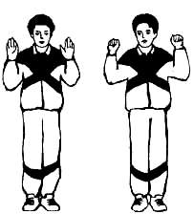  Starting position: standing. We become in the psychic pose: that is, while standing, we bend our elbows, directing them with our palms forward and with our elbows down, as shown in the figure.  We take short, rhythmic, noisy breaths through the nose, while making grasping movements, that is, clenching our palms into fists, as if grabbing something.  Without a break, we take 4 sharp breaths through the nose, rest for 4-5 seconds, lowering our hands, and then repeat. It is necessary to perform in this way 4 breaths 24 times.  This exercise is done in any starting position. If during the exercise you experience a slight dizziness, do not worry. You can just sit down and do the exercise, or you can take a short pause up to 10 seconds, and after it continue the exercise. After a few workouts, this will pass.  - exercise "Peepers"  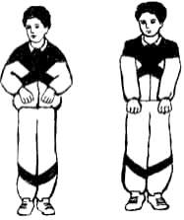  That is the name of the next exercise.  Starting position: standing, clench your fingers into fists and press them to your stomach at waist level.  Taking a breath, we sharply push our fists down, without straining our shoulders, straighten our arms to the end, as if trying to reach the floor with them.  Then we return the brush to its original position at the level of the belt. We perform 8 breaths in a row.  Normally, this should be 12 times 8.  - exercise "Pump (tire inflation)"  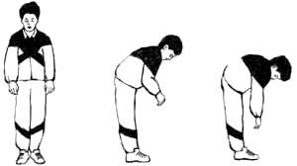  Starting position: standing, legs slightly narrower than shoulder width, arms lowered down, hanging freely at the sides. We make a slight tilt down, trying to reach the floor with our hands without touching it.  This inclination is done simultaneously with inhalation. You should try to inhale at the end of the slope, that is, start from the second half of the slope. Inhalation should be sharp and noisy. The inhalation ends with the inclination. That is, you are completely bent over, and the breath is full at this point.  We rise slightly and again perform a tilt-inhale. That is, we imitate the actions of a person pumping up a car tire. Tilts should be performed easily and in the same rhythm, without leaning too low.  Usually the slope to the level of the belt is considered the norm. The back should be slightly rounded and the head bowed down. This exercise is performed in the rhythm of the front step. The norm is to perform the exercise 12 times.  This exercise has somerestrictions. They should include:  spinal and head injuries,  diseases such as osteochondrosis and sciatica,  high blood pressure,  stones in the liver, bladder and kidneys.  With these problems, try to strictly control the bending, not bending too low. But, despite the short slope, the breath is just as full, that is, noisy, sharp and short. Exhalation, as we remember, is passive, through a not wide open mouth.  This exercise in some cases can stop both a heart attack and an attack of pain in the liver and an attack of bronchial asthma.  - exercise "Cat (half squat with turn)"  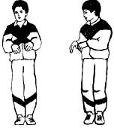  Starting position: standing, legs together or almost together, hands near the waist, palms down, hands relaxed. During the exercise, do not tear off the feet from the floor.  We do a dance squat, while turning the body to the right. This is done on a short and sharp breath.  Turning to the other side, we exhale in the starting position, and without stopping, we do the exercise in the other direction. This is all done without rest.  Exhalation should be performed spontaneously at the indicated point of movement. When performing the exercise, you need to slightly bend and straighten your knees.  It is not necessary to squat strongly, squats should be light and springy. When turning, the hands in the lateral position should perform grasping movements. The back should be kept straight, and the turn should be done in the waist area. The exercise is performed 12 times.  - exercise "Hug your shoulders"  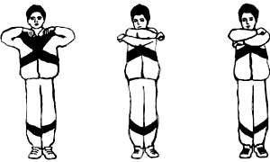  Starting position: arms bent at the elbows and raised to shoulder level. You need to strongly throw your arms in such a way as if you want to hug yourself by the shoulders. This is done while inhaling.  Exhalation is arbitrary, during the breeding of the hands. Don't spread them too wide apart, keep them parallel to each other.  The norm of the exercise is 12 times.  There is alsorestrictions. If you suffer from coronary heart disease, or have suffered a heart attack, or you have a congenital heart disease, the exercise is not recommended.  That is, you can do it, but only after the second week of classes. If the condition is severe and you feel unwell, you need to take fewer breaths. Their number should be either 4 or even 2.  Pregnant women when performing this exercise, starting from 6 months, you need to ensure that your head does not lean back. That is, perform the exercise only with your hands, keeping the spine straight, and looking straight ahead.  - exercise "Big pendulum"  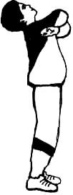  Starting position: standing, legs slightly narrower than shoulder width. We lean forward, trying to touch the floor with our hands, while inhaling. We straighten up, at the same time exhaling, bending in the lower back and leaning back, hugging our shoulders with our hands and inhaling. We exhale arbitrarily between breaths.  The norm of the exercise is 12 times. This exercise can also be done while sitting.  Restrictions:with osteochondrosis, spinal injuries, with displacement of the intervertebral discs, it is necessary to limit movements in such a way that the slopes and deflections are insignificant.  You can increase the range of motion only after a good mastery of the exercise, and you can start this exercise only after you have mastered the previous ones well, and their implementation does not cause you a feeling of discomfort, that is, you do them without straining.  -head turn exercise  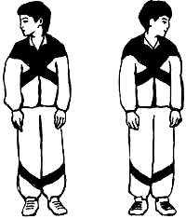  Starting position: standing, legs slightly narrower than shoulder width.  We turn the head to the right, at the same time taking a short, noisy breath through the nose. Then, without stopping the head in the middle of the movement, we do the same in the other direction.  We try not to strain the neck. Exhale through the mouth after each breath. The norm of the exercise is 12 times.  -exercise "Ears"  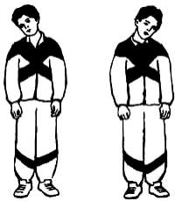  Starting position: standing, legs slightly narrower than shoulder width. We make a slight tilt of the head to the right side at the same time as exhaling through the nose. We repeat the same on the left side.  When performing the exercise, you need to look forward, shaking your head. Breathing should be done simultaneously with movements. When exhaling, do not open your mouth wide.  The norm of the exercise is 12 times.  - exercise "Pendulum head (forward and backward)"  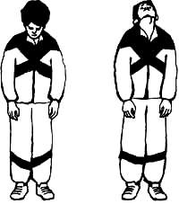  Starting position: standing, legs slightly narrower than shoulder width. We lower our head down, looking at the floor, take a sharp short breath. We raise our head up, slightly tilting back, directing our gaze to the ceiling. Breathe out through your mouth, between breaths.  The norm of the exercise is 12 times.  Restrictions: these are recent head injuries, vegetovascular dystonia, epilepsy, high blood pressure, as well as osteochondrosis of the cervicothoracic region.  Those suffering from these diseases should not make sudden movements of the head, make small inclinations, and breaths are noisy and short. The exercise can be performed while sitting.  -exercise "Rolls"  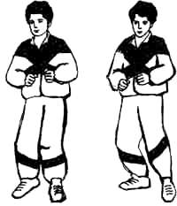  Starting position: standing, left leg slightly forward, right leg slightly back. Now you need to transfer the weight of the body to the left leg. In this case, the body and leg must be kept straight.  We bend the right leg and put it on the toe, maintaining balance, but not leaning. We squat a little on the left leg, while inhaling through the nose.  Immediately after the squat, you need to straighten the left leg, and transfer the center of gravity to the other leg, leaving the body straight and sit down a little while inhaling on the left leg, without leaning.  Important points:do squats while inhaling. Transfer the center of gravity to the supporting leg, that is, to the one on which squats are performed. Immediately after squatting, straighten your leg, rolling from foot to foot.  Normally, the exercise is performed 12 times. The exercise is performed only in a standing position.  -exercise "Steps"  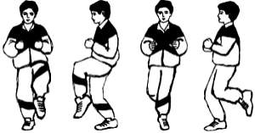  Front step. Starting position: standing, legs slightly narrower than shoulders. We raise the left leg, bent at the knee, to the level of the abdomen, straighten it from the knee, pulling the toe, while squatting on the right leg.  All these actions are done on the inhale. Inhalation, as we know, is short and noisy. After the squat, return the legs to the starting position. Now we do the same, but raising the other leg. The position of the body is kept straight.  Norm - 8 times for 8 breaths.  The exercise is done in any starting position.  Restrictions: ischemic heart disease, diseases of the cardiovascular system, myocardial infarction, congenital malformations.  In the presence of these diseases, you do not need to raise your leg high. If there are leg injuries or thrombophlebitis, the exercise should be done while sitting or lying down, and controlling your actions well.  The pause in this case should be increased to 10 seconds. Also, during pregnancy and urolithiasis, you can not raise the knee high up.  Back step. The starting position is the same as in the previous exercise. Bend the left leg at the knee, take it back, slightly crouching on the right leg. Simultaneously with these actions, you need to take a breath.  We return the legs to their original position on the exhale. Now we do the same on the other leg.  The exercise is performed only while standing. The norm of execution is 4 times for 8 breaths.
3 | Final part of the lesson:  - mobile game;  - oral survey (questions for conducting an oral survey are presented in the FOS);  - summarizing the lesson;  - presenting current grades in the educational journal.
Means of education:
- material and technical: chronometers, equipment and inventory for gymnastics, places for walking and running.

Module 2Educational and training.
Theme 2 Breathing exercises.
Type of lessonpractical lesson
Targetto consolidate the technique of performing breathing exercises.
Lesson plan

No.  p/n | Stages and content of the lesson
1  1.1  1.2  1.3  1.4 | Organizing time.  Announcement of the topic, purpose of the lesson.  Motivational moment (formation of a complex of motor skills and physical qualities necessary in professional activity).  Walking and its varieties:  1 - on socks, arms up;  2 - on the heels, arms to the sides;  3 - on the outside of the foot, hands behind the head;  4 - on the inside of the foot, hands behind the back;  5 - "high" step, hands forward;  6 - in a half-crouch, hands on the belt  Running and its varieties:  1 - running at a slow pace;  2 - running with straightened legs forward;  3 - running with straightened legs back;  4 - running with straightened legs to the sides  “Step march!”, “Stay where you are!”, “To the left!”, “On the first, second, pay!”  switchgear in place  1) I. p. - O. s., hands on the belt. Head tilts to the right, forward, left, back  2) I. p. - O. s., hands on the belt. Head rotation left and right  3) I. n. - O. s., feet shoulder-width apart, arms straight to the sides. Circular rotation of the arms in the elbow joint inward and outward  4) I. p. - O. s., feet shoulder-width apart, arms straight to the sides. Circular rotation of the arms in the shoulder joint forward and backward  5) I. p. - O. s., feet shoulder-width apart, arms bent at the elbows in front of you. Rotation of the upper body to the right and left  6) I. p. - O. s., feet shoulder-width apart, hands on the belt. Circular rotation of the body to the right and left  7) I. n. - O. s., feet shoulder-width apart, hands on the belt. Torso forward alternately to the left leg, between the feet, to the right leg
2  2.1 | The main part of the lesson.  Development of practical skills, testing of practical skills: to consolidate the technique of performing breathing exercises.  Breathing exercises Strelnikova:  - exercise "Palms"  Starting position: standing. We become in the psychic pose: that is, while standing, we bend our elbows, directing them with our palms forward and with our elbows down, as shown in the figure.  We take short, rhythmic, noisy breaths through the nose, while making grasping movements, that is, clenching our palms into fists, as if grabbing something.  Without a break, we take 4 sharp breaths through the nose, rest for 4-5 seconds, lowering our hands, and then repeat. It is necessary to perform in this way 4 breaths 24 times.  This exercise is done in any starting position. If during the exercise you experience a slight dizziness, do not worry. You can just sit down and do the exercise, or you can take a short pause up to 10 seconds, and after it continue the exercise. After a few workouts, this will pass.  - exercise "Peepers"  That is the name of the next exercise.  Starting position: standing, clench your fingers into fists and press them to your stomach at waist level.  Taking a breath, we sharply push our fists down, without straining our shoulders, straighten our arms to the end, as if trying to reach the floor with them.  Then we return the brush to its original position at the level of the belt. We perform 8 breaths in a row.  Normally, this should be 12 times 8.  - exercise "Pump (tire inflation)"  Starting position: standing, legs slightly narrower than shoulder width, arms lowered down, hanging freely at the sides. We make a slight tilt down, trying to reach the floor with our hands without touching it.  This inclination is done simultaneously with inhalation. You should try to inhale at the end of the slope, that is, start from the second half of the slope. Inhalation should be sharp and noisy. The inhalation ends with the inclination. That is, you are completely bent over, and the breath is full at this point.  We rise slightly and again perform a tilt-inhale. That is, we imitate the actions of a person pumping up a car tire. Tilts should be performed easily and in the same rhythm, without leaning too low.  Usually the slope to the level of the belt is considered the norm. The back should be slightly rounded and the head bowed down. This exercise is performed in the rhythm of the front step. The norm is to perform the exercise 12 times.  This exercise has somerestrictions. They should include:  spinal and head injuries,  diseases such as osteochondrosis and sciatica,  high blood pressure,  stones in the liver, bladder and kidneys.  With these problems, try to strictly control the bending, not bending too low. But, despite the short slope, the breath is just as full, that is, noisy, sharp and short. Exhalation, as we remember, is passive, through a not wide open mouth.  This exercise in some cases can stop both a heart attack and an attack of pain in the liver and an attack of bronchial asthma.  - exercise "Cat (half squat with turn)"  Starting position: standing, legs together or almost together, hands near the waist, palms down, hands relaxed. During the exercise, do not tear off the feet from the floor.  We do a dance squat, while turning the body to the right. This is done on a short and sharp breath.  Turning to the other side, we exhale in the starting position, and without stopping, we do the exercise in the other direction. This is all done without rest.  Exhalation should be performed spontaneously at the indicated point of movement. When performing the exercise, you need to slightly bend and straighten your knees.  It is not necessary to squat strongly, squats should be light and springy. When turning, the hands in the lateral position should perform grasping movements. The back should be kept straight, and the turn should be done in the waist area. The exercise is performed 12 times.  - exercise "Hug your shoulders"  Starting position: arms bent at the elbows and raised to shoulder level. You need to strongly throw your arms in such a way as if you want to hug yourself by the shoulders. This is done while inhaling.  Exhalation is arbitrary, during the breeding of the hands. Don't spread them too wide apart, keep them parallel to each other.  The norm of the exercise is 12 times.  There is alsorestrictions. If you suffer from coronary heart disease, or have suffered a heart attack, or you have a congenital heart disease, the exercise is not recommended.  That is, you can do it, but only after the second week of classes. If the condition is severe and you feel unwell, you need to take fewer breaths. Their number should be either 4 or even 2.  Pregnant women when performing this exercise, starting from 6 months, you need to ensure that your head does not lean back. That is, perform the exercise only with your hands, keeping the spine straight, and looking straight ahead.  - exercise "Big pendulum"  Starting position: standing, legs slightly narrower than shoulder width. We lean forward, trying to touch the floor with our hands, while inhaling. We straighten up, at the same time exhaling, bending in the lower back and leaning back, hugging our shoulders with our hands and inhaling. We exhale arbitrarily between breaths.  The norm of the exercise is 12 times. This exercise can also be done while sitting.  Restrictions:with osteochondrosis, spinal injuries, with displacement of the intervertebral discs, it is necessary to limit movements in such a way that the slopes and deflections are insignificant.  You can increase the range of motion only after a good mastery of the exercise, and you can start this exercise only after you have mastered the previous ones well, and their implementation does not cause you a feeling of discomfort, that is, you do them without straining.  -head turn exercise  Starting position: standing, legs slightly narrower than shoulder width.  We turn the head to the right, at the same time taking a short, noisy breath through the nose. Then, without stopping the head in the middle of the movement, we do the same in the other direction.  We try not to strain the neck. Exhale through the mouth after each breath. The norm of the exercise is 12 times.  -exercise "Ears"  Starting position: standing, legs slightly narrower than shoulder width. We make a slight tilt of the head to the right side at the same time as exhaling through the nose. We repeat the same on the left side.  When performing the exercise, you need to look forward, shaking your head. Breathing should be done simultaneously with movements. When exhaling, do not open your mouth wide.  The norm of the exercise is 12 times.  - exercise "Pendulum head (forward and backward)"  Starting position: standing, legs slightly narrower than shoulder width. We lower our head down, looking at the floor, take a sharp short breath. We raise our head up, slightly tilting back, directing our gaze to the ceiling. Breathe out through your mouth, between breaths.  The norm of the exercise is 12 times.  Restrictions: these are recent head injuries, vegetovascular dystonia, epilepsy, high blood pressure, as well as osteochondrosis of the cervicothoracic region.  Those suffering from these diseases should not make sudden movements of the head, make small inclinations, and breaths are noisy and short. The exercise can be performed while sitting.  -exercise "Rolls"  Starting position: standing, left leg slightly forward, right leg slightly back. Now you need to transfer the weight of the body to the left leg. In this case, the body and leg must be kept straight.  We bend the right leg and put it on the toe, maintaining balance, but not leaning. We squat a little on the left leg, while inhaling through the nose.  Immediately after the squat, you need to straighten the left leg, and transfer the center of gravity to the other leg, leaving the body straight and sit down a little while inhaling on the left leg, without leaning.  Important points:do squats while inhaling. Transfer the center of gravity to the supporting leg, that is, to the one on which squats are performed. Immediately after squatting, straighten your leg, rolling from foot to foot.  Normally, the exercise is performed 12 times. The exercise is performed only in a standing position.  -exercise "Steps"  Front step. Starting position: standing, legs slightly narrower than shoulders. We raise the left leg, bent at the knee, to the level of the abdomen, straighten it from the knee, pulling the toe, while squatting on the right leg.  All these actions are done on the inhale. Inhalation, as we know, is short and noisy. After the squat, return the legs to the starting position. Now we do the same, but raising the other leg. The position of the body is kept straight.  Norm - 8 times for 8 breaths.  The exercise is done in any starting position.  Restrictions: ischemic heart disease, diseases of the cardiovascular system, myocardial infarction, congenital malformations.  In the presence of these diseases, you do not need to raise your leg high. If there are leg injuries or thrombophlebitis, the exercise should be done while sitting or lying down, and controlling your actions well.  The pause in this case should be increased to 10 seconds. Also, during pregnancy and urolithiasis, you can not raise the knee high up.  Back step. The starting position is the same as in the previous exercise. Bend the left leg at the knee, take it back, slightly crouching on the right leg. Simultaneously with these actions, you need to take a breath.  We return the legs to their original position on the exhale. Now we do the same on the other leg.  The exercise is performed only while standing. The norm of execution is 4 times for 8 breaths.
3 | Final part of the lesson:  - mobile game;  - oral survey (questions for conducting an oral survey are presented in the FOS);  - summarizing the lesson;  - presenting current grades in the educational journal.
Means of education:
- material and technical: chronometers, equipment and inventory for gymnastics, places for walking and running.

Module 2Educational and training.
Theme 3Improving the technique of Nordic walking.
Type of lessonpractical lesson.
TargetConsolidation of the technique of movements of the legs and pelvis, hands in combination with the movements of the legs in Nordic walking.
Lesson plan
No.  p/n | Stages and content of the lesson
1  1.1  1.2  1.3 | Organizing time.  Announcement of the topic, purpose of the lesson.  Motivational moment (formation of a complex of motor skills and physical qualities necessary in professional activity).  Walking and its varieties:  1 - on socks, arms up;  2 - on the heels, arms to the sides;  3 - on the outside of the foot, hands behind the head;  4 - on the inside of the foot, hands behind the back;  5 - "high" step, hands forward;  6 - in a half-crouch, hands on the belt  Running and its varieties:  1 - running at a slow pace;  2 - running with straightened legs forward;  3 - running with straightened legs back;  4 - running with straightened legs to the sides  “Step march!”, “Stay where you are!”, “To the left!”, “On the first, second, pay!”  switchgear in place  1) I. p. - O. s., hands on the belt. Head tilts to the right, forward, left, back  2) I. p. - O. s., hands on the belt. Head rotation left and right  3) I. n. - O. s., feet shoulder-width apart, arms straight to the sides. Circular rotation of the arms in the elbow joint inward and outward  4) I. p. - O. s., feet shoulder-width apart, arms straight to the sides. Circular rotation of the arms in the shoulder joint forward and backward  5) I. p. - O. s., feet shoulder-width apart, arms bent at the elbows in front of you. Rotation of the upper body to the right and left  6) I. p. - O. s., feet shoulder-width apart, hands on the belt. Circular rotation of the body to the right and left  7) I. n. - O. s., feet shoulder-width apart, hands on the belt. Torso forward alternately to the left leg, between the feet, to the right leg
2  2.1  2.2 | The main part of the lesson.  Development of practical skills and abilities, testing of practical skills.  Improving the technique of Nordic walking  - we walk with a calm, even step, the arms are down along the body, the hands are relaxed, the sticks are held on the hands with the help of lanyards (fasteners for the hands). We drag the sticks behind us, along the torso.  - we also walk with a calm step, dragging the sticks behind us, but only now we begin to swing our arms back and forth a little, alternately with our legs, just as we do during normal walking.  – direct transition to Nordic walking. Now we begin to pick up the stick when moving forward, lean on it and push off, the sticks no longer “drag” along the ground, but leave behind only “holes”.  Nordic walking at an average pace with active work of the arms and shoulder girdle.  Passing a distance of 1000-2000m. in full coordination
3 | Final part of the lesson:  Development of endurance through outdoor games.  Construction. Error analysis. Summarizing. Grading.
Means of education:
- material and technical: chronometers, track and field equipment and inventory, Nordic walking poles, places for walking and running.

Module 2Educational and training.
Theme 4Improving running technique.
Type of lessonpractical lesson.
Targetto fixrunning technique.
Lesson plan
No.  p/n | Stages and content of the lesson
1  1.1  1.2  1.3  1.4  1.5 | Organizing time.  Construction, greeting, assessment of student readiness,  Announcement of the topic, purpose, tasks of the lesson  Brief description of the stages and content of the work of students in the classroom  Attention exercise:  1) I.p.: - o.s.  1 - step forward;  2 - turn "to the right";  3 - arms to the sides;  4 - hands up;  5 - cotton;  6 - arms to the sides;  7 - arms along the body;  8 - turn "left"  Walking and its varieties:  1 - on socks, arms up;  2 - on the heels, arms to the sides;  3 - on the outside of the foot, hands behind the head;  4 - on the inside of the foot, hands behind the back;  5 - "high" step, hands forward;  6 - in a half-crouch, hands on the belt  Running and its varieties:  1 - running at a slow pace;  2 - running with straightened legs forward;  3 - running with straightened legs back;  4 - running with straightened legs to the sides  “Step march!”, “Stay where you are!”, “To the left!”, “On the first, second, pay!”  switchgear in place  1) I. p. - O. s., hands on the belt. Head tilts to the right, forward, left, back  2) I. p. - O. s., hands on the belt. Head rotation left and right  3) I. n. - O. s., feet shoulder-width apart, arms straight to the sides. Circular rotation of the arms in the elbow joint inward and outward  4) I. p. - O. s., feet shoulder-width apart, arms straight to the sides. Circular rotation of the arms in the shoulder joint forward and backward  5) I. p. - O. s., feet shoulder-width apart, arms bent at the elbows in front of you. Rotation of the upper body to the right and left  6) I. p. - O. s., feet shoulder-width apart, hands on the belt. Circular rotation of the body to the right and left  7) I. n. - O. s., feet shoulder-width apart, hands on the belt. Torso forward alternately to the left leg, between the feet, to the right leg
2  2.1  2.2 | Development of practical skills and abilities, testing of practical skills.  Improving running technique  1. Imitation of the positions of the legs, arms, torso, head, standing at the gymnastic wall.  2. Imitation of the movement of the hands, standing still on the toes (one leg in front, the other behind), the torso is vertical.  3. Slow running on the forefoot.  4. Running with a high lift of the hip with the transition to a regular run.  5. Minching run with the transition to normal running.  6. Accelerations on segments of 30-50 m.  7. Acceleration with speed retention on segments of 50-100 m.  8. Running 100-200 meters at a uniform speed on the instructions of the teacher.  9. Run for 100-200 meters at a variable speed on the instructions of the teacher.  10. Free run  from 400 to 1200 m  Development of endurance and speed qualities.  through circuit training
3 | Final part of the lesson:  Stretching exercises for all muscle groups  Construction. Error analysis. Summarizing. Grading.
Means of education:
- material and technical: chronometers, athletics equipment and inventory, places for jumping, walking, running.
Module 2Educational and training.
Theme 5Teaching the technique of coordination exercises.
Type of lessonpractical lesson.
Targetcreate an idea of ​​​​the technique of performing exercises for coordination.
Lesson plan
No.  p/n | Stages and content of the lesson
1  1.1  1.2  1.3 | Organizing time.  Announcement of the topic, purpose of the lesson.  Motivational moment (formation of a complex of motor skills and physical qualities necessary in professional activity).  Walking and its varieties:  1 - on socks, arms up;  2 - on the heels, arms to the sides;  3 - on the outside of the foot, hands behind the head;  4 - on the inside of the foot, hands behind the back;  5 - "high" step, hands forward;  6 - in a half-crouch, hands on the belt  Running and its varieties:  1 - running at a slow pace;  2 - running with straightened legs forward;  3 - running with straightened legs back;  4 - running with straightened legs to the sides  “Step march!”, “Stay where you are!”, “To the left!”, “On the first, second, pay!”  switchgear in place  1) I. p. - O. s., hands on the belt. Head tilts to the right, forward, left, back  2) I. p. - O. s., hands on the belt. Head rotation left and right  3) I. n. - O. s., feet shoulder-width apart, arms straight to the sides. Circular rotation of the arms in the elbow joint inward and outward  4) I. p. - O. s., feet shoulder-width apart, arms straight to the sides. Circular rotation of the arms in the shoulder joint forward and backward  5) I. p. - O. s., feet shoulder-width apart, arms bent at the elbows in front of you. Rotation of the upper body to the right and left  6) I. p. - O. s., feet shoulder-width apart, hands on the belt. Circular rotation of the body to the right and left  7) I. n. - O. s., feet shoulder-width apart, hands on the belt. Torso forward alternately to the left leg, between the feet, to the right leg
2  2.1  2.2  2.2 | The main part of the lesson.  Development of practical skills, testing of practical skills: teaching the technique of exercises for coordination.  1. Standing. Make several simultaneous circular movements with straight arms so that the movement of the right hand is directed forward, and the left hand backwards. Then change the direction of movement of the hands: right back, left forward.  2. Bend your arm at the elbow joint and raise it so that the hand is near the ear, and the forearm is parallel to the floor. Place 3-5 coins on the elbow. With a quick movement of the brush forward and down with simultaneous extension of the arm in the elbow joint, try to catch all the coins in the palm of your hand. If you can't handle this task, practice with one coin first.  3. Take a gymnastic stick about a meter long. Place it vertically on the floor in front of you, pressing it on top with the palm of your right hand. Taking your hand off the stick, try to step over it with a straight leg from right to left and, without letting the stick fall, press it again with your palm. Then step over the stick from left to right. After that, try, tearing your hand away from the stick, make a 360-degree turn and, without letting the stick fall, press it with your palm from above. Then turn to the other side.  4. Take a tennis ball in each hand and raise your arms forward. Then drop the balls and catch them as they bounce off the floor. If this task is easy, you can complicate it: the ball thrown by the right hand, catch with the left, and the ball thrown by the left hand, catch with the right.  5. Performing jumps on the spot during physical exercises, try to diversify them as follows in two versions. In the first variant, jump from the starting position of the legs together, arms along the body. When making a jump, raise your arms to the sides, and put your legs apart. With the second jump, return to the starting position. In the second option, jump from the starting position of the legs together, arms to the sides. When making the first jump, lower your arms down and put your legs apart. With the second jump, raise your arms to the sides, and put your feet together. Try to jump at a fairly high pace.  6. Raise your hand to the side with your palms down. Try, leaving the hand in a horizontal position, to make rotational movements of the shoulder and forearm back and forth.  7. Take a towel or rope, grab it by the ends so that your arms are wider than your shoulders. Stretching the towel, raise your arms forward, then up and move the towel with straight arms behind your back. Return back to the starting position. In the future, bring your hands together with a towel. Raising your hands up, inhale, lowering down - exhale. This exercise develops mobility in the shoulder joints.  8. Sit on a chair sideways to the back, lean with one hand on the seat and the other on the back. Bend your legs and bring them over the seat and place them on the floor. Then return to the starting position in the same way. When performing the exercise, make sure that when moving the legs, the feet do not touch the seat. In the starting position, inhale, bringing your legs over the seat - exhale.  9. Take a sheet of paper, attach it to the wall at chest level. Then, with a pencil in hand, go half a step to the wall and, making circles with your foot on the floor, try to write your initials on a piece of paper. The same can be done while sitting at the table.  10. This exercise should be performed in the gym. After throwing the ball up, try to quickly roll forward, jump to your feet and catch the ball.  11. After tossing the ball over your head, quickly turn 360 degrees and catch the ball. Do the exercise by changing the direction of the turn.  12. Starting position - lying emphasis. Pushing off the floor with both hands at the same time, clap your palms and return to the starting position again. This exercise can be alternated with regular push-ups in lying position.  13. Starting position - emphasis lying behind. Steps of the hands move first forward and then back, without changing the position of the legs and torso.  14. Starting position - sitting, straight legs raised at an angle of 45 degrees, arms raised forward. Make alternating counter movements with your feet from top to bottom and from bottom to top (as when swimming in the crawl way) and at the same time with your hands - cross movements in a horizontal plane, with the right hand passing once over the left, another time - the left over the right. After successful attempts, try to make cross movements with your legs in a horizontal plane, and with your hands in a vertical plane.  15. Stand with your right side against the wall at a distance of half a step. Touch the toe of your left foot to the wall at a height of 20–30 centimeters from the floor and, without taking your left foot off the wall, try to jump over it with your right foot. Then, standing against the wall with the other side, make a jump on your left foot.  16. Standing, tilt your head back and place a plastic cup filled to the brim with water on your forehead. Try, without spilling water and without dropping a glass, sit down, lie on your back and stand up again.  17. Lie on your back, raise your legs and torso to a vertical position and rest your palms on your lower back. Try to keep your torso and legs in a straight line. This exercise is called the “stand on the shoulder blades” or “birch”. Having fixed the accepted position, try to keep it for a few seconds. Then put your hands on the floor, palms down and continue to fix the accepted position.  18. Place two gymnastic sticks about a meter long vertically in front of you on the floor and press them on top with your palms. At the same time, tearing your hands away from the sticks, make a clap with your palms behind your back, after which, without letting the sticks fall, press them with your palms. You can complicate this exercise by adding another clap with your hands above your head.  19. Place a gymnastic stick about a meter long in your palm. While balancing with it, sit on the floor, and then stand up, and when sitting down and getting up, do not help yourself with the other hand and try not to drop the stick.  20. Draw a circle on the floor with a diameter of one meter. Stand in the middle of the circle and jump up with a 180 degree turn. Make the first jump with a turn to the left, the second with a turn to the right. Try not to go outside the circle. If the exercise is easy, try doing 360-degree jumps.  The following exercises are performed with a volleyball, and for the more advanced - with a stuffed ball. Exercises must be performed in the gym.  1. Grab the ball between your feet. Jump up and, sharply bending your legs, throw the ball as high as possible, then catch it with your hands.  2. Grab the ball between your feet. With a simultaneous push of the legs, throw the ball forward as far as possible.  3. Feet shoulder-width apart, ball in hands behind back. Leaning forward sharply, throw the ball forward over your head.
3 | Final part of the lesson:  The development of dexterity through an outdoor game with a volleyball.  Construction. Error analysis. Summarizing. Grading.
Means of education:
- material and technical: chronometers, athletics equipment and inventory, volleyballs, tennis balls, gymnastic sticks, places for walking and running.

Module 2Educational and training.
Theme 6Improving the technique of coordination exercises.
Type of lessonpractical lesson.
Targetto consolidate the technique of performing exercises for coordination.
Lesson plan
No.  p/n | Stages and content of the lesson
1  1.1  1.2  1.3 | Organizing time.  Announcement of the topic, purpose of the lesson.  Motivational moment (formation of a complex of motor skills and physical qualities necessary in professional activity).  Walking and its varieties:  1 - on socks, arms up;  2 - on the heels, arms to the sides;  3 - on the outside of the foot, hands behind the head;  4 - on the inside of the foot, hands behind the back;  5 - "high" step, hands forward;  6 - in a half-crouch, hands on the belt  Running and its varieties:  1 - running at a slow pace;  2 - running with straightened legs forward;  3 - running with straightened legs back;  4 - running with straightened legs to the sides  “Step march!”, “Stay where you are!”, “To the left!”, “On the first, second, pay!”  switchgear in place  1) I. p. - O. s., hands on the belt. Head tilts to the right, forward, left, back  2) I. p. - O. s., hands on the belt. Head rotation left and right  3) I. n. - O. s., feet shoulder-width apart, arms straight to the sides. Circular rotation of the arms in the elbow joint inward and outward  4) I. p. - O. s., feet shoulder-width apart, arms straight to the sides. Circular rotation of the arms in the shoulder joint forward and backward  5) I. p. - O. s., feet shoulder-width apart, arms bent at the elbows in front of you. Rotation of the upper body to the right and left  6) I. p. - O. s., feet shoulder-width apart, hands on the belt. Circular rotation of the body to the right and left  7) I. n. - O. s., feet shoulder-width apart, hands on the belt. Torso forward alternately to the left leg, between the feet, to the right leg
2  2.1  2.2  2.2 | The main part of the lesson.  Development of practical skills, testing of practical skills: improving the technique of coordination exercises.  1. Standing. Make several simultaneous circular movements with straight arms so that the movement of the right hand is directed forward, and the left hand backwards. Then change the direction of movement of the hands: right back, left forward.  2. Bend your arm at the elbow joint and raise it so that the hand is near the ear, and the forearm is parallel to the floor. Place 3-5 coins on the elbow. With a quick movement of the brush forward and down with simultaneous extension of the arm in the elbow joint, try to catch all the coins in the palm of your hand. If you can't handle this task, practice with one coin first.  3. Take a gymnastic stick about a meter long. Place it vertically on the floor in front of you, pressing it on top with the palm of your right hand. Taking your hand off the stick, try to step over it with a straight leg from right to left and, without letting the stick fall, press it again with your palm. Then step over the stick from left to right. After that, try, tearing your hand away from the stick, make a 360-degree turn and, without letting the stick fall, press it with your palm from above. Then turn to the other side.  4. Take a tennis ball in each hand and raise your arms forward. Then drop the balls and catch them as they bounce off the floor. If this task is easy, you can complicate it: the ball thrown by the right hand, catch with the left, and the ball thrown by the left hand, catch with the right.  5. Performing jumps on the spot during physical exercises, try to diversify them as follows in two versions. In the first variant, jump from the starting position of the legs together, arms along the body. When making a jump, raise your arms to the sides, and put your legs apart. With the second jump, return to the starting position. In the second option, jump from the starting position of the legs together, arms to the sides. When making the first jump, lower your arms down and put your legs apart. With the second jump, raise your arms to the sides, and put your feet together. Try to jump at a fairly high pace.  6. Raise your hand to the side with your palms down. Try, leaving the hand in a horizontal position, to make rotational movements of the shoulder and forearm back and forth.  7. Take a towel or rope, grab it by the ends so that your arms are wider than your shoulders. Stretching the towel, raise your arms forward, then up and move the towel with straight arms behind your back. Return back to the starting position. In the future, bring your hands together with a towel. Raising your hands up, inhale, lowering down - exhale. This exercise develops mobility in the shoulder joints.  8. Sit on a chair sideways to the back, lean with one hand on the seat and the other on the back. Bend your legs and bring them over the seat and place them on the floor. Then return to the starting position in the same way. When performing the exercise, make sure that when moving the legs, the feet do not touch the seat. In the starting position, inhale, bringing your legs over the seat - exhale.  9. Take a sheet of paper, attach it to the wall at chest level. Then, with a pencil in hand, go half a step to the wall and, making circles with your foot on the floor, try to write your initials on a piece of paper. The same can be done while sitting at the table.  10. This exercise should be performed in the gym. After throwing the ball up, try to quickly roll forward, jump to your feet and catch the ball.  11. After tossing the ball over your head, quickly turn 360 degrees and catch the ball. Do the exercise by changing the direction of the turn.  12. Starting position - lying emphasis. Pushing off the floor with both hands at the same time, clap your palms and return to the starting position again. This exercise can be alternated with regular push-ups in lying position.  13. Starting position - emphasis lying behind. Steps of the hands move first forward and then back, without changing the position of the legs and torso.  14. Starting position - sitting, straight legs raised at an angle of 45 degrees, arms raised forward. Make alternating counter movements with your feet from top to bottom and from bottom to top (as when swimming in the crawl way) and at the same time with your hands - cross movements in a horizontal plane, with the right hand passing once over the left, another time - the left over the right. After successful attempts, try to make cross movements with your legs in a horizontal plane, and with your hands in a vertical plane.  15. Stand with your right side against the wall at a distance of half a step. Touch the toe of your left foot to the wall at a height of 20–30 centimeters from the floor and, without taking your left foot off the wall, try to jump over it with your right foot. Then, standing against the wall with the other side, make a jump on your left foot.  16. Standing, tilt your head back and place a plastic cup filled to the brim with water on your forehead. Try, without spilling water and without dropping a glass, sit down, lie on your back and stand up again.  17. Lie on your back, raise your legs and torso to a vertical position and rest your palms on your lower back. Try to keep your torso and legs in a straight line. This exercise is called the “stand on the shoulder blades” or “birch”. Having fixed the accepted position, try to keep it for a few seconds. Then put your hands on the floor, palms down and continue to fix the accepted position.  18. Place two gymnastic sticks about a meter long vertically in front of you on the floor and press them on top with your palms. At the same time, tearing your hands away from the sticks, make a clap with your palms behind your back, after which, without letting the sticks fall, press them with your palms. You can complicate this exercise by adding another clap with your hands above your head.  19. Place a gymnastic stick about a meter long in your palm. While balancing with it, sit on the floor, and then stand up, and when sitting down and getting up, do not help yourself with the other hand and try not to drop the stick.  20. Draw a circle on the floor with a diameter of one meter. Stand in the middle of the circle and jump up with a 180 degree turn. Make the first jump with a turn to the left, the second with a turn to the right. Try not to go outside the circle. If the exercise is easy, try doing 360-degree jumps.  The following exercises are performed with a volleyball, and for the more advanced - with a stuffed ball. Exercises must be performed in the gym.  1. Grab the ball between your feet. Jump up and, sharply bending your legs, throw the ball as high as possible, then catch it with your hands.  2. Grab the ball between your feet. With a simultaneous push of the legs, throw the ball forward as far as possible.  3. Feet shoulder-width apart, ball in hands behind back. Leaning forward sharply, throw the ball forward over your head.
3 | Final part of the lesson:  The development of dexterity through an outdoor game with a volleyball.  Construction. Error analysis. Summarizing. Grading.
Means of education:
- material and technical: chronometers, athletics equipment and inventory, volleyballs, tennis balls, gymnastic sticks, places for walking and running.

Module 2Educational and training.
Theme 7Yoga.
Type of lessonpractical lesson.
Targetto create an idea of ​​the technique of performing yoga exercises for beginners.
Lesson plan
No.  p/n | Stages and content of the lesson
1  1.1  1.2  1.3 | Organizing time.  Announcement of the topic, purpose of the lesson.  Motivational moment (formation of a complex of motor skills and physical qualities necessary in professional activity).  Walking and its varieties:  1 - on socks, arms up;  2 - on the heels, arms to the sides;  3 - on the outside of the foot, hands behind the head;  4 - on the inside of the foot, hands behind the back;  5 - "high" step, hands forward;  6 - in a half-crouch, hands on the belt  Running and its varieties:  1 - running at a slow pace;  2 - running with straightened legs forward;  3 - running with straightened legs back;  4 - running with straightened legs to the sides  “Step march!”, “Stay where you are!”, “To the left!”, “On the first, second, pay!”  switchgear in place  1) I. p. - O. s., hands on the belt. Head tilts to the right, forward, left, back  2) I. p. - O. s., hands on the belt. Head rotation left and right  3) I. n. - O. s., feet shoulder-width apart, arms straight to the sides. Circular rotation of the arms in the elbow joint inward and outward  4) I. p. - O. s., feet shoulder-width apart, arms straight to the sides. Circular rotation of the arms in the shoulder joint forward and backward  5) I. p. - O. s., feet shoulder-width apart, arms bent at the elbows in front of you. Rotation of the upper body to the right and left  6) I. p. - O. s., feet shoulder-width apart, hands on the belt. Circular rotation of the body to the right and left  7) I. n. - O. s., feet shoulder-width apart, hands on the belt. Torso forward alternately to the left leg, between the feet, to the right leg
2  2.1  2.2 | The main part of the lesson.  Development of practical skills, testing of practical skills: to create an idea about the technique of performing yoga exercises for beginners.  Yoga for beginners has the following advantages: improves well-being, kneads the joints and spine; effectively strengthens and tones the muscles of the back and the whole body; provides massage of internal organs and enhances blood circulation; harmonizes the internal state and gives an optimistic mood due to the production of endorphins; prepares the body for active mental and physical work during the day.  In yoga, there is a whole complex of asanas, which is called Surya Namaskar (sun salutation). Yoga for beginners involves exercises that are not difficult to perform and do not require special preparation.  Exercises or asanas (postures) should be done at a comfortable pace. Hold each pose for at least 3 inhales and exhales. Take small breaks between poses. Treat every movement carefully. Concentrate on the work of your body and try to let go of all extraneous thoughts. Listen to yourself and don't stress yourself out. The activity should be enjoyable.  1. Camel pose (Ushtrasana). To perform Camel Pose, kneel down with your feet hip-width apart. Lower your hands back freely. Exhale and bend back with support on one arm, while pulling the other up. Tighten your buttocks muscles and make sure they stay perpendicular to the floor - don't lean back or settle on your heels. Hold for 10-15 seconds. Perform on the other side, changing hands. Get on your knees and rest your fists on your lower back. Exhale as you bend back. Hold this position for 5 breaths. The pose allows you to stretch the spine after a long sleep and stretch the abdominal muscles.  2. Chair Pose (Utkatasana) Chair Pose is one of the simplest yet very beneficial asanas. Stand up straight and place your feet shoulder-width apart. Stretch your straight arms up, turning your palms towards each other. Slowly bend your knees, tilting your straight body forward as if you were sitting on a chair with your buttocks. At the same time, the arms remain extended in line with the body. Hold this position for a few tens of seconds, then straighten up again, returning to the starting position. Staying in this pose perfectly strengthens the muscles of the legs and body. Your body will become stronger and more resilient.  3. Footbending Pose (Uttanasana) When bending forward, your spine lengthens and straightens. Stand up straight and place your feet parallel to each other. Turning at the hips, tilt the straight body towards the legs and try to reach the floor with your hands. Relax your back, let your body hang down under its own weight. Don't strain your neck. Try to point your nose towards your knees, and do not bend your legs - they should be straight. Stay in this position for at least 10-15 seconds. This pose perfectly stretches the back, massages the internal organs, in particular, the liver and spleen. Also, the pose has a positive effect on the condition of the kidneys and activates blood circulation in the pelvic organs. Under the influence of your own weight, your spine stretches, muscle clamps relax, the vertebrae fall into place.  4. Triangle Pose (Trikonasana) Triangle Pose strengthens the core muscles. Place your feet wider than your shoulders, the left foot is directed outward, the right foot inward - towards the midline of the body. Spread your straight arms to the sides at shoulder level, point your palms down. Slowly lower your body to the left, trying to reach the little toe of the left foot with your left hand. The second hand is directed vertically upwards. Hold this pose for a few seconds. Slowly return to the starting position. Turn your feet to the right and repeat the tilt to the right side. This pose is also very beneficial for the spine, massages the intestines, strengthens the muscles of the body.  5. Plow pose (Hal-asana) In this pose, try to get your feet to the floor. Lie on the mat on your back, stretch your arms along the body, palms pointing to the floor. Raise your straight legs up and over your head, trying to put your socks on the floor. Try to keep your knees straight. If you can’t reach the floor with straight legs, let your feet hang in the air. Slowly roll back to the starting position vertebra by vertebra. This exercise stretches the lumbosacral and cervical spine.  6. Pose of a candle (Sarvangasana) Candle, she is also a "birch". Starting position - as in the previous exercise. Raise your straight legs vertically up, then lift your pelvis behind your legs, supporting yourself with your palms. Try to move your palms closer to your shoulder blades. First, stay in this position for 10 seconds, then gradually increase the time from session to session until you reach three minutes. Come out of the pose by slowly rolling your spine across the floor. The candle pose is rightly considered one of the most beneficial poses for the organs of the whole body.  7. Dove Pose (Eka Pada Rajkapotasana) This asana can be used to prepare for the split stretch. Get on all fours. Pull the right knee forward between the hands and turn the right foot to the left. The heel of the right foot should be under the left thigh or under the stomach. Stretch your left leg back and try to lower your pelvis down as much as possible. Bend your elbows and lean on your forearms. Bend even lower, stretching your left leg back. To increase the stretch, slowly straighten your arms. Look straight ahead, stretching, but not straining the muscles of the neck. Exit the pose slowly and carefully. Repeat the movement on the other side. There is also a light version of this pose. Sit down and bend your knees. Gently place your right foot on your left thigh. Pull your right knee towards your chest. Keep your head down and look straight ahead. Repeat with the other leg. The pigeon pose is good for preparing the muscles for the split stretch.  8. Half Pose of the King of the Fishes (Arlha Matsienlrasana) Pose of the King of the Fishes or simply twisting the body while sitting. The Half Pose King of the Fish exercise can be performed on the floor or on a bed. Sit down, straighten your back and legs. Cross your right foot over your left. Place your foot next to your left knee. In this case, the left leg should be straight. Grab your right knee with your left hand. As you exhale, slowly twist your spine to the right. For convenience, place your right palm on the floor, and put the elbow of your left hand behind your knee. Look back for yourself. With each exhalation, try to twist the spine even more. Perform for 3-5 breaths. Repeat on the other side.  9. Pose of the child (Balasana). Get down on your knees and sit on your heels. Taking a deep breath, lean forward and press your stomach against your hips. Remember to keep your back straight. Lower your forehead to the bed and extend your arms along your torso. The palms should be turned up. Concentrate and feel the smooth movement of the chest with each inhalation and exhalation. To exit the pose, first raise your head and then slowly straighten your back. This exercise is one of the most important in yoga for beginners. It is aimed at deep relaxation of the back muscles, so it can be used to complete the workout along with Savasana (see below). In addition, this pose is suitable for relieving stress during the day or for reducing muscle tension after a difficult exercise.  10. Dead Pose (Shavasana) In shavasana, you need to lie down for several minutes until you are completely relaxed. Staying in this position for 4-5 minutes ideally completes any set of yoga exercises. For beginners, this is especially important, since learning to relax properly is necessary from the very first lessons. Lie on your back, stretch your arms along the body and close your eyes. Tighten all the muscles of the body as much as possible and hold out for a few seconds. Relax completely, mentally walk through your entire body from head to toes and focus only on your breath.
3 | Final part of the lesson:  Attention exercise.  Construction. Error analysis. Summarizing. Grading.
Means of education:
- material and technical: chronometers, track and field equipment and inventory, places for walking and running, gymnastic mats, music center.

Module 2Educational and training.
Theme 8Yoga.
Type of lessonpractical lesson.
Targetto consolidate the technique of performing yoga exercises for beginners.
Lesson plan
No.  p/n | Stages and content of the lesson
1  1.1  1.2  1.3 | Organizing time.  Announcement of the topic, purpose of the lesson.  Motivational moment (formation of a complex of motor skills and physical qualities necessary in professional activity).  Walking and its varieties:  1 - on socks, arms up;  2 - on the heels, arms to the sides;  3 - on the outside of the foot, hands behind the head;  4 - on the inside of the foot, hands behind the back;  5 - "high" step, hands forward;  6 - in a half-crouch, hands on the belt  Running and its varieties:  1 - running at a slow pace;  2 - running with straightened legs forward;  3 - running with straightened legs back;  4 - running with straightened legs to the sides  “Step march!”, “Stay where you are!”, “To the left!”, “On the first, second, pay!”  switchgear in place  1) I. p. - O. s., hands on the belt. Head tilts to the right, forward, left, back  2) I. p. - O. s., hands on the belt. Head rotation left and right  3) I. n. - O. s., feet shoulder-width apart, arms straight to the sides. Circular rotation of the arms in the elbow joint inward and outward  4) I. p. - O. s., feet shoulder-width apart, arms straight to the sides. Circular rotation of the arms in the shoulder joint forward and backward  5) I. p. - O. s., feet shoulder-width apart, arms bent at the elbows in front of you. Rotation of the upper body to the right and left  6) I. p. - O. s., feet shoulder-width apart, hands on the belt. Circular rotation of the body to the right and left  7) I. n. - O. s., feet shoulder-width apart, hands on the belt. Torso forward alternately to the left leg, between the feet, to the right leg
2  2.1  2.2 | The main part of the lesson.  Development of practical skills, testing of practical skills: to consolidate the technique of performing yoga exercises for beginners.  1. Camel pose (Ushtrasana). To perform Camel Pose, kneel down with your feet hip-width apart. Lower your hands back freely. Exhale and bend back with support on one arm, while pulling the other up. Tighten your buttocks muscles and make sure they stay perpendicular to the floor - don't lean back or settle on your heels. Hold for 10-15 seconds. Perform on the other side, changing hands. Get on your knees and rest your fists on your lower back. Exhale as you bend back. Hold this position for 5 breaths. The pose allows you to stretch the spine after a long sleep and stretch the abdominal muscles.  2. Chair Pose (Utkatasana) Chair Pose is one of the simplest yet very beneficial asanas. Stand up straight and place your feet shoulder-width apart. Stretch your straight arms up, turning your palms towards each other. Slowly bend your knees, tilting your straight body forward as if you were sitting on a chair with your buttocks. At the same time, the arms remain extended in line with the body. Hold this position for a few tens of seconds, then straighten up again, returning to the starting position. Staying in this pose perfectly strengthens the muscles of the legs and body. Your body will become stronger and more resilient.  3. Footbending Pose (Uttanasana) When bending forward, your spine lengthens and straightens. Stand up straight and place your feet parallel to each other. Turning at the hips, tilt the straight body towards the legs and try to reach the floor with your hands. Relax your back, let your body hang down under its own weight. Don't strain your neck. Try to point your nose towards your knees, and do not bend your legs - they should be straight. Stay in this position for at least 10-15 seconds. This pose perfectly stretches the back, massages the internal organs, in particular, the liver and spleen. Also, the pose has a positive effect on the condition of the kidneys and activates blood circulation in the pelvic organs. Under the influence of your own weight, your spine stretches, muscle clamps relax, the vertebrae fall into place.  4. Triangle Pose (Trikonasana) Triangle Pose strengthens the core muscles. Place your feet wider than your shoulders, the left foot is directed outward, the right foot inward - towards the midline of the body. Spread your straight arms to the sides at shoulder level, point your palms down. Slowly lower your body to the left, trying to reach the little toe of the left foot with your left hand. The second hand is directed vertically upwards. Hold this pose for a few seconds. Slowly return to the starting position. Turn your feet to the right and repeat the tilt to the right side. This pose is also very beneficial for the spine, massages the intestines, strengthens the muscles of the body.  5. Plow pose (Hal-asana) In this pose, try to get your feet to the floor. Lie on the mat on your back, stretch your arms along the body, palms pointing to the floor. Raise your straight legs up and over your head, trying to put your socks on the floor. Try to keep your knees straight. If you can’t reach the floor with straight legs, let your feet hang in the air. Slowly roll back to the starting position vertebra by vertebra. This exercise stretches the lumbosacral and cervical spine.  6. Pose of a candle (Sarvangasana) Candle, she is also a "birch". Starting position - as in the previous exercise. Raise your straight legs vertically up, then lift your pelvis behind your legs, supporting yourself with your palms. Try to move your palms closer to your shoulder blades. First, stay in this position for 10 seconds, then gradually increase the time from session to session until you reach three minutes. Come out of the pose by slowly rolling your spine across the floor. The candle pose is rightly considered one of the most beneficial poses for the organs of the whole body.  7. Dove Pose (Eka Pada Rajkapotasana) This asana can be used to prepare for the split stretch. Get on all fours. Pull the right knee forward between the hands and turn the right foot to the left. The heel of the right foot should be under the left thigh or under the stomach. Stretch your left leg back and try to lower your pelvis down as much as possible. Bend your elbows and lean on your forearms. Bend even lower, stretching your left leg back. To increase the stretch, slowly straighten your arms. Look straight ahead, stretching, but not straining the muscles of the neck. Exit the pose slowly and carefully. Repeat the movement on the other side. There is also a light version of this pose. Sit down and bend your knees. Gently place your right foot on your left thigh. Pull your right knee towards your chest. Keep your head down and look straight ahead. Repeat with the other leg. The pigeon pose is good for preparing the muscles for the split stretch.  8. Half Pose of the King of the Fishes (Arlha Matsienlrasana) Pose of the King of the Fishes or simply twisting the body while sitting. The Half Pose King of the Fish exercise can be performed on the floor or on a bed. Sit down, straighten your back and legs. Cross your right foot over your left. Place your foot next to your left knee. In this case, the left leg should be straight. Grab your right knee with your left hand. As you exhale, slowly twist your spine to the right. For convenience, place your right palm on the floor, and put the elbow of your left hand behind your knee. Look back for yourself. With each exhalation, try to twist the spine even more. Perform for 3-5 breaths. Repeat on the other side.  9. Pose of the child (Balasana). Get down on your knees and sit on your heels. Taking a deep breath, lean forward and press your stomach against your hips. Remember to keep your back straight. Lower your forehead to the bed and extend your arms along your torso. The palms should be turned up. Concentrate and feel the smooth movement of the chest with each inhalation and exhalation. To exit the pose, first raise your head and then slowly straighten your back. This exercise is one of the most important in yoga for beginners. It is aimed at deep relaxation of the back muscles, so it can be used to complete the workout along with Savasana (see below). In addition, this pose is suitable for relieving stress during the day or for reducing muscle tension after a difficult exercise.  10. Dead Pose (Shavasana) In shavasana, you need to lie down for several minutes until you are completely relaxed. Staying in this position for 4-5 minutes ideally completes any set of yoga exercises. For beginners, this is especially important, since learning to relax properly is necessary from the very first lessons. Lie on your back, stretch your arms along the body and close your eyes. Tighten all the muscles of the body as much as possible and hold out for a few seconds. Relax completely, mentally walk through your entire body from head to toes and focus only on your breath.
3 | Final part of the lesson:  Attention exercise.  Construction. Error analysis. Summarizing. Grading.
Means of education:
- material and technical: chronometers, track and field equipment and inventory, places for walking and running, gymnastic mats, music center.

Module 2Educational and training.
Theme 9 Performing a control exercise.
Type of lessonpractical lesson.
TargetComprehensive physical development and health promotion of students.
Lesson plan
No. p / p | Stages and content of the lesson
1 | Organizing time.  Organizational moment: construction, greeting, assessment of students' readiness.  Announcement of the topic, purpose and objectives of the lesson.  Posture exercises:  - exercises for the head and neck;  - exercises for arms and shoulder girdle;  - exercises for the legs;  outdoor switchgear  1) I.p. - hands in front of the chest in the castle  1 - 4 - circular movements in the beam - carpal joint "to the right";  1 - 4 - the same - "to the left"  2) I.p. - hands to the side  1 - 4 - circular movements in the elbow joint "inside";  1 - 4 - the same - "to the outside"  3) I.p. - hands to shoulders  1 - 4 - circular movements in the shoulder joint "forward";  1 - 4 - the same - "back"  4) I.p. - right hand at the top, left - along the body  1 - 2 - abduction of straightened arms back;  3 - 4 - the same, change of hands  5) I.p. - hands in front of the chest, bent at the elbow joint  1 - 2 - abduction of bent arms in the elbow joint, back;  3 - 4 - abduction of straightened arms in the elbow joint, back with a turn of the body to the right;  1 - 4 the same - to the left  6) I.p. - right hand at the top, left - on the belt  1 - step left, torso tilt to the left;  2 - change of hands, right step, torso tilt to the right;  3 - 4 - the same  7) I.p. - hands on the belt  1 - step left, slope;  2 - i.p.;  3 - step right, tilt;  4 - i.p.  8) I.p. - hands in front of the chest, bent at the elbow joint  1 - lunge left, turn the body to the left;  2- i.p.;  3 - 4 - the same - to the right  9) I.p. - the same as exercise No. 8  1 - lunge left, turn the body to the left;  2 - right lunge, body turn to the right;  3 - 4 - the same.  SBU  1) running with a high hip lift;  2) running with shin overwhelm;  3) right side with a side step, hands on the belt;  4) the same - left side  5) jumps on the right / left leg  6) shuttle run
2 | The main part of the lesson.  Development of practical skills, testing of practical skills.  - taking control exercises:  Control exercise: 2.1. Performing a set of breathing exercises.  Control exercise: 2.2. Running not short distances (30m in full coordination),presented in the FOS.
3 | Final part of the lesson:  - an exercise in attention;  - summing up the results of the lesson;  - presenting current grades in the educational journal.
Means of education:
-logistics: stopwatch, mats, gymnastic mats.
Module 2Educational and training.
Theme 10 Performing a control exercise.
Type of lessonpractical lesson.
TargetComprehensive physical development and health promotion of students.
Lesson plan
No. p / p | Stages and content of the lesson
1 | Organizing time.  Organizational moment: construction, greeting, assessment of students' readiness.  Announcement of the topic, purpose and objectives of the lesson.  Posture exercises:  - exercises for the head and neck;  - exercises for arms and shoulder girdle;  - exercises for the legs;  outdoor switchgear  1) I.p. - hands in front of the chest in the castle  1 - 4 - circular movements in the beam - carpal joint "to the right";  1 - 4 - the same - "to the left"  2) I.p. - hands to the side  1 - 4 - circular movements in the elbow joint "inside";  1 - 4 - the same - "to the outside"  3) I.p. - hands to shoulders  1 - 4 - circular movements in the shoulder joint "forward";  1 - 4 - the same - "back"  4) I.p. - right hand at the top, left - along the body  1 - 2 - abduction of straightened arms back;  3 - 4 - the same, change of hands  5) I.p. - hands in front of the chest, bent at the elbow joint  1 - 2 - abduction of bent arms in the elbow joint, back;  3 - 4 - abduction of straightened arms in the elbow joint, back with a turn of the body to the right;  1 - 4 the same - to the left  6) I.p. - right hand at the top, left - on the belt  1 - step left, torso tilt to the left;  2 - change of hands, right step, torso tilt to the right;  3 - 4 - the same  7) I.p. - hands on the belt  1 - step left, slope;  2 - i.p.;  3 - step right, tilt;  4 - i.p.  8) I.p. - hands in front of the chest, bent at the elbow joint  1 - lunge left, turn the body to the left;  2- i.p.;  3 - 4 - the same - to the right  9) I.p. - the same as exercise No. 8  1 - lunge left, turn the body to the left;  2 - right lunge, body turn to the right;  3 - 4 - the same.  SBU  1) running with a high hip lift;  2) running with shin overwhelm;  3) right side with a side step, hands on the belt;  4) the same - left side  5) jumps on the right / left leg  6) shuttle run
2 | The main part of the lesson.  Development of practical skills, testing of practical skills.  - taking control exercises:  Control exercise: 2.3. Performing a set of coordination exercises (presented in the FOS).
3 | Final part of the lesson:  - stretching exercise;  - summing up the results of the lesson;  - presenting current grades in the educational journal.
Means of education:
-logistics: stopwatch, mats, gymnastic mats.

Module 2Educational and training.
Topic 11Acceptance of control standards.
Type of lessonpractical lesson.
TargetComprehensive physical development and health promotion of students.
Lesson plan
No. p / p | Stages and content of the lesson
1 | Organizing time.  Organizational moment: construction, greeting, assessment of students' readiness.  Announcement of the topic, purpose and objectives of the lesson.  Posture exercises:  - exercises for the head and neck;  - exercises for arms and shoulder girdle;  - exercises for the legs;  outdoor switchgear  1) I.p. - hands in front of the chest in the castle  1 - 4 - circular movements in the beam - carpal joint "to the right";  1 - 4 - the same - "to the left"  2) I.p. - hands to the side  1 - 4 - circular movements in the elbow joint "inside";  1 - 4 - the same - "to the outside"  3) I.p. - hands to shoulders  1 - 4 - circular movements in the shoulder joint "forward";  1 - 4 - the same - "back"  4) I.p. - right hand at the top, left - along the body  1 - 2 - abduction of straightened arms back;  3 - 4 - the same, change of hands  5) I.p. - hands in front of the chest, bent at the elbow joint  1 - 2 - abduction of bent arms in the elbow joint, back;  3 - 4 - abduction of straightened arms in the elbow joint, back with a turn of the body to the right;  1 - 4 the same - to the left  6) I.p. - right hand at the top, left - on the belt  1 - step left, torso tilt to the left;  2 - change of hands, right step, torso tilt to the right;  3 - 4 - the same  7) I.p. - hands on the belt  1 - step left, slope;  2 - i.p.;  3 - step right, tilt;  4 - i.p.  8) I.p. - hands in front of the chest, bent at the elbow joint  1 - lunge left, turn the body to the left;  2- i.p.;  3 - 4 - the same - to the right  9) I.p. - the same as exercise No. 8  1 - lunge left, turn the body to the left;  2 - right lunge, body turn to the right;  3 - 4 - the same.  SBU  1) running with a high hip lift;  2) running with shin overwhelm;  3) right side with a side step, hands on the belt;  4) the same - left side  5) jumps on the right / left leg  6) shuttle run
2 | The main part of the lesson.  Development of practical skills, testing of practical skills.  - acceptance of control standards, "Table of control standards" is presented in the FOS.
3 | Final part of the lesson:  - stretching exercise;  - summing up the results of the lesson;  - presenting current grades in the educational journal.
Means of education:
-logistics: stopwatch, starting blocks, whistle.
Module 2Educational and training.
Topic 12Acceptance of control standards.
Type of lessonpractical lesson.
TargetComprehensive physical development and health promotion of students.
Lesson plan
No. p / p | Stages and content of the lesson
1 | Organizing time.  Organizational moment: construction, greeting, assessment of students' readiness.  Announcement of the topic, purpose and objectives of the lesson.  Posture exercises:  - exercises for the head and neck;  - exercises for arms and shoulder girdle;  - exercises for the legs;  outdoor switchgear  1) I.p. - hands in front of the chest in the castle  1 - 4 - circular movements in the beam - carpal joint "to the right";  1 - 4 - the same - "to the left"  2) I.p. - hands to the side  1 - 4 - circular movements in the elbow joint "inside";  1 - 4 - the same - "to the outside"  3) I.p. - hands to shoulders  1 - 4 - circular movements in the shoulder joint "forward";  1 - 4 - the same - "back"  4) I.p. - right hand at the top, left - along the body  1 - 2 - abduction of straightened arms back;  3 - 4 - the same, change of hands  5) I.p. - hands in front of the chest, bent at the elbow joint  1 - 2 - abduction of bent arms in the elbow joint, back;  3 - 4 - abduction of straightened arms in the elbow joint, back with a turn of the body to the right;  1 - 4 the same - to the left  6) I.p. - right hand at the top, left - on the belt  1 - step left, torso tilt to the left;  2 - change of hands, right step, torso tilt to the right;  3 - 4 - the same  7) I.p. - hands on the belt  1 - step left, slope;  2 - i.p.;  3 - step right, tilt;  4 - i.p.  8) I.p. - hands in front of the chest, bent at the elbow joint  1 - lunge left, turn the body to the left;  2- i.p.;  3 - 4 - the same - to the right  9) I.p. - the same as exercise No. 8  1 - lunge left, turn the body to the left;  2 - right lunge, body turn to the right;  3 - 4 - the same.  SBU  1) running with a high hip lift;  2) running with shin overwhelm;  3) right side with a side step, hands on the belt;  4) the same - left side  5) jumps on the right / left leg  6) shuttle run
2 | The main part of the lesson.  Development of practical skills, testing of practical skills.  - acceptance of control standards, the table "Control standards" is presented in the FOS.
3 | Final part of the lesson:  - stretching exercise;  - summing up the results of the lesson;  - presenting current grades in the educational journal.
Means of education:-logistics: stopwatch, starting blocks, whistle.

Module 2Educational and training.
SubjectYoga, breathing exercises, running.
Targetcontrol of independent work.
No.  p/n | Stages and content of the lesson
1 | Organizing time.  Announcement of the topic, purpose of the lesson.
2 | The main part of the lesson.  Checking the control work on the studied topic
3 | Final part of the lesson:  - summarizing the lesson;  - announcement of points for the performance of control work.

Module 2Educational and training.
Topic 13Sports safety briefing. Volleyball. Top serve (get into the field). Taking into account the nosology of the student.
Type of lessonpractical lesson.
Targetto instruct on safety in the classroom for sports games, to create an idea of ​​​​the top serve in volleyball.
Lesson plan
No.  p/n | Stages and content of the lesson
1 | Organizing time.  Announcement of the topic, purpose of the lesson.  Motivational moment (formation of a complex of motor skills and physical qualities necessary in professional activity)  - familiarization of students with the content of educational material;  - organization of classes in the gym and outdoors;  - conduct a safety briefing: general requirements, safety requirements before the start of classes, safety requirements during classes, safety requirements in emergency situations, safety requirements at the end of classes;  - short rules of sports games;  Walking and its varieties:  1 - on socks, arms up;  2 - on the heels, arms to the sides;  3 - on the outside of the foot, hands behind the head;  4 - on the inside of the foot, hands behind the back;  5 - "high" step, hands forward;  6 - in a semi-squat, hands on the belt  Running and its varieties:  1 - running at a slow pace;  2 - running with straightened legs forward;  3 - running with straightened legs back;  4 - running with straightened legs to the sides  “Step march!”, “Stay where you are!”, “To the left!”, “On the first, second, pay!”  switchgear in place  1) I. p. - O. s., hands on the belt. Head tilts to the right, forward, left, back  2) I. p. - O. s., hands on the belt. Head rotation left and right  3) I. n. - O. s., feet shoulder-width apart, arms straight to the sides. Circular rotation of the arms in the elbow joint inward and outward  4) I. p. - O. s., feet shoulder-width apart, arms straight to the sides. Circular rotation of the arms in the shoulder joint forward and backward  5) I. p. - O. s., feet shoulder-width apart, arms bent at the elbows in front of you. Rotation of the upper body to the right and left  6) I. p. - O. s., feet shoulder-width apart, hands on the belt. Circular rotation of the body to the right and left  7) I. n. - O. s., feet shoulder-width apart, hands on the belt. Torso forward alternately to the left leg, between the feet, to the right leg
2  2.1  2.2  2.3 | The main part of the lesson.  Development of practical skills and skills, testing of practical skills: withto give the players an idea of ​​the top serve in volleyball.  Warm-up exercises in pairs with balls:  1) throwing the ball with two hands from behind the partner's head;  2) throwing the ball with the right / left hand from behind the partner's head;  3) throwing the ball with two hands from behind the head to the floor to the partner;  4) throwing the ball with two hands from behind the head to the floor in a jump to a partner.  Teaching Top Straight Feed Technique:  1 - in pairs;  2 - in the middle of the site through the net;  3 - through the net from the end line  The development of speed through a two-sided game of volleyball:  3 games up to 15 points (taking into account the nosology of students).
3 | Final part of the lesson:  - oral survey (questions for conducting an oral survey are presented in the FOS);  - summarizing the lesson;  - presenting current grades in the educational journal.
Means of education:
- material and technical: equipment and inventory for sports games, a game gym.

Module 2Educational and training.
Topic 14 Basketball. Racks, movements of a basketball player (step, run, jumps).
Type of lessonpractical lesson.
Targetcreate an idea of ​​the basketball player's stance and his movements around the court.
Lesson plan
No. p / p | Stages and content of the lesson
1 | Organizing time.  Organizational moment: construction, greeting, assessment of students' readiness.  Announcement of the topic, purpose and objectives of the lesson.  Posture exercises:  - exercises for the head and neck;  - exercises for arms and shoulder girdle;  - exercises for the legs;  outdoor switchgear  1) I.p. - hands in front of the chest in the castle  1 - 4 - circular movements in the beam - carpal joint "to the right";  1 - 4 - the same - "to the left"  2) I.p. - hands to the side  1 - 4 - circular movements in the elbow joint "inside";  1 - 4 - the same - "to the outside"  3) I.p. - hands to shoulders  1 - 4 - circular movements in the shoulder joint "forward";  1 - 4 - the same - "back"  4) I.p. - right hand at the top, left - along the body  1 - 2 - abduction of straightened arms back;  3 - 4 - the same, change of hands  5) I.p. - hands in front of the chest, bent at the elbow joint  1 - 2 - abduction of bent arms in the elbow joint, back;  3 - 4 - abduction of straightened arms in the elbow joint, back with a turn of the body to the right;  1 - 4 the same - to the left  6) I.p. - right hand at the top, left - on the belt  1 - step left, torso tilt to the left;  2 - change of hands, right step, torso tilt to the right;  3 - 4 - the same  7) I.p. - hands on the belt  1 - step left, slope;  2 - i.p.;  3 - step right, tilt;  4 - i.p.  8) I.p. - hands in front of the chest, bent at the elbow joint  1 - lunge left, turn the body to the left;  2- i.p.;  3 - 4 - the same - to the right  9) I.p. - the same as exercise No. 8  1 - lunge left, turn the body to the left;  2 - right lunge, body turn to the right;  3 - 4 - the same.  SBU  1) running with a high hip lift;  2) running with shin overwhelm;  3) right side with a side step, hands on the belt;  4) the same - left side  5) jumps on the right / left leg  6) shuttle run
2  2.1  2.2  2.3 | The main part of the lesson.  Development of practical skills, testing of practical skills:create an idea of ​​the basketball player's stance and his movements around the court.  Movement technique:  1) side step - jerk;  2) moving sideways with side steps with a “snake” back forward;  3) running "snake" facing forward  4) moving with added steps along a triangle  6x 6 meters:  - backwards;  - face forward;  - right side;  - backwards;  - face forward;  - left side.  Development of speed through two-sided basketball game:  (taking into account the nosology of students).
3 | Final part of the lesson:  - stretching exercise;  - summing up the results of the lesson;  - presenting current grades in the educational journal.
Means of education:
- material and technical: equipment and inventory for sports games, a game gym.

Module 2Educational and training.
Topic 15 Basketball. Ring shots.
Type of lessonpractical lesson.
Targetto create an idea of ​​the technique of throwing into the ring from a place and in motion.
Lesson plan
No. p / p | Stages and content of the lesson
1 | Organizing time.  Organizational moment: construction, greeting, assessment of students' readiness.  Announcement of the topic, purpose and objectives of the lesson.  Posture exercises:  - exercises for the head and neck;  - exercises for arms and shoulder girdle;  - exercises for the legs;  outdoor switchgear  1) I.p. - hands in front of the chest in the castle  1 - 4 - circular movements in the beam - carpal joint "to the right";  1 - 4 - the same - "to the left"  2) I.p. - hands to the side  1 - 4 - circular movements in the elbow joint "inside";  1 - 4 - the same - "to the outside"  3) I.p. - hands to shoulders  1 - 4 - circular movements in the shoulder joint "forward";  1 - 4 - the same - "back"  4) I.p. - right hand at the top, left - along the body  1 - 2 - abduction of straightened arms back;  3 - 4 - the same, change of hands  5) I.p. - hands in front of the chest, bent at the elbow joint  1 - 2 - abduction of bent arms in the elbow joint, back;  3 - 4 - abduction of straightened arms in the elbow joint, back with a turn of the body to the right;  1 - 4 the same - to the left  6) I.p. - right hand at the top, left - on the belt  1 - step left, torso tilt to the left;  2 - change of hands, right step, torso tilt to the right;  3 - 4 - the same  7) I.p. - hands on the belt  1 - step left, slope;  2 - i.p.;  3 - step right, tilt;  4 - i.p.  8) I.p. - hands in front of the chest, bent at the elbow joint  1 - lunge left, turn the body to the left;  2- i.p.;  3 - 4 - the same - to the right  9) I.p. - the same as exercise No. 8  1 - lunge left, turn the body to the left;  2 - right lunge, body turn to the right;  3 - 4 - the same.  SBU  1) running with a high hip lift;  2) running with shin overwhelm;  3) right side with a side step, hands on the belt;  4) the same - left side  5) jumps on the right / left leg  6) shuttle run
2  2.1  2.2  2.3  2.4 | The main part of the lesson.  Development of practical skills, testing of practical skills:to create an idea of ​​the technique of throwing into the ring from a place and in motion.  Throwing the ball from a place:  1) imitation of a throw on the spot, over oneself;  2) throws through the volleyball net in pairs;  3) throws into the basket at a right angle;  4) throws into the basket at an angle of 45 º  Throwing the ball in motion:  1) Showing and telling the cast in motion;  2) Imitation of a throw in motion without attacking the ring;  3) Throw in motion at an angle of 45º  Development of speed through two-sided basketball game:  (taking into account the nosology of students).
3 | Final part of the lesson:  - stretching exercise;  - summing up the results of the lesson;  - presenting current grades in the educational journal.
Means of education:
- material and technical: equipment and inventory for sports games, a game gym.

Module 2Educational and training.
Topic 16Table tennis. Racks, moving.
Type of lessonpractical lesson.
TargetTraining in starting positions (stances) and methods of movement in table tennis.
Lesson plan
No. p / p | Stages and content of the lesson
1 | Organizing time.  Organizational moment: construction, greeting, assessment of students' readiness.  Announcement of the topic, purpose and objectives of the lesson.  Posture exercises:  - exercises for the head and neck;  - exercises for arms and shoulder girdle;  - exercises for the legs;  outdoor switchgear  1) I.p. - hands in front of the chest in the castle  1 - 4 - circular movements in the beam - carpal joint "to the right";  1 - 4 - the same - "to the left"  2) I.p. - hands to the side  1 - 4 - circular movements in the elbow joint "inside";  1 - 4 - the same - "to the outside"  3) I.p. - hands to shoulders  1 - 4 - circular movements in the shoulder joint "forward";  1 - 4 - the same - "back"  4) I.p. - right hand at the top, left - along the body  1 - 2 - abduction of straightened arms back;  3 - 4 - the same, change of hands  5) I.p. - hands in front of the chest, bent at the elbow joint  1 - 2 - abduction of bent arms in the elbow joint, back;  3 - 4 - abduction of straightened arms in the elbow joint, back with a turn of the body to the right;  1 - 4 the same - to the left  6) I.p. - right hand at the top, left - on the belt  1 - step left, torso tilt to the left;  2 - change of hands, right step, torso tilt to the right;  3 - 4 - the same  7) I.p. - hands on the belt  1 - step left, slope;  2 - i.p.;  3 - step right, tilt;  4 - i.p.  8) I.p. - hands in front of the chest, bent at the elbow joint  1 - lunge left, turn the body to the left;  2- i.p.;  3 - 4 - the same - to the right  9) I.p. - the same as exercise No. 8  1 - lunge left, turn the body to the left;  2 - right lunge, body turn to the right;  3 - 4 - the same.  SBU  1) running with a high hip lift;  2) running with shin overwhelm;  3) right side with a side step, hands on the belt;  4) the same - left side  5) jumps on the right / left leg  6) shuttle run
2  2.1  2.2  2.3  2.4  2.5 | The main part of the lesson.  Development of practical skills, testing of practical skills:training in starting positions (stances) and methods of movement in table tennis.  The study of starting positions (racks):  main:  - implementation of the main rack at the mirror;  - at the tennis table.  - performance by each student one by one in front of the group, with a discussion of errors.  right hand:  the exercises are the same as in the study of the main stance.  left side:  the exercises are the same as in the study of the main stance.  The study of modes of movement.  Performing movements:  - near the mirror;  - next to the table;  a) movements with one leg (steps and lunges relying on the second leg):  - step with one foot to the right-forward;  - step with one foot to the right-back;  b) one-step mode of movement:  - side steps to the side;  - side steps diagonally;  c) jumping  - from two legs to two;  - one leg to two;  - from one foot to another;  (apply attacking style to players when playing at the table);  d) cross step  (used when a player needs to get an obliquely sent ball);  e) running  (for defensive style players to reach the ball, at a considerable distance);  Development of manual dexterity, orientation in space:  - tossing the ball with one hand (left, right);  -throwing a tennis ball for a distance.  Development of dexterity through outdoor play.
3 | Final part of the lesson:  - stretching exercise;  - summing up the results of the lesson;  - presenting current grades in the educational journal.
Means of education:
- material and technical: sports equipment and equipment for the game "table tennis".

Module 2Educational and training.
Topic 17How to hold a racket. Game with open and closed racket.
Type of lessonpractical lesson.
Targetto create an idea about the ways of gripping a racket, attacking blows.
Lesson plan
No. p / p | Stages and content of the lesson
1 | Organizing time.  Organizational moment: construction, greeting, assessment of students' readiness.  Announcement of the topic, purpose and objectives of the lesson.  Posture exercises:  - exercises for the head and neck;  - exercises for arms and shoulder girdle;  - exercises for the legs;  outdoor switchgear  1) I.p. - hands in front of the chest in the castle  1 - 4 - circular movements in the beam - carpal joint "to the right";  1 - 4 - the same - "to the left"  2) I.p. - hands to the side  1 - 4 - circular movements in the elbow joint "inside";  1 - 4 - the same - "to the outside"  3) I.p. - hands to shoulders  1 - 4 - circular movements in the shoulder joint "forward";  1 - 4 - the same - "back"  4) I.p. - right hand at the top, left - along the body  1 - 2 - abduction of straightened arms back;  3 - 4 - the same, change of hands  5) I.p. - hands in front of the chest, bent at the elbow joint  1 - 2 - abduction of bent arms in the elbow joint, back;  3 - 4 - abduction of straightened arms in the elbow joint, back with a turn of the body to the right;  1 - 4 the same - to the left  6) I.p. - right hand at the top, left - on the belt  1 - step left, torso tilt to the left;  2 - change of hands, right step, torso tilt to the right;  3 - 4 - the same  7) I.p. - hands on the belt  1 - step left, slope;  2 - i.p.;  3 - step right, tilt;  4 - i.p.  8) I.p. - hands in front of the chest, bent at the elbow joint  1 - lunge left, turn the body to the left;  2- i.p.;  3 - 4 - the same - to the right  9) I.p. - the same as exercise No. 8  1 - lunge left, turn the body to the left;  2 - right lunge, body turn to the right;  3 - 4 - the same.  SBU  1) running with a high hip lift;  2) running with shin overwhelm;  3) right side with a side step, hands on the belt;  4) the same - left side  5) jumps on the right / left leg  6) shuttle run
2  2.1  2.2  2.3  2.4 | The main part of the lesson.  Development of practical skills, testing of practical skills:to create an idea about the ways of gripping a racket, attacking blows.  Learning how to grip the racquet.  - juggling the ball with the outer, inner side of the racket in place (the grip of the racket is horizontal);  - hitting the ball against the wall with the right, left sides of the racket, two sides alternately;  - juggling the ball in motion - stepping, running with the ball lying on the surface of the playing surface of the racket;  Study of attacking blows (without rotation).  a) attacking blow to the right:  I.p. - the player stands diagonally, the body is turned at an angle of 45 degrees to the right in relation to the table line, the left foot is closer to the table, the right foot is further. When swinging, the player turns the upper part of the body to the right and at the same time pulls the racket back, the right shoulder is pulled back, the left one moves forward. The arm with the racket is bent at the elbow at an angle of 90 degrees, the forearm is vertical, close to the body.  b) attacking blow to the left:  I.p. - the player stands diagonally relative to the end line of the table, the body is turned at an angle of 45 degrees to the left, the left leg is located further, and the right leg is closer to the table. The player turns the hips and body to the left, the left shoulder is retracted, and the right one moves forward. When swinging, the player's body is turned to the left, the arm with the racket is bent at the elbow at an angle of 90 degrees, and the elbow should not be pressed against the body. The forearm is located horizontally and somewhat laid back diagonally relative to the elbow, the racket is in a closed position to the side of the body and at waist level. The main direction of movement during impact is forward-up. The forearm of the playing arm and the hand with the racket go forward. Upon impact, an additional brush movement is carried out. The body and shoulder girdle do not participate in the impact (no rotation).  c) push to the right;  d) push to the left;  e) "top spin" on the right  f) "top spin" on the left  Exercises:  1) imitation of movements on the right and left near the mirror;  2) strikes to the right and left near the training wall;  3) strikes to the right and left on the table at the balls tossed (beaten off) by the coach, partner, simulator;  4) playing on the table with a partner with one type of strike (right or left) diagonally.  Development of dexterity, attention due to two-sided game:  3 games up to 11 points.
3 | Final part of the lesson:  - stretching exercise;  - summing up the results of the lesson;  - presenting current grades in the educational journal.
Means of education:
- material and technical: sports equipment and equipment for the game "table tennis".

Module 2Educational and training.
Topic 18Types of serve in table tennis.
Type of lessonpractical lesson.
Targetto develop an understanding of the technique of serves in table tennis.
Lesson plan
No. p / p | Stages and content of the lesson
1 | Organizing time.  Organizational moment: construction, greeting, assessment of students' readiness.  Announcement of the topic, purpose and objectives of the lesson.  Posture exercises:  - exercises for the head and neck;  - exercises for arms and shoulder girdle;  - exercises for the legs;  outdoor switchgear  1) I.p. - hands in front of the chest in the castle  1 - 4 - circular movements in the beam - carpal joint "to the right";  1 - 4 - the same - "to the left"  2) I.p. - hands to the side  1 - 4 - circular movements in the elbow joint "inside";  1 - 4 - the same - "to the outside"  3) I.p. - hands to shoulders  1 - 4 - circular movements in the shoulder joint "forward";  1 - 4 - the same - "back"  4) I.p. - right hand at the top, left - along the body  1 - 2 - abduction of straightened arms back;  3 - 4 - the same, change of hands  5) I.p. - hands in front of the chest, bent at the elbow joint  1 - 2 - abduction of bent arms in the elbow joint, back;  3 - 4 - abduction of straightened arms in the elbow joint, back with a turn of the body to the right;  1 - 4 the same - to the left  6) I.p. - right hand at the top, left - on the belt  1 - step left, torso tilt to the left;  2 - change of hands, right step, torso tilt to the right;  3 - 4 - the same  7) I.p. - hands on the belt  1 - step left, slope;  2 - i.p.;  3 - step right, tilt;  4 - i.p.  8) I.p. - hands in front of the chest, bent at the elbow joint  1 - lunge left, turn the body to the left;  2- i.p.;  3 - 4 - the same - to the right  9) I.p. - the same as exercise No. 8  1 - lunge left, turn the body to the left;  2 - right lunge, body turn to the right;  3 - 4 - the same.  SBU  1) running with a high hip lift;  2) running with shin overwhelm;  3) right side with a side step, hands on the belt;  4) the same - left side  5) jumps on the right / left leg  6) shuttle run
2  2.1  2.2  2.3  2.4 | The main part of the lesson.  Development of practical skills, testing of practical skills:create an understanding of technologyinnings in table tennis.  The study of submissions.  a) by the way the player is positioned:  - serving from the left corner of the table;  - feed from the center;  - serving from the right corner of the table;  b) at the point of contact between the racket and the ball.  Submissions:  1) backhand serve with bottom rotation;  2) backhand serve with bottom and left side rotation;  3) backhand serve with bottom and right side rotation;  4) backhand serve without rotation (flat serve);  5) “forehand” serve with bottom and left lateral rotation and deceptive movement to the right;  6) “forehand” serve with bottom and right lateral rotation and deceptive movement to the left;  7) "forehand" serve with bottom and left lateral rotation and deceptive movement to the right;  8) “forehand” serve with bottom rotation with a high toss to the left corner of the table, to the center;  9) "forehand" serve with and right side rotation to the right, left corner, to the center of the table;  Improving the technique of the game and its variability in the game for the score (from 3 games to 11 points).
3 | Final part of the lesson:  - stretching exercise;  - summing up the results of the lesson;  - presenting current grades in the educational journal.
Means of education:
- material and technical: sports equipment and equipment for the game "table tennis".

Module 2Educational and training.
Topic 19Imitation of movement at the table in a 3-meter zone in the tennis player's stance.
Type of lessonpractical lesson.
Targetcreate an idea of ​​​​the technique of moving at the table in the rack of a tennis player.
Lesson plan
No. p / p | Stages and content of the lesson
1 | Organizing time.  Organizational moment: construction, greeting, assessment of students' readiness.  Announcement of the topic, purpose and objectives of the lesson.  Posture exercises:  - exercises for the head and neck;  - exercises for arms and shoulder girdle;  - exercises for the legs;  outdoor switchgear  1) I.p. - hands in front of the chest in the castle  1 - 4 - circular movements in the beam - carpal joint "to the right";  1 - 4 - the same - "to the left"  2) I.p. - hands to the side  1 - 4 - circular movements in the elbow joint "inside";  1 - 4 - the same - "to the outside"  3) I.p. - hands to shoulders  1 - 4 - circular movements in the shoulder joint "forward";  1 - 4 - the same - "back"  4) I.p. - right hand at the top, left - along the body  1 - 2 - abduction of straightened arms back;  3 - 4 - the same, change of hands  5) I.p. - hands in front of the chest, bent at the elbow joint  1 - 2 - abduction of bent arms in the elbow joint, back;  3 - 4 - abduction of straightened arms in the elbow joint, back with a turn of the body to the right;  1 - 4 the same - to the left  6) I.p. - right hand at the top, left - on the belt  1 - step left, torso tilt to the left;  2 - change of hands, right step, torso tilt to the right;  3 - 4 - the same  7) I.p. - hands on the belt  1 - step left, slope;  2 - i.p.;  3 - step right, tilt;  4 - i.p.  8) I.p. - hands in front of the chest, bent at the elbow joint  1 - lunge left, turn the body to the left;  2- i.p.;  3 - 4 - the same - to the right  9) I.p. - the same as exercise No. 8  1 - lunge left, turn the body to the left;  2 - right lunge, body turn to the right;  3 - 4 - the same.  SBU  1) running with a high hip lift;  2) running with shin overwhelm;  3) right side with a side step, hands on the belt;  4) the same - left side  5) jumps on the right / left leg  6) shuttle run
2  2.1  2.2  2.3 | The main part of the lesson.  Development of practical skills, testing of practical skills:create an understanding of technologymoving around the table in a 3-meter zone in a tennis stance.  A quick change in game situations requires the player to frequently change the starting positions, the most rational for both receiving balls and serving. During the game, the tennis player performs steps, jumps, jerks. Most often, when moving for small segments, athletes use steps. A step is understood as any movement of the leg with the simultaneous transfer of the center of gravity of the body to that leg, which in this case is considered stepping or portable (the other is supporting or pushing). In this case, three main types of steps can be distinguished in width:  • incomplete or insignificant,  • medium or regular,  • wide.  An incomplete step can be called a half step, while the general center of mass of the player moves simultaneously with the stepping leg in the direction of movement, and when performing a strike, it is transferred to the supporting leg with its removal forward. A half step is performed in any direction, but the step foot must not cross the line of support of the other foot.  For a turn on the spot or a slight movement back and forth, a combination of two, three or more half steps is possible. Let's call these movements stepping over. To move left and right, side steps are used. In this case, the first main step is performed with the foot closest to the ball, and the second leg is pulled up to the level of the main rack.  When a tennis player moves in the middle or far playing zones, cross steps are used: here the stepping leg is carried in front of the supporting one - the front cross step or behind the supporting one - the back cross step, then the supporting leg is pulled up and placed at the distance necessary to strike. It is important that the movement in the direction of the ball flight is started not by the nearest, but by the far (opposite) leg to the ball (for example, when moving to the right, the left leg will take the first step). Usually, cross steps are performed with a turn of the torso and a subsequent side step or stepping over.  Attacking style tennis players use this method of movement as a lunge much less frequently than defensive style tennis players. When performing a lunge, the general center of gravity shifts while performing a wide step, in which the leg at the knee joint bends more than usual. Jerks in their structure of movement are close to sharp quick steps, but the center of gravity with this method of movement is transferred before the start of movement with the foot. Stepovers are used for turning on the spot or moving slightly back and forth. The player seems to be marking time. Jumping is also used in the movements of tennis players. It is possible to distinguish such varieties of jumps as from two legs to two, from one leg to two and from one leg to another.  The main condition for successful movement to the ball, in addition to the timely application of these methods, is the use of the correct starting positions. A stance on toes and legs bent at the knees allows you to quickly move on to the next of the listed movement options in any direction.  Improving the technique of the game and its variability in the game for the score (from 3 games to 11 points).
3 | Final part of the lesson:  - stretching exercise;  - summing up the results of the lesson;  - presenting current grades in the educational journal.
Means of education:
- material and technical: sports equipment and equipment for the game "table tennis".

Module 2Educational and training.
Topic 20Imitation of movement at the table in a 3-meter zone in the tennis player's stance.
Type of lessonpractical lesson.
Targetcreate an idea of ​​​​the technique of moving at the table in the rack of a tennis player.
Lesson plan
No. p / p | Stages and content of the lesson
1 | Organizing time.  Organizational moment: construction, greeting, assessment of students' readiness.  Announcement of the topic, purpose and objectives of the lesson.  Posture exercises:  - exercises for the head and neck;  - exercises for arms and shoulder girdle;  - exercises for the legs;  outdoor switchgear  1) I.p. - hands in front of the chest in the castle  1 - 4 - circular movements in the beam - carpal joint "to the right";  1 - 4 - the same - "to the left"  2) I.p. - hands to the side  1 - 4 - circular movements in the elbow joint "inside";  1 - 4 - the same - "to the outside"  3) I.p. - hands to shoulders  1 - 4 - circular movements in the shoulder joint "forward";  1 - 4 - the same - "back"  4) I.p. - right hand at the top, left - along the body  1 - 2 - abduction of straightened arms back;  3 - 4 - the same, change of hands  5) I.p. - hands in front of the chest, bent at the elbow joint  1 - 2 - abduction of bent arms in the elbow joint, back;  3 - 4 - abduction of straightened arms in the elbow joint, back with a turn of the body to the right;  1 - 4 the same - to the left  6) I.p. - right hand at the top, left - on the belt  1 - step left, torso tilt to the left;  2 - change of hands, right step, torso tilt to the right;  3 - 4 - the same  7) I.p. - hands on the belt  1 - step left, slope;  2 - i.p.;  3 - step right, tilt;  4 - i.p.  8) I.p. - hands in front of the chest, bent at the elbow joint  1 - lunge left, turn the body to the left;  2- i.p.;  3 - 4 - the same - to the right  9) I.p. - the same as exercise No. 8  1 - lunge left, turn the body to the left;  2 - right lunge, body turn to the right;  3 - 4 - the same.  SBU  1) running with a high hip lift;  2) running with shin overwhelm;  3) right side with a side step, hands on the belt;  4) the same - left side  5) jumps on the right / left leg  6) shuttle run
2  2.1  2.2  2.3 | The main part of the lesson.  Development of practical skills, testing of practical skills:create an understanding of technologymoving around the table in a 3-meter zone in a tennis stance.  A quick change in game situations requires the player to frequently change the starting positions, the most rational for both receiving balls and serving. During the game, the tennis player performs steps, jumps, jerks. Most often, when moving for small segments, athletes use steps. A step is understood as any movement of the leg with the simultaneous transfer of the center of gravity of the body to that leg, which in this case is considered stepping or portable (the other is supporting or pushing). In this case, three main types of steps can be distinguished in width:  • incomplete or insignificant,  • medium or regular,  • wide.  An incomplete step can be called a half step, while the general center of mass of the player moves simultaneously with the stepping leg in the direction of movement, and when performing a strike, it is transferred to the supporting leg with its removal forward. A half step is performed in any direction, but the step foot must not cross the line of support of the other foot.  For a turn on the spot or a slight movement back and forth, a combination of two, three or more half steps is possible. Let's call these movements stepping over. To move left and right, side steps are used. In this case, the first main step is performed with the foot closest to the ball, and the second leg is pulled up to the level of the main rack.  When a tennis player moves in the middle or far playing zones, cross steps are used: here the stepping leg is carried in front of the supporting one - the front cross step or behind the supporting one - the back cross step, then the supporting leg is pulled up and placed at the distance necessary to strike. It is important that the movement in the direction of the ball flight is started not by the nearest, but by the far (opposite) leg to the ball (for example, when moving to the right, the left leg will take the first step). Usually, cross steps are performed with a turn of the torso and a subsequent side step or stepping over.  Attacking style tennis players use this method of movement as a lunge much less frequently than defensive style tennis players. When performing a lunge, the general center of gravity shifts while performing a wide step, in which the leg at the knee joint bends more than usual. Jerks in their structure of movement are close to sharp quick steps, but the center of gravity with this method of movement is transferred before the start of movement with the foot. Stepovers are used for turning on the spot or moving slightly back and forth. The player seems to be marking time. Jumping is also used in the movements of tennis players. It is possible to distinguish such varieties of jumps as from two legs to two, from one leg to two and from one leg to another.  The main condition for successful movement to the ball, in addition to the timely application of these methods, is the use of the correct starting positions. A stance on toes and legs bent at the knees allows you to quickly move on to the next of the listed movement options in any direction.  Improving the technique of the game and its variability in the game for the score (from 3 games to 11 points).
3 | Final part of the lesson:  - stretching exercise;  - summing up the results of the lesson;  - presenting current grades in the educational journal.
Means of education:
- material and technical: sports equipment and equipment for the game "table tennis".

Module 2Educational and training.
Topic 21 Performing a control exercise.
Type of lessonpractical lesson.
TargetComprehensive physical development and health promotion of students.
Lesson plan
No. p / p | Stages and content of the lesson
1 | Organizing time.  Organizational moment: construction, greeting, assessment of students' readiness.  Announcement of the topic, purpose and objectives of the lesson.  Posture exercises:  - exercises for the head and neck;  - exercises for arms and shoulder girdle;  - exercises for the legs;  outdoor switchgear  1) I.p. - hands in front of the chest in the castle  1 - 4 - circular movements in the beam - carpal joint "to the right";  1 - 4 - the same - "to the left"  2) I.p. - hands to the side  1 - 4 - circular movements in the elbow joint "inside";  1 - 4 - the same - "to the outside"  3) I.p. - hands to shoulders  1 - 4 - circular movements in the shoulder joint "forward";  1 - 4 - the same - "back"  4) I.p. - right hand at the top, left - along the body  1 - 2 - abduction of straightened arms back;  3 - 4 - the same, change of hands  5) I.p. - hands in front of the chest, bent at the elbow joint  1 - 2 - abduction of bent arms in the elbow joint, back;  3 - 4 - abduction of straightened arms in the elbow joint, back with a turn of the body to the right;  1 - 4 the same - to the left  6) I.p. - right hand at the top, left - on the belt  1 - step left, torso tilt to the left;  2 - change of hands, right step, torso tilt to the right;  3 - 4 - the same  7) I.p. - hands on the belt  1 - step left, slope;  2 - i.p.;  3 - step right, tilt;  4 - i.p.  8) I.p. - hands in front of the chest, bent at the elbow joint  1 - lunge left, turn the body to the left;  2- i.p.;  3 - 4 - the same - to the right  9) I.p. - the same as exercise No. 8  1 - lunge left, turn the body to the left;  2 - right lunge, body turn to the right;  3 - 4 - the same.  SBU  1) running with a high hip lift;  2) running with shin overwhelm;  3) right side with a side step, hands on the belt;  4) the same - left side  5) jumps on the right / left leg  6) shuttle run
2 | The main part of the lesson.  Development of practical skills, testing of practical skills.  - taking control exercises:  Control exercise: 2.4. Top pass in volleyball, hit the field (6 innings).  Control exercise: 2.5. Performing a throw in basketball on the ring for accuracy (10 throws),presented in the FOS.
3 | Final part of the lesson:  - an exercise in attention;  - summing up the results of the lesson;  - presenting current grades in the educational journal.
Means of education:
- material and technical: stopwatch, mats, gymnastic mats, sports equipment and equipment for sports games.

Module 2Educational and training.
Topic 22 Performing a control exercise.
Type of lessonpractical lesson.
TargetComprehensive physical development and health promotion of students.
Lesson plan
No. p / p | Stages and content of the lesson
1 | Organizing time.  Organizational moment: construction, greeting, assessment of students' readiness.  Announcement of the topic, purpose and objectives of the lesson.  Posture exercises:  - exercises for the head and neck;  - exercises for arms and shoulder girdle;  - exercises for the legs;  outdoor switchgear  1) I.p. - hands in front of the chest in the castle  1 - 4 - circular movements in the beam - carpal joint "to the right";  1 - 4 - the same - "to the left"  2) I.p. - hands to the side  1 - 4 - circular movements in the elbow joint "inside";  1 - 4 - the same - "to the outside"  3) I.p. - hands to shoulders  1 - 4 - circular movements in the shoulder joint "forward";  1 - 4 - the same - "back"  4) I.p. - right hand at the top, left - along the body  1 - 2 - abduction of straightened arms back;  3 - 4 - the same, change of hands  5) I.p. - hands in front of the chest, bent at the elbow joint  1 - 2 - abduction of bent arms in the elbow joint, back;  3 - 4 - abduction of straightened arms in the elbow joint, back with a turn of the body to the right;  1 - 4 the same - to the left  6) I.p. - right hand at the top, left - on the belt  1 - step left, torso tilt to the left;  2 - change of hands, right step, torso tilt to the right;  3 - 4 - the same  7) I.p. - hands on the belt  1 - step left, slope;  2 - i.p.;  3 - step right, tilt;  4 - i.p.  8) I.p. - hands in front of the chest, bent at the elbow joint  1 - lunge left, turn the body to the left;  2- i.p.;  3 - 4 - the same - to the right  9) I.p. - the same as exercise No. 8  1 - lunge left, turn the body to the left;  2 - right lunge, body turn to the right;  3 - 4 - the same.  SBU  1) running with a high hip lift;  2) running with shin overwhelm;  3) right side with a side step, hands on the belt;  4) the same - left side  5) jumps on the right / left leg  6) shuttle run
2 | The main part of the lesson.  Development of practical skills, testing of practical skills.  - taking control exercises:  Control exercise: 2.6. Serving in table tennis (presented in the FOS).
3 | Final part of the lesson:  - stretching exercise;  - summing up the results of the lesson;  - presenting current grades in the educational journal.
Means of education:
- material and technical: stopwatch, mats, gymnastic mats, sports equipment and equipment for sports games.

Module 2Educational and training.
Topic 23Acceptance of control standards.
Type of lessonpractical lesson.
TargetComprehensive physical development and health promotion of students.
Lesson plan
No. p / p | Stages and content of the lesson
1 | Organizing time.  Organizational moment: construction, greeting, assessment of students' readiness.  Announcement of the topic, purpose and objectives of the lesson.  Posture exercises:  - exercises for the head and neck;  - exercises for arms and shoulder girdle;  - exercises for the legs;  outdoor switchgear  1) I.p. - hands in front of the chest in the castle  1 - 4 - circular movements in the beam - carpal joint "to the right";  1 - 4 - the same - "to the left"  2) I.p. - hands to the side  1 - 4 - circular movements in the elbow joint "inside";  1 - 4 - the same - "to the outside"  3) I.p. - hands to shoulders  1 - 4 - circular movements in the shoulder joint "forward";  1 - 4 - the same - "back"  4) I.p. - right hand at the top, left - along the body  1 - 2 - abduction of straightened arms back;  3 - 4 - the same, change of hands  5) I.p. - hands in front of the chest, bent at the elbow joint  1 - 2 - abduction of bent arms in the elbow joint, back;  3 - 4 - abduction of straightened arms in the elbow joint, back with a turn of the body to the right;  1 - 4 the same - to the left  6) I.p. - right hand at the top, left - on the belt  1 - step left, torso tilt to the left;  2 - change of hands, right step, torso tilt to the right;  3 - 4 - the same  7) I.p. - hands on the belt  1 - step left, slope;  2 - i.p.;  3 - step right, tilt;  4 - i.p.  8) I.p. - hands in front of the chest, bent at the elbow joint  1 - lunge left, turn the body to the left;  2- i.p.;  3 - 4 - the same - to the right  9) I.p. - the same as exercise No. 8  1 - lunge left, turn the body to the left;  2 - right lunge, body turn to the right;  3 - 4 - the same.  SBU  1) running with a high hip lift;  2) running with shin overwhelm;  3) right side with a side step, hands on the belt;  4) the same - left side  5) jumps on the right / left leg  6) shuttle run
2 | The main part of the lesson.  Development of practical skills, testing of practical skills.  - acceptance of control standards, "Table of control standards" is presented in the FOS.
3 | Final part of the lesson:  - stretching exercise;  - summing up the results of the lesson;  - presenting current grades in the educational journal.
Means of education:
-logistics: stopwatch, starting blocks, whistle,sports equipment and equipment for athletics and gymnastics.
Module 2Educational and training.
Topic 24Acceptance of control standards.
Type of lessonpractical lesson.
TargetComprehensive physical development and health promotion of students.
Lesson plan
No. p / p | Stages and content of the lesson
1 | Organizing time.  Organizational moment: construction, greeting, assessment of students' readiness.  Announcement of the topic, purpose and objectives of the lesson.  Posture exercises:  - exercises for the head and neck;  - exercises for arms and shoulder girdle;  - exercises for the legs;  outdoor switchgear  1) I.p. - hands in front of the chest in the castle  1 - 4 - circular movements in the beam - carpal joint "to the right";  1 - 4 - the same - "to the left"  2) I.p. - hands to the side  1 - 4 - circular movements in the elbow joint "inside";  1 - 4 - the same - "to the outside"  3) I.p. - hands to shoulders  1 - 4 - circular movements in the shoulder joint "forward";  1 - 4 - the same - "back"  4) I.p. - right hand at the top, left - along the body  1 - 2 - abduction of straightened arms back;  3 - 4 - the same, change of hands  5) I.p. - hands in front of the chest, bent at the elbow joint  1 - 2 - abduction of bent arms in the elbow joint, back;  3 - 4 - abduction of straightened arms in the elbow joint, back with a turn of the body to the right;  1 - 4 the same - to the left  6) I.p. - right hand at the top, left - on the belt  1 - step left, torso tilt to the left;  2 - change of hands, right step, torso tilt to the right;  3 - 4 - the same  7) I.p. - hands on the belt  1 - step left, slope;  2 - i.p.;  3 - step right, tilt;  4 - i.p.  8) I.p. - hands in front of the chest, bent at the elbow joint  1 - lunge left, turn the body to the left;  2- i.p.;  3 - 4 - the same - to the right  9) I.p. - the same as exercise No. 8  1 - lunge left, turn the body to the left;  2 - right lunge, body turn to the right;  3 - 4 - the same.  SBU  1) running with a high hip lift;  2) running with shin overwhelm;  3) right side with a side step, hands on the belt;  4) the same - left side  5) jumps on the right / left leg  6) shuttle run
2 | The main part of the lesson.  Development of practical skills, testing of practical skills.  - acceptance of control standards, the table "Control standards" is presented in the FOS.
3 | Final part of the lesson:  - stretching exercise;  - summing up the results of the lesson;  - presenting current grades in the educational journal.
Means of education:stopwatch, starting blocks, whistle,sports equipment and equipment for athletics and gymnastics.

Module 2Educational and training.
SubjectBasketball, volleyball, table tennis.
Targetcontrol of independent work.
No.  p/n | Stages and content of the lesson
1 | Organizing time.  Announcement of the topic, purpose of the lesson.
2 | The main part of the lesson.  Checking the control work on the studied topic
3 | Final part of the lesson:  - summarizing the lesson;  - announcement of points for the performance of control work.

Module 2Educational and training.
SubjectOffset.
Targetdetermination of the success of students in achieving learning outcomes in the academic discipline.
Lesson plan
No.  p/n | Stages and content of the lesson
1 | Organizing time.  Announcement of the topic, purpose of the lesson.
2 | The main part of the lesson.  Self workout.  The answer of students on credit cards (presented in the FOS):  Practical tasks:  - control exercises,  - control standards.
3 | Final part of the lesson:  - summarizing the lesson;  - announcement of the disciplinary rating;  - issuing an account.
Means of education:
- material and technical: gym, gymnastic mats, gymnastic rugs, gymnastic benches, hoops, gymnastic sticks, skipping ropes, weights for arms and legs, medicine balls, mats, stopwatches.
Module 3Mind games.
Topic 1Safety briefing. Chess pieces and their initial arrangement.
Type of lessonpractical lesson.
TargetInstruct people with disabilities (including the disabled) about safety precautions in physical education classes, familiarize them with chess pieces and their placement in front of a chess game.
Lesson plan
No.  p/n | Stages and content of the lesson
1 | Organizing time.  Announcement of the topic, purpose of the lesson.  Motivational moment (the relevance of studying the topic of the lesson)  Safety briefing:  I. General safety requirements.  The student must:  - undergo a medical examination and engage in the medical group to which he belongs for health reasons;  - to have a neat sports uniform (panties, T-shirt, T-shirt, tracksuit, tights, clean shoes - sneakers, sneakers), corresponding to the weather conditions and the topic of the lesson;  - leave the locker room at the first request of the teacher;  - after an illness, provide the teacher with a certificate from a doctor;  - to be present at the lesson in case of release by the doctor from classes after illness;  - treat sports equipment and equipment with care and use it for its intended purpose;  - have short-cut nails;  - Know and follow the safety instructions.  Students cannot:  - sharply open the doors and hang on them, turn off the light, touch the ceiling lights in the locker room, gym;  - insert foreign objects into sockets;  - drink cold water before and after class;  - exercise on wet ground, slippery and uneven ground.  II. Safety requirements before the start of classes.  The student must:  - change clothes in the locker room, put on a sports uniform and shoes;  - take off objects that are dangerous for other trainees (earrings, watches, bracelets, etc.);  - remove prickly and other foreign objects from the pockets of the sports uniform;  - under the guidance of a teacher, prepare the inventory and equipment necessary for the lesson;  - with the permission of the teacher to go to the place of the lesson;  - at the command of the teacher, stand in line for a common formation.  III. Safety requirements during classes.  The student must:  - listen carefully and clearly follow the instructions of the teacher;  - take sports equipment and perform exercises with the permission of the teacher;  - while moving, look ahead, keep sufficient interval and distance, avoid collisions;  - perform exercises with serviceable inventory and engage in serviceable equipment.  Students cannot:  - leave the place of the lesson without the permission of the teacher;  - push, put steps in the ranks and movement;  - climb onto basketball uniforms, hang on the rings;  - chew chewing gum;  - interfere and distract when explaining tasks and performing exercises;  - perform exercises with wet palms;  - sharply change the direction of its movement.  IV. Safety requirements in case of accidents and extreme situations.  student must:  - in case of injury or deterioration of health, stop classes and notify the teacher;  - with the help of a teacher, provide first aid to the injured, if necessary, take him to the hospital or call an ambulance;  - in the event of a fire in the gym, immediately stop the lesson, in an organized manner, under the guidance of a teacher, leave the place of the lesson through emergency exits according to the evacuation plan;  - by order of the teacher, notify the administration of the educational institution and report the fire to the fire department.  V. Safety requirements at the end of classes.  The student must:  - under the guidance of a teacher, remove sports equipment to its storage places;  - leave the place of the lesson in an organized manner;  - change clothes in the locker room, take off your tracksuit and sports shoes;  - Wash your hands with soap.
2 | The main part of the lesson.  Development of practical skills, testing of practical skills:chess pieces, arrangement of pieces on the board.  Chess is an intellectual board game in which two sides compete with imitation of military actions and an almost inexhaustible number of options.  A chessboard is a place where a chess game is held, that is, a kind of training ground for conducting military operations. As fans of computer strategies would say "map".  The following can be said about the chessboard:  There are 64 squares on the board, of which 32 are white and 32 are black. I write in quotation marks, because on some boards the “white” and “black” cells have completely different shades.  Accordingly, a chessboard is a square of 8 by 8 cells.  On a chessboard, one of the key rules of geometry does NOT work, which is that the hypotenuse is always longer than the leg. In chess they are equal. Indeed, from the first to the last line there are only 8 cells, it does not matter if you count vertically or diagonally.  A prerequisite for the location of the board: the first cell to the left of the player must be black.  There are 6 types of pieces in a chess game. This:  1. King2. Queen3. Rook4. Elephant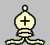  5. Horse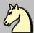6. Pawn  Each army, respectively, has one king and a queen, two rooks, two bishops, two knights and eight pawns each.  It turns out that each side has 16 pieces at the beginning of the game.  In total, there are 32 pieces on the board, respectively, that is, at the beginning of the game, exactly 50% of the entire board is occupied.  The starting position looks like this:  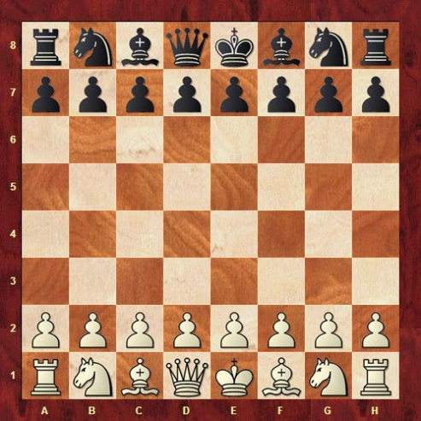  Remembering the location of the figures in the initial position is quite simple - the figures are symmetrical. The confusion usually only occurs in the positioning of the king and queen (they are often confused). Here it is important to remember only 1 rule: in the initial position, the queen stands on the field of her color.  That is, the white queen in the initial position stands on a white square, and the black queen, respectively, on a black one.  It is very important to remember that when one piece captures another, it moves to the square of the captured piece.  Practice putting the initial position on the board several times, learn to distinguish the figures by name.
3 | Final part of the lesson:  - oral questioning;  - summing up the results of the lesson;  - presenting current grades in the educational journal.
Means of education:logistical (multimedia projector,
laptop, situational tasks, chess boards, chess pieces).

Module 3Mind games.
Theme 2, 3Moves and capture of pieces.
Type of lessonpractical lesson
Targetstudy the moves and capture of pieces; contribute to the formation of logical thinking, the ability to comprehend their actions during the game.
Lesson plan
No.  p/n | Stages and content of the lesson
1 | Organizing time.  Announcement of the topic, purpose of the lesson.  Motivational moment (the relevance of studying the topic of the lesson)
2 | The main part of the lesson.Development of practical skills, testing of practical skills:moves and captures.  Pawn  Pawns only move forward. This is the only piece that can NOT move and strike backwards or horizontally. When the pawn is in its initial position (2nd rank for white, 7th for black), with its first move, it can move one or two squares forward at the player's request.  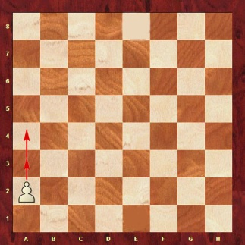  After its first move, the pawn moves only one square forward per move.  A pawn can beat the opponent's pieces one square forward diagonally to the right and left  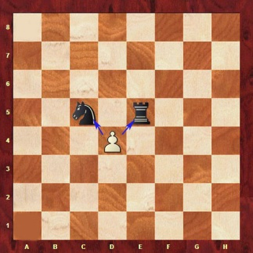  Thus, the pawn moves forward, but strikes diagonally one square. This is the only piece in chess that moves according to one rule and strikes according to another. For the rest of the figures, the trajectory of the move and the impact is the same. Below are two items. In the “A” position, the white pawn has as many as four options for moving: it can move one or two squares forward, and it can also hit one of the black pieces. In the "B" position, the pawn has no possible move - the opponent's pawn is in front, and there are no pieces that can be hit  A B  One of the most interesting rules in chess is associated with the pawn - the rule of promotion. It consists in the following. If a pawn reaches the last rank (8th for white pawns and 1st for black), it promotes to any other piece (except the king). This is clearly seen in the positions below.  Before the move After the move  The pawn moved on its own to the last file and turned into a queen. It is important to understand that such a transformation is one move. That is, after such a transformation, the turn of the move passes to the opponent.  Horse  The knight is the most "fidgety" piece on the chessboard. It walks in an unusual trajectory compared to the others and is the only piece that can jump over other pieces. The nominal value of a knight is 3 points.  "Make a knight's move" - ​​in real life, as you know, this is the name of some unusual or especially cunning step.  The horse walks with the letter "G". Its trajectory is shown in the diagram below:  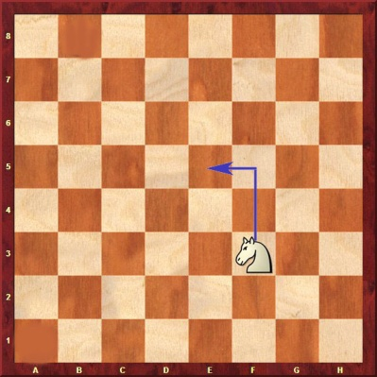  That is, the knight on its own moves 2 cells forward and one cell to the side, forming the letter "G". In this way, the horse can move and strike in any direction. Being in the center of the board, he has eight possible moves, and only two in the very corner.  Practical tasks:  How many moves does the white knight need to capture the black pawn? The black knight attacked the white pawn. How can it be defended?  Elephant  The bishop is a strong, long-range piece. An elephant is roughly equivalent to a knight. Its nominal value is also 3 points. However, they are difficult to compare. It is believed that the elephant is slightly stronger than the horse. But here much depends on the character of the player and on the requirements of the position on the board.  The knight and bishop are considered "light pieces" in chess. It sounds, of course, strange, in life you can’t call them easy :) But, as they called it, they called it that way.  The elephant walks and strikes only diagonally in all directions and at any distance as shown in the figure.  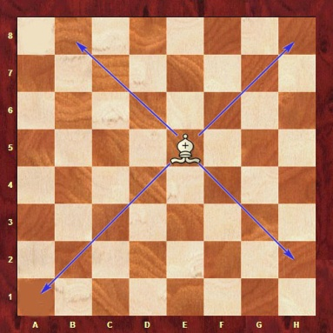  The bishop cannot jump over pieces. Thus, if other pieces stand in the way of the bishop, its action is limited. The diagram below clearly shows how their own figures limited the bishop from three sides. On the fourth side, a black horse stands in the path of the elephant. You can't jump over it either, but you can at least hit it :) Of course, you can't beat your own pieces.  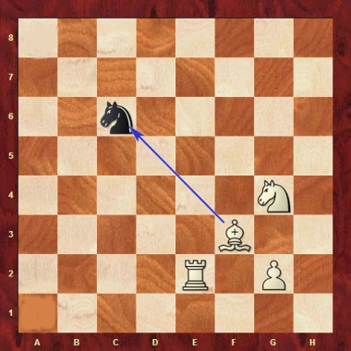  Rook.  The rook, on a par with the queen, is considered a heavy piece. Its face value is 5 points. The rook is considered a strong, but at the same time straightforward and not very maneuverable piece.  “This figure in war can be compared to a cannon. Shoots hard and far. In view of its high nominal value, it is better to take care of it and keep it a little delayed, not letting it into the thick of things, ”one of the Italian chess teachers quotes such a lyrical digression about the rook.  So, the rook moves and strikes in a straight line for any distance and in all directions (forward, backward, right and left). Cannot jump over other pieces. Everything that has been said about limiting the bishop also applies to the rook.  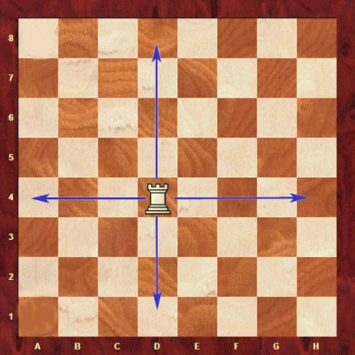  Thus, in order for the rook to bring maximum benefit, it is desirable to place it on open files.  Practical tasks to remember how the rook and bishop move.  White's move. How can the white bishop attack the black rook and knight at the same time? Black's move. The rook can hit the white bishop. Is such a hit profitable for Black? Justify your answer.  Queen.  The queen is the most powerful chess piece. The nominal value is 10 points.  The queen moves in all directions vertically and diagonally for any distance. That is, he has the capabilities of a rook and a bishop at the same time. Can NOT jump over pieces. Schematically indicated in the diagram below.  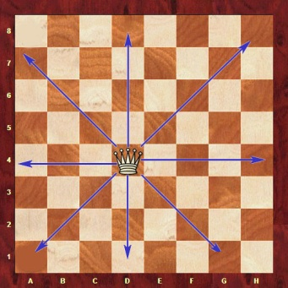  The importance of the queen is hard to overestimate. He is very effective both in defense and attack, very mobile and strong. The only negative that is associated with the queen is that it must be protected from attacks. For example, in the position in the following diagram, the white queen can attack one of several black pieces: a knight, a bishop, and a pawn. However, all these pieces are protected by the black queen. If the white queen decides to hit either of them, the black queen's next move will hit the white one. And any such exchange will be disadvantageous for White, because he will lose his strongest piece, and take a piece of lesser value for it.  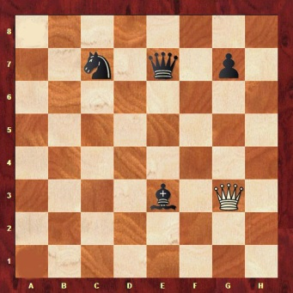  Swapping a queen, say, for a knight or bishop is almost always not profitable. Equally, the queen can be exchanged only for the opponent's queen, or for several pieces at once. Although there are times when chess players give away the queen on purpose to achieve some task. But more on that later. For now, you need to realize that the queen should be protected and used rationally as your strongest weapon.  King.  The king is the most important figure. It has no face value. It cannot be exchanged, kept under attack by the opponent's pieces. It requires constant protection. But this is not because the king is too weak as a piece, but because if he dies, then the game is lost for the player.  On the other hand, the king can also move and capture the opponent's pieces. At the end of the game, when there are an order of magnitude fewer pieces on the board, and there are not so many direct threats to the king, its strength is estimated approximately as the strength of a minor piece (knight or bishop).  The king, like the queen, moves and strikes in all directions vertically and diagonally, but only on one square.  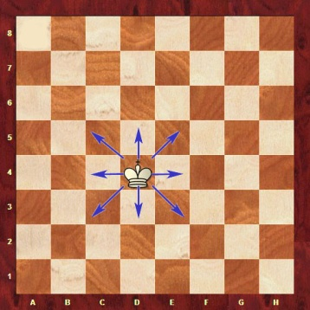  Practical yoke: "Chess maze":  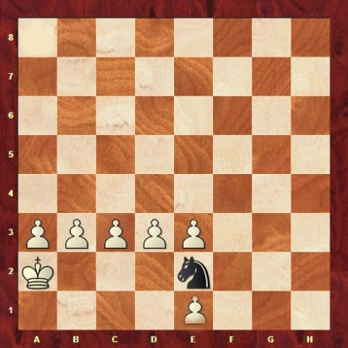  The scenario is as follows: the white king is you. Pawns are the walls of your house. They cannot be moved. The black horse is a guest to be greeted. In other words, it is necessary to reach the knight with the king. How the king walks, I think you remember.  In essence, everything is simple, the king reaches the knight one square at a time, but not quite ... You have a lot of furniture at home that prevents you from reaching the guest. For example, like this:  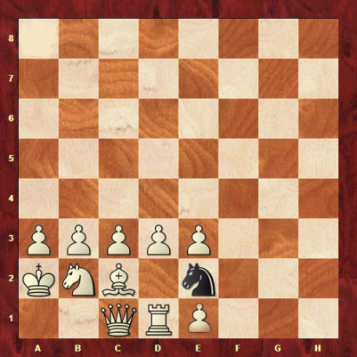  Furniture must be moved to clear a path. Thanks to this game, you can quickly remember how each piece of this "furniture" moves :)  Make it difficult for yourself until there is very little space left in your house. For example, like this:  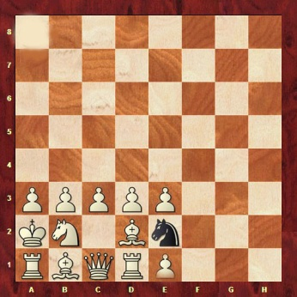
3 | Final part of the lesson:  - summarizing the lesson;  - presenting current grades in the educational journal.
Means of education:logistical (multimedia projector, laptop, chess boards, chess pieces).

Module 3Mind games.
Topic 4, 5Play with all the pieces from the starting position.
Type of lessonpractical lesson.
Targetform ideas about the chess game and the rules of the game.
Lesson plan
No.  p/n | Stages and content of the lesson
1 | Organizing time.  Announcement of the topic, purpose of the lesson.  Motivational moment (the relevance of studying the topic of the lesson)
2 | The main part of the lesson.  1. Consolidation of theoretical material:  Reports on:  - The concept of "chess game".  - Basic rules of the game.  - Development of practical skills, testing of practical skills:play with all the pieces from the starting position.
3 | Final part of the lesson:  - summarizing the lesson;  - presenting current grades in the educational journal.
Means of education:
- logistical (multimedia projector, laptop, chess boards, chess pieces).

Module 3Mind games.
Topic 6, 7Chess game. Three stages of a chess game.
Type of lessonpractical lesson.
Targetform an idea of ​​the stages of a chess game.
Lesson plan
No.  p/n | Stages and content of the lesson
1 | Organizing time.  Announcement of the topic, purpose of the lesson.  Motivational moment (the relevance of studying the topic of the lesson)
2 | The main part of the lesson.  1. Consolidation of theoretical material:  Reports on:  - The concept of "chess game".  - Stages of a chess game.  2. Development of practical skills and skills, testing of practical skills: form an idea of ​​the stages of a chess game.  A chess game is conditionally divided into 3 parts: opening, middlegame and endgame. Each stage has its own distinctive features.  1) The opening is called the first 10-15 moves of the game. In the opening, both sides seek to develop pieces, capture the center, hide the king, etc. Since White moves first, he has a little initiative that he wants to develop. Black tries to equalize the game and, on occasion, seize the initiative. Early attacks on the king like an attemptput up a baby matwith proper protection, as a rule, they do not pass.  2) The middle game is the middle of the game, from the German Mittelspiel. The pieces are brought into combat positions, and the opponents are trying to carry out their plans: improve the position of their pieces, capture important squares, achieve material advantages, etc. If the situation allows, then you can immediately attack the king. Often the winner of the game is determined in the middle game.  3) Endgame - the ending of the game, from the German Endspiel. A distinctive feature of the endgame is the ability of the king to actively participate in the game, because due to the small number of remaining pieces it is difficult for the opponent to play for a checkmate. In most of the endgames, the fight goes without queens. Significantly increases the role of pawns. The struggle is around their rapid advance towards the field of transformation. The goal is to get a new queen or force the opponent to destroy passed pawns at the cost of pieces. In both cases, the increased material preponderance made it possible to organize a decisive hunt for the king.  Of course, not always a chess game has all 3 stages. If games end quite rarely in the opening and only as a result ofblunders, then the middlegame is already limited to a fairly large number of fights. Sometimes it also happens that in the opening most of the pieces are exchanged, including queens, and the game immediately goes into the endgame, bypassing the middlegame.  Educational and training game in chess.
3 | Final part of the lesson:  - summarizing the lesson;  - presenting current grades in the educational journal.
Means of education:
- logistical (multimedia projector, laptop, chess boards, chess pieces).

Module 3Mind games.
Topic 8, 9Chess. Position analysis and evaluation.
Type of lessonpractical lesson
Targetteach to analyze and evaluate positions in a chess game
Lesson plan
No.  p/n | Stages and content of the lesson
1 | Organizing time.  Announcement of the topic, purpose of the lesson.  Motivational moment (the relevance of studying the topic of the lesson)
2 | The main part of the lesson.  1. Consolidation of theoretical material:  Reports on:  - Basic Rules.  - different positions in the game.  - The ability to evaluate various enemy positions.  2. Development of practical skills and abilities:position analysis and evaluation.  The strength of a piece depends on the specific chess position. And these positions can be countless.  But there is an approximate, nominal cost, from which you can build on:  Pawn - 1 point  Horse and elephant - 3 points  Rook - 5 points  Queen - 10 points.  The king is priceless...  For example, if the opponent's knight attacks your bishop. And your rook protects the bishop, then, in general, there is nothing to be afraid of - if the knight hits the bishop on the next move, then your rook will hit the knight. You get a three-for-three exchange.  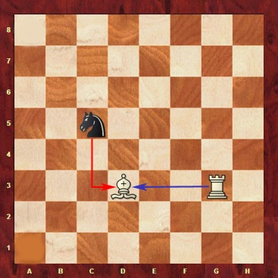  And if your queen will stand in place of the bishop, then you should immediately take care of saving him - take him to a safe position, otherwise Black will hit the queen, you will hit the black knight in the next move. It will turn out to be an extremely unfavorable exchange for White - they gave 10 and took 3.  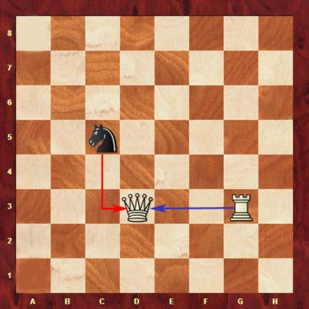  It happens that a stronger figure is given for a weaker one (or even for free) on purpose, in order to achieve a higher goal. It's called "sacrifice".  The goal is victory. To achieve it, you need to checkmate the opponent's king. Checkmate in chess is an attack on the king from which there is no defense.  For example, below are two positions where the black and white kings are checkmate. Accordingly, White won in the first position, and Black won in the second.  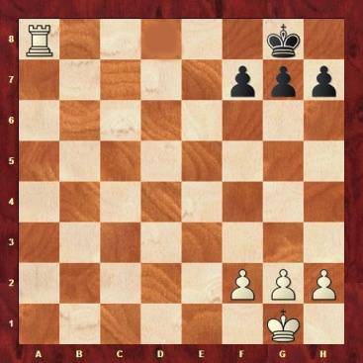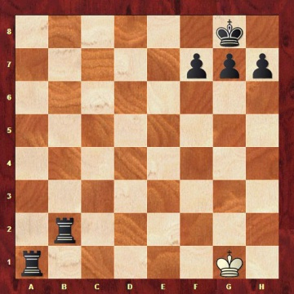  In the first position, the white rook attacked the black king. At the same time, the king is prevented by his own pawns from escaping to the 7th rank. In the second position, the black rook attacked the white king. At the same time, the second rook does not allow the king to go to the 2nd rank. Such a mat is usually called "linear".  Thus, the figures are a tool to achieve the ultimate goal. The more and stronger pieces you have and the smaller and weaker pieces your opponent has, the easier it will be to checkmate the opponent's king.  But to capture more of the opponent's pieces is not the primary goal. Even if you have few pieces, but you checkmate the opponent's king, you win.  Below are two tasks. In both it's White's move and you have to checkmate the black king in 1 move.  If you clearly remember how the chess pieces move and know what a checkmate is, there should be no problems.  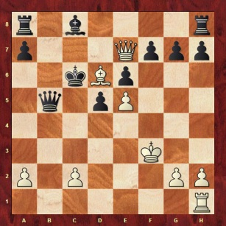  The king is the most important piece on the chessboard and therefore needs constant protection. Usually, at the beginning of the game, the struggle is tied up in the center. Exactly where the king is located. Therefore, the question arises of where to hide it from potential shelling of the opponent's pieces. The answer is to castling!  Castling is a move in chess in which the king jumps over one square to the right or left, and the rook closes it by standing on the adjacent square.  Castling can be done by both White and Black. Castling is short and long. A short one is made towards the kingside, a long one is made towards the queenside. Visually, how white and black castling is shown in the diagrams below.  Short castling  Before castling After castling  Castling long  Before castling After castling  Thus, the king will be well protected, and his safety can be taken care of to a lesser extent.  Castling can be done if the following rules are met:  Neither the king nor the rook with which castling is being made has made a single move before.  There are no other pieces between the king and the rook.  The king is not in check. That is, if you have been declared a check, then castling at this moment cannot be done.  The square over which the king jumps and the square into which he stands is not penetrated by the opponent's pieces.  Castling is considered one move, despite the fact that two pieces take part in it. Castling can only be done once per game.  Taking on the pass.  An aisle capture is a move in which a pawn can hit an opponent's pawn if it jumped over an attacked square.  If this square is penetrated by the opponent's pawn, then it can make a capture.  Visually it looks like this:  1) The white pawn has just moved two moves forward. The square that she jumped is penetrated by a black pawn 2) The black pawn captures the white one. At the same time, it becomes on a beaten field  Thus, the black pawn hit the white one and at the same time stood on the beaten square, and not on the square where the white pawn stood, as is the case with ordinary blows. At the same time, it is possible to capture on the aisle only on the next move, otherwise this right is then lost.  A check is an attack on the opponent's king.  There are three options for protection against the check:  Leave as a king.  Cover the king with some piece.  Hit an opponent's piece that declares check.  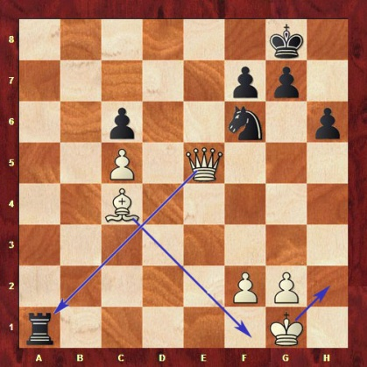  In the position on the diagram, the black rook has declared check to the white king. White can defend in three ways:  The king can get away from this check  The elephant can protect the king from attack,  The queen can hit the black rook and remove the attack from the king.  Checkmate is a check against which there is no defense.  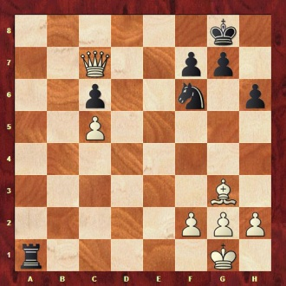  In this position, the black rook also attacked the white king, but the king has nowhere to run, there is nothing to hide behind, and there is also nothing to hit the black rook with. So it's checkmate, black won.  In total, there can be three types of result in a chess game:  White wins  Black wins  Draw  According to the traditional scoring system, 1 point is given for a victory. For a draw 0.5 points. For defeat 0.  Statistically, whites win more often than blacks because they make the first move. Victory is awarded to one side or the other if the opponent is checkmated or if one of the sides surrenders due to imminent defeat. In professional competitions, chess is played against the clock, that is, each player is given a certain amount of time to think. If time runs out, a defeat is counted.  Draw in chess.  A draw at the professional level is quite common. More often than the victory of one of the parties. This is mainly due to the fact that a lot of chess has already been studied and there are even whole theoretical variations that automatically lead to a draw.  The International Chess Federation (FIDE) has recently begun to even fight against the so-called draw drought in professional chess. In some tournaments, a special rule is introduced, according to which it is impossible to offer the opponent a draw before a certain move, etc. I must say that not all chess players like such rules.  So, a draw in chess is the result of a game, which means the sides are equal. That is, neither whites nor blacks won.  A draw can be fixed in the following cases:  1. Exhausted material for further struggle.  This means that neither one nor the other side will be able to checkmate the opponent, due to the fact that there are too few pieces left, or there are none left at all. A classic example, there are only kings left on the board. Both armies perished in a terrible battle, only the monarchs remained, who could not checkmate each other.  There are a lot of options for positions when the material is exhausted. One side may have a minor piece against a lone king. Most positions where each side has a rook left; by queen, etc. these are all theoretical draws. There are very few such cases in modern professional chess. Strong chess players usually foresee such a prospect in advance.  There are only kings on the board, it's a draw It is impossible to checkmate with one minor piece. Therefore, a draw  2. Three repetitions of the position.  If the same position is repeated three times on the board, then either side can claim a draw. Usually such a situation occurs when chess players deliberately repeat positions one after another, in case a draw suits them. Some chess players offer a draw in this "silent" way, if, so to speak, the "voice" offer of a draw is prohibited by the tournament regulations.  3. Agreeing to a draw due to an offer by one of the parties.  There is an approximate balance on the board, the opponent is not weaker than you, a draw suits you. In this case, it would be optimal to offer the opponent a draw. One of the students once asked me: “How to do it?”. I answer with all responsibility: Look at the opponent and tell him: “I offer a draw!” :) As already described above, such an offer is sometimes prohibited. But this applies only to the highest level.  In general, this is the most common draw option in modern chess.  Keep in mind that you should only offer a draw when it is your opponent's turn to move. If it is your turn now and you offer a draw, your opponent may ask you to make a move first, and only then consider your offer. The essence of this practically does not change, but psychologically it is not always pleasant. In terms of psychology, by the way, the offer of a draw is a very powerful weapon. For example, if you feel that the opponent is thinking about some risky continuation, doubts and is not entirely sure of success, the offer of a draw can further confuse his thoughts. But this is the topic of a completely different lesson.  4. Perpetual check.  There is nothing eternal in the world, but in chess there is a perpetual check! A check, as we know, is an attack by a piece on the opponent's king. Perpetual check is a situation where a check is placed on the king with each subsequent move.  At the same time, the king, hiding from the attack, can in no way prevent a further attack on himself. Given that the moves in chess are made in turn, such checks will be infinite. But no one will be able to win, since there is no checkmate on the board. The king can always run away from the attack, but the next move he is attacked again. This game can be continued indefinitely. The chess players, anticipating this prospect, agree to a draw.  There are a lot of options for perpetual check. Most often it is used to save from defeat.  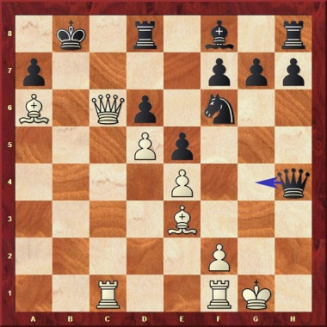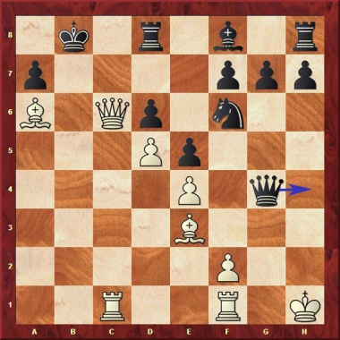  In the diagram above, White pinned the black king and is ready to checkmate with the next move. Black has no defense against this threat, but it is his turn to move and his queen can check the white king. As we know, when a check is declared, the only thing to think about is how to protect the king. His own threats fade into the background. White's king moves away from the attack, but the black queen again announces check, as indicated in the following diagram. Thus, the perpetual check saves Black from an inevitable loss.  5. Pat.  A stalemate is a situation in chess where the side with the right to move is unable to make a given move. In this case, there is no check on the board. The stalemate is often used as a save for the losing side.  An example of a stalemate is shown in the positions below. It's Black's turn to move, but there isn't a single possible move. This is called a stalemate - a draw.  Note that in checkers such a situation is considered a win, not a draw.  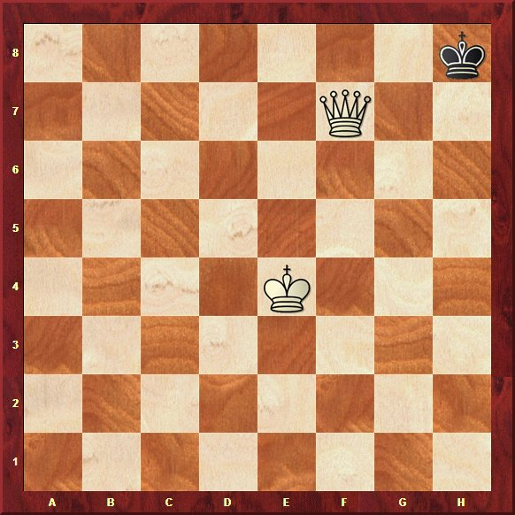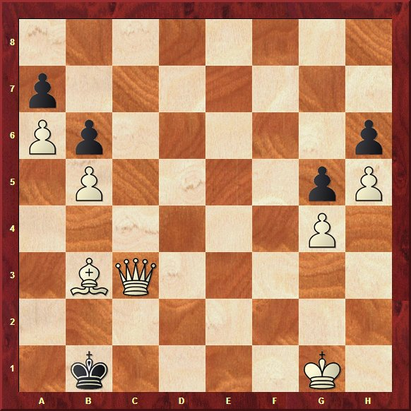  6. 50 moves without capturing and without moving pawns.  If within 50 moves neither side has captured the opponent's pieces, and there has not been a single move by pawns, any of the participants in the game can record a draw.  Educational and training game in chess.
3 | Final part of the lesson:  - summarizing the lesson;  - presenting current grades in the educational journal.
Means of education:
- logistical (multimedia projector, laptop, chess boards, chess pieces).

Module 3Mind games.
Topic 10, 11Chess. Chess combination.
Type of lessonpractical lesson.
Targetto form ideas about chess combinations and their use during the game.
Lesson plan
No.  p/n | Stages and content of the lesson
1 | Organizing time.  Announcement of the topic, purpose of the lesson.  Motivational moment (the relevance of studying the topic of the lesson)
2 | The main part of the lesson.  1. Consolidation of theoretical material:  Reports on:  - Basic Rules.  - Combinations and their types.  2. Development of practical skills and abilities:chess combination.  Solution of chess problems.
3 | Final part of the lesson:  - summarizing the lesson;  - presenting current grades in the educational journal.
Means of education:
- logistical (multimedia projector, laptop, chess problems, chess boards, chess pieces).

Module 3Mind games.
Topic 12Checkers. Rules of the game. tournament discipline.
Type of lessonpractical lesson.
TargetLearn the basic rules of chess.
Lesson plan
No.  p/n | Stages and content of the lesson
1 | Organizing time.  Announcement of the topic, purpose of the lesson.  Motivational moment (the relevance of studying the topic of the lesson)
2 | The main part of the lesson.  1. Consolidation of theoretical material:  Reports on:  - Basic rules of the game  2. Development of practical skills and abilities: rules of the game, tournament discipline.  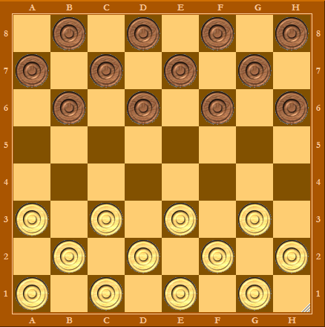  1. The game is played by two persons on a checkers board, divided into 64 squares, painted white and black, with 12 white checkers belonging to one player, and 12 black checkers belonging to another player.  2. The board between the players is placed so that the main road goes from the player from left to right.  3. Checkers on each side are placed in black squares on the first three rows from the player.  4. The moves are made alternately by the players.  5. A move is considered to be moving a checker forward to an adjacent black square, as well as capturing enemy checkers.  6. If the adjacent square is occupied by an enemy, say, black checker, and the black square following it is free, then the black checker "beats", i.e., the white checker jumps over the black checker behind it, which is a free black square, and the black checker " eat" - removed from the board.  7. At one time, as many checkers “beat” as there are on the way on the above conditions.  8. If it is possible to capture the opponent's checkers simultaneously in two directions, the choice, regardless of the number, is at the discretion of the taker.  9. When capturing, checkers are removed from the board only at the end of the move.  10. It is not allowed to take a checker twice in one move during a move (to cross it with a striker).  11. If the checker of one of the players during the game penetrates to the last row, then it turns into a king.  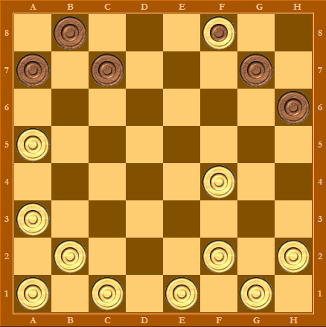  12. If a simple checker, when capturing the opponent's checkers, becomes a king and after that it again opens up the opportunity to beat the enemy checkers, then such a capture is obligatory (unlike Polish checkers).  13. The queen has the right to move along the entire length of the row of black squares to any place not occupied by checkers.  14. It “beats” the enemy checker if a free black square remains directly behind it. It strikes along the entire length of a row of black squares at any distance from itself.  15. Both a simple checker and a queen are required to “hit”, if an opportunity presents itself.  16. Both a simple and a king “hit” enemy checkers both forward and backward.  17. The winner of the game is the one who either takes all the opponent's checkers or deprives him of the opportunity to make any moves by locking the remaining checkers on the board.  18. If it is impossible for both sides to win the game, the game is considered a draw.  19. When the same moves are repeated three times directly on the one hand, the opponent is given the right to recognize the game as a draw.  20. When three queens fight against one, no more than 15 moves are given to win.  21. If there is one or more checkers with one king, no more than 30 moves are allowed to win, until the balance of forces changes.  22. If a win is not achieved in the last two cases, the game is considered a draw.  23. To keep in memory the game played, it is written down. To do this, all the rows of the drafts player longitudinal to the player are marked with the letters: a, b, c, d, e, f, g, h. The transverse rows are marked with numbers: 1, 2, 3, 4, 5, 6, 7 and 8.  24. To record the checker's move, first mark the cell on which it stood, using the number and letter that correspond to this cell, put a dash and then attribute the name of the cell on which it stands in the same way.  25. If you need to indicate the removal of a checker from the board, then between the name of the cell from which the movement begins and the name of the cell on which the checker is placed after the battle, a colon is put instead of a dash (sometimes the sign X).  26. When fighting a row of checkers, only the beginning and end of the fight are indicated, omitting the intermediate cells.  Educational and training game in checkers.
3 | Final part of the lesson:  - summarizing the lesson;  - presenting current grades in the educational journal.
Means of education:logistical (multimedia projector laptop, checkers board, checkers).

Module 3Mind games.
Topic 13Analysis and introspection of drafts games.
Type of lessonpractical lesson.
Targetto form the ability to analyze and introspection of drafts games.
Lesson plan
No.  p/n | Stages and content of the lesson
1 | Organizing time.  Announcement of the topic, purpose of the lesson.  Motivational moment (the relevance of studying the topic of the lesson)
2 | The main part of the lesson.  1. Development of practical skills: analysis and introspection of drafts games.  Educational and training game in checkers.
3 | Final part of the lesson:  - summarizing the lesson;  - presenting current grades in the educational journal.
Means of education:logistical (multimedia projector laptop, checkers board, checkers).

Module 3Mind games.
Topic 14Analysis of typical positions.
Type of lessonpractical lesson.
Targetto form the ability to parse standard positions.
Lesson plan
No.  p/n | Stages and content of the lesson
1 | Organizing time.  Announcement of the topic, purpose of the lesson.  Motivational moment (the relevance of studying the topic of the lesson)
2 | The main part of the lesson.  1. Development of practical skills and abilities: analysis of typical positions.  Educational and training game in checkers.
3 | Final part of the lesson:  - summarizing the lesson;  - presenting current grades in the educational journal.
Means of education:logistical (multimedia projector laptop, checkers board, checkers).

Module 3Mind games.
Topic 15Preparation and holding of the intellectual game "Own game".
Type of lessonpractical lesson.
Targetto teach the preparation and conduct of intellectual games.
Lesson plan
No.  p/n | Stages and content of the lesson
1 | Organizing time.  Announcement of the topic, purpose of the lesson.  Motivational moment (the relevance of studying the topic of the lesson)
2 | The main part of the lesson.  - Development of practical skills and abilities:preparation and holding of the intellectual game "Own game".  - Topic: adaptive physical culture and sports for the disabled.  - Stages of preparation:  I. Goals and objectives.  II. Organization and conduct of the game.  III. Location.  IV. Team composition.  V. Conditions of the game.  VI. Summarizing.  VII. Rewarding.  - Conducting the game.
3 | Final part of the lesson:  - summing up the results of the lesson (game);  - presenting current grades in the educational journal.
Means of education:
- logistical(chalk, blackboard, multimedia projector, laptop).

Module 3Mind games.
Topic 16Preparation and holding of the intellectual game “What? Where? When?".
Type of training session:practical lesson.
Target:to teach the preparation and conduct of intellectual games.
Lesson plan
No.  p/n | Stages and content of the lesson
1 | Organizing time.  Announcement of the topic, purpose of the lesson.  Motivational moment (the relevance of studying the topic of the lesson)
2 | The main part of the lesson.  - Development of practical skills and abilities:preparation and holding of the intellectual game “What? Where? When?".  - Subject: Paralympic Games in 2014.  - Stages of preparation:  I. Goals and objectives.  II. Organization and conduct of the game.  III. Location.  IV. Team composition.  V. Conditions of the game.  VI. Summarizing.  VII. Rewarding.  - Conducting the game.
3 | Final part of the lesson:  - summing up the results of the lesson (game);  - presenting current grades in the educational journal.
Means of education:logistical(chalk, blackboard, multimedia projector, laptop).

Module 3Mind games.
Topic 17Preparation and holding of the intellectual game “What? Where? When?".
Type of lessonpractical lesson.
Targetto teach the preparation and conduct of intellectual games.
Lesson plan
No.  p/n | Stages and content of the lesson
1 | Organizing time.  Announcement of the topic, purpose of the lesson.  Motivational moment (the relevance of studying the topic of the lesson)
2 | The main part of the lesson.  - Development of practical skills and abilities:preparation and holding of the intellectual game “What? Where? When?".  - Subject: Paralympic Games in 2014.  - Stages of preparation:  I. Goals and objectives.  II. Organization and conduct of the game.  III. Location.  IV. Team composition.  V. Conditions of the game.  VI. Summarizing.  VII. Rewarding.  - Conducting the game.
3 | Final part of the lesson:  - summing up the results of the lesson (game);  - presenting current grades in the educational journal.
Means of education:logistical(chalk, blackboard, multimedia projector, laptop).

Module 3Mind games.
Topic 18 Performing a control exercise.
Type of lessonpractical lesson.
Targetcomprehensive physical development and health promotion of students.
Lesson plan
No. p / p | Stages and content of the lesson
1 | Organizing time.  Organizational moment: construction, greeting, assessment of students' readiness.  Announcement of the topic, purpose and objectives of the lesson.  Posture exercises:  - exercises for the head and neck;  - exercises for arms and shoulder girdle;  - exercises for the legs;  outdoor switchgear  1) I.p. - hands in front of the chest in the castle  1 - 4 - circular movements in the beam - carpal joint "to the right";  1 - 4 - the same - "to the left"  2) I.p. - hands to the side  1 - 4 - circular movements in the elbow joint "inside";  1 - 4 - the same - "to the outside"  3) I.p. - hands to shoulders  1 - 4 - circular movements in the shoulder joint "forward";  1 - 4 - the same - "back"  4) I.p. - right hand at the top, left - along the body  1 - 2 - abduction of straightened arms back;  3 - 4 - the same, change of hands  5) I.p. - hands in front of the chest, bent at the elbow joint  1 - 2 - abduction of bent arms in the elbow joint, back;  3 - 4 - abduction of straightened arms in the elbow joint, back with a turn of the body to the right;  1 - 4 the same - to the left  6) I.p. - right hand at the top, left - on the belt  1 - step left, torso tilt to the left;  2 - change of hands, right step, torso tilt to the right;  3 - 4 - the same  7) I.p. - hands on the belt  1 - step left, slope;  2 - i.p.;  3 - step right, tilt;  4 - i.p.  8) I.p. - hands in front of the chest, bent at the elbow joint  1 - lunge left, turn the body to the left;  2- i.p.;  3 - 4 - the same - to the right  9) I.p. - the same as exercise No. 8  1 - lunge left, turn the body to the left;  2 - right lunge, body turn to the right;  3 - 4 - the same.
2 | The main part of the lesson.  Development of practical skills, testing of practical skills.  - taking control exercises:  Control exercise: 3.1. Rules of the game of chess.  Control exercise: 3.2. chess problems,presented in the FOS.
3 | Final part of the lesson:  - an exercise in attention;  - summing up the results of the lesson;  - presenting current grades in the educational journal.
Means of education:logistical: sports hall, stopwatch, mats, gymnastic rugs.

Module 3Mind games.
Topic 19 Performing a control exercise.
Type of lessonpractical lesson.
Targetcomprehensive physical development and health promotion of students.
Lesson plan
No. p / p | Stages and content of the lesson
1 | Organizing time.  Organizational moment: construction, greeting, assessment of students' readiness.  Announcement of the topic, purpose and objectives of the lesson.  Posture exercises:  - exercises for the head and neck;  - exercises for arms and shoulder girdle;  - exercises for the legs;  outdoor switchgear  1) I.p. - hands in front of the chest in the castle  1 - 4 - circular movements in the beam - carpal joint "to the right";  1 - 4 - the same - "to the left"  2) I.p. - hands to the side  1 - 4 - circular movements in the elbow joint "inside";  1 - 4 - the same - "to the outside"  3) I.p. - hands to shoulders  1 - 4 - circular movements in the shoulder joint "forward";  1 - 4 - the same - "back"  4) I.p. - right hand at the top, left - along the body  1 - 2 - abduction of straightened arms back;  3 - 4 - the same, change of hands  5) I.p. - hands in front of the chest, bent at the elbow joint  1 - 2 - abduction of bent arms in the elbow joint, back;  3 - 4 - abduction of straightened arms in the elbow joint, back with a turn of the body to the right;  1 - 4 the same - to the left  6) I.p. - right hand at the top, left - on the belt  1 - step left, torso tilt to the left;  2 - change of hands, right step, torso tilt to the right;  3 - 4 - the same  7) I.p. - hands on the belt  1 - step left, slope;  2 - i.p.;  3 - step right, tilt;  4 - i.p.  8) I.p. - hands in front of the chest, bent at the elbow joint  1 - lunge left, turn the body to the left;  2- i.p.;  3 - 4 - the same - to the right  9) I.p. - the same as exercise No. 8  1 - lunge left, turn the body to the left;  2 - right lunge, body turn to the right;  3 - 4 - the same.
2 | The main part of the lesson.  Development of practical skills, testing of practical skills.  - taking control exercises:  Control exercise: 3.3. Checkers game rulespresented in the FOS).
3 | Final part of the lesson:  - stretching exercise;  - summing up the results of the lesson;  - presenting current grades in the educational journal.
Means of education:logistical: stopwatch, mats, gymnastic rugs.

Module 3Mind games.
Topic 20Acceptance of control standards.
Type of lessonpractical lesson.
Targetcomprehensive physical development and health promotion of students.
Lesson plan
No. p / p | Stages and content of the lesson
1 | Organizing time.  Organizational moment: construction, greeting, assessment of students' readiness.  Announcement of the topic, purpose and objectives of the lesson.  Posture exercises:  - exercises for the head and neck;  - exercises for arms and shoulder girdle;  - exercises for the legs;  outdoor switchgear  1) I.p. - hands in front of the chest in the castle  1 - 4 - circular movements in the beam - carpal joint "to the right";  1 - 4 - the same - "to the left"  2) I.p. - hands to the side  1 - 4 - circular movements in the elbow joint "inside";  1 - 4 - the same - "to the outside"  3) I.p. - hands to shoulders  1 - 4 - circular movements in the shoulder joint "forward";  1 - 4 - the same - "back"  4) I.p. - right hand at the top, left - along the body  1 - 2 - abduction of straightened arms back;  3 - 4 - the same, change of hands  5) I.p. - hands in front of the chest, bent at the elbow joint  1 - 2 - abduction of bent arms in the elbow joint, back;  3 - 4 - abduction of straightened arms in the elbow joint, back with a turn of the body to the right;  1 - 4 the same - to the left  6) I.p. - right hand at the top, left - on the belt  1 - step left, torso tilt to the left;  2 - change of hands, right step, torso tilt to the right;  3 - 4 - the same  7) I.p. - hands on the belt  1 - step left, slope;  2 - i.p.;  3 - step right, tilt;  4 - i.p.  8) I.p. - hands in front of the chest, bent at the elbow joint  1 - lunge left, turn the body to the left;  2- i.p.;  3 - 4 - the same - to the right  9) I.p. - the same as exercise No. 8  1 - lunge left, turn the body to the left;  2 - right lunge, body turn to the right;  3 - 4 - the same.  SBU  1) running with a high hip lift;  2) running with shin overwhelm;  3) right side with a side step, hands on the belt;  4) the same - left side  5) jumps on the right / left leg  6) shuttle run
2 | The main part of the lesson.  Development of practical skills, testing of practical skills.  - acceptance of control standards, "Table of control standards" is presented in the FOS.
3 | Final part of the lesson:  - stretching exercise;  - summing up the results of the lesson;  - presenting current grades in the educational journal.
Means of education:logistical: stopwatch, starting blocks, whistle.

Module 3Mind games.
Topic 21Acceptance of control standards.
Type of lessonpractical lesson.
Targetcomprehensive physical development and health promotion of students.
Lesson plan
No. p / p | Stages and content of the lesson
1 | Organizing time.  Organizational moment: construction, greeting, assessment of students' readiness.  Announcement of the topic, purpose and objectives of the lesson.  Posture exercises:  - exercises for the head and neck;  - exercises for arms and shoulder girdle;  - exercises for the legs;  outdoor switchgear  1) I.p. - hands in front of the chest in the castle  1 - 4 - circular movements in the beam - carpal joint "to the right";  1 - 4 - the same - "to the left"  2) I.p. - hands to the side  1 - 4 - circular movements in the elbow joint "inside";  1 - 4 - the same - "to the outside"  3) I.p. - hands to shoulders  1 - 4 - circular movements in the shoulder joint "forward";  1 - 4 - the same - "back"  4) I.p. - right hand at the top, left - along the body  1 - 2 - abduction of straightened arms back;  3 - 4 - the same, change of hands  5) I.p. - hands in front of the chest, bent at the elbow joint  1 - 2 - abduction of bent arms in the elbow joint, back;  3 - 4 - abduction of straightened arms in the elbow joint, back with a turn of the body to the right;  1 - 4 the same - to the left  6) I.p. - right hand at the top, left - on the belt  1 - step left, torso tilt to the left;  2 - change of hands, right step, torso tilt to the right;  3 - 4 - the same  7) I.p. - hands on the belt  1 - step left, slope;  2 - i.p.;  3 - step right, tilt;  4 - i.p.  8) I.p. - hands in front of the chest, bent at the elbow joint  1 - lunge left, turn the body to the left;  2- i.p.;  3 - 4 - the same - to the right  9) I.p. - the same as exercise No. 8  1 - lunge left, turn the body to the left;  2 - right lunge, body turn to the right;  3 - 4 - the same.  SBU  1) running with a high hip lift;  2) running with shin overwhelm;  3) right side with a side step, hands on the belt;  4) the same - left side  5) jumps on the right / left leg  6) shuttle run
2 | The main part of the lesson.  Development of practical skills, testing of practical skills.  - acceptance of control standards, the table "Control standards" is presented in the FOS.
3 | Final part of the lesson:  - stretching exercise;  - summing up the results of the lesson;  - presenting current grades in the educational journal.
Means of education:logistical: stopwatch, starting blocks, whistle.

Module 3Mind games.
SubjectChess. Checkers.
Targetcontrol of independent work.
No.  p/n | Stages and content of the lesson
1 | Organizing time.  Announcement of the topic, purpose of the lesson.
2 | The main part of the lesson.  Checking tests on the topics studied.
3 | Final part of the lesson:  - summarizing the lesson;  - announcement of points for the performance of control work.

Module 3Mind games.
SubjectOffset.
Targetcontrol of the level of assimilation of educational material.
Lesson plan
No.  p/n | Stages and content of the lesson
1 | Organizing time.  Announcement of the topic, purpose of the lesson.
2 | The main part of the lesson.  Self workout.  The answer of students on credit cards (presented in the FOS):  Practical tasks:  - control exercises,  - control standards.
3 | Final part of the lesson:  - summarizing the lesson;  - announcement of the disciplinary rating;  - issuing an account.
Means of education:
- material and technical: gym, gymnastic mats, gymnastic rugs, gymnastic benches, hoops, gymnastic sticks, skipping ropes, weights for arms and legs, medicine balls, mats, stopwatches.

